Rationality

Rationality is nothing but status of being reasonable, sensible, and having good sense of judgment.

Rationality is concerned with expected actions and results depending upon what the agent has perceived. Performing actions with the aim of obtaining useful information is an important part of rationality.

What is Ideal Rational Agent?

An ideal rational agent is the one, which is capable of doing expected actions to maximize its performance measure, on the basis of −

* Its percept sequence
* Its built-in knowledge base

Rationality of an agent depends on the following four factors −

* The **performance measures**, which determine the degree of success.
* Agent’s **Percept Sequence** till now.
* The agent’s **prior knowledge about the environment**.
* The **actions** that the agent can carry out.

A rational agent always performs right action, where the right action means the action that causes the agent to be most successful in the given percept sequence. The problem the agent solves is characterized by Performance Measure, Environment, Actuators, and Sensors (PEAS).

The Structure of Intelligent Agents

Agent’s structure can be viewed as −

* Agent = Architecture + Agent Program
* Architecture = the machinery that an agent executes on.
* Agent Program = an implementation of an agent function.

Simple Reflex Agents

* They choose actions only based on the current percept.
* They are rational only if a correct decision is made only on the basis of current precept.
* Their environment is completely observable.

**Condition-Action Rule** − It is a rule that maps a state (condition) to an action.

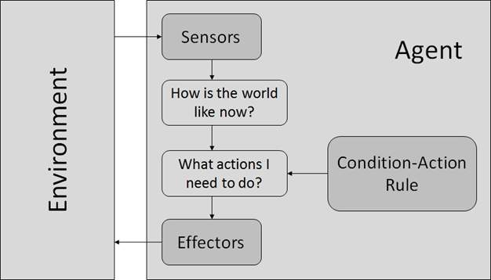

Model Based Reflex Agents

They use a model of the world to choose their actions. They maintain an internal state.

**Model** − The knowledge about how the things happen in the world.

**Internal State** − It is a representation of unobserved aspects of current state depending on percept history.

**Updating the state requires the information about −**

* How the world evolves.
* How the agent’s actions affect the world.

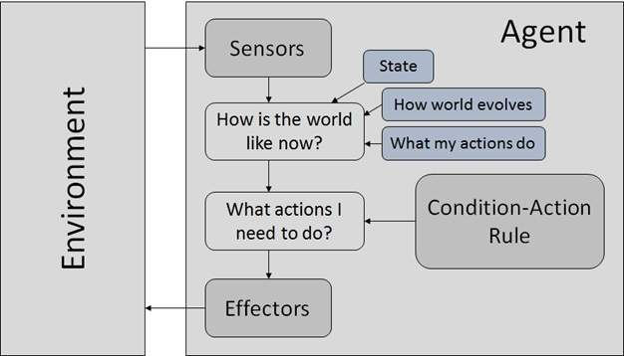

Goal Based Agents

They choose their actions in order to achieve goals. Goal-based approach is more flexible than reflex agent since the knowledge supporting a decision is explicitly modeled, thereby allowing for modifications.

**Goal** − It is the description of desirable situations.

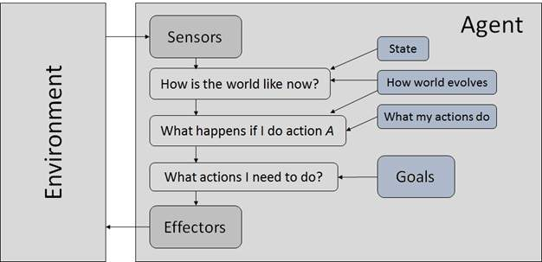

Utility Based Agents

They choose actions based on a preference (utility) for each state. Goals are inadequate when −

* There are conflicting goals, out of which only few can be achieved.
* Goals have some uncertainty of being achieved and you need to weigh likelihood of success against the importance of a goal.