VIETNAM NATIONAL UNIVERSITY OF HOCHIMINH CITY

THE INTERNATIONAL UNIVERSITY

SCHOOL OF COMPUTER SCIENCE AND ENGINEERING

Ho Chi Minh City, Vietnam

2023

**SPECIAL STUDY OF THE FIELD**

PRE-THESIS REPORT

Teaching Assistants Support System

By

**Bùi Đăng Khoa** – ITITIU19146

Advisor: **Mrs. Huynh Kha Tu**

**Table of Contents**

CHAPTER 1: INTRODUCTION AND GOALS3

1.1 Background3

1.2 Motivation3

1.3 Goals of project3

CHAPTER 2: PLANNING THE PROJECT4

2.1 Student functions4

2.2 Teacher functions6

2.3 Teaching assistant functions7

2.4 Admin functions7

CHAPTER 3: GOAL ATTAINMENT8

3.1 Function interface design student 8

3.2 Function interface design teacher11

3.3 Function interface design teaching assistant15

3.4 Function interface design admin16

3.5 Compare with original project requirements17

CHAPTER 4: PROJECT PLANNING FUTURES17

1. **Introduction and goals**

One of the problems faced by university students today is finding and communicating with teaching assistants to be able to solve academic problems. The use of computers and the internet has become popular, so my goal is to bring an online teaching support system to solve this problem. This system allows students and teachers to easily connect with each other with a common purpose in the spirit of supporting each other.

* 1. **Background:**
* A teaching assistance system's backdrop establishes the setting and structure within which the system functions. It provides a personalized platform to promote successful teaching and learning experiences by fitting with the structure, instructional environment, and requirements of the educational institution.
  1. **Motivation:**
* The motivation behind establishing a system to support teaching assistants is to create an environment that values ​​effective teaching, supports student success, fosters professional growth, encourages collaboration, and promotes consistency in the quality of education. By investing in teaching assistants' development, the university strengthens its commitment to providing a high-quality and enriching learning experience for its students.
  1. **Goals of project:**
* **Facilitating student learning:** Teaching assistants play a crucial role in supporting student learning by answering questions, providing explanations, and offering guidance during office hours or online forums. They may also conduct review sessions, lead small group activities, or provide one-on-one assistance to students who need additional support.
* **Promoting effective communication:** Teaching assistants help facilitate effective communication between students and faculty members. They may serve as a liaison, relaying important information or announcements between the professor and the students. Additionally, they can provide feedback on student performance and communicate it to both the students and the professor.
* **Professional development**: The possibility for both professional and personal improvement is another benefit of working as a teaching assistant. Teaching assistants may receive guidance from faculty members, participate in seminars or training sessions on efficient teaching techniques, and earn important experience in lesson planning and classroom management.
* **Maintaining a positive learning environment**: Teaching assistants contribute to fostering a positive and inclusive learning environment. They promote respectful and collaborative interactions among students, encourage participation, and ensure that all students have equal opportunities to succeed.
* **Recognition and rewards:** An important component of the initiative is recognizing the contributions and accomplishments of teaching assistants. The initiative encourages teaching assistants to strive for greatness by developing a mechanism to recognize excellent performance, novel teaching strategies, or noteworthy student results. It also develops a culture of acknowledgment inside the institution.

1. **Planning the project:**
   1. **Student functions:**

* **User Registration:** The register feature in a web-based teaching assistant system facilitates user account creation, allowing new users to join the system and access its functionalities. It focuses on collecting accurate user information, validating and verifying accounts, and providing a smooth onboarding experience to ensure users can start utilizing the teaching assistant system effectively.
* **User Login:** A web-based teaching assistant system's login function makes sure that only authorized users may access their accounts and make use of the services. For the purposes of facilitating effective use of the teaching assistant system's features, it focuses on user identification, data security, and offering a smooth user experience.
* **Reset password when forgot password:** When users forget their passwords, a web-based teaching assistant system's reset password feature offers a simple and safe way for them to get back into their accounts. It streamlines the password reset procedure so users may quickly get back to using the teaching assistant system.
* **Follow or unfollow the another user:** Within the teaching assistant system, users have the option to follow or unfollow particular classes, instructors, teaching assistants, or even particular students. They can get notifications or updates on the activity of a course or user by following them. Users may use this tool to remain up to date on significant announcements, conversations, or changes affecting the courses or people they are interested in. persons may also unfollow persons or courses they no longer desire to follow in order to cease receiving updates from them.
* **Manage the posts:** Users can create posts within the teaching assistant system. This feature allows them to compose and publish messages or announcements that are visible to the relevant audience, such as a specific course or a broader group of users. Moreover, users who create posts typically have the option to edit or delete their own posts. This allows them to make updates or corrections to their content or remove posts that are no longer relevant.
* **Register to become the teaching assistant:** Students wishing to become teaching assistants will register to fill out a form in the teaching assistant system. This form helps teachers gather necessary information, assess qualifications, and allows them to effectively evaluate candidates on a face-to-face basis for the teaching assistant position.
* **See all teaching assistants:** Users can view a list of all teaching assistants inside the teaching assistant system or connected to a course using this function. It assists users in finding and getting in touch with the relevant teaching assistants for needs such as questions, support, or cooperation. This feature improves the effectiveness of user interactions and supports efficient communication inside the teaching assistant system by offering pertinent information and search options.
* **Communication with group or individual:** The system provides a messaging or chat functionality that allows users to send direct messages to each other. Instructors, teaching assistants, and students can initiate one-on-one or group conversations to discuss course-related matters, seek clarification, or provide feedback.
* **Have notification:** The system sends notifications and reminders to the users to notify them of important or past events. Users may receive notifications about discussion forum activity or any other relevant system updates. These notifications help users stay engaged and on track with their course.
* **Join the meeting online:** These meeting online streaming features in a teaching assistant system facilitate real-time communication, collaboration, and engagement in remote learning environments. They provide a robust platform for conducting live classes, interactive discussions, and presentations, bridging the gap between physical and virtual classrooms.
* **React with the post** their users can engage in discussions by commenting on posts. This feature facilitates conversation, encourages collaboration, and allows users to ask questions, seek clarifications, or provide feedback on the posted content.
* **Personal Profile:** The profile feature may include a bio or "About Me" section where users can provide a brief description of themselves. They can share information like name, phone number, area of ​​expertise or post
  1. **Teaching assistant functions:**
* **Function similar of role user students**
* **Create the conversations of group:** feature enables users to engage in collaborative discussions and knowledge sharing within the teaching assistant system. It promotes communication and interaction among participants, facilitating group learning, problem-solving, and the exchange of ideas within the context of specific topics or courses.
* **Create the meeting:** In order to host the online meeting or live streaming session, the system develops a virtual conference room or area. This room has capabilities including screen sharing, audio communication, and video conferencing.
  1. **Teacher functions:**
* **Manage the schedules:** Instructors or professors have access to a dedicated control panel or interface in the tutoring system. This dashboard provides an overview of their assigned teaching assistants and related information. If a student's information is found to be correct, teachers will contact them directly if they are in the conversation. If the conversation meets the teacher's needs, the student will be approved to become a teaching assistant.
* **Manage teaching assistants:** Administrators or higher-level users may effectively plan, interact with, and manage the teaching assistants inside the teaching assistant system using this function.
  1. **Admin functions:**
* **Manage users:** Based on their duties and needs, the administrator gives users roles and permissions. Administration, teacher, and teaching assistant are typical positions in a teaching assistant system.
* **Manage the subjects:** Using the teaching assistant system's manage subjects capability, administrators or higher-level users may effectively develop, manage, update, and monitor subjects. It guarantees correct and current topic information, encourages instructor participation, and streamlines the subject management procedure.

1. **Goal attainment:**
   1. **Display student side:**

* **Student login page:**

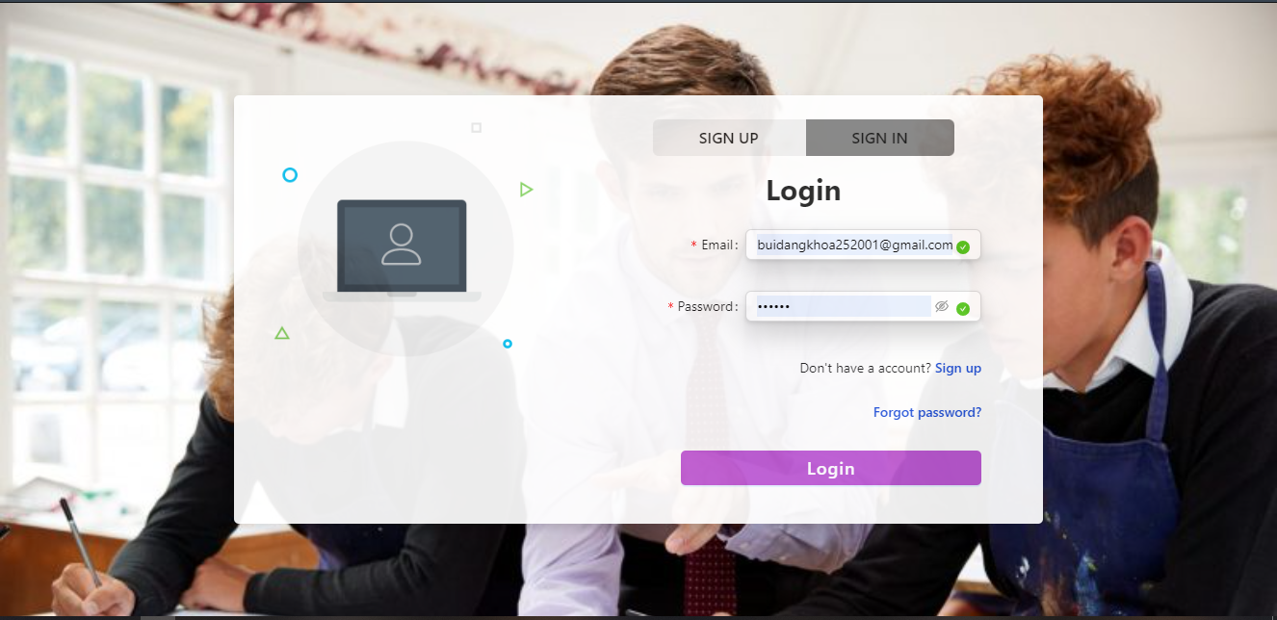

* **Student registration page:**

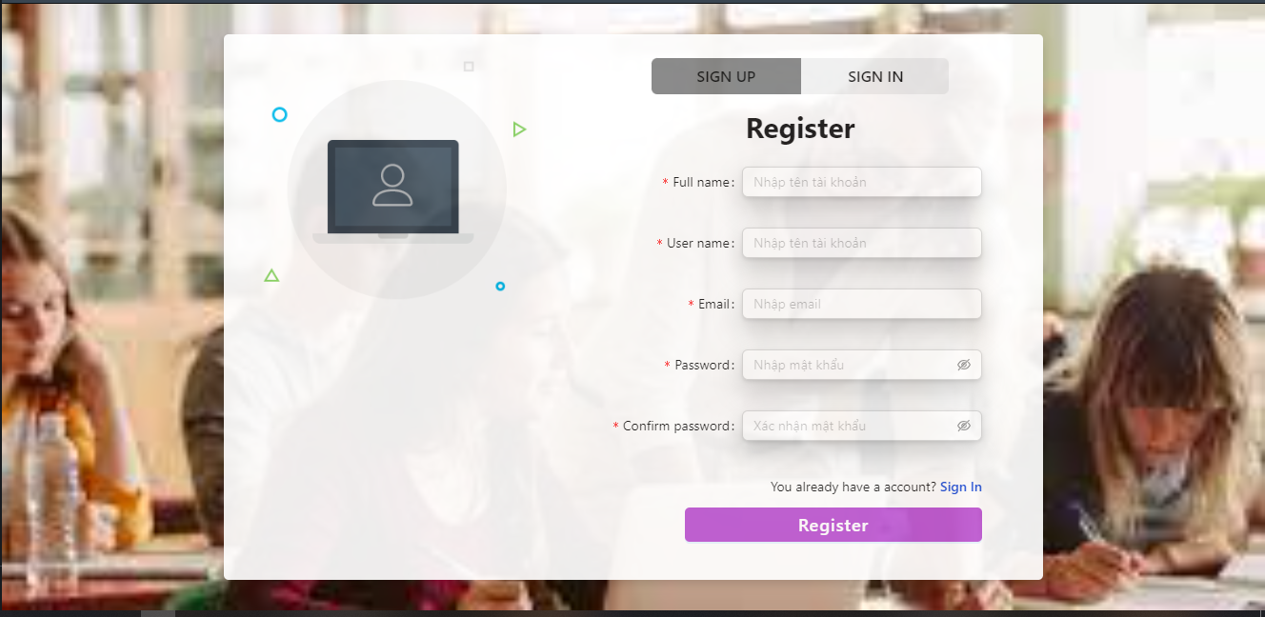

* **Home page**

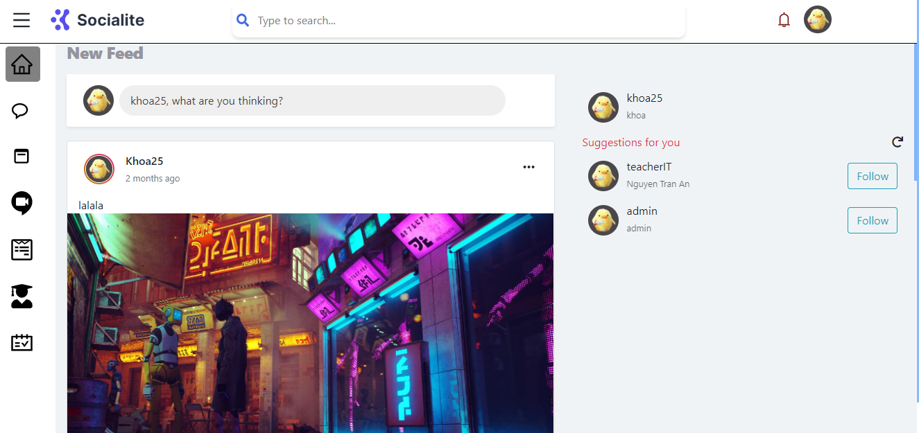

* **Profile page**

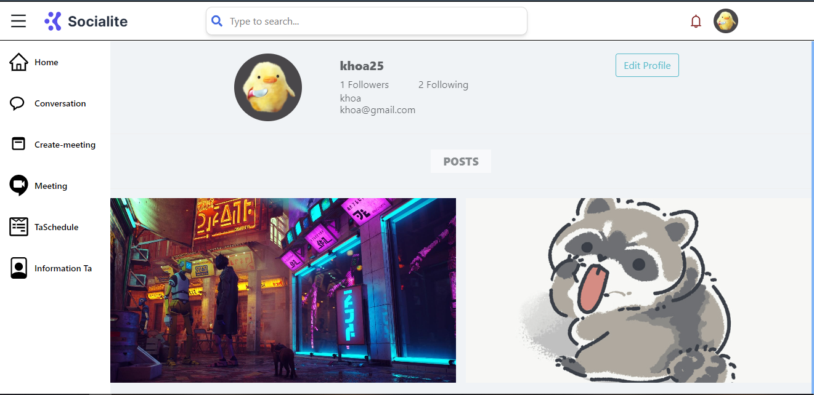

* **Notification:**

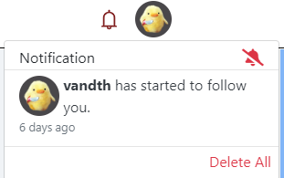

* **View all the teaching assistant:**

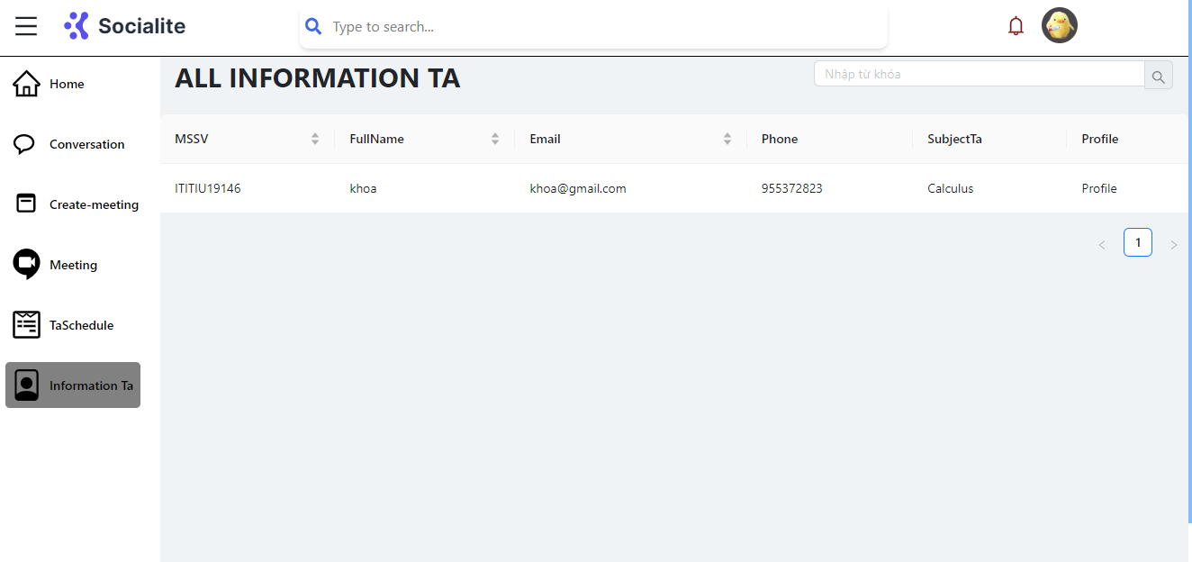

* 1. **Display teacher side:**
* **Home page**



* **Conversation page:**

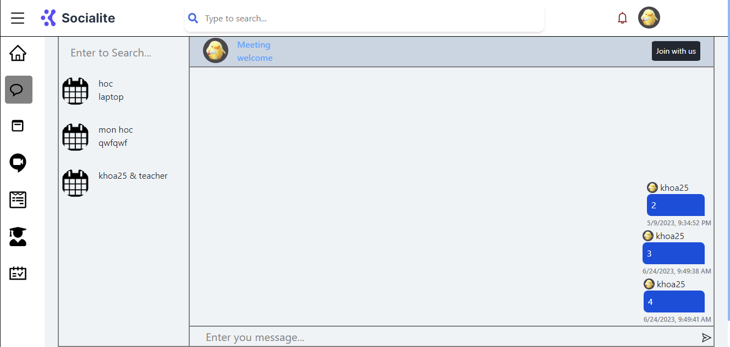

* **Create meeting online page**

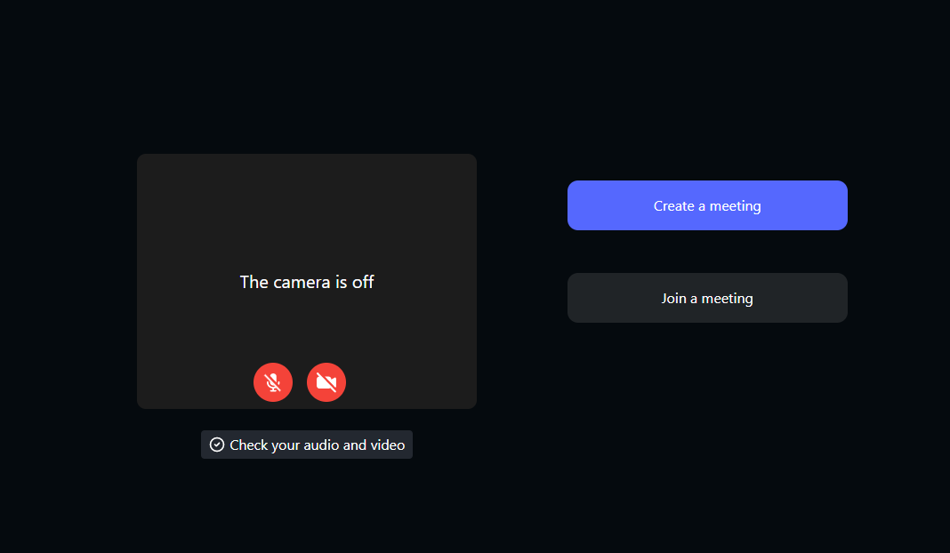

* **In the meeting page:**

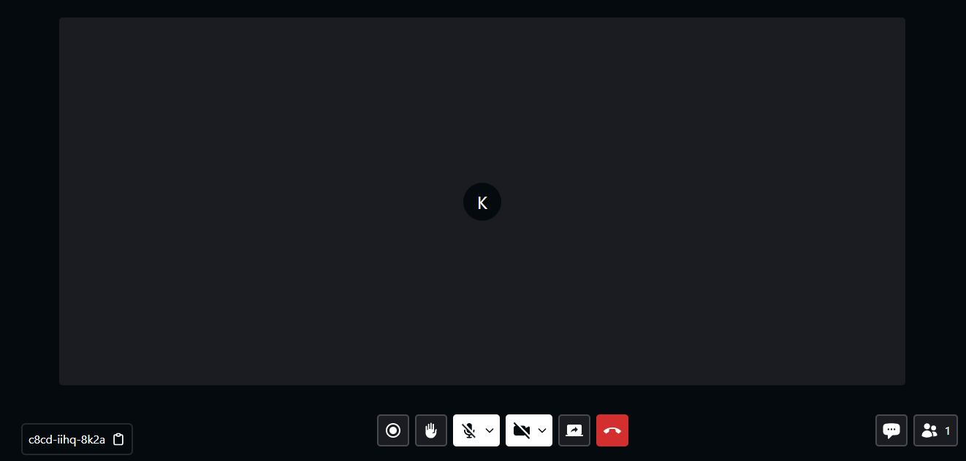

* **Create the meeting group page**

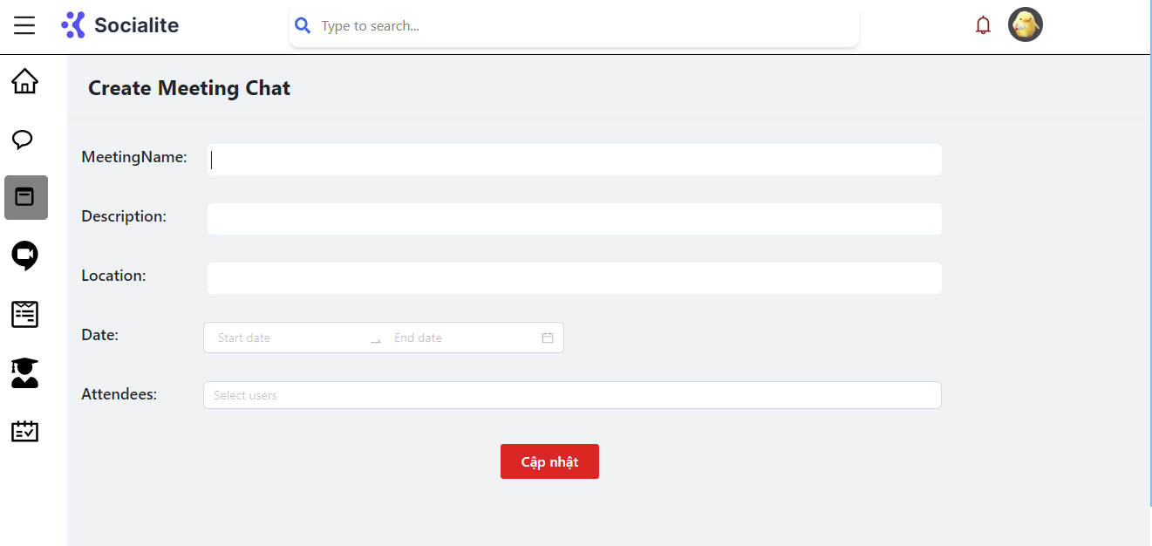

* **Create the form for applying teaching assistant page:**

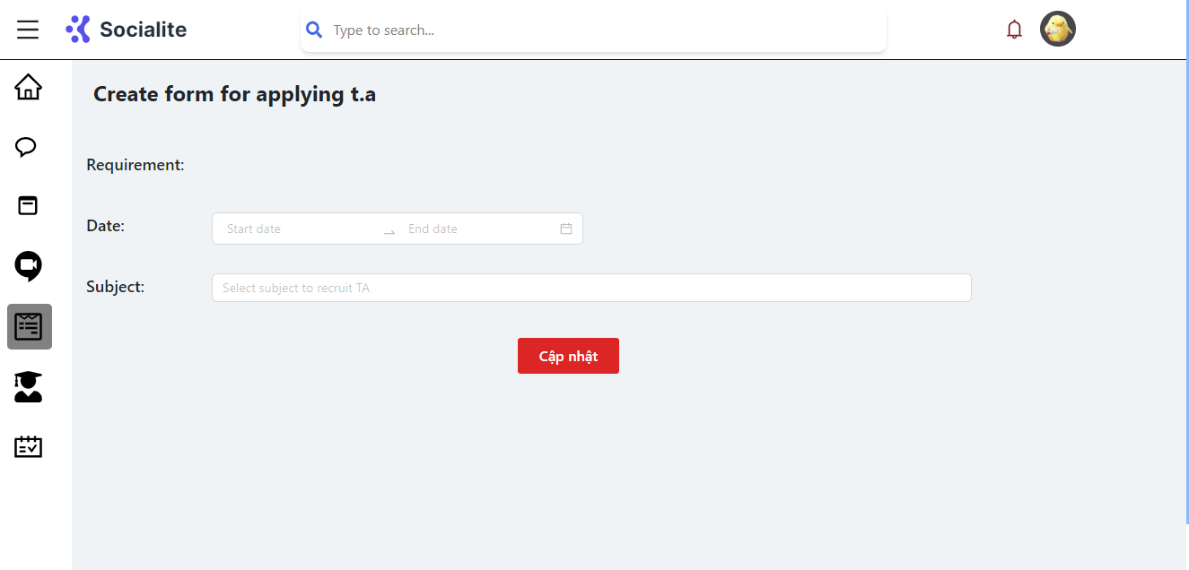

* **Manage own teaching assistants page:**

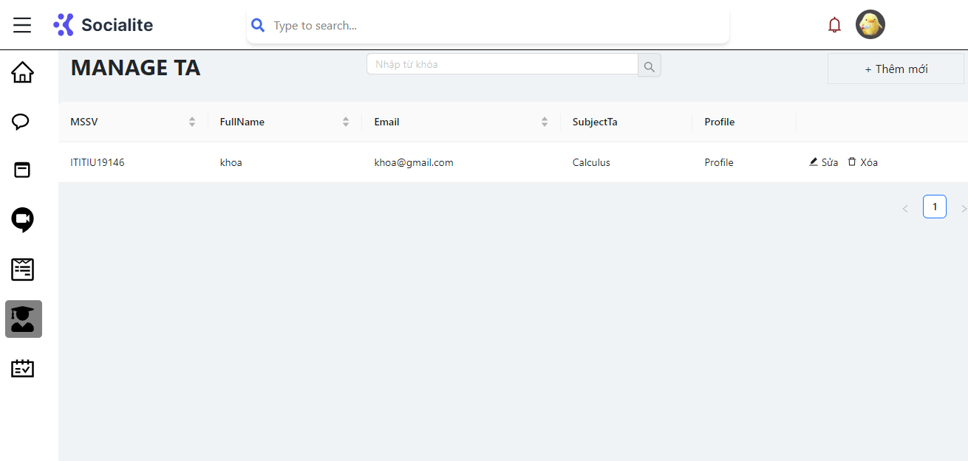

* **Manage teaching assistant schedules page:**

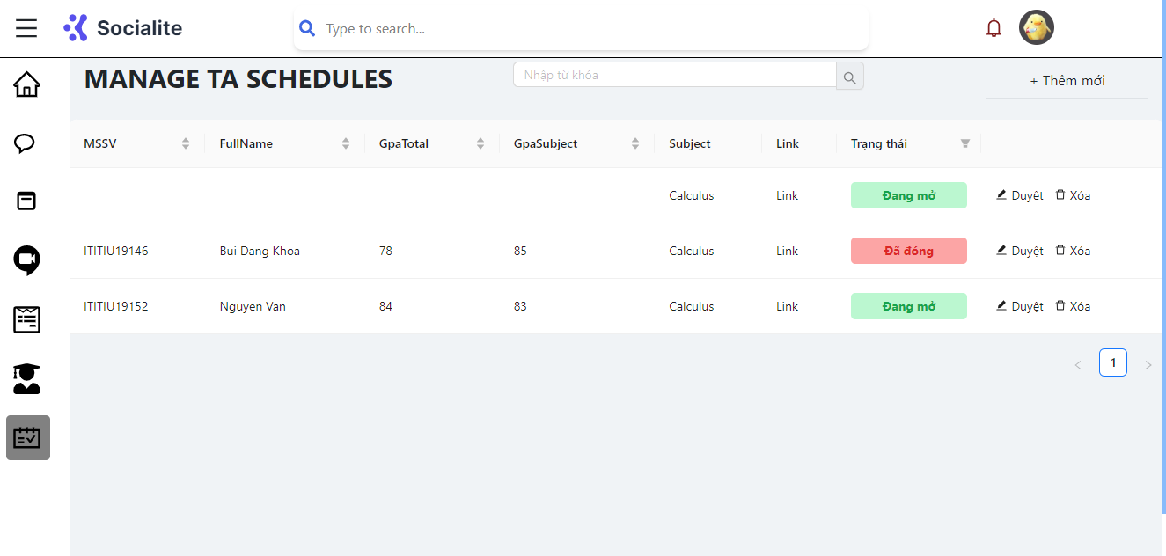

* 1. **Display TA side:**
* **Function similar to student role but can create the meeting and conversations:**

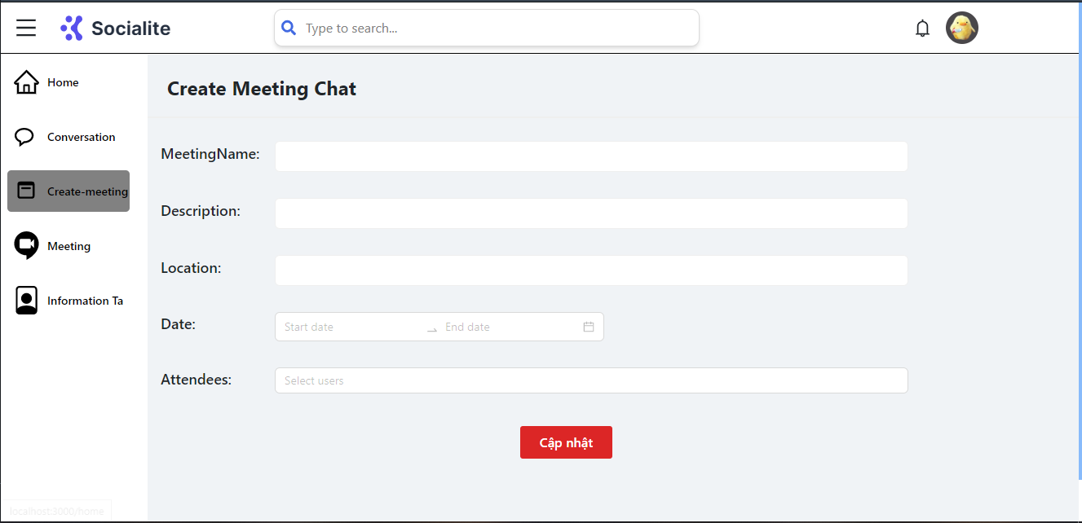

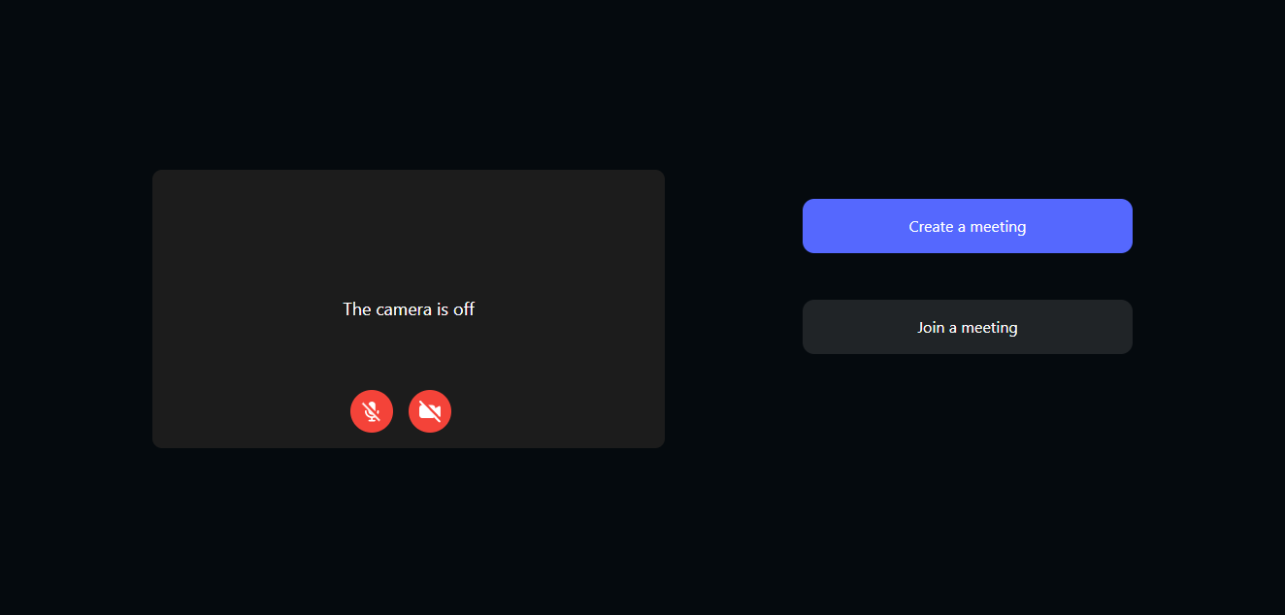

**3.4 Display admin side:**

* **Manage users page:**

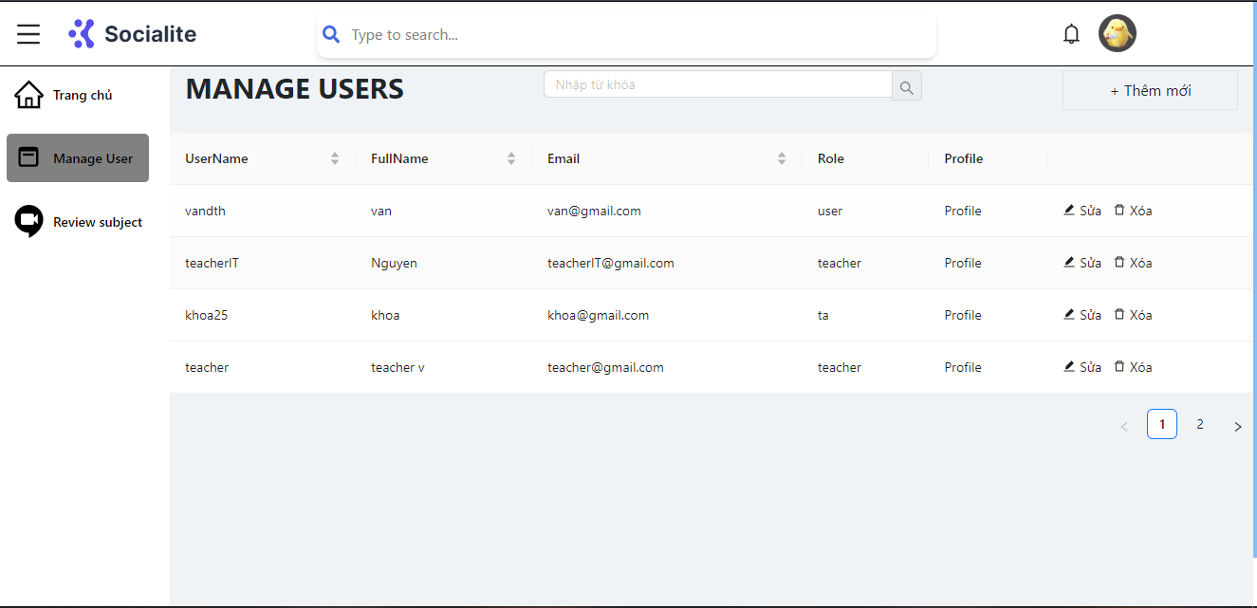

* **Manage subjects page:**

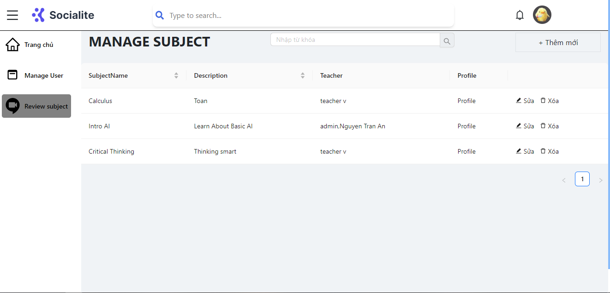

* 1. **Compare with original project requirements**
* **Student role:** The student role still fully meets the functions as well as the interface in the most perfect way. There is a route guard that prevents students from entering other routes on their own. I haven't integrated the calendar yet because of some issues. reason has arisen error and this does not reach agreement but I will try to develop this feature will try to develop in the future
* **Teaching assistant role:** Developed based on the role of students, but with additional functions such as creating meetings and creating conversations with a large group. The features in the role of teaching assistant are also carefully prepared, meeting the requirements set out
* **Teacher role:** Functions such as form management as well as teaching assistant management are completed as planned. The role of the teacher plays a huge role in the system because it closely manages its students so that the system is stable. The functions mentioned in the request have also been implemented and I will try to perfect it
* **Admin role:** The role can be said to be the most authoritative in the system, including the user management function and the university department. I think these functions seem to be enough for this system, other functions will be given to the role of teachers and teaching assistants to increase the information security of the system.

1. **Project planning futures:**

* **Improve UX/UI for future:** For visitors to our website, we want to improve usability, engagement, and intuitiveness. To make sure the enhancements are successful and in line with user expectations, the plan combines approaches for research, design, and testing.
* **Make the calendar for student:** We are able to create and execute a useful online meeting schedule for the teaching assistant system. This will simplify scheduling procedures, boost coordination, and improve teaching assistants' general time management, ultimately resulting in more productivity and efficiency in educational settings.
* **Make the real time system:** The processes and tactics to transform the teaching assistant system into a real-time system are described in this strategy. Real-time capabilities will make it possible for teaching assistants, teachers, and students to collaborate and handle tasks more quickly and effectively. We want to improve the responsiveness, efficacy, and overall user experience of the teaching assistant system by utilizing real-time technology.
* **Strengthen the security of the system:** the educational institution can protect sensitive data, prevent unauthorized access, and ensure the confidentiality, integrity, and availability of the system
* **Optimize the system:** Optimizing this system improves speed, usability, integration, and automation, contributing to a streamlined and effective tutoring system that supports an effective teaching and learning experience.