Proto 88 Board
ver 1.1.0
August 7, 2022
Will Cooke

1. Introduction

The Proto-88 board is an AVR development board for use with various 28 pin DIP AVR microcontrollers. The ATMega8, ATMega88, ATMega168, and ATMega328 can all be used. The PC board has onboard circuitry for the basic microcontroller and a large prototyping area. The board is Arduino compatible, but there is no built-in USB circuitry for bootloading.

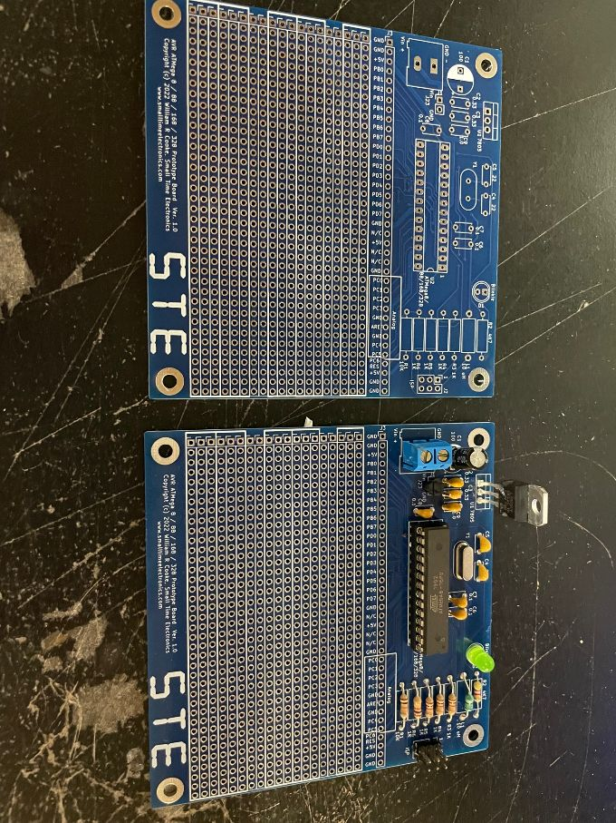
The hardware design is open source. The gerber files needed to have the board manufactured are available online. Feel free to have as many made as you like. You are welcome to do what you want with them, including selling them. If you do make millions of dollars selling them, please remember where you got it. One stipulation – you MUST keep the copyright notice on the board.

2. Overview

This is a simple board with just basic necessities of building an AVR project. The board includes the most common things needed and is mostly prototyping area. I have wanted this and intended to build it for a very long time. Before this the two alternatives I had were: 1) build the entire AVR circuit on a common, generic prototyping board, duplicating the same circuitry over and over, and 2) use an Arduino (Nano) and solder it onto a generic proto board. To me, this is a much better solution. I suspect other people will feel the same way.

The board’s features:
- Processor: Can use ATMega8, ATMega88, ATMega168, ATMega328 in narrow DIP 28 package.
- Crystal oscillator circuit.
- Power input connector and filtering.
- Voltage regulator. LM7805 or pin compatible.
- Filtering for Analog VCC.
- Prototyping connections to all processor pins as well as input voltage.
- Programming header (AVR ISP 6 pin.)
- Large prototyping area with 3 hole strips and long power bus strips.
- Arduino compatible.

Schematic and Parts List:

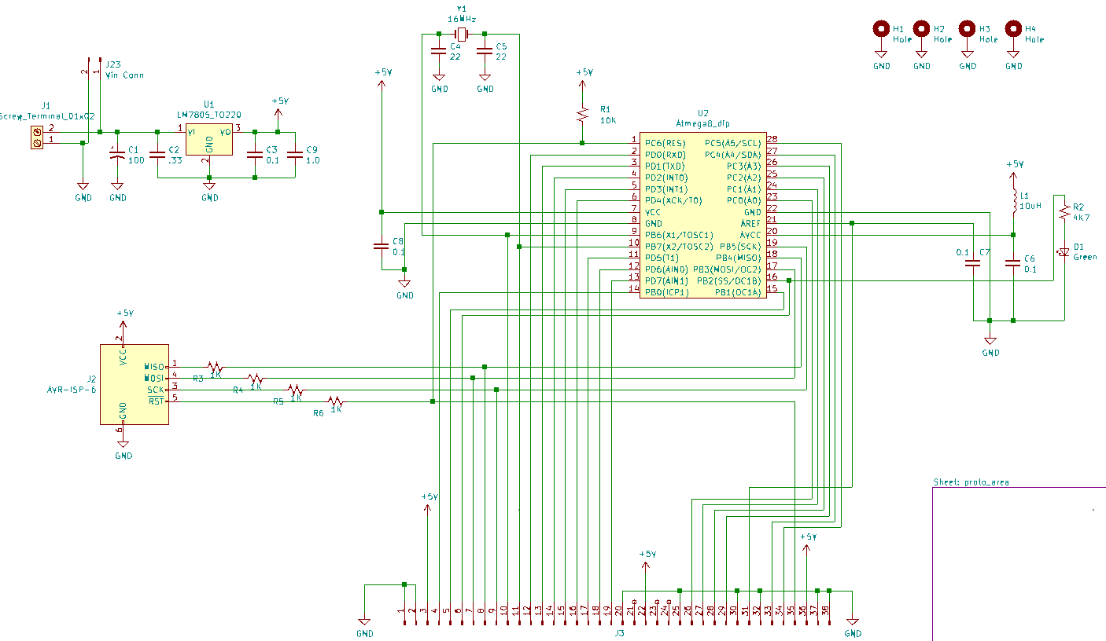

Parts List
C1 100 uF electrolytic capacacitor 5.04 mm
C2 0.33 uF ceramic capacitor 5.04mm
C3,C6,C7,C8 0.1 uF ceramic capacitor 5.04 mm
C4,C5 22 pF ceramic capacitor 5.04mm
C5 22 pF ceramic capacitor 5.04 mm
C9 1.0 uF ceramic capacitor 5.04 mm

D1 LED, T1 ¾ through hole green

J1 1x2 5mm terminal block
J2 2x3 pin header 2.54 mm AVR ISP connector
J23 1x2 pin header 2.54 mm

L1 10 uH axial leaded inductor (Tayda ???)

R1 10K 1/8 watt through hole
R2 4K7 1/8 watt through hole
R3,R4,R5,R6 1K 1/8 watt through hole

U1` LM7805 TO220 voltage regulator
U2 AVR ATMega8, 48, 88, 168, 328, etc

Y1 16 MHz quartz crystal in HC49 package

Configuration:

power section – It is possible to leave off most of the power input section. The power input terminal block, J1, can be omitted and wires soldered directly to the board. If the board will be powered by a regulated or otherwise acceptable voltage, the LM7805 regulator and C2 and C3 can be left off. A jumper will need to be wired from pin 1 to pin 3 of the regulator position. It’s a good idea to leave C1 and C9 to filter the incoming power. If you have another regulator that is pin compatible, as are many low-dropout regulators, it can be used instead of the LM7805. The two pin header, J23, can be left off in most cases. It connects directly to the power inputs on J1. Its purpose is to make the input power easily available to the prototype area with wires soldered into the holes instead of a header.

CPU – A number of different CPUs can be used. The ATMega8, ATMega88, ATMega168, ATMega328 and probably others (ATMega48, etc) can all be used. They must be in the “narrow” (0.3 inch) 28 pin DIP package. L1 is for filtering the analog to digital converter (ADC) power supply. If you aren’t using the ADC or if the normal CPU power is good enough for your uses, you can replace L1 with a wire jumper and do without the extra filtering. It is recommended to leave the capacitor, C6, in any case.

Programming Header – If for some reason you don’t need the programming header, J2, it and resistors R3, R4, R5, and R6 can be left off.

LED – Under no circumstances should D1 and R2 be left off! People will say bad things about your mother if you build a microcontroller prototyping board without a blinkie light!

The board can be built in many different configurations based on your needs and desires, as well as parts you have on hand.

Prototyping:

They prototype area consists of five rows of 3-hole connected pads on 0.1 inch centers to hold components and wires. Four of the rows are grouped in twos and adjacent to each other to accommodate larger components (e.g. 0.6 inch ICs.) Between the three sections of 3-hole pads are bus strips. There are a total of four strips arranged in two groups of two. The bus strips are independent and not connected to each other or anything else. They would typically be used for power rails (Vcc and GND) but that is not a requirement. You will need to connect them to whatever you desire them to be.

