LCBDK Instructions

Parts List

PC Board
PC Board Standoffs (4) with screws (4), nuts (4), and washers (8).
28 pin narrow machined pin DIP socket

C1 680pF ceramic
C2a1 1000pF ceramic
C2b1 20pF ceramic (optional)
C3 10uF electrolytic
C4 10uF electrolytic
C5 0.1uF ceramic
C6 0.1uF ceramic
C7 0.1uF ceramic
C8 0.1uF ceramic
C9 22pF ceramic
C10 22pF ceramic
C11 10 uF electrolytic
C12 0.33uF ceramic
C13 0.01uF ceramic
C14 0.1uF ceramic
16 pin header / DISP1 LCD_SD1602H_16x2
j1 Binding Post Black
j2 Binding Post Red
J3 Conn_01x02 9V battery connector
J4 AVR-ISP-6 2 x 3 header
L1 68uH axial
R1 100K ¼ watt
R2 100K ¼ watt
R3 100K ¼ watt
R4 47K ¼ watt
R5 1K ¼ watt
R6 10K ¼ watt
RV1 10K Trimmer potentiometer
RY1 COMUS_ReedRelay_3570-1331
SW1 Zero Momentary (blue)
SW2 Meas_L Latch on / Latch off (brown)
SW3 Meas_C Latch on / Latch off (brown)
SW4 Power Latch on / Latch off (brown)
U1 LM311 DIP 8
U2 Atmega8_dip DIP 28
U3 L78L05 TO92
Y1 16 MHz HC-49U

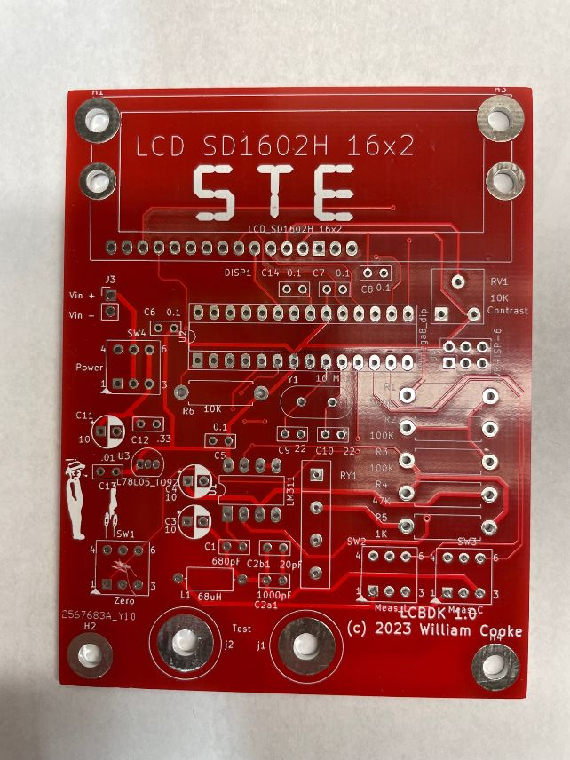

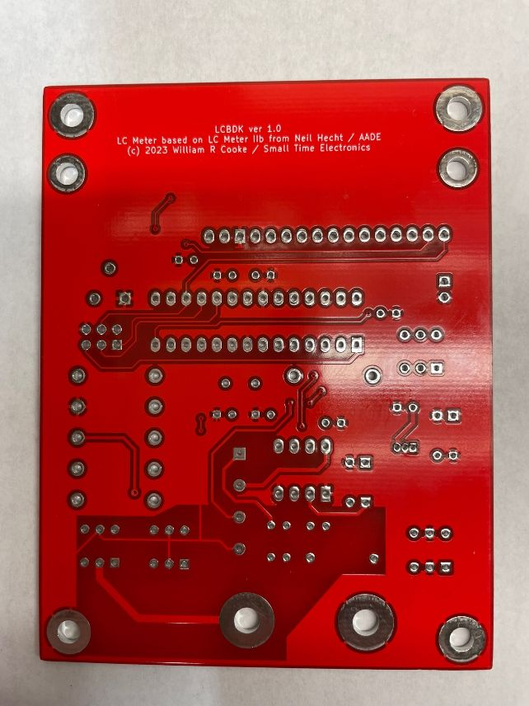

Assembly Instructions

1. Install all fixed resistors (R1 through R6.)
2. Install L1.
3. If using a socket for U2, install the socket now but not the chip. If not using a socket, install U2 now. When installing the IC, make sure pin 1 of the IC goes to pin 1 on the PC Board. With the letters STE upright near the top of the board, pin 1 of U2 will be the lower left pin. It also has a square pad.
4. Install U1. Ensure pin 1 goes to pin 1 on the PC board. With board held as above, pin 1 is on the lower left. It has a square pad. A socket for this chip is NOT recommended.
5. Install RV1.
6. Install C1, C2a1, C5 through C10, C12 through C14. C2b1 is not used.
7. Install U3. Pay close attention and make sure the flat side of the IC package aligns with the flat side marking on the PC Board.
8. Install the 16 pin FEMALE connector for the LCD display, DISP-1.
9. Solder the male 16 pin header to the LCD display, DISP-1. The header should be installed on the bottom (non-display) side with the short end of the pins attached to the display.
10. Install the relay, RY1. Verify that pin 1 of the relay goes to pin 1 on the PC Board. With the board oriented as before, pin 1 will be at the top with a square pad.
11. Install J4, the six pin programming connector.
12. Install the oscillator crystal, Y1.
13. Install C3, C4, and C11, the electrolytic capacitors. The negative side of the capacitors goes to the right on the PC Board, in the hole with the solid block of silkscreening around it. The negative side of the cap is marked either with a long mark along the capacitor next to that pin, or a negative sign, or both.
14. Install the ZERO switch, SW1. It is the switch with the blue plunger. The switch has a narrow line molded into the case from top to bottom along one side. That side must go toward the left side of the PC board. There was a layout error on this PC Board version that shorted the wrong pins together on the ZERO switch. The trace has already been cut to fix this.
15. Install switches S2, S3, and S4. Again, make sure the alignment mark on the switches goes toward the left side of the PC board.
16. Install J1, the black binding post, to the left hole and J2, the red binding post, to the right hole. Remove the two nuts and the electrical connector from the binding post. Leave the washer on. Insert the screw through the hole, then place the electrical connector on and screw the two nuts down. Orient the electrical connector so that it protrudes from the lower edge of the PC board, with the small hole in it exposed. It can be handy later for making measurements. Screw the first nut down fairly ight, then tighten the second nut down on the first. Not now, but later after you have used the device a while, you may want to add a very small “tack solder” joint to the first nut to keep it from vibrating loose.
17. Solder the wires from the battery snap into the holes for J3. The positive (red) wire should go to the top hole, marked “Vin +”. It is a good idea to put a drop of glue over the top of the wires to glue them to the PC board as a strain relief.
18. Install the standoffs to the four mounting holes at the corners of the PC board. I recommend that the male thread of the standoff fo through the hole, but if need be you can mount them with the screw through the hole into the standoff below.
19. If you used a socket for U2, install U2 in the socket now.
20. Insert the male header of the display into the femaile header on the PC board. Note the mounting holes for the display are incorrectly placed and not usable.
21. Adjust variable resistor RV1, the contrast control for the display, fully counterclockwise.
22. Ensure all three brown (latching) switches are in the “up” or “off” state.
23. Attach a 9V battery to the battery connector.
24. Turn on the power switch. The display should briefly show “LCBDK” and then begin operation.
25. Adjust contrast control RV1 for best display.

Using the LCBDK
Turn off capacitance and inductance reading switches.
Turn on power.
Display will show initializing screen.
Once Ready appears, connect component to test jacks and press appropriate button for L or C.
Display should show value of component.
Press component button again to turn it off.
Continue taking readings of other components as above until complete.
Press power switch again to turn unit off.

Theory of Operation

Magic …

U1, the LM311 comparator, is configured as a free-running oscillator. The inductor L1 and capacitor C1 form a parallel resonant circuit that determines the oscillator’s frequency. With no other inductance or capacitance in the circuit, the frequency will be approximately 750,000 Hz. When a component is to be tested, inductance is placed in series with L1 or capacitance is placed in parallel with C1 by the appropriate switch. In either case, the added component causes the frequency to be lowered.

If the exact values for L1 and C1 are known, the test component value can be found from the change in frequency.
( math to follow)
However, the specified parts for L1 and C1 can be off as much as 10% to 20%. We can calculate the product of L1 and C1 from the frequency, but not their individual values; we have two unknowns but only one equation.
By placing C2 in the circuit, which is known to 1%, we now have two equations and two unknowns (L1 and C1) and can therefore find their exact values. Once those exact values are known, we can find the value of a component under test to approximately the same accuracy (1%.)

The AVR microcontroller U2 controls all the action. On startup, the free-running frequency is measured and stored byt the AVR. Then C2 is switched in by RY1 and the frequency measured again after a warmup period. With those two frequencies, the values of L1 and C1 are stored and C2 is switched back out of the circuit. The device is now ready to measure.

When one of the component switches is activated to measure a component, the new frequency is measured and the value calculated and displayed. The measurement and display will repeat approximately four to five times per second until the switch is deactivated.

(more to follow)

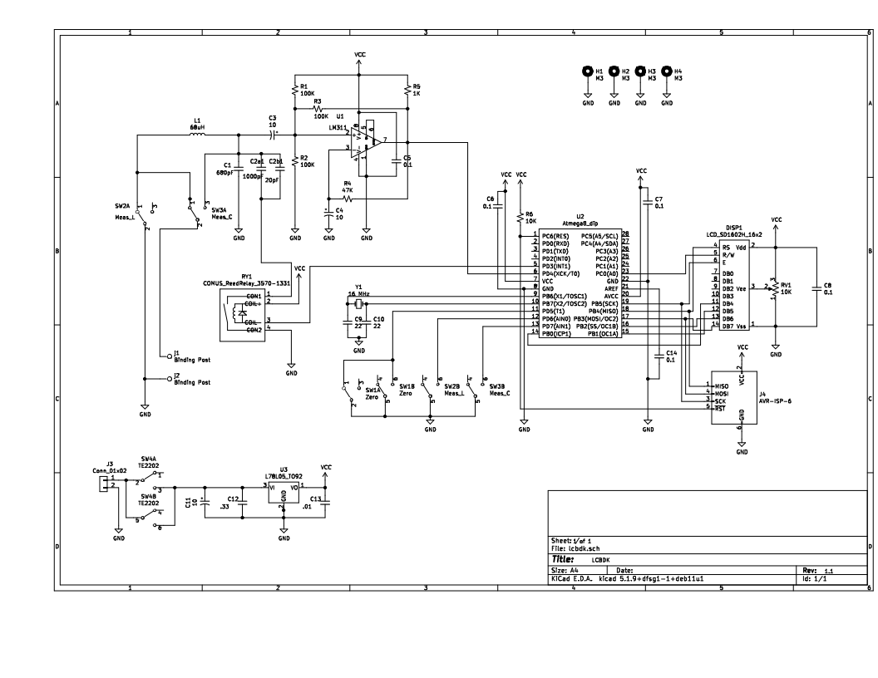
Schematic Diagram

