**UNIVERSIDAD DE LAS FUERZAS ARMADAS ESPE**

**Review of Exam project**

**NOMBRE:** Yury Ricardo Romero Gómez

**MATERIA:** ING. De Software

**FECHA:** 16/01/18

The first shot of the product it’s an interface that show all the listed products on the database, as we can see:

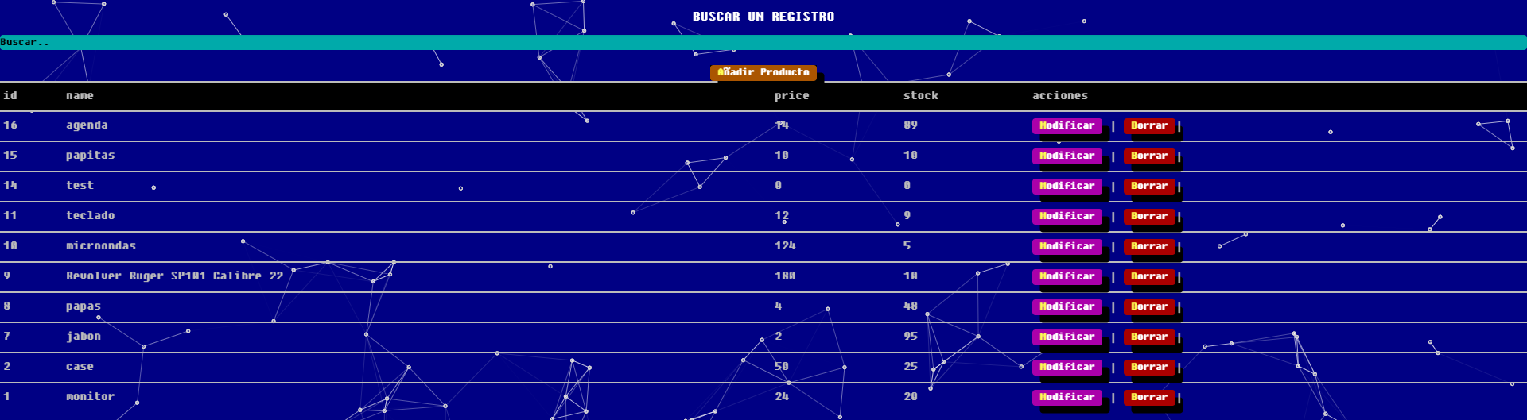

Also we can see that every item can be treated as a dynamic crud, cause of the buttons beside of all the items, there’s also the fact that every entry its validated. For example:

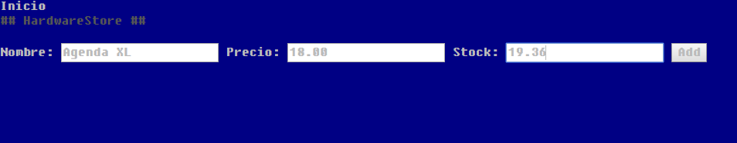

The stock will be rounded to its next or last close number.

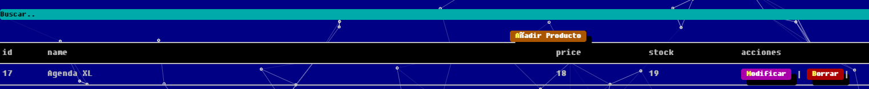

Also the requirement of update only the item via id its realized, cause the program identify the item that is chosen and then deploys the next interface

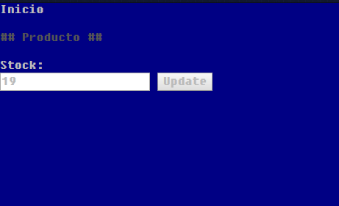

Then we can see in the primary interface that the delete buttons are activated, this could be dangerous but still accomplish with the user requirements.

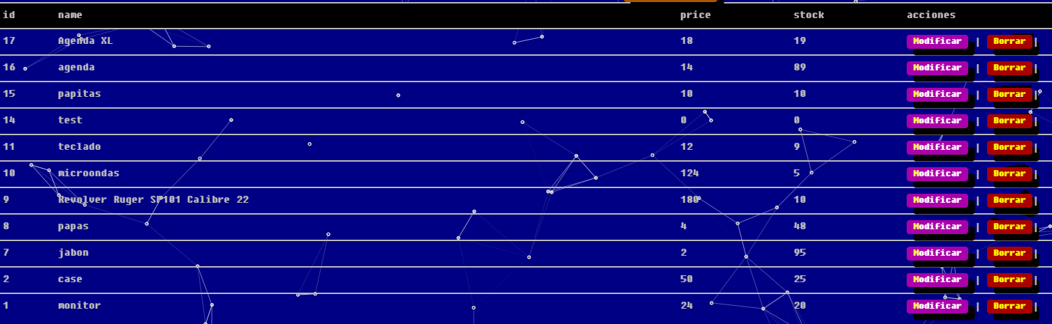

There’s still something that don’t go with the interface and user interaction, and it’s the implementation of “Spanglish”, meaning that some buttons are in Spanish and to be clear the modify button open an interface that shows the button on English.



To conclude the product satisfies the customer requirements, there’s two minor fixed to be applied and they’re the problem of the language of the application, and a background that doesn’t merge with the font color of the application, besides that accomplish with the specification.