1. Project Title, Team name, Version, Date

Title: Marketing Effects Report Generator (MERG)

Team Name: Team H

Version: 1.0

Date: 10/25/2019

1. Overview

The Marketing Report Generator is a web application that pulls data from various online tools, the data is then consolidated and displayed on a web page. The application is used by the account managers of [White Stone Marketing](https://www.whitestonemarketing.com/), a digital marketing agency, to create marketing reports for their clients. The purpose of the report is to convey the results of the current marketing strategy and to facilitate the elicitation of future strategies. The report is presented via a secure website, during scheduled meetings, as the participants are remotely located.

1. Glossary

Users:

1. Account Managers (AM)- employees of White Stone Marketing. (typically, service ~20 clients)
2. Inn Owners - The clients of White Stone Marketing.
3. Senior Account Managers (SAM) - The supervisor of Account Managers

Terms:

* + - 1. Clearance Level – used to determine which pages the user will be allowed to view upon logging in.
      2. Profile – refers to the database record which holds user’s information including but not limited to ID, Name, Email, ClientID, API Key, and Clearance Level.
      3. Edit - in reference to user profiles, to edit, means to create, remove, update, or display.

1. System Overview Diagram

Figure 1 shows the system architecture of MERG. The database and website will be hosted on the Bluehost server. Records will be added, updated, and fetched from the database via the website. The website will send requests to and receive information from various APIs. The data received from the API will be used to create graphs and charts. The system will generate new webpages to display the graphs and charts so they can be viewed by the users.

1. Functional Requirements

Include at least 10 user requirements

**User Requirements**

1. Account Managers must be able to login to the Marketing Report Generator page.
2. Account Managers must be able to generate the reports.
   1. Account Managers must be able to specify which Inn Owner the report is generated for.
   2. Account Managers must be able to specify the date range the report is generated for.
   3. Account Managers must be able to specify any combination of sources the report is generated from.
      1. Possible Sources: Google Analytics, MailChimp, Facebook, Cart Stack, Trip Tease, Think Reservations. (TBD)
3. Account managers must be able to access everything the Inn Owners can access.
4. Inn Owners must be able to login to view the report page.
5. Inn Owners must NOT be able to view other Inn Owners’ report page.
6. Inn Owners must be able to view all previously generated reports.
7. The Senior Managers must be able to edit Account Managers' profiles.
8. The Senior Managers must be able to edit Inn Owners’ profiles.
9. The Senior Managers must be able to access everything the Account Managers can access.
10. system requirements

**System Requirements**

Assumptions:

* + - 1. The database has been created
      2. The Senior Account Managers’ profiles have been added to the database.
      3. The user has navigated to the login screen for all users.

General System Requirements

The system should redirect non-authenticated users to login page.

The system should query database for relevant information based on metrics provided by user. (Generate Report)

The system should query various APIs for requested data.

The system should generate a new web page for each report generated.

The system should name each new web page with a unique name ((ex. *clientid/mm_dd_yyy.html*)

The system should store URLs in database.

The system should populate page with graphs, charts, etc. to visually represent data retrieved from APIs.

Senior Account Managers Interactions:

The system must authenticate the user.

The system should gather usernames and passwords via online form.

The system should compare credentials entered by user to those stored in the database

The system should retrieve user types from database.

The system should redirect to the SAM page. (assuming credentials were valid).

The system should have forms that allow SAM to edit user profiles.

Create form should allow SAM to provide user’s profile info

Update form should allow SAM to update the user’s profile info

1. The system should allow SAM to display all account managers.
2. The system should allow SAM to display all Inn owners.
3. The system should allow SAM to generate marketing reports
   * + - 1. The system should allow SAM to select Inn Owner from a drop-down menu.
         2. The system should allow SAM to choose a Start date from JavaScript calendar.
         3. The system should allow SAM to choose an End date from JavaScript calendar.
         4. The system should allow SAM to choose sources for report data from list(checkboxes).
         5. The system should allow SAM to indicate they would like the report to be generated. (Generate report Button).

Account Managers Interactions:

The system must authenticate user.

System should gather username and password via online form.

System should compare credentials entered by user to those stored in the database

System should retrieve user type from data base.

System should redirect to IO page. (assuming credentials were valid).

Each IO will have a unique page, URL for the page will have a unique identifier (ex. *clientid/index.html*)

System should allow AM to generate marketing reports.

System should allow AM to select Inn Owner from a drop-down menu.

System should allow AM to choose a Start date from JavaScript calendar.

System should allow AM to choose an End date from JavaScript calendar.

System should allow AM to choose sources for report data from list(checkboxes).

System should allow AM to indicate they would like the report to be generated. (Generate report Button).

Inn Owners Interactions:

The system must authenticate the user.

The system should gather usernames and passwords via online form.

The system should compare credentials entered by user to those stored in the database

The system should retrieve user type from data base.

The system should redirect to IO page. (assuming credentials were valid).

The system should allow IO to view marketing reports.

The system should fetch list of URLs from database.

The system should display a list of URLs in the form of hyperlinks.

a few essential non-functional requirements.

TODO: FULL TEAM

1. References

BACS 487 course work

Fig.1

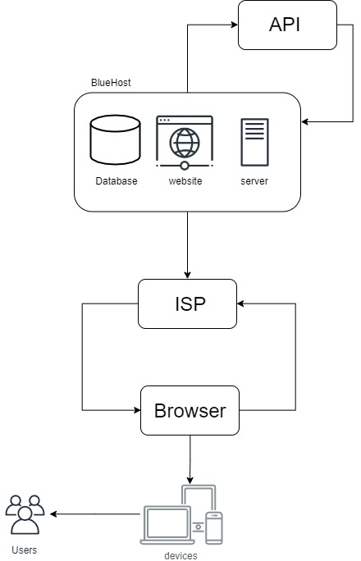

E/R Diagram for Reports Generator

