Title: Marketing Effects Report Generator (MERG)

Team Name: Team H

Version: 1.0

Date: 10/25/2019

Overview

The Marketing Report Generator is a web application that pulls data from various online tools, the data is then consolidated and displayed on a web page. The application is used by the account managers of [White Stone Marketing](https://www.whitestonemarketing.com/), a digital marketing agency, to create marketing reports for their clients. The purpose of the report is to convey the results of the current marketing strategy and to facilitate the elicitation of future strategies. The report is presented via a secure website, during scheduled meetings, as the participants are remotely located.

Glossary

Users:

1. Account Managers (AM)- employees of White Stone Marketing.
2. Inn Owners - The clients of White Stone Marketing.
3. Senior Account Managers (SAM) - The supervisor of Account Managers.

Terms:

1. Clearance Level – used to determine which pages the user will be allowed to view upon logging in.
2. Profile – refers to the database record which holds user’s information including but not limited to ID, Name, Email, ClientID, API Key, and Clearance Level.
3. Edit - in reference to user profiles, to edit, means to create, remove, update, or display.
4. Login Page – the webpage used to gather user information required for authentication.
5. Marketing reports – a collection of graphs, charts etc. which visually represent data. (specific details to be provided by White Stone Marketing by 11/4/2019)

System Overview Diagram

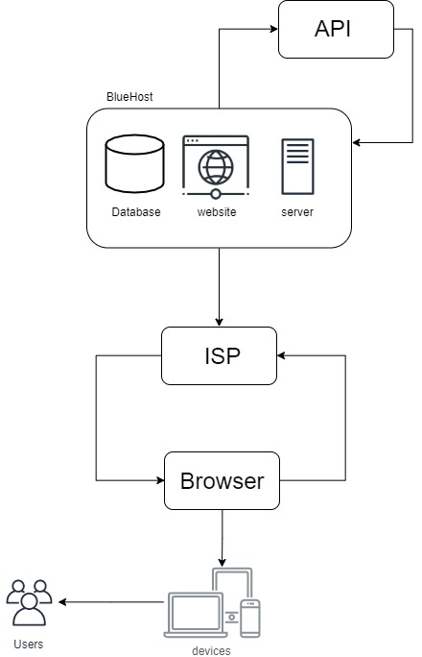Fig.1

Figure 1 shows the system architecture of MERG. The database and website will be hosted on the Bluehost server. Records will be added, updated, and fetched from the database via the website. The website will send requests to and receive information from various APIs. The data received from the API will be used to create graphs and charts. The system will generate new webpages to display the graphs and charts so they can be viewed by the users.

Functional Requirements

User Requirements

Account Managers

1. Account Managers must be able to login to the Marketing Report Generator page.
2. Account Managers must be able to generate the reports.
3. Account Managers must be able to specify which Inn Owner the report is generated for.
4. Account Managers must be able to specify the date range the report is generated for.
5. Account Managers must be able to specify any combination of sources the report is generated from.
6. Possible Sources: Google Analytics, MailChimp, Facebook, Cart Stack, TripTease, Think Reservations.
7. Account managers must be able to access everything the Inn Owners can access.
8. Inn Owners must be able to login to view the report page.

Inn Owners

1. Inn Owners must not be able to view other Inn Owners’ report page.
2. Inn Owners must be able to view all previously generated reports.

Senior Managers

1. The Senior Managers must be able to edit Account Managers' profiles.
2. The Senior Managers must be able to edit Inn Owners’ profiles.
3. The Senior Managers must be able to access everything the Account Managers can access.

System Requirements

Assumptions:

* + - 1. The database has been created
      2. The Senior Account Managers’ profiles have been added to the database.
      3. The user has navigated to the login screen for all users.

General System Requirements

The system should redirect non-authenticated users to login page.

The system should query database for relevant information based on metrics provided by user.

The system should query various APIs for requested data.

The system should generate a new web page for each report generated.

The system should name each new web page with a unique name ((ex. *clientid/mm_dd_yyy.html*)

The system should store URLs in database.

The system should populate page with graphs, charts, etc. to visually represent data retrieved from APIs.

Senior Account Managers Interactions:

The system must authenticate the user.

The system should redirect to the SAM page.

The system should allow SAM to edit user profiles.

The system should allow SAM to display all account managers.

The system should allow SAM to display all Inn owners.

The system should allow SAM to specify which Inn Owner to generate a report for.

The system should allow SAM to specify a Start date for the report.

The system should allow SAM to specify an End date for the report.

The system should allow SAM to specify sources for the report.

The system should allow SAM to indicate they would like the report to be generated based on the Inn Owner, start date, end date, and sources specified by SAM.

Account Managers Interactions:

The system must authenticate user.

System should redirect to AM page. (assuming credentials were valid).

System should allow AM to generate marketing reports.

The system should allow AM to specify which Inn Owner to generate a report for.

The system should allow AM to specify a Start date for the report.

The system should allow AM to specify an End date for the report.

The system should allow AM to specify sources for the report.

The system should allow AM to indicate they would like the report to be generated based on the Inn Owner, start date, end date, and sources specified by AM.

Inn Owners Interactions:

The system must authenticate the user.

The system should redirect to IO page.

The system should allow IO to view marketing reports.

The system should request URLs from the database.

The system should display URLs.

The system should allow IO to specify a URL.

The system should redirect to specified URL.

a few essential non-functional requirements.

1. References

BACS 487 course work

ERD

