Title: Marketing Effects Report Generator (MERG)

Team Name: Team H

Version: 0.1

Date: 12/15/2019

Overview

The Marketing Effects Report Generator is a web application that pulls data from various online tools, the data is then consolidated and displayed on a web page. The application is used by the account managers of White Stone Marketing, a digital marketing agency, to create marketing reports for their clients. The purpose of the report is to convey the results of the current marketing strategy and to facilitate the elicitation of future strategies. The report is presented via a secure website, during scheduled meetings, as the participants are remotely located.

Glossary

1. Users
   1. Inn Owners (IO) - The clients of White Stone Marketing.
   2. Account Managers (AM)- employees of White Stone Marketing. (typically, service ~20 clients).
   3. Senior Account Managers (SAM) - The supervisor of Account Managers.
2. User Type – used to determine which pages the user will be allowed to view upon logging in.
3. Profile – refers to the database record which holds user’s information including but not limited to ID, Name, Email, ClientID, API Key, and Clearance Level.
4. Edit - in reference to user profiles, to edit, means to create, remove, update, or display.
5. Login Page – the webpage used to gather user information required for authentication.
6. Marketing report – a web page that displays information in the form of charts, graphs, and text. Specific details regarding which information will be displayed to be provided by White Stone Marketing in the future as feasibility is still being established.

System Overview Diagram

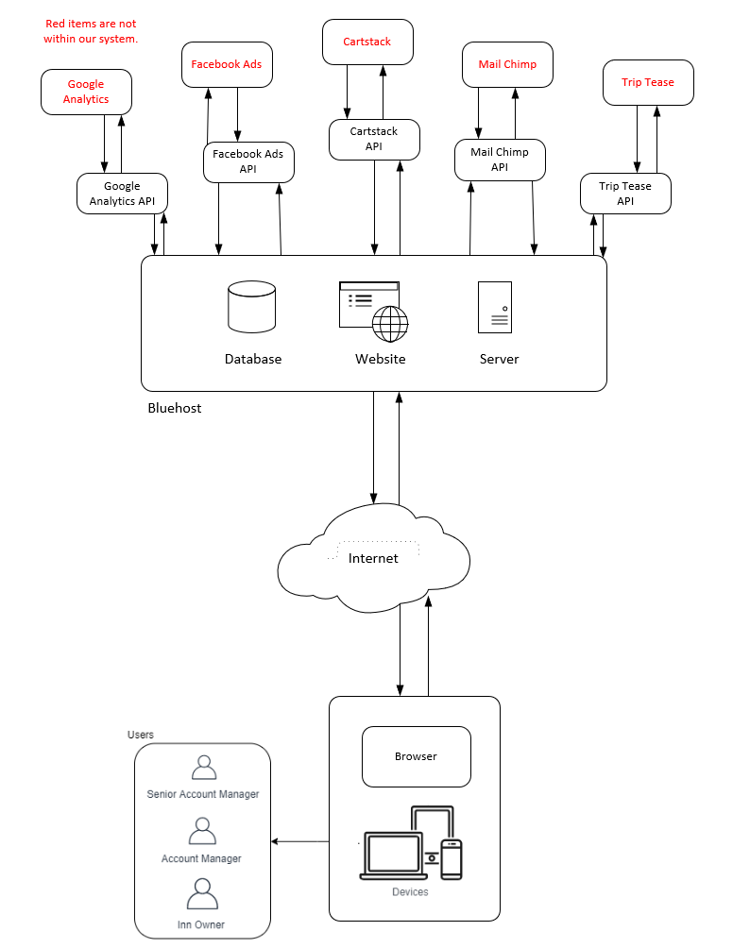

**Figure 1** Overview of MERG System

Figure 1 shows the system architecture of MERG. The database and website will be hosted on the Bluehost server. Records will be added, updated, and fetched from the database via the website. The website will send requests to and receive information from various APIs. The data received from the API will be used to create graphs and charts. The system will generate new webpages to display the graphs and charts so they can be viewed by the users. There are three types of users, Senior Account Managers, Account Managers, and Inn Owners. The Inn Owners are the clients of White Stone Marketing, they own high-end boutique Bed and Breakfast style inns. The inn owners should only be able to view the marketing reports. The Account Managers are employees of White Stone Marketing, they interact directly with the Inn Owners to discuss marketing strategies and budget. Account Managers should be able to generate and view marketing reports. The Senior Account Manager supervises and mentors the Account Managers as well as provides higher-end services such as data analysis and elicitation of effective marketing strategies to the Inn Owners. The Senior Account Manager should be able to generate and view marketing reports as well as edit the profiles of the Account Managers and Inn Owners

Functional Requirements

User Requirements

Senior Account Managers

1. The Senior Managers must be able to edit Account Managers' profiles.
2. The Senior Managers must be able to edit Inn Owners’ profiles.
3. Account Managers must be able to login to the Marketing Report Generator page.
4. Account Managers must be able to generate the reports.
   1. Senior Account Managers must be able to specify which Inn Owner the report is generated for.
   2. Senior Account Managers must be able to specify the date range the report is generated for.
   3. Senior Account Managers must be able to specify any combination of sources the report is generated from.
   4. Possible Sources: Google Analytics, MailChimp, Facebook, Cart Stack, Trip Tease, Think Reservations. Specific details regarding which sources to be provided by White Stone Marketing after 11/4/2019.

Account Managers

1. Account Managers must be able to login to the Marketing Report Generator page.
2. Account Managers must be able to generate the reports.
   1. Account Managers must be able to specify which Inn Owner the report is generated for.
   2. Account Managers must be able to specify the date range the report is generated for.
   3. Account Managers must be able to specify any combination of sources the report is generated from.
   4. Possible Sources: Google Analytics, MailChimp, Facebook, Cart Stack, Trip Tease, Think Reservations. Specific details regarding which sources to be provided by White Stone Marketing after 11/4/2019.
3. Account managers must be able to access everything the Inn Owners can access.

Inn Owners

1. Inn Owners must be able to login to view the report page.
2. Inn Owners must NOT be able to view other Inn Owners’ report page.
3. Inn Owners must be able to view all previously generated reports.

System Requirements

Assumptions

1. The database has been created.
2. Profile information for each Senior Account Manager has been added to the database.
3. The user has navigated to the website which hosts the MERG web application.

General System Requirements

Web Pages

1. The system should have the following pages.
   1. Senior Account Manager’s page.
      1. Accessible to Senior Account Managers only.
   2. Account Manager’s page.
      1. Accessible to Account Managers and Senior Account Managers
   3. Inn Owner’s pages.
      1. Accessible to Inn Owners, Account Managers, and Senior Account Managers.
      2. Each Inn Owner’s page should not be accessible to other Inn Owners.
      3. Each Inn Owner should have a page with a unique URL. (ex. *www.merg.com/clientId/index.html)*
   4. Marketing report pages.
      1. Accessible to pertinent Inn Owners, Account Managers, and Senior Account Managers.
         1. Each marketing report page should have a unique URL. (ex. *www.merg.com clienId/mm_dd_yyy.html*)

Marketing Report

1. The system should generate marketing reports based upon metrics specified by either the Account Manager or Senior Account manager.
   1. The system should request data from sources.
   2. The system should generate a new file for each report generated.
   3. The system should store the file path (URL) for each marketing report.
   4. The system should write data received from sources to the file.

User Interactions

User Authentication

1. The system must authenticate each user.
   1. The system should gather a username and password.
   2. The system should compare credentials provided by the user to those stored in the database.
   3. The system should retrieve user types from the database.
   4. The system should redirect to the user page based on user type.

Senior Account Managers (SAM) Interactions

1. The system must authenticate SAM
2. The system should redirect SAM to Senior Account Manager’s page.
3. The system should allow SAM to edit user profiles.
4. The system should allow SAM to display all account managers.
5. The system should allow SAM to display all Inn owners.
6. The system should allow SAM to specify metrics for marketing reports.
   1. The system should allow SAM to specify which Inn Owner to generate a report for.
   2. The system should allow SAM to specify a Start Date for the report.
   3. The system should allow SAM to specify an End Date for the report.
   4. The system should allow SAM to specify sources for the report.
7. The system should allow SAM to indicate they would like the report to be generated.

Account Managers (AM) Interactions

1. The system must authenticate AM.
2. The system should redirect AM to the Account Manager’s page.
3. The system should allow AM to edit user profiles.
4. The system should allow AM to display all account managers.
5. The system should allow AM to display all Inn owners.
6. The system should allow AM to specify metrics for marketing reports.
   1. The system should allow AM to specify which Inn Owner to generate a report for.
   2. The system should allow AM to specify a Start date for the report.
   3. The system should allow AM to specify an End date for the report.
   4. The system should allow AM to specify sources for the report.
7. The system should allow AM to indicate they would like the report to be generated.

Inn Owners (IO) Interactions:

1. The system must authenticate IO.
2. The system should redirect IO to Inn Owner’s page.
3. The system should request the URLs for the marketing reports from the database.
4. The system should display URLs with labels so that IO can identify the marketing report. (ex. Report for 10/1/2019 to 11/1/2019)
5. The system should allow IO to select a URL.
6. The system should redirect to the specified URL.

Non-Functional Requirements

1. The system shall be accessible from the following browsers: Chrome, Firefox, Safari, and Edge.
2. The System shall always be accessible by all users.
3. Passwords shall never be viewable at any point. (ex. Password box shows ********* rather than actual characters)
4. A video should be provided demonstrating the functionality of AM related features.
5. Usability
   1. The system must be faster and easier to use than the existing system.
   2. Faster: White Stone’s existing system takes roughly 45 min. MERG should allow SAM and AMs to generate the marketing reports in less than 5 min from the time they are authenticated to the time the report is generated. This is an arbitrary number provided by White Stone Marketing, longer times may be acceptable if necessary.
   3. Easier: The current system requires SAM and AM to have a working knowledge of how to navigate the websites for each of the sources, screen capturing, image manipulation, and WordPress. MERG should allow the reports to be generated by SAM and AM after watching the demo video once.
   4. Usability tests will be designed and conducted by White Stone Marketing on both the existing system and MERG.

E/R Diagram for MERG

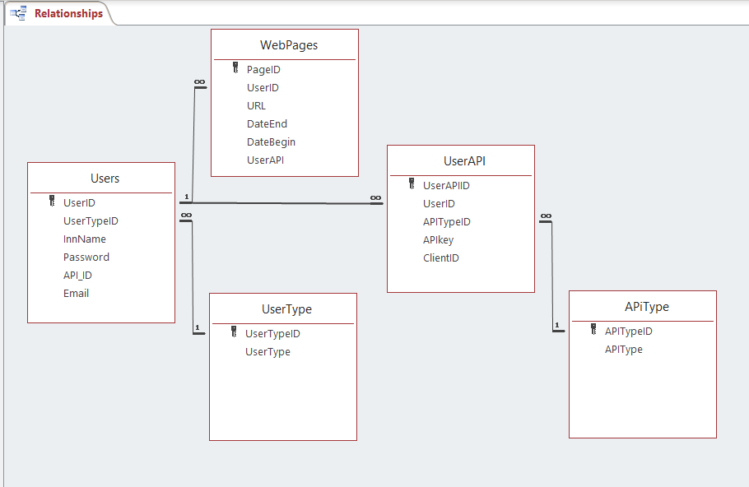

Figure 2. Entity Relationship Diagram for the MERG application database

Users (UserID, UserTypeID, InnName, Password, API_ID, Email)

WebPages (PageID, UserID, URL, DateEnd, DateBegin, UserAPI)

UserAPI (UserAPIID, UserID, APITypeID, APIkey, ClientID)

UserType (UserTypeID, UserType)

APiType (APITypeID, APIType)

Figure 2 shows the entity-relationship diagram (ERD) which represents the relational database utilized by the MERG application. There is a total of 5 tables. These tables include Users, Webpages, UserType, UserAPI, and APiType. Directly below the ERD is the relational notation for the database. It shows the entities (table names) along with their attributes. If an attribute is underlined, it is a primary key. If an attribute has a dotted underline, it is a foreign key. From the table “Users” the primary key is set to be the UserID attribute. The foreign key in UserTypeID is pointed to from the UserTypeID primary key within the “UserType” table. Within the “Webpages” table, the primary key is set to PageID, and the foreign key is UserID which is pointed to from UserID in the “Users” table. Within the “UserAPI” table, the primary key is set to UserAPIID, there are two 2 foreign keys within this table. The first foreign key is UserID, which is pointed to from the “Users” table. The second foreign key in the “UserAPI” table is TypeID, and it is pointed to from the “APiType” table’s primary key which is APITypeID. Every table is connected to at least one other table, whether it is being pointed to or it is pointing at another table.

For the “Users” table, the attribute field types are as follows: UserID, UserTypeID, and API_ID are all (integer, required, not nullable). Attributes InnName and Email are (VARCHAR 255) and InnName can be nullable. Last for this table is Password which will be (hash, required, not nullable, min of 8 characters).

For the table “Webpages” attributes PageID and UserID will both be (integer, required, not nullable). Attributes DateEnd and DateBegin will be (date, nullable). Attribute URL and UserAPI will be (VARCHAR 255, required).

For the “UserAPI” table, attributes UserAPIID, UserID, APITypeID, APIkey, and ClientID will all be (integer, required, not nullable).

For the table “UserType”, UserTypeID will be (integer, required, not nullable) and the attribute UserType will be (CHAR with a max of 3, required, not nullable).

For the “APiType” table, APITypeId will be (integer, required, not nullable) and APIType will be (VARCHAR 9, required, not nullable).

**Name:** Login Page **ID:** UC-1 **Priority**: High

**Created:** Nov. 10, 2019 **Last Modified:** Nov. 24, 2019

**Actor:** Senior Account Managers, Account Managers or Inn Owners

**Description:** The webpage used to gather user information required for authentication.

**Trigger:** A user would like to login to the system.

**Type:** External

**Preconditions:**

1. The user is on the right webpage to perform this action.

**Normal Course:**

N1. The user fills out all the required fields and the systems authenticate their credentials against the existing database record.

1. The webpage contains the following fields.
   1. Username field: The user types in their username. Required. Unique.
   2. Password field: The user types in their password. Required. Each character in the password will be masked with a (*) symbol.
2. The webpage contains a login button. The button is inactive until all the required fields have been filled. The user presses this button.
3. The system should compare credentials provided by the user to those stored in the database.

**Post Conditions:**

P1. The user is logged in to the system

1. If the user is SAM or AM, the system redirects the user to the Accounts Manager page. See **UC-2**.
2. Inn Owners get redirected to the Inn Owners page. See **UC-7**.

**Exceptions:**

E1. The system fails to authenticate the user and prints out an error message below the password field saying, “Credentials entered do not match our records”.

**Name:** Accounts Manager Page **ID:** UC-2 **Priority**: High

**Created:** Nov. 4, 2019 **Last Modified:** Nov. 24, 2019

**Actor:** Senior Account Managers or Account Managers

**Description:** The Senior Account Manager or Account Manager provides metrics for a marketing report page to be generated. The marketing report page is a web page that displays information in the form of charts, graphs, and text. Specific details regarding which information will be displayed to be provided by White Stone Marketing in the future as feasibility is still being established.

**Trigger:** Inn Owner requests a marketing report to be generated for them.

**Type:** External

**Preconditions:**

1. The user is on the right webpage to perform this action.

**Normal Course:**

N1. The user fills out all the required fields and generates the marketing report.

1. The webpage contains the following fields.
   1. The user specifies which Inn Owner the marketing report is generated from a drop-down menu. Required.
   2. The user specifies the date range the marketing report is generated from a JavaScript Calendar. Required.
   3. The user specifies any combination of sources the marketing report is generated from. Required a minimum of one source. Checkboxes will be used to choose from the following sources.
      1. Possible Sources: Google Analytics, MailChimp, Facebook, Cart Stack, Trip Tease, Think Reservations.
2. The webpage contains a generate button. The button is inactive until all the required fields have been filled. The user submits by pressing this button.

**Post Conditions:**

P1. A new marketing report page is generated successfully.

1. The system has successfully generated a marketing report page based upon metrics specified by either the Account Manager or Senior Account Manager.
2. A record containing the URL for the marketing report page has been added to the database.

**Exceptions:**

E1. The marketing report already exists – if the marketing report has already been generated by another user. A pop-up error message saying “This marketing report has already been generated” will be displayed.

E1.1. Bellow the error message will be a button to close the pop-up error message.

E1.2. When the pop-up error message is closed, the page will be refreshed, and all fields will be reset.

**Name:** Editing Page **ID:** UC-3 **Priority:** High

**Created:** Nov. 12, 2019 **Last Modified:** Nov. 14, 2019

**Actor:** Senior Account Manager

**Description:** The user is permitted access to add, update, or delete users by clicking the add, update, or delete buttons on the editing page.

**Trigger:** The Senior Account Manager wants to add, update, or delete any other users.

**Type:** External

**Preconditions:**

1. The user is authenticated and logged in the system.
2. The user is on the correct screen/form to perform this action.

**Normal Course:**

N1. The user clicks either the add, update, or delete button on the editing web form.

1. The form contains the following button: Add
   1. If the button is clicked, it will take the user to the Add User Page that will allow the actor to add users to the database. **UC-4**
2. The form contains the following button: Update
   1. If the button is clicked, it will take the user to the Update User Page that will allow the actor to change the information for an existing user record in the database. **UC-5**
3. The form contains the following button: Delete
   1. If the button is clicked, it will take the user to the Delete User Page that will allow the actor to remove an existing user record in the database. **UC-6**
4. If no button is clicked, the user will remain on the same page until further action takes place.

**Post Conditions:**

P1. If the button is clicked the user will be at the page desired.

1. If page loads and has fields that can be edited, then it was successful.

**Exceptions:**

There are no exceptions.

**Name:** Add User Page **ID:** UC-4 **Priority:** High

**Created:** Nov. 14, 2019 **Last Modified:** Nov. 24, 2019

**Actor:** Senior Account Manager

**Description:** The user enters the information needed to create a new user that will have access to reports.

**Trigger:** The Senior Account Manager would like to create a new user for the system.

**Type:** External

**Preconditions:**

1. The user is on the right screen/form to perform this action.
2. The user is authorized to access the form that allows them to create new users.
3. The “Add” button has been clicked on the editing form and the new page has loaded.

**Normal Course:**

N1. The user fills out the form with the necessary information needed to create a new user.

1. The form contains the following required fields: First name, last name, title, and email. These will all be numbers/letters for type.
   1. If any of the required fields are empty, or a field is filled with invalid characters or exceeds the length specified by the data type, then a red caption appears warning the user of an invalid entry.
   2. The submit button will not be activated unless all the required fields are provided and valid.
2. The user clicks the submit button. The following actions can occur:
   1. The user already exists, see E1.
   2. The user information is recorded in the system.

**Post Conditions:**

P1. Successful submission of the user form.

1. A message box is displayed on the screen notifying the user that the submission has been successful.
2. The user information is recorded and stored in the database.

**Exceptions:**

E1 – The user account already exists within the database.

1. The system will display a dialog box with the text “This user already exists.”
   1. The dialog box will display a Continue button.
      1. The actor clicks the Continue button to return to Add User Page.
      2. Nothing happens until the Continue button is clicked.

**Name:** Update User Page **ID:** UC-5 **Priority:** High

**Created:** Nov. 14, 2019 **Last Modified:** Nov. 24, 2019

**Actor:** Senior Account Manager

**Description:** The user enters the information needed to update a new user.

**Trigger:** The Senior Account Manager would like to update a user that has access to the system.

**Type:** External

**Preconditions:**

1. The user is on the right screen/form to perform this action.
2. The user is authorized to access the form that allows them to update new users.
3. The “update” button has been clicked on the editing form and the new page has loaded.

**Normal Course:**

N1. The user fills out the form with the necessary information needed to update a new user.

1. The form contains the following required fields: First name, last name, title, and email. These will all be numbers, letters, or one “@” symbol for type and they will be entered in a text box.
   1. If any of the required fields are empty, or a field is filled with invalid characters specified by the data type, then a red caption appears warning the user of an invalid entry.
   2. The submit button will not be activated unless all the required fields are provided and valid.
2. The user clicks the submit button. The following actions can occur:
   1. The user information is recorded and updated in the system.
   2. The user does not currently exist within the database, see E1.

**Post Conditions:**

P1. Successful submission of the user form.

1. A message box is displayed on the screen notifying the user that the update has been successful.
2. The user information is updated, and the new information is stored in the database.

**Exceptions:**

E1 – The user account does not exist within the database.

1. The user is notified that the user does not exist within the database currently, thus cannot be updated with this new information.
2. Nothing is recorded or updated in this scenario.

**Name:** Delete User Page **ID:** UC-6 **Priority:** High

**Created:** Nov. 14, 2019 **Last Modified:** Nov. 24, 2019

**Actor:** Senior Account Manager

**Description:** The user will enter in the necessary info to delete an existing user.

**Trigger:** The Senior Account Manager would like to delete a user that has access to the system.

**Type:** External

**Preconditions:**

1. The user is on the right screen/form to perform this action.
2. The user is authorized to access the form that allows them to delete users.
3. The “delete user” button has been clicked on the editing form and the new page has loaded.

**Normal Course:**

N1. The user fills out the form with the necessary information needed to delete a user.

1. The form contains the following required fields: First name, last name, and email. These will all be numbers, letters, or one “@” symbol for type and they will be entered in a text box.
   1. If any of the required fields are empty, or a field is filled with invalid characters specified by the data type, then a red caption appears warning user of invalid entry.
   2. The delete button will not be activated unless all the required fields are provided and valid.
   3. The user account that will be deleted must be a valid and active account. If not, see E1.
2. The user clicks the submit button. The following actions can occur:
   1. The user information is deleted from the system.
   2. The user does not currently exist within the database, also see E1.

**Post Conditions:**

P1. Successful deletion of the user.

1. A message box is displayed on the screen notifying the user that the deletion has been successful.
2. The user information is removed from the database.

**Exceptions:**

E1 – The user account does not exist within the database.

1. The user is notified that the user does not exist within the database currently, thus cannot be deleted.
2. Nothing is removed or updated in this scenario.

**Name:** Inn Owners Page **ID:** UC-7 **Priority**: High

**Created:** Nov. 20, 2019 **Last Modified:** Nov. 24, 2019

**Actor:** Inn Owners, Account Managers, and Senior Account Managers

**Description:** A webpage containing hyperlinks to all the marketing report pages that have been generated for the Inn Owner.

**Trigger:** An Inn Owner would like to see a marketing report.

**Type:** External

**Preconditions:**

1. The user has been authenticated and logged in to the system successfully. See **UC-1**
2. The user is on the right webpage to perform this action.

**Normal Course:**

N1. The systems display’s a list links to the marketing reports that have been generated for the Inn Owner

1. The system requests the URLs for the marketing report pages from the database.
2. The system will display links to the six most recently generated marketing report pages.
   1. The marketing report pages are ordered by the date in which they were generated, with the most recent at the top of the list.
3. If the Inn Owner has more than six marketing reports, a button with the text “Find Reports” will be visible under the sixth link.
   1. If the “Find Reports” button is clicked, the system will display two calendars for the user to select a specific date range. One calendar for the start date and another for the end date.
   2. Upon selecting the dates in the calendars, the system will request the URLs for the corresponding marketing report pages, and they will be displayed on the screen in the form of links.
4. The user finds the marketing report page link they would like to view from the displayed list.

**Post Conditions:**

P1. The user clicks a marketing report from the list.

1. The system will open a new tab in the browser containing the marketing report page for the selected link. See **UC-8**.

**Exceptions:**

E1. No marketing reports have been generated for the user, this webpage will display a message saying “No marketing reports available at this time, please contact your WSM representative.”.

E2. If no marketing report pages exist for the specified date range, the system will display a pop-up notification informing the user “No marketing reports found for this date range”.

1. The notification will contain a button to close the pop-up. User will be back on the Inn Owners Page **UC-7**

**Notes:**

1. Each Inn Owner should have a page with a unique URL. (ex. *ClientID/mm_dd_yyy.html)*
   1. Inn Owners are not able to view each other’s Inn Owners’ page.

**Name:** Marketing Report Page **ID:** UC-8 **Priority**: High

**Created:** Nov. 21, 2019 **Last Modified:** Nov. 24, 2019

**Actor:** Inn Owners, Account Managers, and Senior Account Managers

**Description:** A webpage that displays information in the form of charts, graphs and typed summaries. Each marketing report page will have a unique URL. There will be multiple similar marketing report pages.

**Trigger:** An Inn Owner wishes to view their marketing report.

**Type:** External

**Preconditions:**

1. The user has been authenticated and logged in to the system successfully. See **UC-1**
2. The user is on the right webpage to perform this action.
3. The system has successfully generated a marketing report based upon metrics specified by either the Account Manager or Senior Account Manager. See **UC-2**

**Normal Course:**

N1. The user can view the marketing report they selected from the Inn Owners page. See **UC-7**

1. The combination of sources the marketing report is generated from will be displayed to the user.
   1. Possible Sources include Google Analytics, MailChimp, Facebook, Cart Stack, Trip Tease, Think Reservations.
   2. Depending on the sources, the system will display information in chart form.
   3. Depending on the sources, the system will display information in graphs form.
2. The webpage contains a button that takes the user to the Inn Owners page. See **UC-7**

**Post Conditions:**

P1. The user is done viewing the marketing report page.

1. The user closes the marketing report page using the close button in the browser.

**Exceptions:**

There are no exceptions.

**Note:**

No exceptions could be reported at this time as the Marketing Reports page is a view-only page.

**Context Diagram**

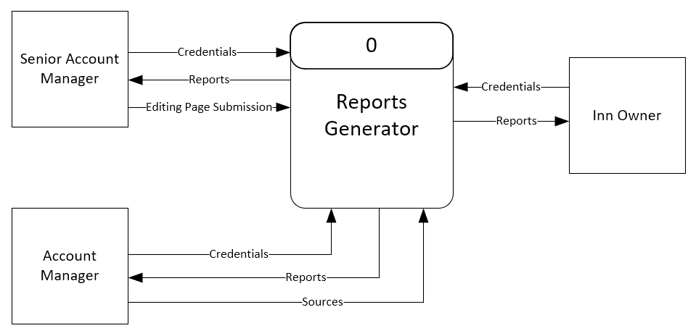

For the context diagram, the senior account manager first enters their credentials. The senior account manager also has the ability to access the editing pages and submit them. The editing pages include an add user page, a delete user page, and an update user page. The senior account manager also has access to reports. In addition, the account manager also enters credentials and gains access to the reports. The account manager is able to specify the sources from which the reports are generated (e.g., Google Analytics, Facebook, MailChimp, etc.). Inn owners must log in to the reports generator, which gives them access generated reports.

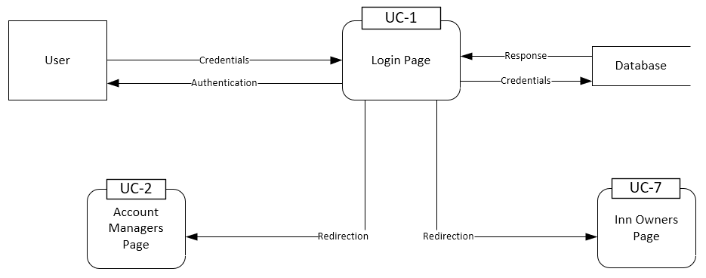**Data Flow Diagram for UC-1**

For use case 1, the user fills out all the required fields to gain access to the system. The user types in their username and password in the login page, then the system compares the input to the credentials stored in the database. If authentication is successful, the user gets redirected to another use case depending on which type of user they are. If the user is Senior Account Manager or Account manager, they get redirected to UC-2. Inn Owners get redirected to UC-7. If the system fails to authenticate the user the system will inform the user with an error message.

**Data Flow Diagram for UC-4**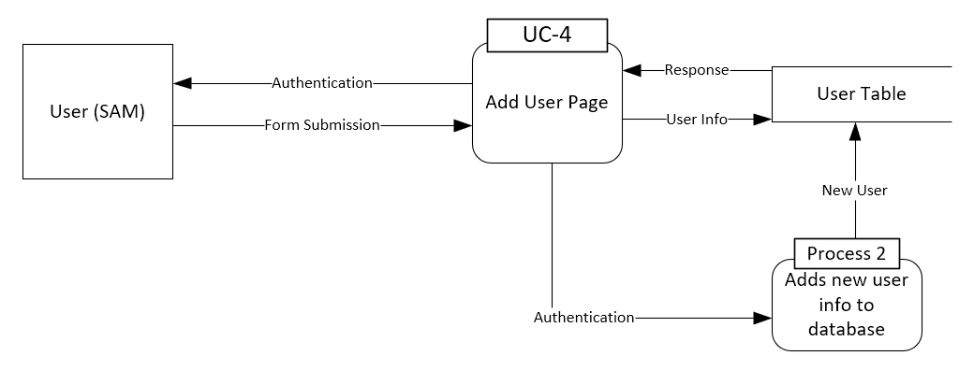

Use case 4 explains the Add User Page. During this process, the Senior Account Manager will fill out the fields required to add a new user to the database. It will then check for validity, making sure all necessary forms are filled out. If these forms are all properly filled out, it will then check the database to see if the user exists already or not. Once it confirms the user does not exist, it will then process the data and add all the new user info and store it within the database.