Benchmarking Machine Learning Classifiers for Heart Disease Prediction
Comparative Analysis of SVM, KNN, and Naive Bayes Classifiers
Full Name: [Your Full Name]
Student ID: [Your Student ID]
Course: PMIT_6121 – Machine Learning
Assignment: Comparative Analysis of SVM, KNN, and Naive Bayes Classifiers
Submission Date: 15 June 2026

Abstract / Executive Summary
This report presents a comparative benchmarking of three supervised classification algorithms — Support Vector Machines (SVM), K-Nearest Neighbors (KNN), and Gaussian Naive Bayes — applied to the CDC Behavioral Risk Factor Surveillance System “Personal Key Indicators of Heart Disease” dataset. The data were verified to contain no missing values, categorical variables were encoded (binary mapping, ordinal encoding, and one-hot encoding), and continuous features were standardized. An 80/20 stratified train–test split was used on a representative 15,000-record stratified sample. SVM (linear and RBF kernels), KNN (K = 3, 5, 11), and Gaussian Naive Bayes were trained and evaluated using accuracy, precision, recall, and F1-score. While SVM and KNN achieved the highest raw accuracy (~91–92%), Naive Bayes achieved the highest recall (56.4%) and F1-score (0.360) for the minority “Heart Disease” class, making it the most clinically useful model despite its lower overall accuracy, due to the severe class imbalance in the dataset (~91.4% negative cases).

1. Introduction & Exploratory Data Analysis
Cardiovascular disease remains one of the leading causes of death worldwide, and early identification of high-risk individuals through routine, low-cost health indicators (such as BMI, smoking status, general health rating, and physical activity) can support preventive screening at scale. Automated classification models trained on large-scale public health survey data, such as the CDC’s Behavioral Risk Factor Surveillance System (BRFSS), offer a practical way to flag individuals who may benefit from further clinical evaluation, without requiring expensive diagnostic tests as inputs. This assignment benchmarks three classical machine learning algorithms — Support Vector Machines, K-Nearest Neighbors, and Gaussian Naive Bayes — on this task, comparing their predictive performance and discussing their suitability for a healthcare screening context.

1.1 Dataset Overview
The “Personal Key Indicators of Heart Disease” dataset contains 319,795 records and 18 columns derived from the 2020 BRFSS annual survey of US adults. The dataset contained no missing or null values in any column. The binary target variable, HeartDisease, is highly imbalanced: 292,422 respondents (91.44%) reported no heart disease, while 27,373 (8.56%) reported having been diagnosed with coronary heart disease or myocardial infarction.
The feature set combines numerical clinical/lifestyle measurements (BMI, PhysicalHealth, MentalHealth, SleepTime) with categorical demographic and lifestyle indicators (Smoking, AlcoholDrinking, Stroke, DiffWalking, Sex, AgeCategory, Race, Diabetic, PhysicalActivity, GenHealth, Asthma, KidneyDisease, SkinCancer).

1.2 Computational Sampling Strategy
Training a Support Vector Machine (particularly with the RBF kernel, whose training time scales roughly between O(n²) and O(n³)) on the full ~256,000-row training partition is computationally impractical on standard hardware. To keep the comparison fair and feasible, a stratified random sample of 15,000 records was drawn from the full dataset, preserving the original class ratio (13,716 “No” / 1,284 “Yes”, i.e. 91.44% / 8.56%). All three classifiers were trained and evaluated on this same sample using an identical 80/20 train–test split.
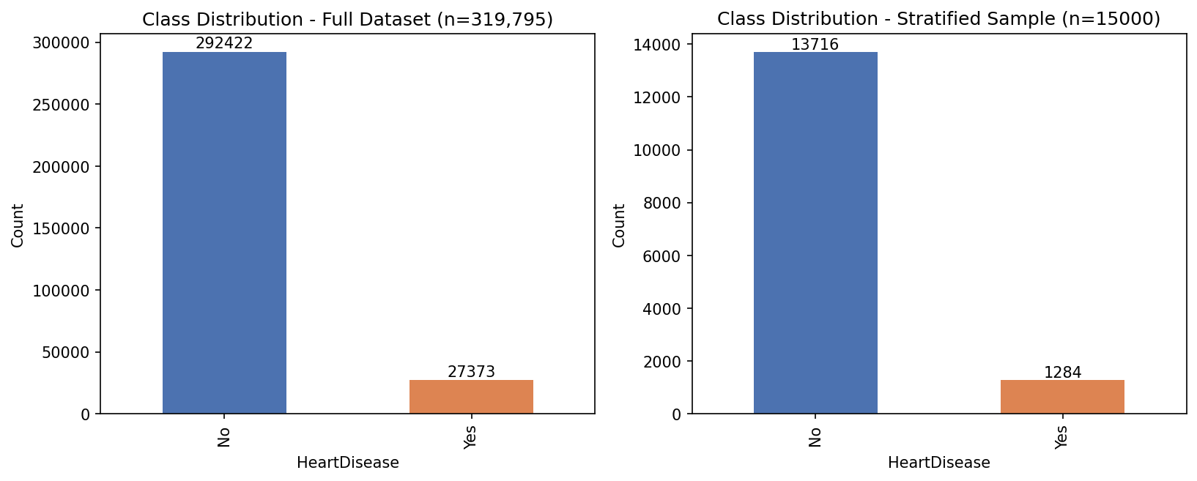
Figure 1. Class distribution of the full dataset (n = 319,795) and the stratified working sample (n = 15,000).

2. Methodology & Data Preprocessing
All preprocessing and modelling was implemented in Python using pandas (data handling), scikit-learn (preprocessing, models, metrics) and matplotlib (visualization). The following steps were applied, in order:
- Missing values: the dataset was checked column-by-column and contained zero missing values, so no imputation was required.
- Target encoding: HeartDisease was mapped to a binary integer (Yes → 1, No → 0).
- Binary categorical encoding: Eight Yes/No lifestyle/medical-history columns (Smoking, AlcoholDrinking, Stroke, DiffWalking, PhysicalActivity, Asthma, KidneyDisease, SkinCancer) and Sex were mapped directly to 0/1 integers.
- Ordinal encoding: GenHealth (Poor < Fair < Good < Very good < Excellent) and AgeCategory (13 ordered age brackets, e.g. 18–24 … 80 or older) were mapped to ordered integers, since these categories have a natural ranking.
- One-hot (dummy) encoding: The remaining nominal categorical columns, Race (5 categories) and Diabetic (4 categories, including the “borderline” and “during pregnancy” responses), were one-hot encoded with the first category dropped to avoid multicollinearity (drop_first=True).
- After encoding, the feature set comprised 23 input variables.
- Train/test split: An 80% / 20% stratified split (sklearn.model_selection.train_test_split, stratify=y, random_state=42) produced 12,000 training records and 3,000 test records, preserving the ~91.4% / 8.6% class ratio in both partitions.
- Feature scaling: sklearn.preprocessing.StandardScaler was fitted on the training set only (mean = 0, variance = 1) and applied to the continuous numerical columns (BMI, PhysicalHealth, MentalHealth, SleepTime, AgeCategory, GenHealth) for both the training and test sets, preventing data leakage.

2.1 Why is scaling essential for SVM and KNN but optional for Naive Bayes?
KNN classifies a point based on the Euclidean distance to its nearest neighbors. Without scaling, a feature with a large numeric range (e.g. BMI, roughly 12–95) would dominate the distance calculation over a feature with a small range (e.g. a 0/1 binary flag or PhysicalHealth, 0–30), regardless of each feature's actual predictive importance. Standardization places every feature on a comparable scale so that each contributes proportionally to the distance metric.
SVM, especially with the RBF kernel (which computes similarity as exp(−γ‖x−x′‖²)), is similarly distance-based, and the underlying margin-maximization optimization can converge slowly or be dominated by large-magnitude features if the data is unscaled. Scaling therefore improves both the correctness and the numerical stability/convergence speed of the SVM solver.
Gaussian Naive Bayes, in contrast, models each feature independently as a univariate Gaussian conditioned on the class, estimating its own mean and variance per feature directly from the training data. A linear rescaling of a feature simply rescales the parameters of that feature's estimated Gaussian without changing the relative likelihood ratio between classes, so the model's predictions are essentially unaffected by scaling — making it optional (though it was applied here for pipeline consistency).

2.2 Models and Hyperparameters
- SVM (sklearn.svm.SVC): two configurations were trained — (a) kernel='linear', C=1.0, and (b) kernel='rbf', C=1.0, gamma='scale'.
- KNN (sklearn.neighbors.KNeighborsClassifier): three values of K were tested — K = 3, K = 5, and K = 11, using default Euclidean distance and uniform weighting.
- Gaussian Naive Bayes (sklearn.naive_bayes.GaussianNB): used with default hyperparameters (var_smoothing = 1e-9).
All models were trained on the same X_train_scaled / y_train data and evaluated on the same X_test_scaled / y_test data using sklearn.metrics (accuracy_score, precision_score, recall_score, f1_score, confusion_matrix).

3. Results & Comparative Analysis
Table 1 summarizes the best configuration of each model family (selected by F1-score on the positive “Heart Disease” class). Table 2 (Appendix) reports all six tested configurations in full.
Model | Hyperparameters | Accuracy | Precision | Recall | F1-Score
SVM | Kernel=RBF, C=1.0, gamma=scale | 0.916 | 0.692 | 0.035 | 0.067
KNN | K=3 | 0.897 | 0.266 | 0.113 | 0.159
Naive Bayes | Default Gaussian (var_smoothing=1e-9) | 0.828 | 0.265 | 0.564 | 0.360
Table 1. Summary comparison of the best configuration per model on the held-out test set (n = 3,000).
Figure 2 shows the confusion matrices for the best configuration of each model. Figure 3 (Appendix) shows the confusion matrices for all six tested configurations.
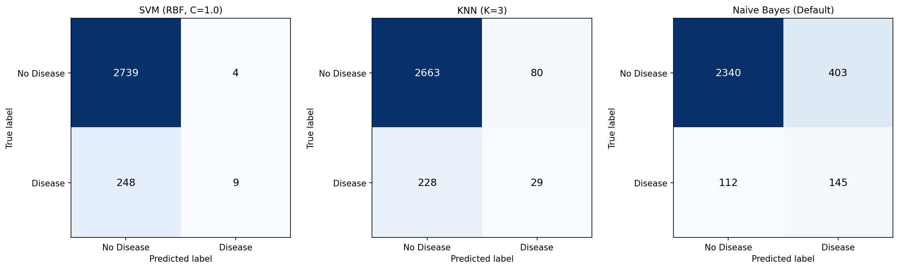
Figure 2. Confusion matrices for the best SVM configuration (RBF kernel), best KNN configuration (K = 3), and Gaussian Naive Bayes on the test set.

4. Discussion & Critical Thinking

4.1 Why did certain algorithms outperform others?
On raw accuracy, SVM (RBF) and KNN (K = 11) both reach ~91.6%, essentially matching the proportion of the majority “No Disease” class (91.4%). This is a strong signal that these models are largely defaulting to the majority-class prediction: the SVM (linear) configuration achieved 0% recall and 0% precision for the “Disease” class — it predicted “No Disease” for every single test sample, which still yields 91.4% accuracy purely because of the class imbalance. The RBF-kernel SVM and the larger-K KNN models manage to correctly flag only a handful of true positive cases (9 and lower numbers of true positives respectively), again dominated by the majority class.
Gaussian Naive Bayes behaves very differently: its independence assumption between features, combined with class-conditional Gaussian likelihoods, makes it considerably less sensitive to the prior class imbalance than the margin- or distance-based methods. As a result, Naive Bayes achieves substantially higher recall (56.4%) for the “Disease” class — correctly identifying 145 of 257 true positive cases in the test set — at the cost of a much higher false-positive rate (403 healthy individuals incorrectly flagged) and therefore lower overall accuracy (82.8%) and lower precision (26.5%).
In short: SVM and KNN, as configured here (without class-weighting or resampling), are biased toward the majority class and therefore look strong on accuracy but are nearly useless for detecting the minority “Heart Disease” class. Naive Bayes is far less biased by the class imbalance and is the only model that meaningfully detects a majority of true positive cases, at the cost of more false alarms.

4.2 Clinical Impact: False Positives vs. False Negatives
In a heart disease screening context, a False Negative (a patient who actually has heart disease but is predicted as “no disease”) is far more dangerous than a False Positive (a healthy patient incorrectly flagged as at-risk). A false negative means a person who needs further medical evaluation and possible early intervention is told they are low-risk, potentially delaying diagnosis and treatment of a life-threatening condition. A false positive, while not free — it causes unnecessary anxiety and additional testing costs — simply results in a healthy person undergoing further (typically low-risk) clinical evaluation that ultimately rules out disease.
Given this asymmetry, recall (sensitivity) on the “Disease” class is the most clinically important metric for a screening tool, since it directly measures the proportion of at-risk patients the model successfully catches (minimizing false negatives), even if this comes at the cost of precision.

4.3 Which model is safest to deploy in a hospital screening setting?
Based on recall alone, Gaussian Naive Bayes is the safest of the three models evaluated here: it identifies 56.4% of true heart disease cases in the test set, versus only 11.3% for the best KNN configuration and 3.5% for the best SVM configuration. While Naive Bayes’ lower precision (26.5%) means roughly three out of four people it flags as “at risk” do not actually have heart disease, in a low-cost, non-invasive screening context this trade-off is generally preferable to missing nearly half (or almost all) of the genuinely at-risk patients, as the SVM and KNN models do in their current, unbalanced configuration. For deployment, however, none of these models in their current form would be considered clinically adequate — all three would benefit substantially from explicit handling of class imbalance (see Section 5).

5. Conclusion & Future Work
This assignment implemented an end-to-end machine learning pipeline — preprocessing, encoding, scaling, model training, hyperparameter exploration, and evaluation — for three classical classifiers (SVM, KNN, Gaussian Naive Bayes) on the CDC Personal Key Indicators of Heart Disease dataset. The results highlight a critical lesson in applied machine learning on imbalanced medical data: headline accuracy can be misleading. SVM and KNN achieved the highest accuracy (~91–92%) largely by defaulting toward the majority “no disease” class, while Gaussian Naive Bayes, despite lower accuracy (82.8%), achieved by far the highest recall (56.4%) and F1-score (0.360) for the clinically important minority class, making it the most useful of the three models for a screening application as configured.
Two directions for future improvement are proposed:
- Address class imbalance directly: apply techniques such as SMOTE (Synthetic Minority Over-sampling Technique) or class-weighted loss functions (e.g. class_weight='balanced' in SVC and other sklearn estimators) so that SVM and KNN are not overwhelmed by the 91:9 class ratio, and re-evaluate all three models on the rebalanced data.
- Explore ensemble and tree-based methods: algorithms such as Random Forests, Gradient Boosting (XGBoost/LightGBM), or a stacked ensemble of the three models evaluated here often handle mixed categorical/numerical features and class imbalance more gracefully, and could be benchmarked against the same train/test split for a more comprehensive comparison.

Appendix / Code Link
The complete, executable source code for this assignment is provided as a Jupyter Notebook (heart_disease_classification.ipynb), submitted alongside this report. It contains the full preprocessing pipeline, model training and tuning code, evaluation metrics, and confusion matrix visualizations described above.

Table 2. Full results for all six tested configurations
Model | Hyperparameters | Accuracy | Precision | Recall | F1-Score
SVM | Kernel=Linear, C=1.0 | 0.914 | 0.000 | 0.000 | 0.000
SVM | Kernel=RBF, C=1.0, gamma=scale | 0.916 | 0.692 | 0.035 | 0.067
KNN | K=3 | 0.897 | 0.266 | 0.113 | 0.159
KNN | K=5 | 0.906 | 0.318 | 0.082 | 0.130
KNN | K=11 | 0.916 | 0.593 | 0.062 | 0.113
Naive Bayes | Default Gaussian (var_smoothing=1e-9) | 0.828 | 0.265 | 0.564 | 0.360
Table 2. Accuracy, Precision, Recall and F1-Score for every model/hyperparameter configuration evaluated.
Figure 3 below shows the confusion matrices for all six configurations, including the two SVM kernels and all three KNN values of K.
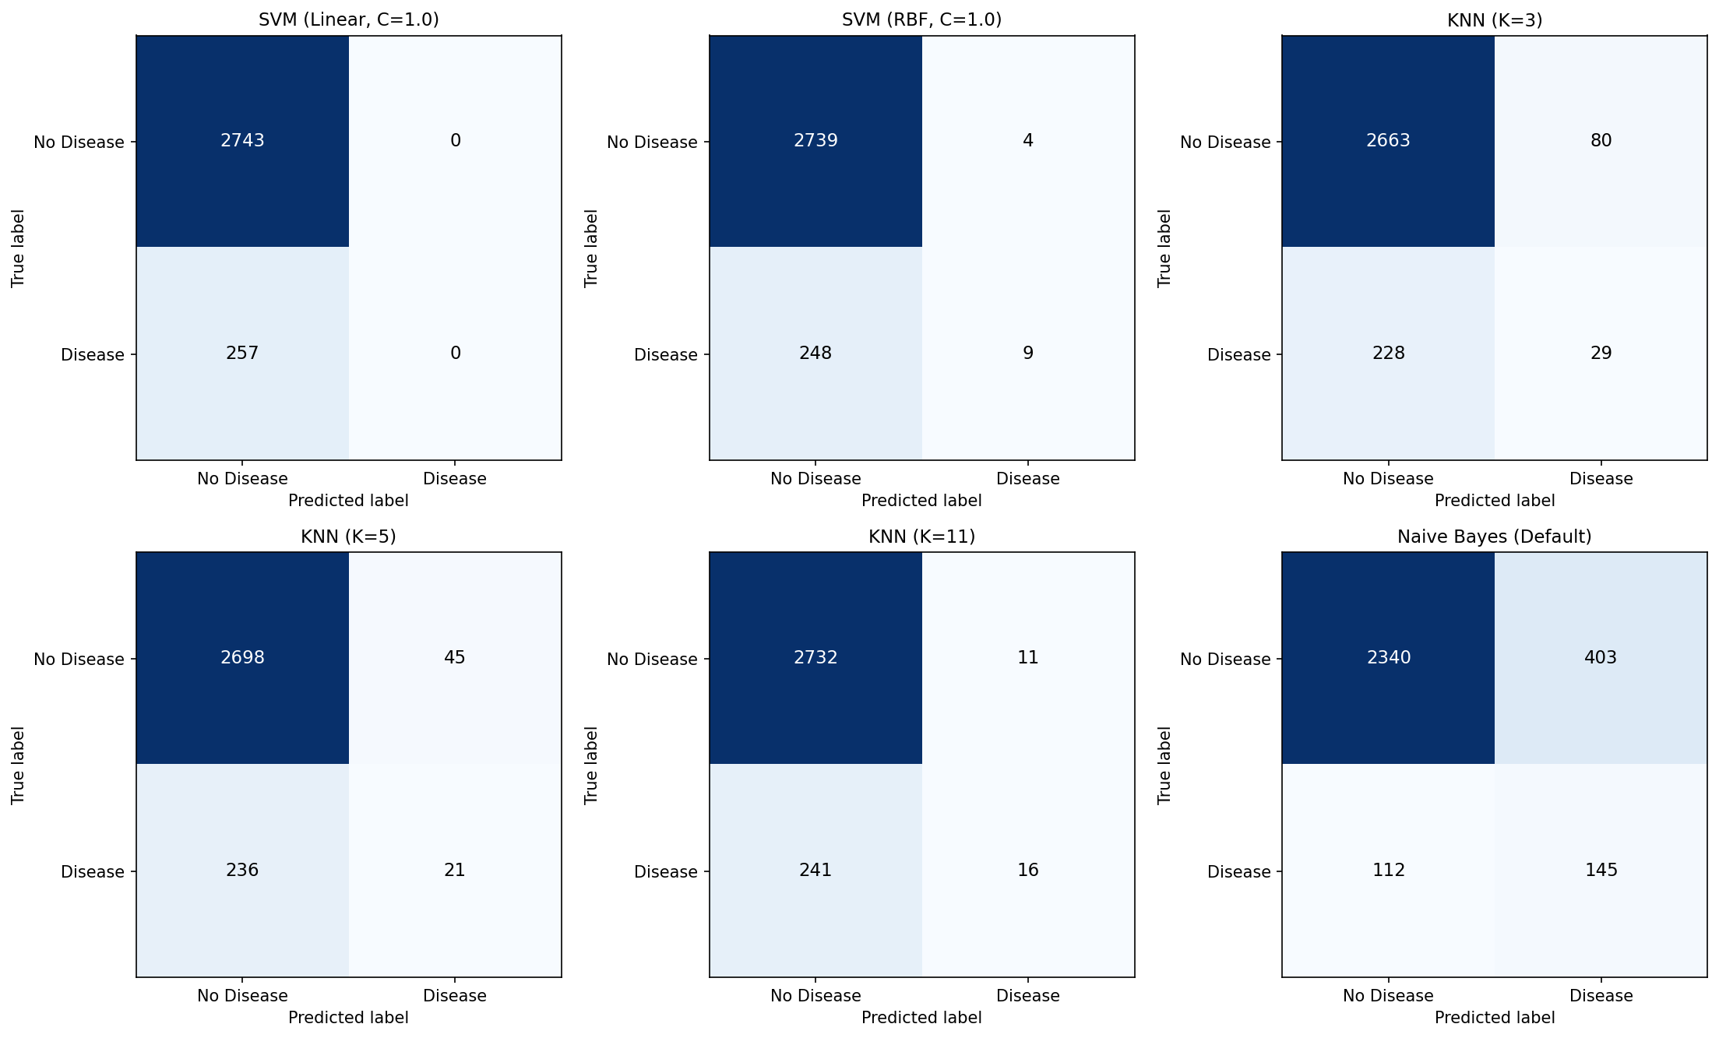
Figure 3. Confusion matrices for all six evaluated model configurations.

