UNIVERSITY OF CALIFORNIA AT BERKELEY

College of Engineering

Department of Electrical Engineering and Computer Sciences

EE105 Lab Experiments

Lab 2: Non-Ideal Op-Amps, Pre-Lab Worksheet

Student 1 name: Bryan Ngo

Student 2 name: Kyle Lui

Lab group: Tuesday 8-11 / Tuesday 5-8 / Thursday 8-11 / Thursday 5-8

# Pre-Lab

# Intro to LTSpice

What Resistor value did you use to get a gain of 10? Please attach the plot.

100 kΩ

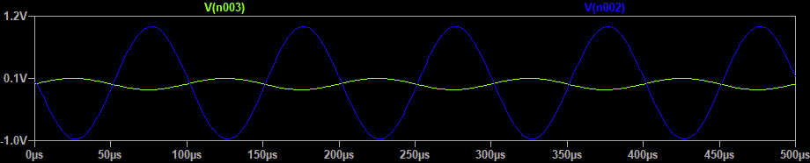

# DC current consumption

Simulated DC current consumption: 79.625 nA

Is it in the range defined in the datasheet? Yes

# DC Open Loop Transfer Characteristic

Open loop gain A0: -200 058

Voltage offset Voffset ≡ −Vshift: 1 mV

Plot of the DC Open Loop Transfer Characteristic:

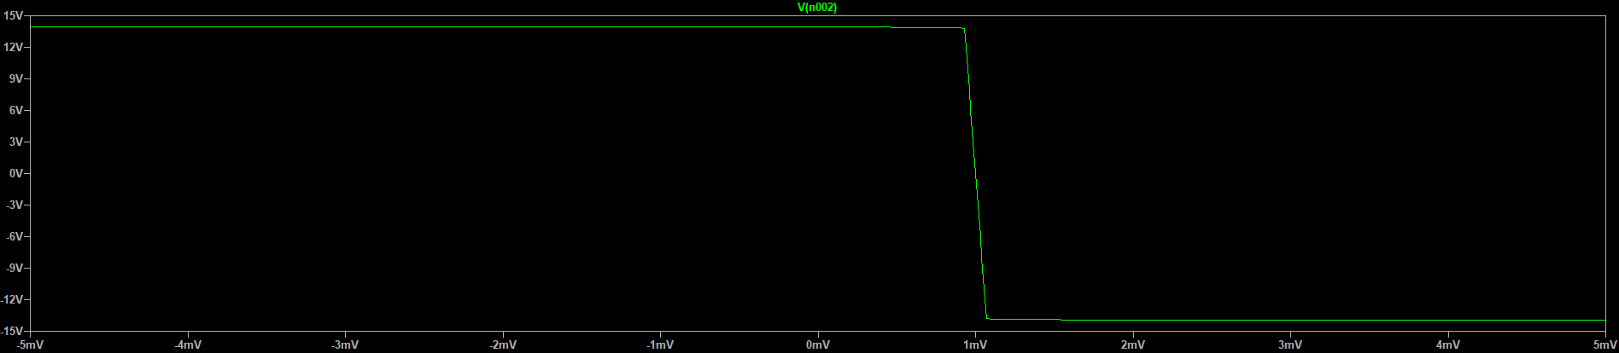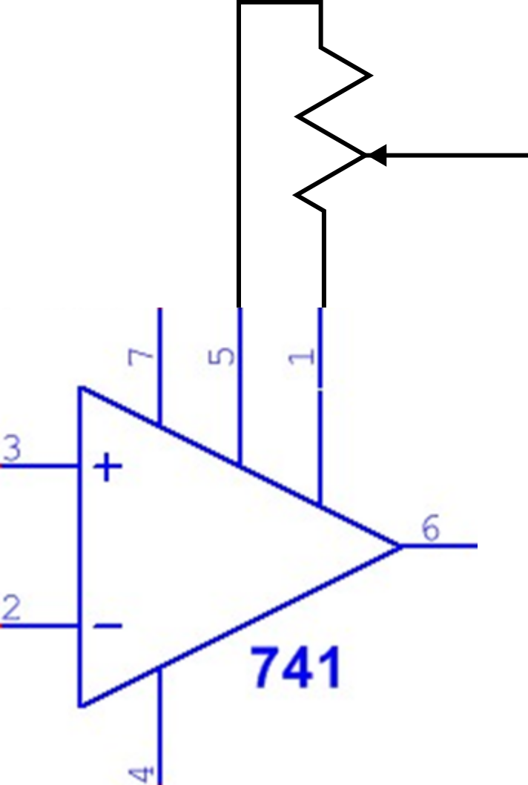

# Nulling the Offset Voltage

Draw the circuit used to null the offset voltage connected to the pinout diagram below:

Why do we use a potentiometer to null the offset voltage? So we can easily adjust our offset voltage to an arbitrary value.

# Slew Rate in Unity Gain Configuration

Slew Rate: 0.33 V/µs

Is it reasonable based on the datasheet? Yes

Plot of Vout and Vin versus time:

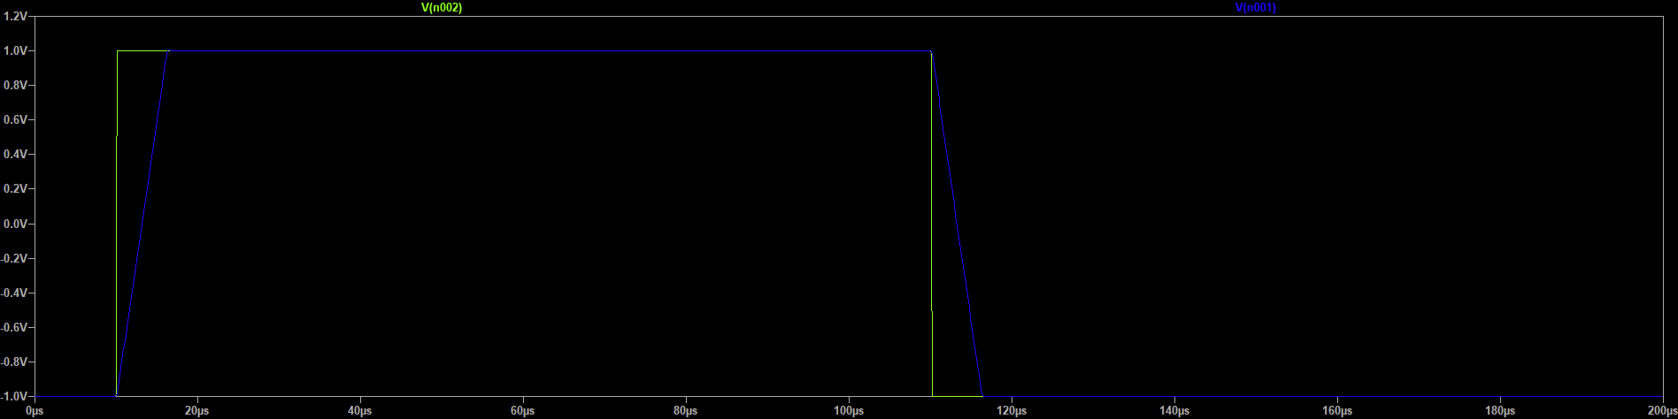

Is the slew rate different for rising and falling voltages? No

# Gain and Bandwidth in Unity Gain Configuration

Gain A0: 1

Bandwidth f3dB: 1.54 MHz

Plot of the gain vs frequency (log-log scale):

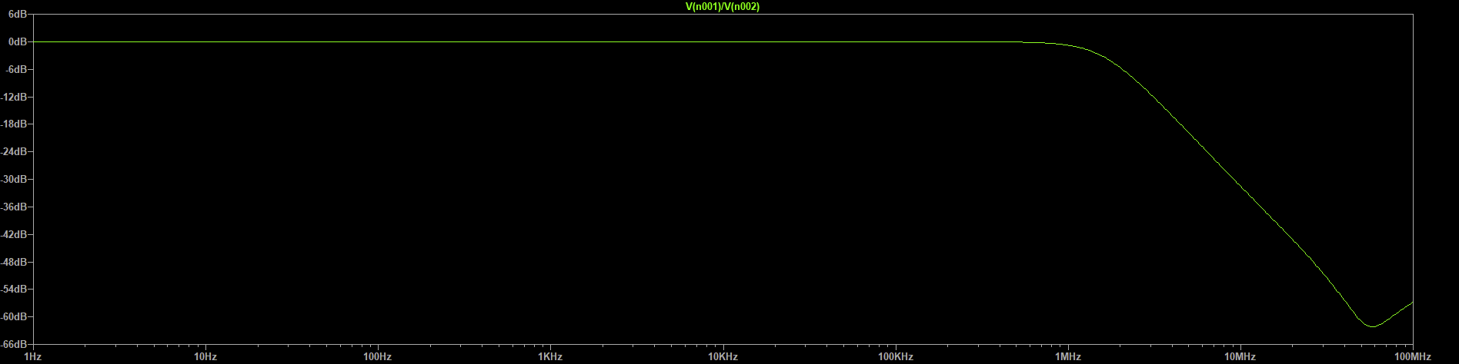

For 100KHz input at what amplitude the amplifier will start slewing? 0.5 V

Plot of the input and the output for this amplitude, and for twice this amplitude, at the same plot:

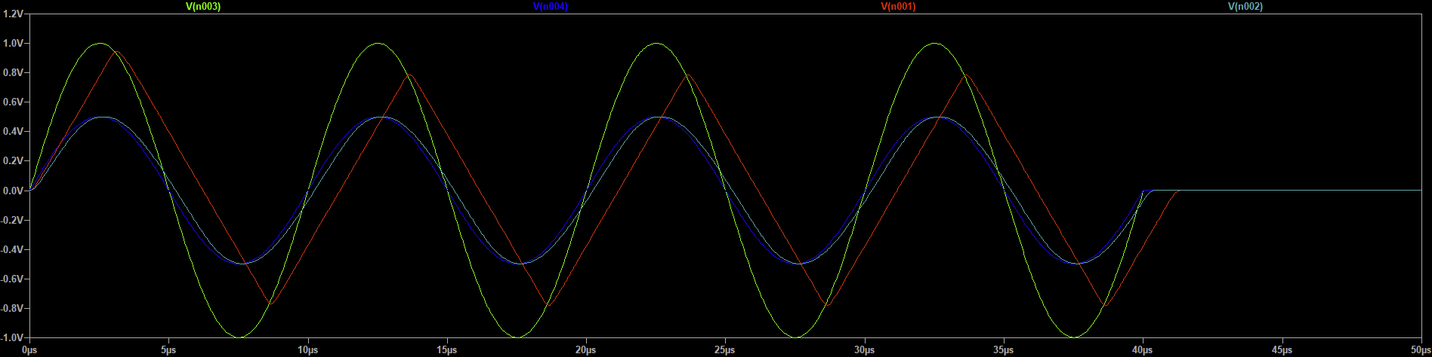

# Gain and Bandwidth in Non-Inverting Amplifier Configuration

|  |  |
| --- | --- |
| R=10kΩ | Gain A0: 10 |
| Bandwidth f3dB: 110 kHz |
| R=100kΩ | Gain A0: 100 |
| Bandwidth f3dB: 10 kHz |

Plot of magnitude response of the voltage gain in log-log scale for the two non-inverting amplifier circuits and the circuit from Problem 2.6 on the same plot:

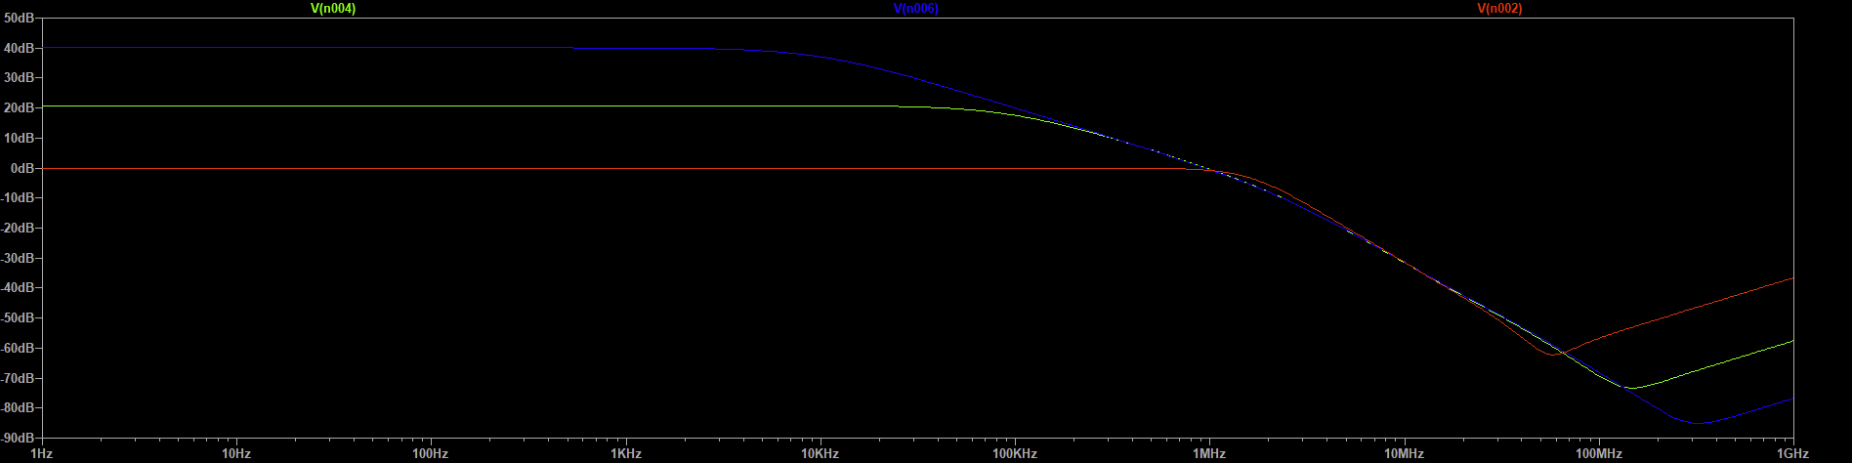

At approximately what frequency and gain do the three curves intersect on the plot? What does this mean? 10 MHz. This point can be interpreted as the point at which all the circuits have the same signal energy/power, since the magnitude of the signals are all equal here.

With R=10kΩ, for 10KHz input at what amplitude the amplifier will start slewing? 0.5 V

Plot of the input and the output for this amplitude, and for twice this amplitude, at the same plot:

