UNIVERSITY OF CALIFORNIA AT BERKELEY

College of Engineering

Department of Electrical Engineering and Computer Sciences

EE105 Lab Experiments

Experiment 1: Non-Ideal Op-Amps, Lab Report

Student 1 name: Bryan Ngo

Student 2 name: Kyle Lui

Lab group: Monday 11-2 / Monday 2-5 / Monday 5-8 / Wednesday 9-12 / Thursday 8-11

# Lab

# DC current consumption

Measured DC current consumption: 1.3 mA

Is it in the range defined in the datasheet? No

# DC Open Loop Transfer Characteristic

Measured values of attenuator resistors: 100.2 kΩ, 98.2 Ω

Open loop gain A0: 11 672

Voltage offset Voffset ≡ −Vshift: 0.83 V

Plot of the DC Open Loop Transfer Characteristic:

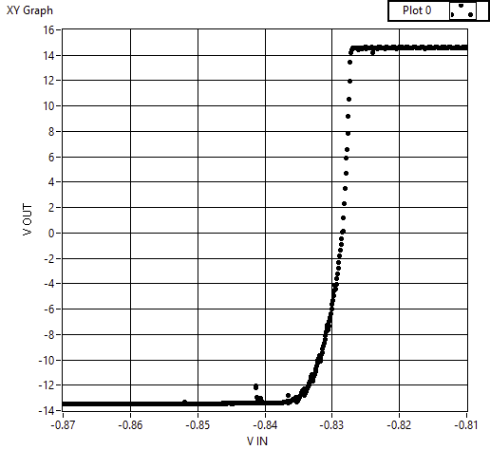

# Nulling the Offset Voltage

The resistance from -15V to pin1 of the opamp: 4.1 kΩ

The resistance from -15V to pin5 of the opamp: 6.5 kΩ

# Slew Rate in Unity Gain Configuration

Rising Slew Rate: 0.75 V/µs

Falling Slew Rate: 0.65 V/µs

Is it reasonable based on the datasheet? Yes

Oscilloscope trace(s) of the slew rate measurements:

# Gain and Bandwidth in Unity Gain Configuration

Based on your slew rate measurements, for 100KHz input at what amplitude the amplifier will start slewing? 1.2 V rising, 1 V falling

Oscilloscope trace of the slewing output sine signal when doubling this amplitude:

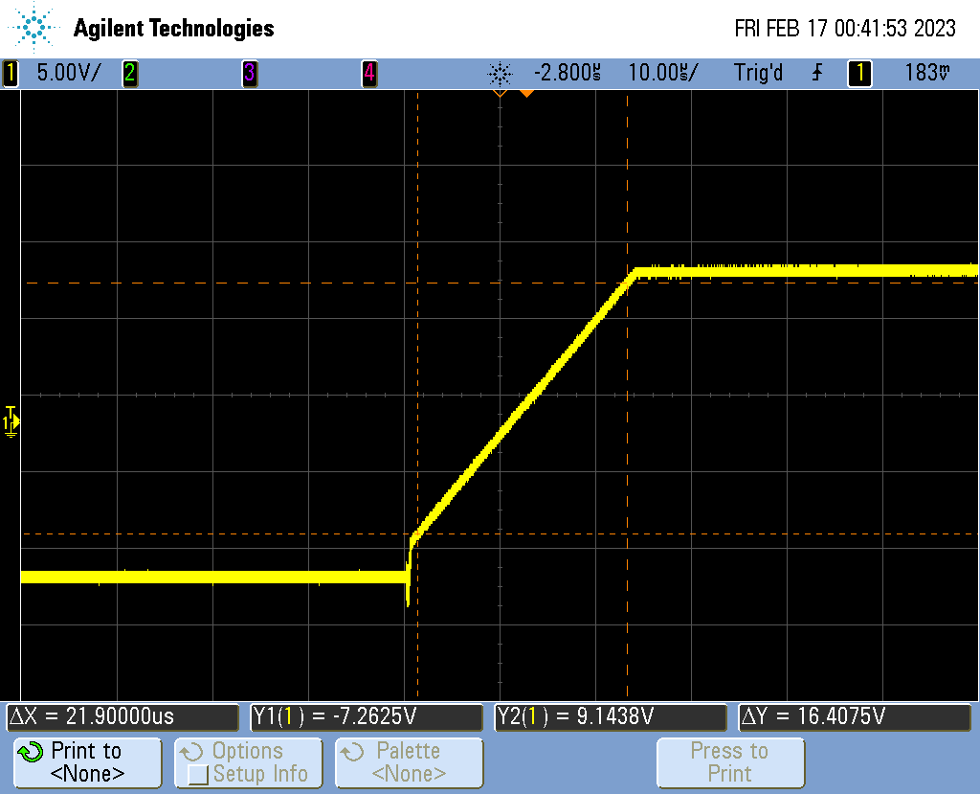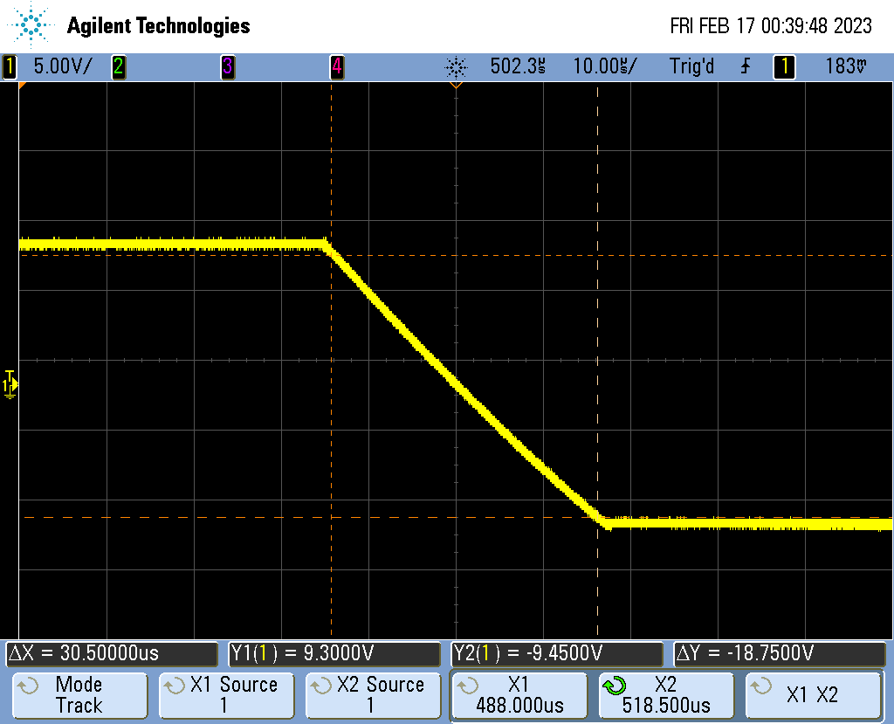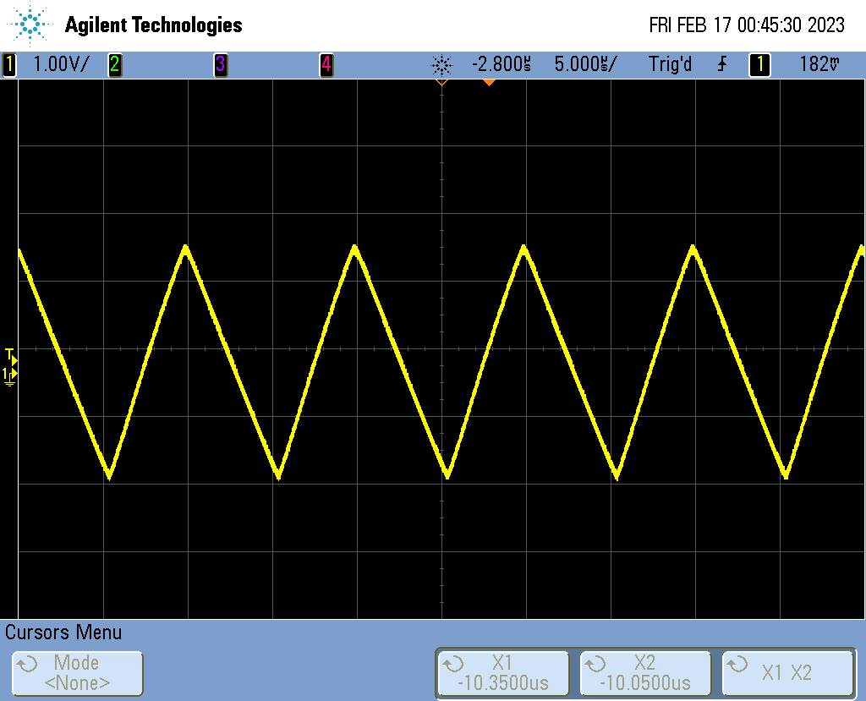Gain A0: 1.06

Bandwidth f3dB: 800 kHz

# Gain and Bandwidth in Non-Inverting Amplifier Configuration

|  |  |
| --- | --- |
| R=10kΩ | Gain A0: 11 |
| Bandwidth f3dB: 75 kHz |
| R=100kΩ | Gain A0: 109 |
| Bandwidth f3dB: 10 kHz |

Plot of magnitude response of the voltage gain in dB for the two non-inverting amplifier circuits and the circuit from Problem 3.5 on the same plot:

