UNIVERSITY OF CALIFORNIA AT BERKELEY

College of Engineering

Department of Electrical Engineering and Computer Sciences

EE105 Lab Experiments

Experiment 4: Diodes, LEDs, Photodetectors

Pre-Lab Worksheet

Student 1 name: Bryan Ngo

Student 2 name: Kyle Lui

Lab group: Tuesday 8-11 / Tuesday 5-8 / Thursday 8-11 / Thursday 5-8

Before adding Cadence plots to your report, please **change the background color to white**:

Edit->Properties-> Click the black rectangle near the "Background" -> change to white.

# Pre-Lab

# Intro to Diodes

Estimated threshold voltage for the 1N4148 diode from the datasheet 0.65 V

# Rectifiers

Attach a drawing/plot of the expected output of the half-bridge recti er circuit for a sinusoidal input.

Be sure to mark the amplitude and zero crossings on your axes (can be in terms of variables). Assume

the sinusoid amplitude is larger than the threshold voltage.

# LED transmitter

The supply voltage Vs for an LED current of 20mA: 2 V

# Receiver - DC

What is the expected reverse bias photo current for the TEFD4300 with an irradiance of 1000uW/cm2? 19 µA

Why do we need the amplifier in Receiver 1? Can we connect the photodiode directly to the indicator LED? We need the amplifier in Reciever 1 since the LED will load the already small current from the photodiode. We cannot connect the photodiode directly for this reason.

Why is the indicator LED flipped in Receiver 2? The indicator LED is flipped in Reciever 2 since the LED is now connected to the inverting input of the op amp.

|  |  |
| --- | --- |
| Receiver 1 | Receiver 2 |
| Rf = 215.8 kΩ  Vdd = 9.1 V  Schematic showing the DC voltages at every node and the current through every resistor: | Rf = 5.3 kΩ  Vdd = 5 V  Schematic showing the DC voltages at every node and the current through every resistor: |

From DC standpoint, can you see an advantage to one of the implementations?

Reciever 2 has the advantage of requiring half the supply voltage.

# Receiver - AC, infinite speed opamp

Parasitic Capacitance for the TEFD4300: 1.25 pF

The expected bandwidth (-3dB frequency) in each implementation?

Receiver 1: 1.12 THz

Receiver 2: 113 THz

Cadence schematics:

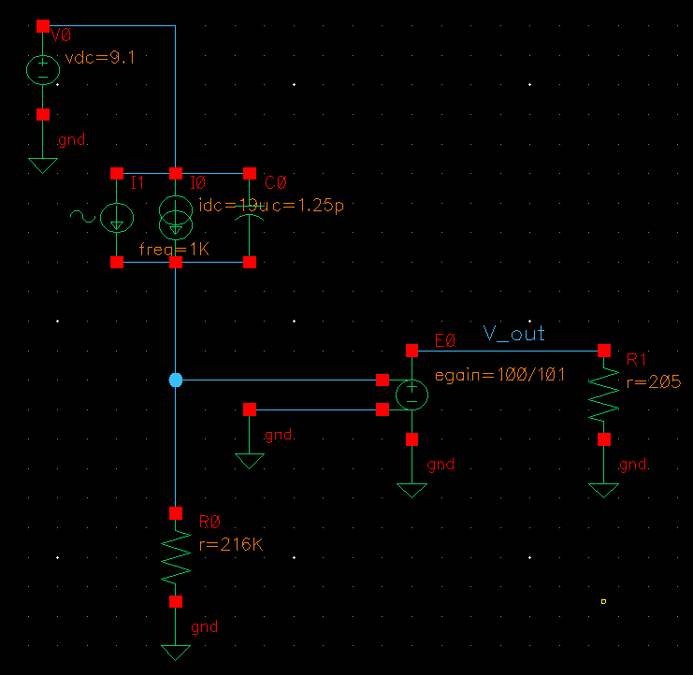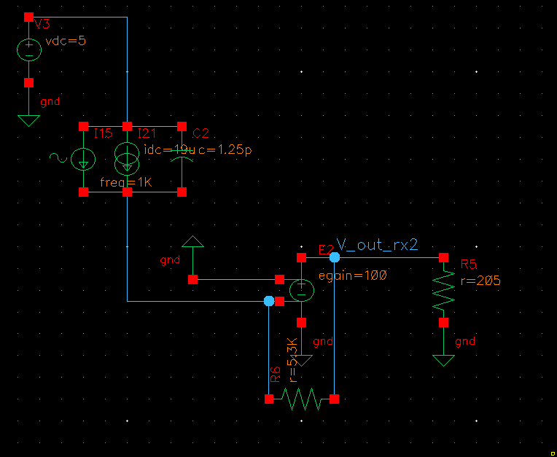

Plots of the gain vs frequency:

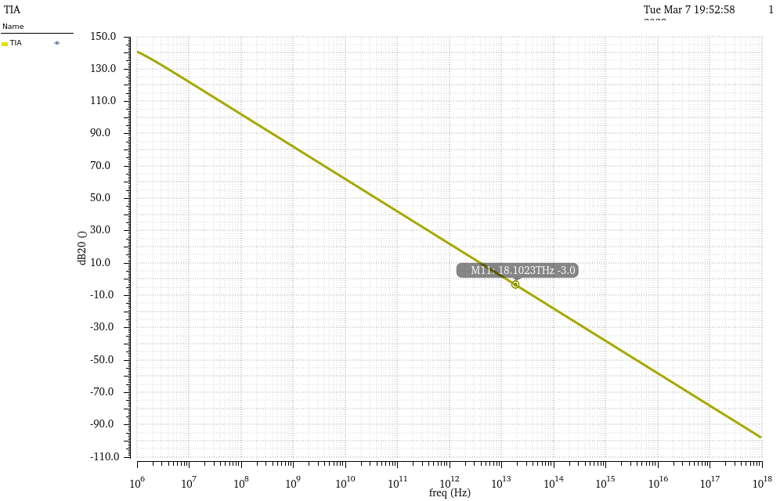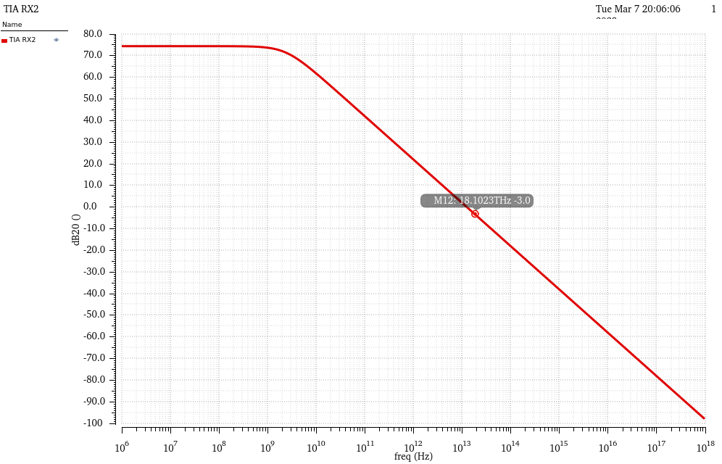

Simulated bandwidth in each implementation:

# Receiver - AC, real opamp

Cadence simulation - open-loop opamp

Opamp low-frequency gain:

Opamp 3dB frequency:

Hand calculations

Receiver 1 transfer function:

Receiver 1 3dB frequency:

Receiver 2 transfer function:

Receiver 2 3dB frequency:

Cadence simulation - receivers

Cadence schematics:

Plots of the gain vs frequency:

Simulated bandwidth in each implementation:

# Receiver - transient

Cadence schematics:

Plots of the transient voltage vs time at the photodiode output and at the amplifier output:

Explain the result. What is limiting the speed of the receiver in each implementation?