KEEP PLEDGE FORM
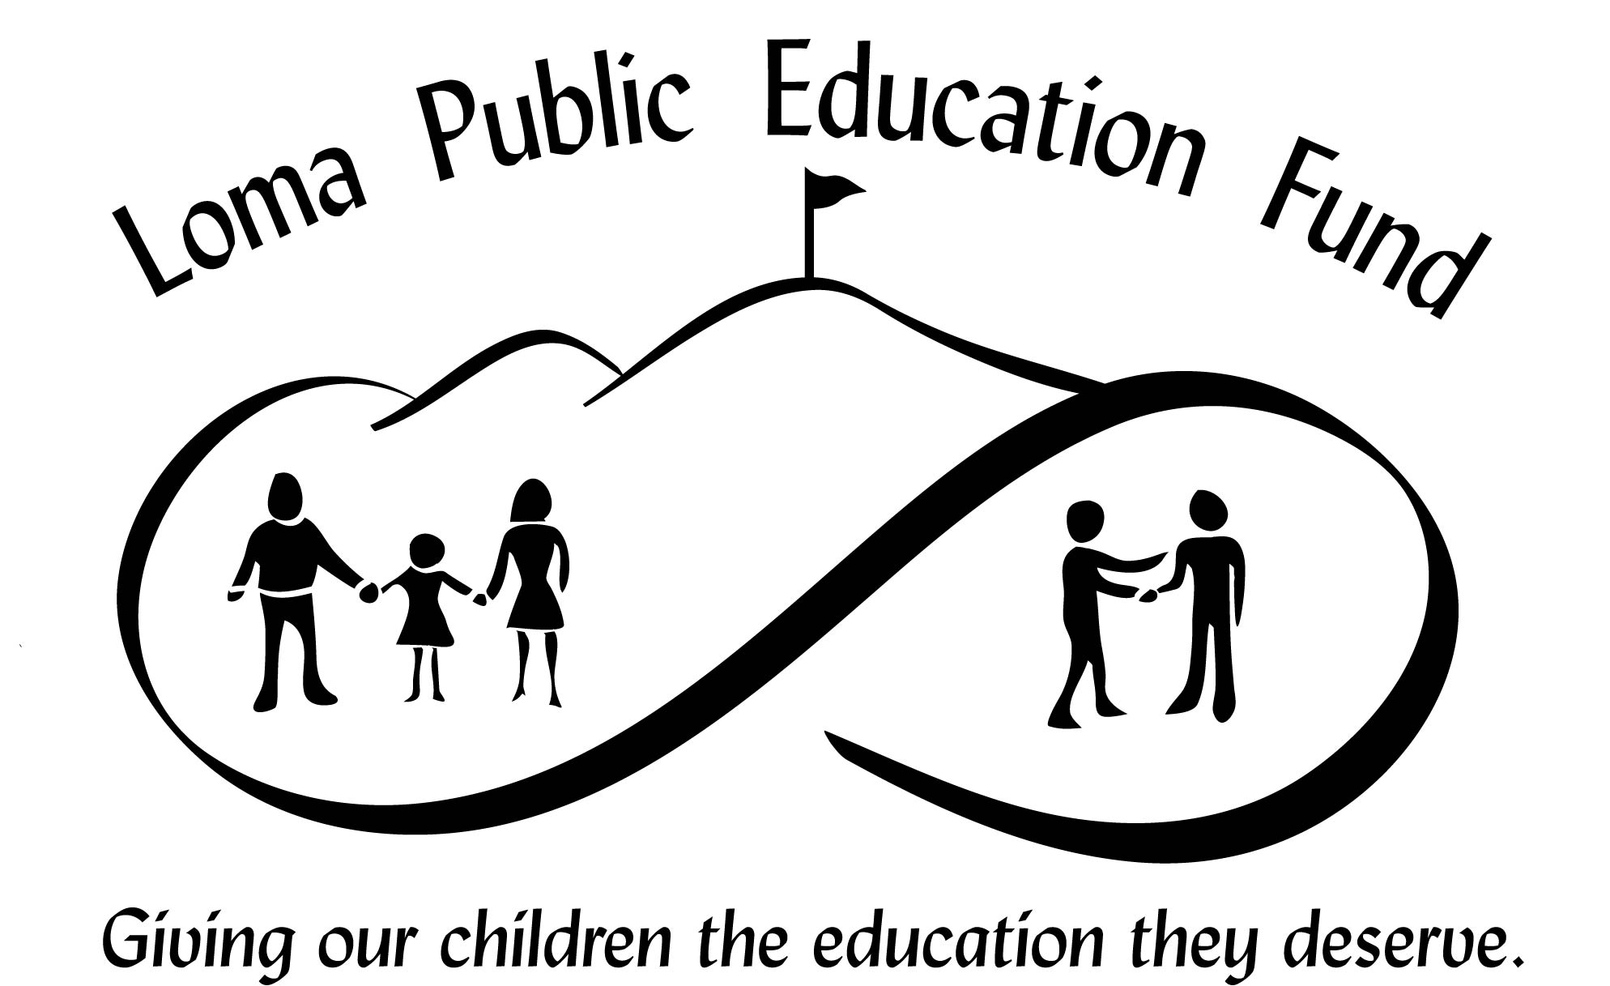
Does your company offer matching funds? Yes ___

KEEP: Keep Excellent Education Programs

Suggested minimum family donation:
$600 (1 child)
$900 (2 or more children).
Not a Parent? Please consider sponsoring a child or a family.

Amount pledged: $_______________________________

Last Name: ____________________________First Name: _______________________________

Address___________________________________ City: ________________ ST: ___ Zip: _____
Phone: ________________________ Email: ___________________________________________

PAYMENT BY CHECK:

Check enclosed ______

Checks should be made to: LPEF
Mail to: LPEF, 23800 Summit Rd, Los Gatos, CA 95033. Fax to: 408-353-6772

CREDIT CARD PAYMENT ONLY:
Bill my credit card: (Visa or MasterCard) ____

Name on Card:_________________________ Acct. #: ___________________________________

Expiration Date: __________CVV # on back: _________ My donation is anonymous: Yes____

(Optional) I would prefer two credit card transactions,
one donation of $_________ today
and a donation of $___________ on 9/1/05.
Minimum donations of $300 for each transaction are required.

Signed: _______________________________________________________

Mail this form to: LPEF, 23800 Summit Rd, Los Gatos, CA 95033.
Or fax to: 408-353-6772

Thank you for your tax-deductible contribution! Tax ID # 03-0440872.

Questions? Call 408/566-3007. Additional information may be found at: www.lpef.org

