NEXT YEAR
WITHOUT YOUR HELP

Keep
Excellent
Educational
Programs
NEXT YEAR
WITH YOUR HELP

2005-2006 School Year

- 5 teaching positions eliminated
- Reading Recovery at 20% of 04-05
- Developmental PE eliminated
- Library Aides eliminated
- CTE Elective classes at 50% of 04-05
Yearbook
Spanish
Speech/Debate
- Music,Visual & Performing Arts eliminated
- Loma/CTE Counseling eliminated
2005-2006 School Year

- 2 teaching positions saved, one at CTE and one at Loma
- Reading Recovery at 80% of 04-05
- Developmental PE saved
- Library Aides saved
- CTE Elective classes at 80% of 04-05
Yearbook World Issues
Spanish Technology
Fine Arts Speech/Debate
- Music, Visual & Performing Arts saved
- Loma/CTE Counseling saved
- New CTE tech lab

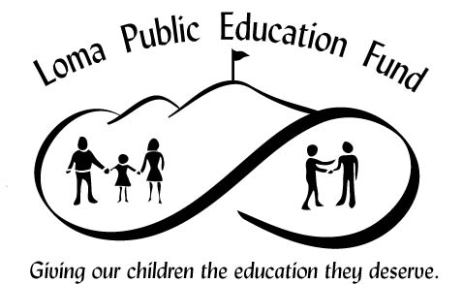
To save teachers and programs, we must have your donation by May 1.
Donation forms are at www.lpef.org, and at the CTE or Loma offices.

