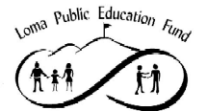
Giving our children the education they deserve

CONDITIONAL FUNDING APPROVAL
KEEP PROGRAM AWARD

PROGRAM/GRANT NAME:  COUNSELING |  | STUDENTS BENEFITED:  K-8 Students
MAXIMUM AWARD, THIS YR: $10,000 | FUNDING PERIOD: 8/2005 through 6/2006

GRANT DESCRIPTION:

Continue to offer counseling services for students in grades K-8.

MEASUREMENTS METRICS & REPORTING REQUIREMENTS:
Employ Counselor; determine whether or not all student counseling needs are being met.

FUNDING DATES:
Actual program expenses will be funded on February 15 and June 30, 2006 or two weeks after submission of expenses to LPEF.

LPEF APPROVAL: _______________________________ Date: _____________________________

ACCEPTED By District: __________________________________ Date: ____________________

