UNIVERSITY OF CAPE COAST
MSc Information Technology
MS/ITE/25/0027

HOSPITAL MANAGEMENT SYSTEM (HospitalGUI)
A Desktop Java Swing Application for Multi-Department Hospital Administration

A Technical Report Submitted in Partial Fulfilment of the Requirements for the Award of MSc Information Technology

By
Barnaby Frederick Dodoo

Supervisor
Linda Otoo

7th July, 2026

TABLE OF CONTENTS

1. INTRODUCTION 5
2. PROBLEM STATEMENT 6
3. OBJECTIVES OF THE SYSTEM 7
4. SCOPE OF THE SYSTEM 8
4.1 In Scope 8
4.2 Out of Scope 8
5. METHODOLOGY 9
5.1 Development Environment and Tools 9
5.2 Design Approach 9
5.3 Verification Approach 10
6. SYSTEM DESIGN 11
6.1 Navigation Architecture 12
6.2 Cross-Module Data Flow 12
6.3 Persistence Model 12
7. DESCRIPTION OF CLASSES AND METHODS 14
7.1 base.Entity (abstract class) 14
7.2 base.Manager<T extends Entity> (generic abstract class) 14
7.3 base.Displayable (interface) 15
7.4 ui.BasePanel (abstract class extending JPanel) 15
7.5 ui.MainWindow (extends JFrame) and ui.FormDialog (extends JDialog) 15
7.6 util.AppTheme, util.Validator, util.FileUtil 16
7.7 Manager Classes (manager package) 16
7.8 Model and Panel Classes 17
8. GUI DESIGN EXPLANATION 18
9. OOP CONCEPTS IMPLEMENTED 19
9.1 Encapsulation 19
9.2 Abstraction 19
9.3 Inheritance 19
9.4 Composition (contrasted with Inheritance) 19
9.5 Polymorphism 20
9.6 Generics 20
9.7 Design Patterns Observed 20
10. SCREENSHOTS AND OUTPUTS 21
11. GITHUB REPOSITORY LINK 29
12. CHALLENGES ENCOUNTERED 30
13. CONCLUSION 31
14. RECOMMENDATIONS 32
15. REFERENCES 33

1. INTRODUCTION
HospitalGUI is a standalone desktop application, built in Java using the Swing GUI toolkit, that implements a Hospital Management System spanning ten clinical and administrative modules - Queue Management, Medical Records, Pharmacy, Appointments, Blood Donation, Vaccination, Ambulance Dispatch, Laboratory, Billing and Payment, and Maternal Health - together with a shared Patients/Doctors registry used across all of them.
The application is entirely self-contained: it requires no external database server or network connection, persisting all data to plain, pipe-delimited text files under a local data/ directory. The entry point, MainApp, applies the host operating system's native look and feel and launches MainWindow, a single JFrame that hosts every module behind a sidebar-driven, card-switching navigation shell.
Architecturally, the codebase is organised into five packages that mirror a clear separation of concerns: base (the abstract Entity, the generic abstract Manager, and the Displayable interface that every module builds on), model (24 concrete entity classes, one or more per module), manager (10 domain manager classes containing business rules), panel (10 Swing panels, one per module, plus the shared registry panels), and ui/util (the application shell, reusable dialog, theming and validation helpers). This structure allows ten functionally different hospital modules to be built from, and remain consistent with, the same small set of reusable base types.

2. PROBLEM STATEMENT
Many small hospitals, clinics and health posts still manage patient queueing, medical records, pharmacy stock, appointments, blood donation, vaccination, ambulance dispatch, laboratory testing, billing and maternal monitoring using paper registers or disconnected spreadsheets, one per department. This creates several concrete problems:
- Patient and doctor information is re-entered separately in every department that needs it, increasing data-entry effort and the risk of inconsistent records.
- Charges raised in one department (pharmacy sales, lab tests, vaccinations, queue consultations) are not automatically linked to a patient's bill, making it easy to under-bill or lose track of what a patient owes.
- There is no consistent way to validate input (dates, phone numbers, quantities) across departments, so malformed data can easily enter paper or spreadsheet records.
- Paper-based or spreadsheet-based processes give staff no single place to search, view, edit or safely delete a record, and no confirmation safeguard against accidental data loss.
- Small clinics frequently cannot justify the cost or IT overhead of a full client-server hospital information system, yet still need a structured, department-aware way to manage records.
HospitalGUI addresses this gap by providing a single, installable desktop application that gives every department a consistent way to manage its own records while sharing one patient/doctor registry and one billing account per patient, without requiring any database administration or network setup.

3. OBJECTIVES OF THE SYSTEM
The specific objectives pursued in the design and implementation of HospitalGUI are to:
- Provide a single, shared registry of Patients and Doctors that is reused consistently by every clinical module (Appointments, Medical Records, and all ten department panels).
- Provide ten dedicated hospital modules - Queue Management, Medical Records, Pharmacy, Appointments, Blood Donation, Vaccination, Ambulance Dispatch, Laboratory, Billing and Payment, and Maternal Health - each with full Add / View / Edit / Delete and search capability.
- Enforce a consistent create-read-update-delete (CRUD) user experience across all modules through a single reusable abstract panel, so staff do not need to learn a different interaction pattern per department.
- Automatically roll charges raised in Pharmacy, Laboratory, Vaccination and Queue modules into a patient's billing account as pending charges that can later be consolidated into a single bill.
- Validate all user-entered data centrally (required fields, positive numbers, dates in a fixed format, phone numbers) before it is persisted, and surface validation failures as clear, user-facing messages.
- Persist every module's data locally to disk in a simple, human-readable file format so the system can run standalone on a single machine with no database engine or server installation.
- Present a single, visually consistent desktop interface - a common colour palette, fonts, and button styling - across all ten modules and the shared registry.

4. SCOPE OF THE SYSTEM

4.1 In Scope
- Shared Patients and Doctors registry, plus general Medical Records linked to a patient and a doctor.
- Queue Management: department-based patient queueing with priority-based 'serve next' processing.
- Pharmacy: medicine stock, sales, low-stock reporting, and automatic pending-charge creation.
- Appointments: booking, status tracking (Scheduled / Completed / Cancelled), and per-doctor/per-patient lookups.
- Blood Donation: donors, blood requests and stock records.
- Vaccination: vaccine catalogue and per-patient vaccination records.
- Ambulance Dispatch: drivers, vehicles and dispatch records.
- Laboratory: test catalogue, test constituents, test orders and results.
- Billing and Payment: services, bills, payments, and cross-module pending charges, with partial/full payment tracking.
- Maternal Health: mothers and their antenatal/health records.
- Centralised input validation and a consistent Add/View/Edit/Delete/Search UI across every module.

4.2 Out of Scope
- Multi-user or networked operation; the application is single-user, single-machine, with no client-server layer or concurrent-access control.
- Database-backed storage; persistence is limited to local flat text files rather than a relational or NoSQL database engine.
- User authentication, login, or role-based access control - any user who can run the application has full access to every module.
- Reporting/analytics exports (e.g. PDF or spreadsheet report generation) beyond what is visible in the on-screen tables.
- Mobile or web access; the system is a Windows/Java desktop (Swing) application only.

5. METHODOLOGY
HospitalGUI was built module-by-module using an incremental, reuse-first methodology rather than designing all ten modules independently from scratch. A small set of abstract base types - Entity, the generic Manager, BasePanel, and the Displayable interface - was established early to define a fixed skeleton for persistence, validation and CRUD interaction; each subsequent module (Queue, Records, Pharmacy, Appointments, Blood, Vaccination, Ambulance, Lab, Billing, Maternal) was then implemented by extending or composing these base types with domain-specific fields, file names, and business rules.

5.1 Development Environment and Tools
- Language and GUI toolkit: Java with the Swing/AWT GUI toolkit (JFrame, JPanel, JTable, JDialog, CardLayout, GridBagLayout, BoxLayout).
- IDE and project structure: an IntelliJ IDEA project (.idea metadata, src/bin/out directories); a separate, ancillary Maven sub-project (demo/) exists alongside the main source tree but is not part of the core application.
- Persistence: no external database - a custom util.FileUtil class reads and writes plain, pipe-delimited (|) text files under a local data/ directory, one file per entity type (for example rec_patients.txt, bill_bills.txt, ph_medicines.txt).
- Look and feel: util.AppTheme applies the host operating system's native Swing look and feel and centralises the colour palette, fonts, and button styling used by every panel.

5.2 Design Approach
The project follows a Template Method style of reuse: base.Manager defines the complete CRUD and file-persistence algorithm once (add, update, remove, findById, search, nextId, loadFromFile, saveToFile) and simply asks each concrete manager to supply two things - how to parse one file line into an entity (fromFileString) and what ID prefix to use (getIdPrefix). Likewise, ui.BasePanel defines the entire panel layout once (title/count bar, searchable table, coloured action bar) and asks each concrete panel to supply its title, its columns, how to populate the table, and what each of the four action buttons should do. This let ten structurally different modules be added with a small, predictable amount of new code each, rather than dozens of largely-duplicated JPanel and file-handling implementations.

5.3 Verification Approach
There is no separate automated test suite; verification was carried out by exercising each module's Add, View, Edit, Delete and Search actions directly through the running Swing application. Defensive checks embedded in the manager classes (for example PharmacyManager.sell() rejecting a sale when stock is insufficient, or BillingManager.recordPayment() rejecting a payment against an already-fully-paid bill) and in util.Validator (rejecting empty fields, malformed dates or phone numbers) surface as immediate, user-facing dialog messages, giving fast feedback during manual testing.

6. SYSTEM DESIGN
HospitalGUI is a single-process, layered desktop application. The layers are organised by package as follows:
Layer | Package / Key Classes | Responsibility
Presentation | panel.* (10 module panels), ui.MainWindow, ui.FormDialog | Swing views: the application shell, module navigation, tables, and add/edit/detail dialogs.
Domain / Service | manager.* (10 manager classes: AppointmentManager, BillingManager, PharmacyManager, QueueManager, RecordManager, AmbulanceManager, BloodManager, LabManager, MaternalManager, VaccinationManager) | Business rules and cross-module coordination (booking, billing, stock control, queue priority, etc.).
Domain Model | model.* (24 entity classes) | Plain data-holding entities, one or more per module, each extending Entity and implementing Displayable.
Base / Framework | base.Entity, base.Manager<T>, base.Displayable | Abstract skeleton shared by every module: identity, validation contract, generic CRUD + file persistence, and a display contract.
Persistence | util.FileUtil, data/*.txt | Flat, pipe-delimited text-file storage, one file per entity type, read on manager construction and rewritten on every mutation.
Cross-cutting | util.AppTheme, util.Validator | Shared styling/component factory and centralised input validation used across all panels and managers.

6.1 Navigation Architecture
ui.MainWindow is a single JFrame using a BorderLayout: a header bar (NORTH) with a live clock driven by a javax.swing.Timer; a sidebar (WEST) of navigation buttons grouped under REGISTRY (Patients, Doctors) and SYSTEMS (the ten modules); and a CardLayout-managed content area (CENTER) that swaps between a Home dashboard and the thirteen registered panels (Home, Patients, Doctors, and the ten modules) without ever opening a second top-level window. The Home dashboard additionally shows the ten modules as clickable 'cards' in a grid, giving two equivalent routes - sidebar or dashboard - into the same module panel.

6.2 Cross-Module Data Flow
Several modules do not operate in isolation. PharmacyManager.sell(), for example, decrements a Medicine's stock, records a Sale, and then calls BillingManager.addPendingCharge() to raise an unbilled charge against the patient; QueueManager, LabManager and VaccinationManager follow the same pattern for their own chargeable services. BillingManager.billPendingCharges() can later collect all of a patient's pending charges in a category into a single consolidated Bill, and BillingManager.recordPayment() tracks partial payments against that bill until it is marked 'Paid'. This is a clear example of association between manager classes - Billing logic is written once and reused by every revenue-generating module, rather than being reimplemented per module.

6.3 Persistence Model
Persistence is intentionally simple: util.FileUtil.readLines()/writeLines() operate on plain text files under a local data/ directory (one file per entity type, e.g. q_patients.txt, bill_payments.txt, mat_records.txt). Manager<T> loads its entire file into an in-memory List<T> when a manager is first constructed and rewrites the whole file on every add, update, or remove - trading transactional robustness and concurrent-access safety for zero external dependencies and full portability.

7. DESCRIPTION OF CLASSES AND METHODS

7.1 base.Entity (abstract class)
The abstract superclass of every domain model in the system.
- Property: protected String id, with getId()/setId() accessors.
- toFileString() - abstract; each subclass serialises its own fields to a pipe-delimited line for storage.
- toTableRow() - abstract; each subclass returns the String[] row shown in its module's JTable.
- validate() - abstract; throws IllegalArgumentException with a user-friendly message when a field is invalid, called before every add/update.
- toString() - overridden to return the entity's id.

7.2 base.Manager<T extends Entity> (generic abstract class)
A single, reusable, generic implementation of CRUD plus flat-file persistence, parameterised over any entity type T.
- Properties: protected final List<T> items, protected final String fileName.
- fromFileString(String line) / getIdPrefix() - abstract; supplied by each concrete manager to parse one file line and to define its ID prefix (e.g. 'P' -> P0001, 'APT' -> APT0007).
- add(T item) / update(T updated) / remove(String id) / findById(String id) / getAll() - standard CRUD operations, validating on add/update and persisting to disk on every mutation.
- search(String query) - case-insensitive substring search across each entity's serialised file-string.
- count() / nextId() / refresh() - record count, sequential ID generation, and forced reload from disk.
- loadFromFile() / saveToFile() (protected) - read all lines through FileUtil, parse or serialise each one, silently skipping malformed lines during load.

7.3 base.Displayable (interface)
A pure abstraction implemented by every model class so that generic UI code can describe any entity without knowing its concrete type: getDisplayName(), getSummary(), and getColumnHeaders().

7.4 ui.BasePanel (abstract class extending JPanel)
The shared visual and behavioural skeleton for all ten module panels, following the Template Method pattern.
- build() - lays out a fixed structure: a top bar (title, live record count, search field, refresh button), a centred JTable in a JScrollPane with a custom alternating-row cell renderer, and a bottom action bar of Add/View/Edit/Delete buttons.
- refresh() / filter(String q) - repopulate the table (optionally filtered) and update the record-count label.
- selectedId() - returns the ID of the currently selected table row, or warns the user if nothing is selected.
- info(String) / warn(String) / error(String) / confirmDelete() - shared JOptionPane-based feedback and destructive-action confirmation.
- Abstract hook methods supplied by each subclass: getTitle(), getColumns(), populate(String query), handleAdd(), handleView(), handleEdit(), handleDelete(), and an optional extraButtons() for module-specific extras.

7.5 ui.MainWindow (extends JFrame) and ui.FormDialog (extends JDialog)
MainWindow assembles the header, sidebar, CardLayout content area and Home dashboard described in Section 6.1. FormDialog is a generic, reusable modal form builder: given a String[][] array of {key, label, type, options/default} rows, it constructs an entire GridBagLayout form (supporting TEXT, NUMBER, DATE, SELECT, AREA and READONLY field types) with Save/Cancel buttons, and exposes get(key)/set(key, value) accessors plus a static showDetail() helper for read-only detail pop-ups - avoiding hand-built dialog code in every panel.

7.6 util.AppTheme, util.Validator, util.FileUtil
- AppTheme - centralised colour palette and font constants, apply() to switch to the native look-and-feel, and factory methods (btnPrimary, btnSuccess, btnWarning, btnDanger, btnInfo, labeledField, labeledCombo, labeledArea) that build consistently styled Swing components.
- Validator - static helpers (requireNonEmpty, requirePositiveDouble, requirePositiveInt, requireNonNegativeInt, requireDate, requirePhone) that throw IllegalArgumentException with a ready-to-display message on invalid input.
- FileUtil - static readLines(filename)/writeLines(filename, lines) wrapping simple buffered file I/O against the data/ directory.

7.7 Manager Classes (manager package)
Ten manager classes implement the business rules for their module, each built around one or more Manager<T> instances:
- RecordManager - implemented as a Singleton (private constructor, static get()) because Patients, Doctors and general Medical Records must be shared identically by the Patients, Doctors, Appointments and Records panels; also exposes addRecord()/getRecordsByPatient().
- AppointmentManager - book(), updateStatus(), getByDoctor(), getByPatient().
- PharmacyManager - sell() (stock check, sale record, pending-charge creation), getLowStock(), totalRevenue().
- BillingManager - createBill(), createSimpleBill(), addPendingCharge(), getPendingCharges()/getPendingTotal(), billPendingCharges(), recordPayment(), getTotalPaid().
- QueueManager - the one manager that extends Manager<QueuePatient> directly (rather than composing it), adding addPatient() and a priority-ordered serveNext(department).
- AmbulanceManager, BloodManager, LabManager, MaternalManager, VaccinationManager - follow the same composition-of-Manager<T> pattern as AppointmentManager/PharmacyManager/BillingManager, each wrapping the file(s) relevant to its module (e.g. drivers/vehicles/dispatches; donors/requests/stock; tests/orders/results/constituents; mothers/records; vaccines/records).

7.8 Model and Panel Classes
The model package contains 24 concrete entity classes (for example Appointment, Bill, BillService, Payment, PendingCharge, Medicine, Sale, QueuePatient, MedRecord, RecPatient, RecDoctor, Donor, BloodRequest, Vaccine, VaccRecord, AmbDriver, AmbulanceVehicle, Dispatch, LabTest, TestOrder, TestResult, TestConstituent, Mother, HealthRecord), each extending Entity and implementing Displayable, and each providing a matching static fromFile() factory method used by its manager's fromFileString() override. The panel package contains 10 module panels plus PatientsPanel/DoctorsPanel/RecordsPanel for the shared registry, each extending BasePanel and supplying the seven hook methods described in Section 7.4.

8. GUI DESIGN EXPLANATION
HospitalGUI presents a single-window desktop interface built entirely with Java Swing. ui.MainWindow is a JFrame using BorderLayout, combining a header bar (module title and a live clock updated every second by a javax.swing.Timer), a sidebar of grouped navigation buttons with hover and active-selection colour states, and a CardLayout-managed content area that swaps between a Home dashboard and each module panel without ever opening a second window.
- Home dashboard - a GridLayout of clickable 'module cards' (title, one-line description, coloured accent bar) that jump straight into a module and keep the sidebar's active-button highlight in sync, plus a footer strap naming the OOP pillars the system demonstrates.
- Per-module layout - every one of the ten module panels (and the registry panels) inherits an identical structure from BasePanel: a top bar with the module title, a live record/result count, a search field that filters the table as the user types, and a Refresh button; a centred, alternating-row JTable inside a JScrollPane with a styled header; and a bottom action bar of colour-coded buttons - green Add, blue View, amber Edit, red Delete - so the interaction pattern is identical whether the user is in Pharmacy, Billing, or Maternal Health.
- Data entry dialogs - simple modules reuse the generic ui.FormDialog, which builds an entire GridBagLayout form purely from a field-definition table (supporting text, numeric, date, dropdown, multi-line and read-only fields); more involved workflows (for example AppointmentPanel's 'Book Appointment' dialog, which must populate patient/doctor dropdowns from the shared registry) use a bespoke GridBagLayout form built directly in the panel class.
- Consistent feedback - validation and business-rule failures (an empty required field, an invalid date, insufficient pharmacy stock, an already-paid bill) all surface through BasePanel's shared info()/warn()/error() dialogs, and destructive actions are always guarded by a Yes/No confirmDelete() prompt.
- Look and feel - util.AppTheme.apply() switches Swing to the host operating system's native look and feel at start-up and centralises fonts and colours application-wide, so all ten modules share one visual identity rather than each panel defining its own styling.

9. OOP CONCEPTS IMPLEMENTED

9.1 Encapsulation
Entity exposes its id only through getId()/setId(), keeping the field itself protected; every concrete model (for example Appointment) keeps its remaining fields private, exposing only the getters (and selective setters such as setStatus()) that the rest of the application actually needs. Manager<T> similarly keeps its items list and fileName as protected/final state, exposing behaviour only through its public add/update/remove/find/search methods rather than letting callers manipulate the underlying list directly.

9.2 Abstraction
Entity and Manager<T> are abstract classes that declare what must happen (toFileString(), validate(), fromFileString(), getIdPrefix()) without dictating how, leaving each concrete subclass to supply the domain-specific detail. Displayable takes this further as a pure interface, abstracting 'a thing that can describe itself for display' independently of what kind of entity it is.

9.3 Inheritance
Every one of the 24 model classes extends Entity; every one of the ten module panels extends BasePanel; and QueueManager extends Manager<QueuePatient> directly, adding queue-specific behaviour (addPatient(), serveNext()) on top of the inherited CRUD/persistence machinery.

9.4 Composition (contrasted with Inheritance)
Most other managers - AppointmentManager, BillingManager, PharmacyManager, RecordManager, and the rest - do not extend Manager<T>; instead they hold one or more Manager<T> instances as fields (often built inline as anonymous subclasses, e.g. new Manager<Appointment>('appt_appointments.txt'){ ... }) and add their own business methods around them. Placing QueueManager's direct-inheritance style next to this composition style within the same codebase is a deliberate, teachable contrast between 'is-a' and 'has-a' relationships.

9.5 Polymorphism
Manager<T>'s abstract fromFileString() and getIdPrefix() are overridden differently by every concrete manager, and BasePanel's seven abstract hook methods (getTitle(), getColumns(), populate(), handleAdd(), handleView(), handleEdit(), handleDelete()) are overridden differently by every one of the ten panels. This lets MainWindow, BasePanel's shared layout code, and Manager's shared CRUD/file code operate uniformly on any panel or manager through its base type, invoking behaviour that differs per concrete subclass at run time - a direct example of polymorphism through method overriding.

9.6 Generics
Manager<T extends Entity> is a single, bounded generic class reused verbatim for more than twenty different entity types across all ten modules, giving compile-time type safety for CRUD and file-persistence operations without duplicating the class once per module.

9.7 Design Patterns Observed
- Template Method - both Manager (constructor triggers loadFromFile(), which calls the abstract fromFileString() hook) and BasePanel (build() lays out the fixed UI skeleton around abstract hook methods) define an algorithm's shape once and let subclasses fill in the variable steps.
- Singleton - RecordManager.get() ensures exactly one shared Patients/Doctors/Records store is used everywhere it is referenced.
- Simple Factory - AppTheme's btnPrimary/btnSuccess/btnWarning/btnDanger/btnInfo and labeledField/labeledCombo/labeledArea methods centralise the construction of consistently styled Swing components.

10. SCREENSHOTS AND OUTPUTS
The figures below are placeholders. Replace each placeholder image/box with an actual screenshot of the corresponding screen before final submission.
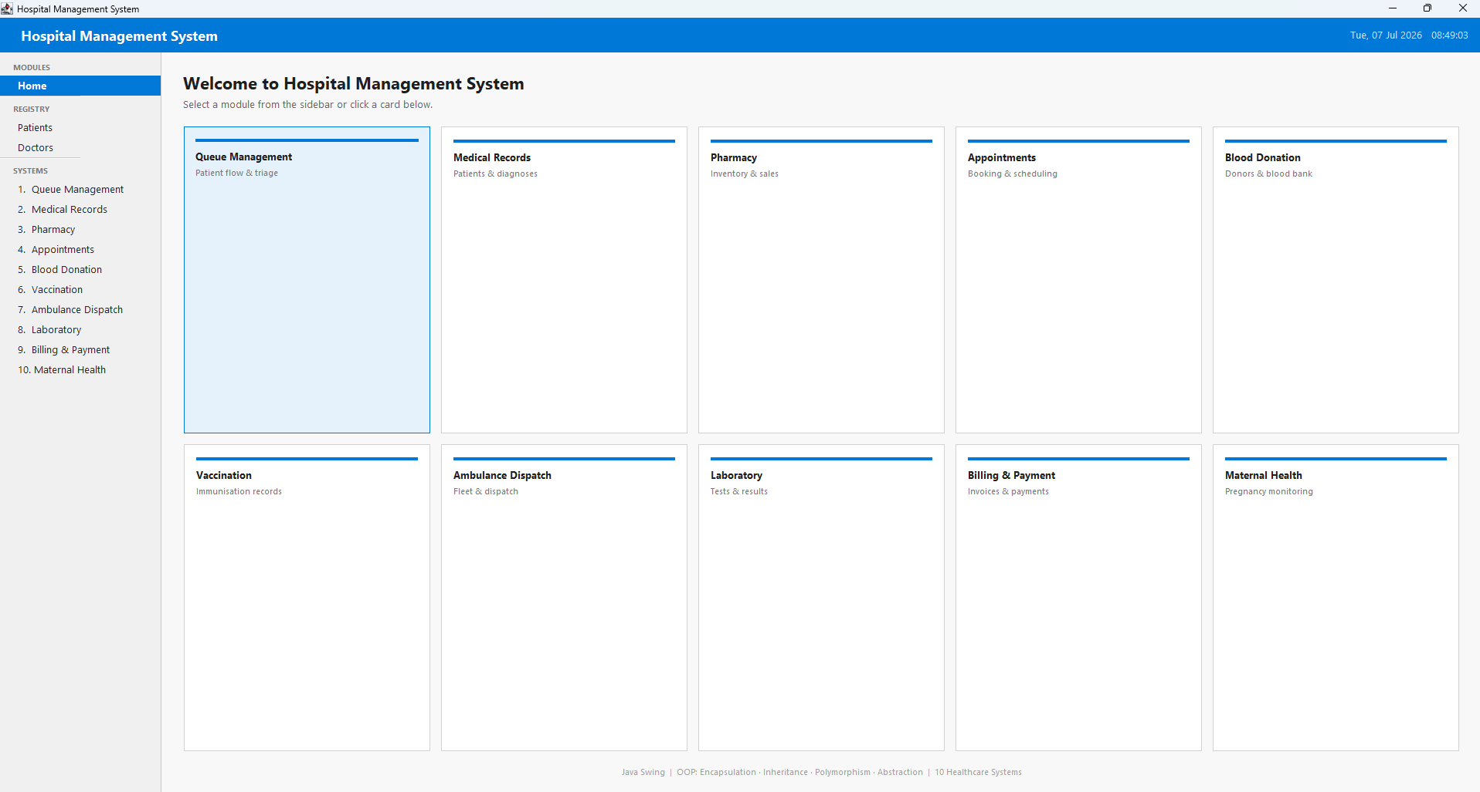
Figure 1: Home dashboard with module cards

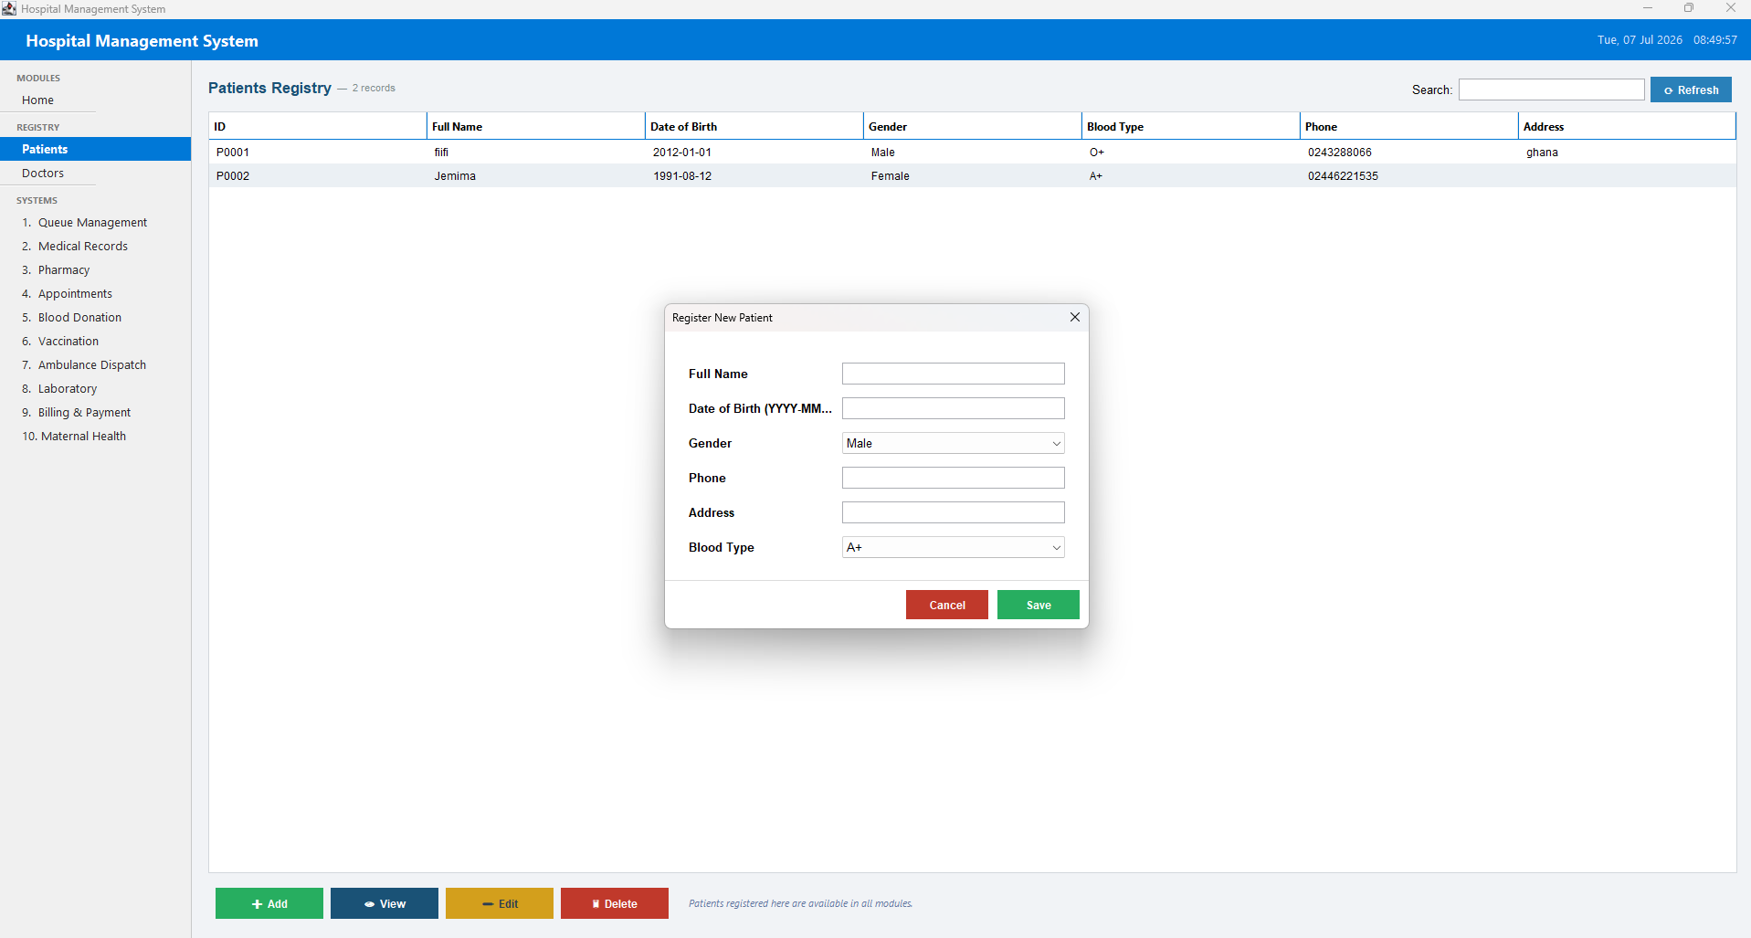
Figure 2: Patients registry with Register New Patient dialog

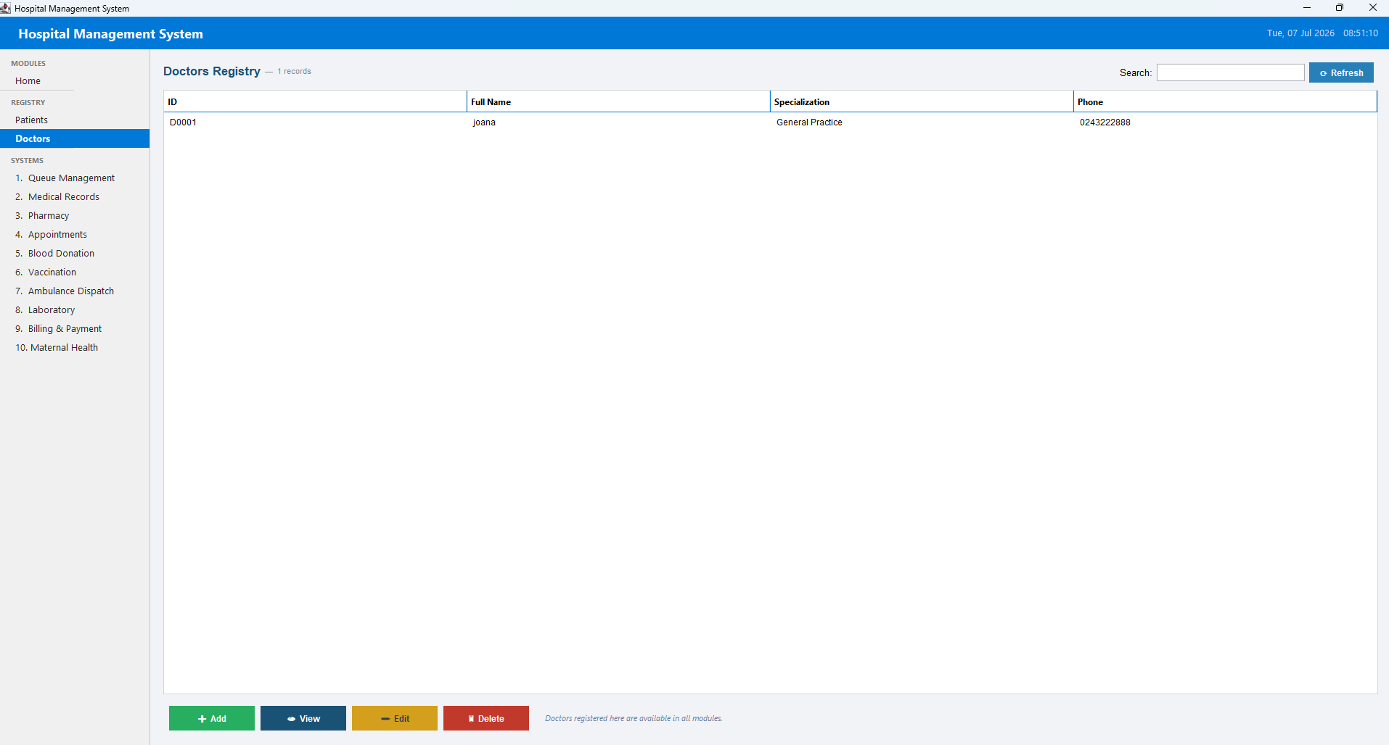
Figure 3: Doctors registry

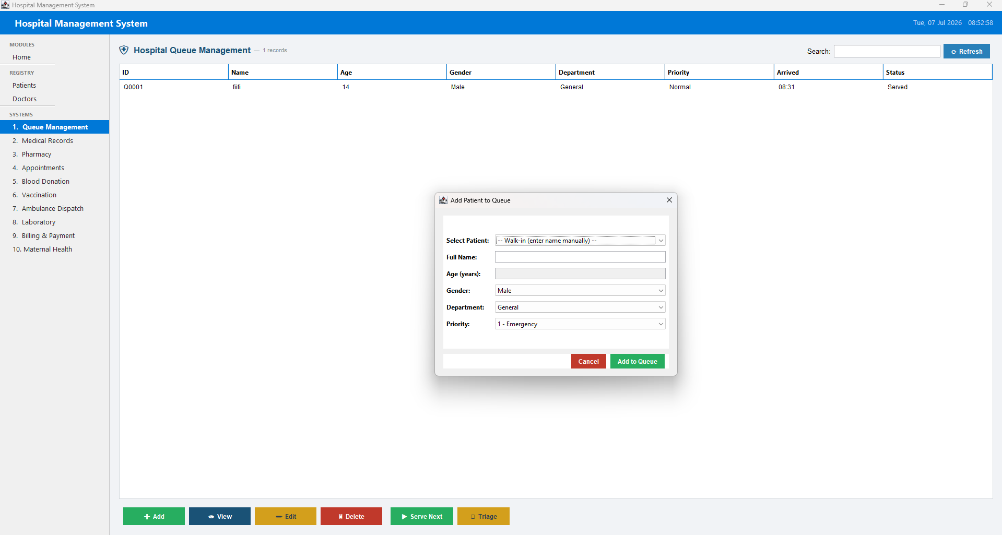
Figure 4: Queue Management - department queue and ‘serve next’

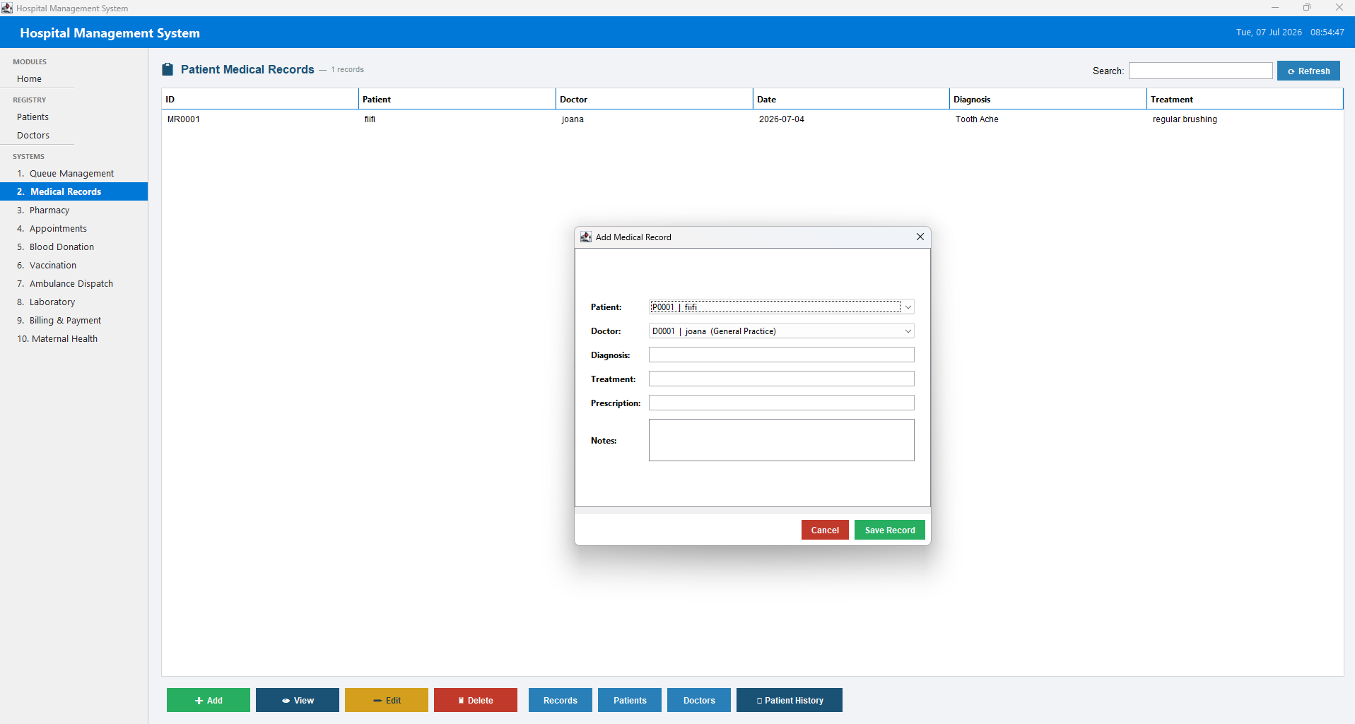
Figure 5: Medical Records - patient diagnosis/treatment entry

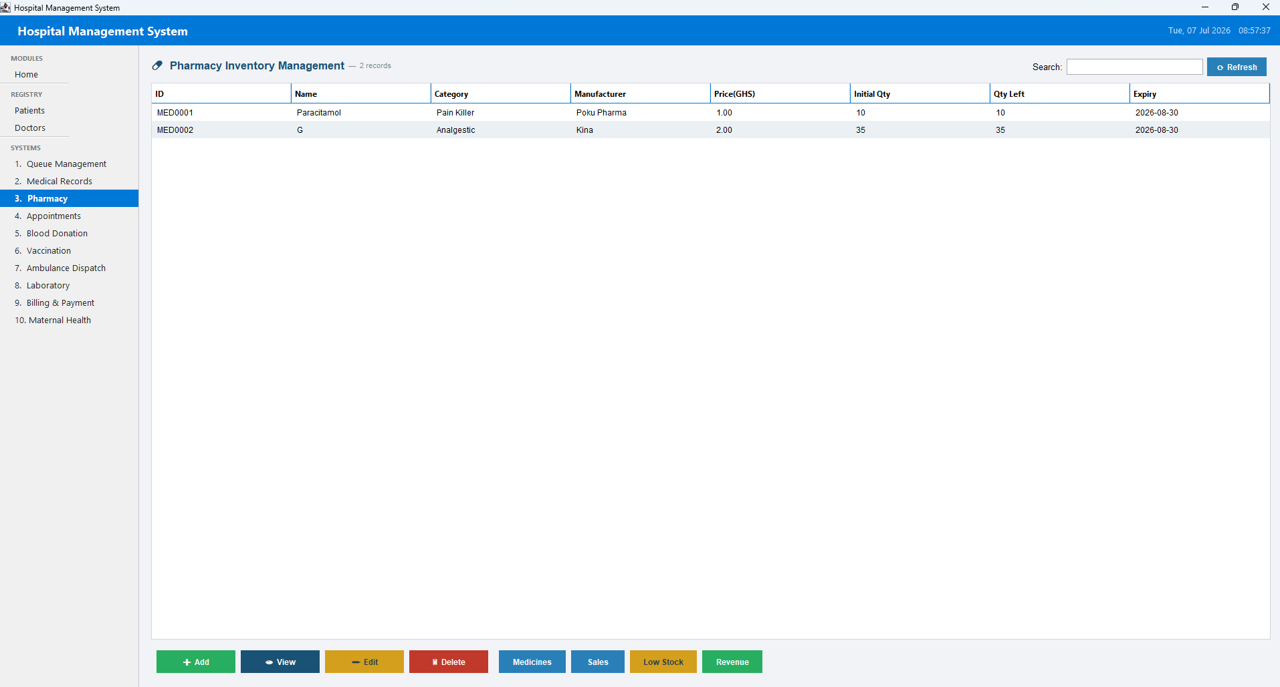
Figure 6: Pharmacy - medicine stock and sale

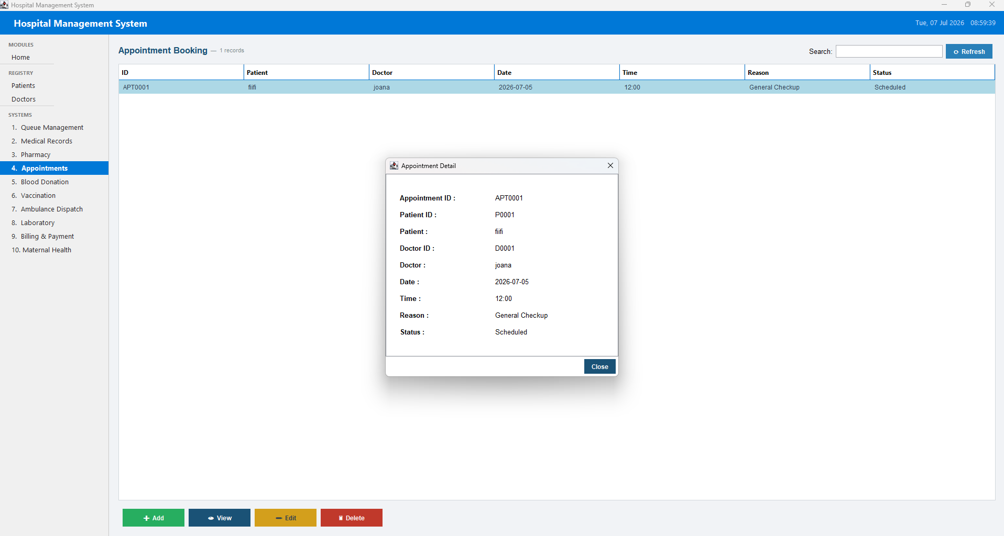
Figure 7: Appointments - list and appointment detail view

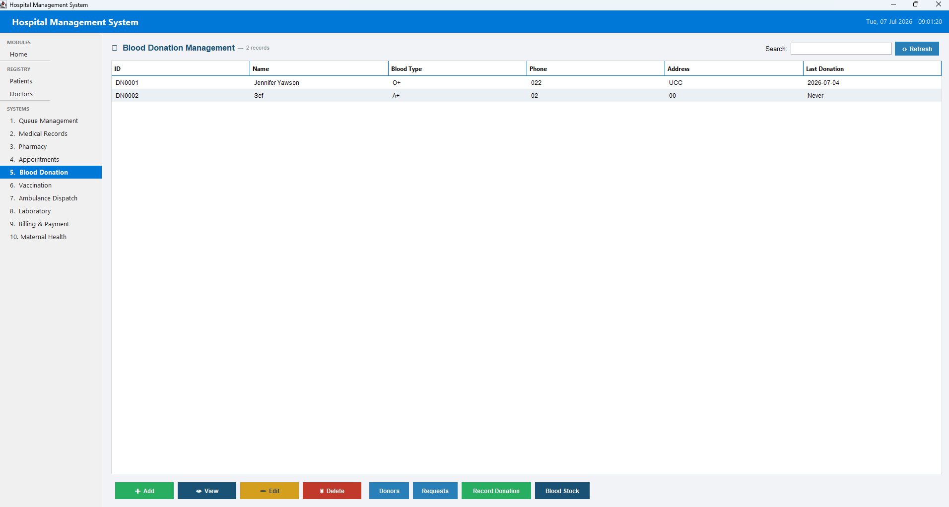
Figure 8: Blood Donation - donors and requests

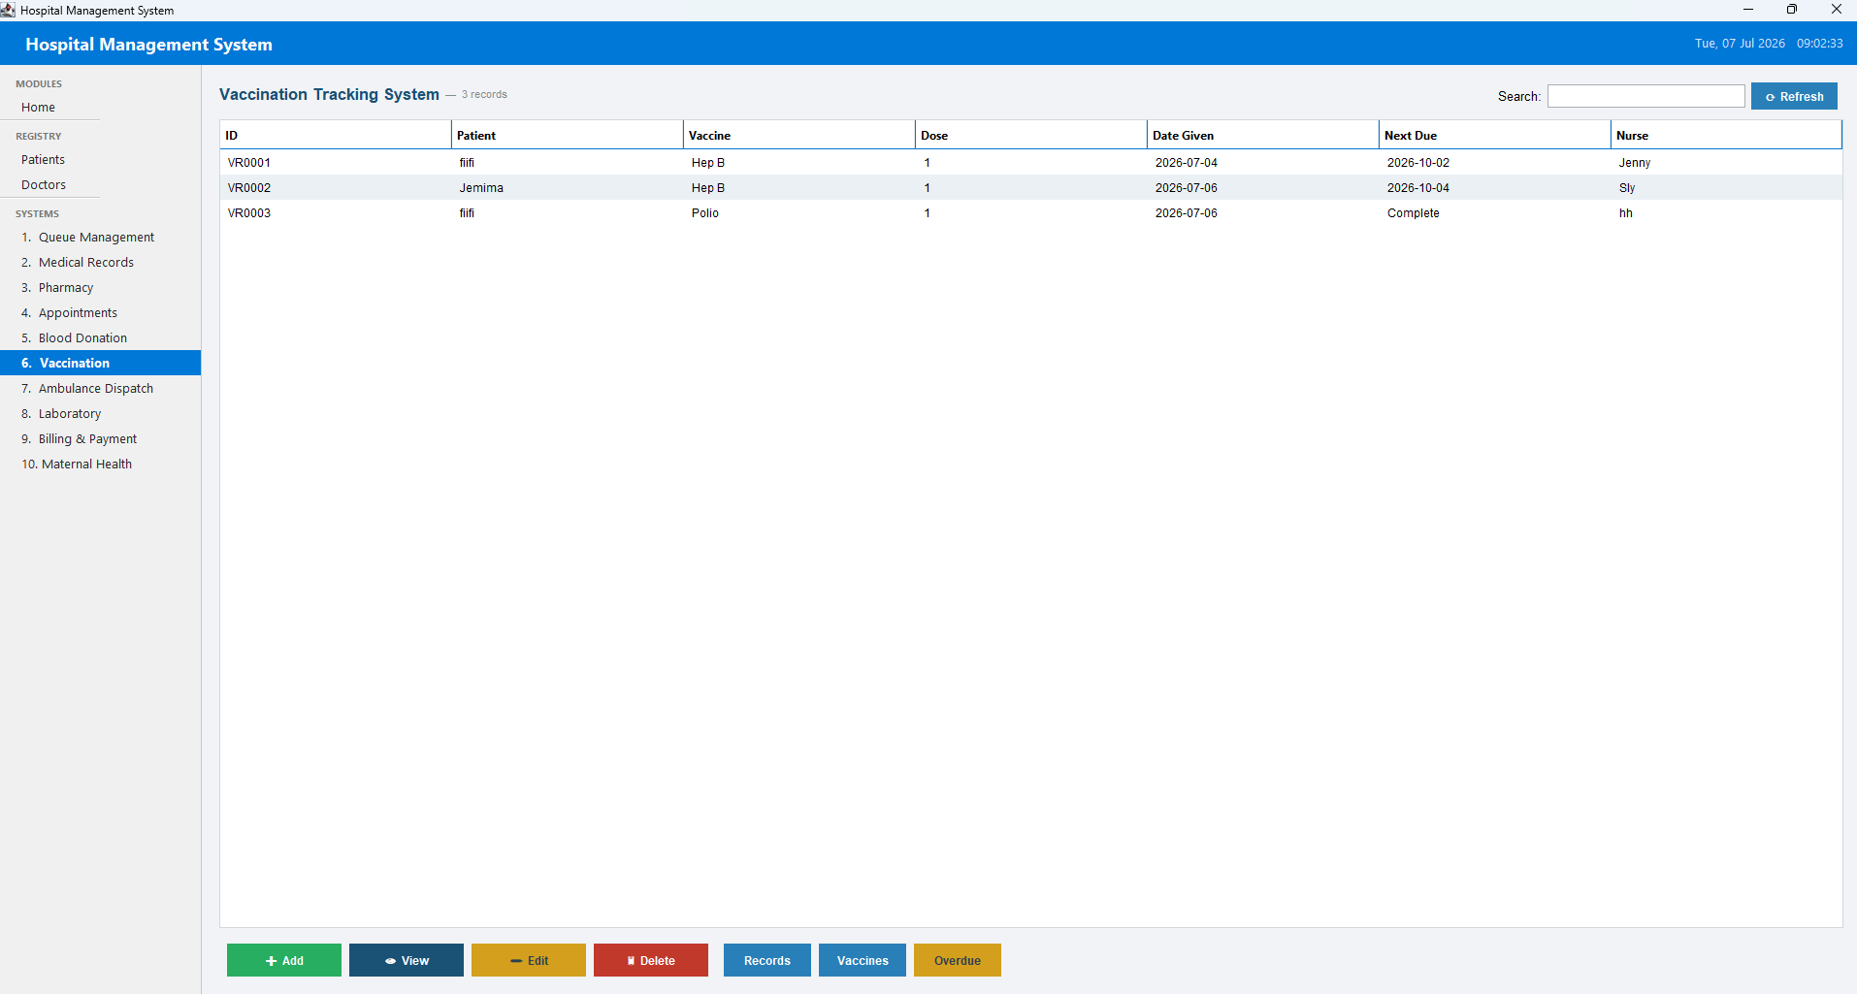
Figure 9: Vaccination records

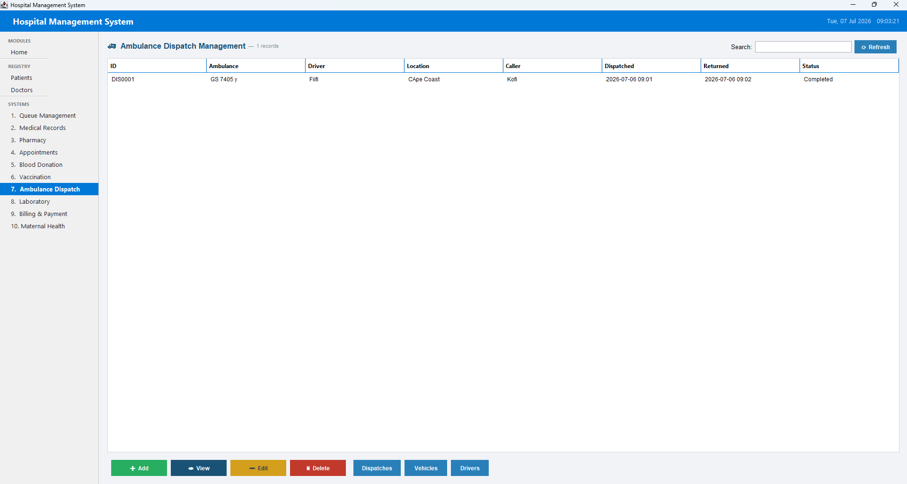
Figure 10: Ambulance Dispatch

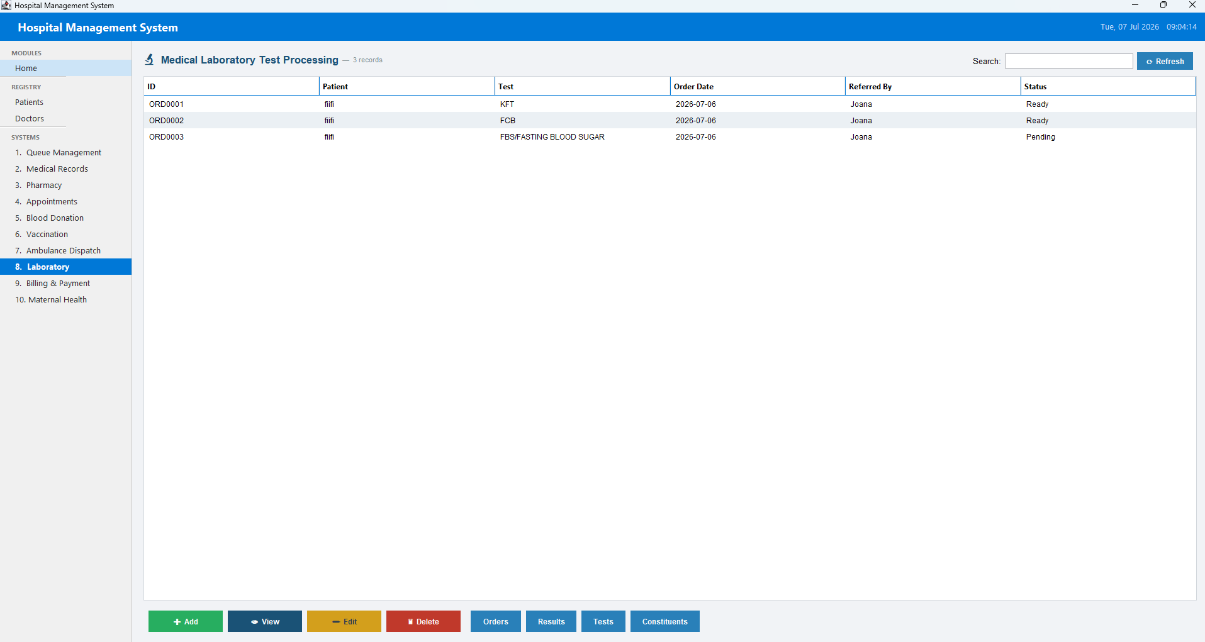
Figure 11: Laboratory - test orders and results

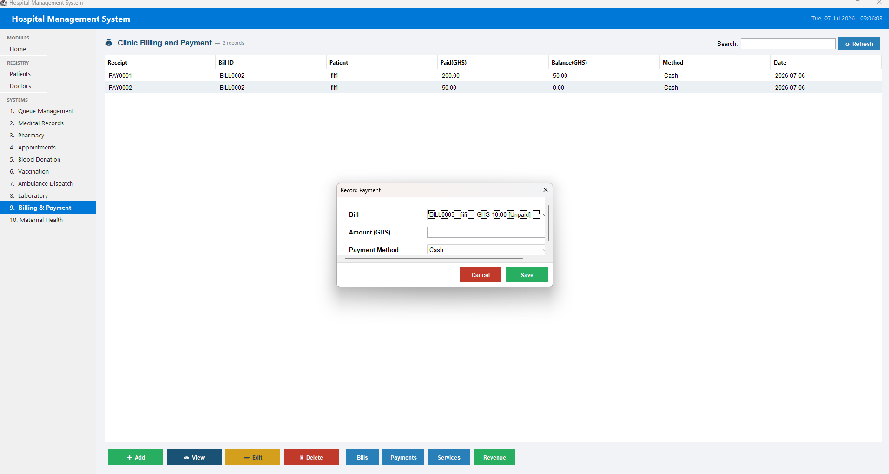
Figure 12: Billing and Payment - bill creation and payment recording

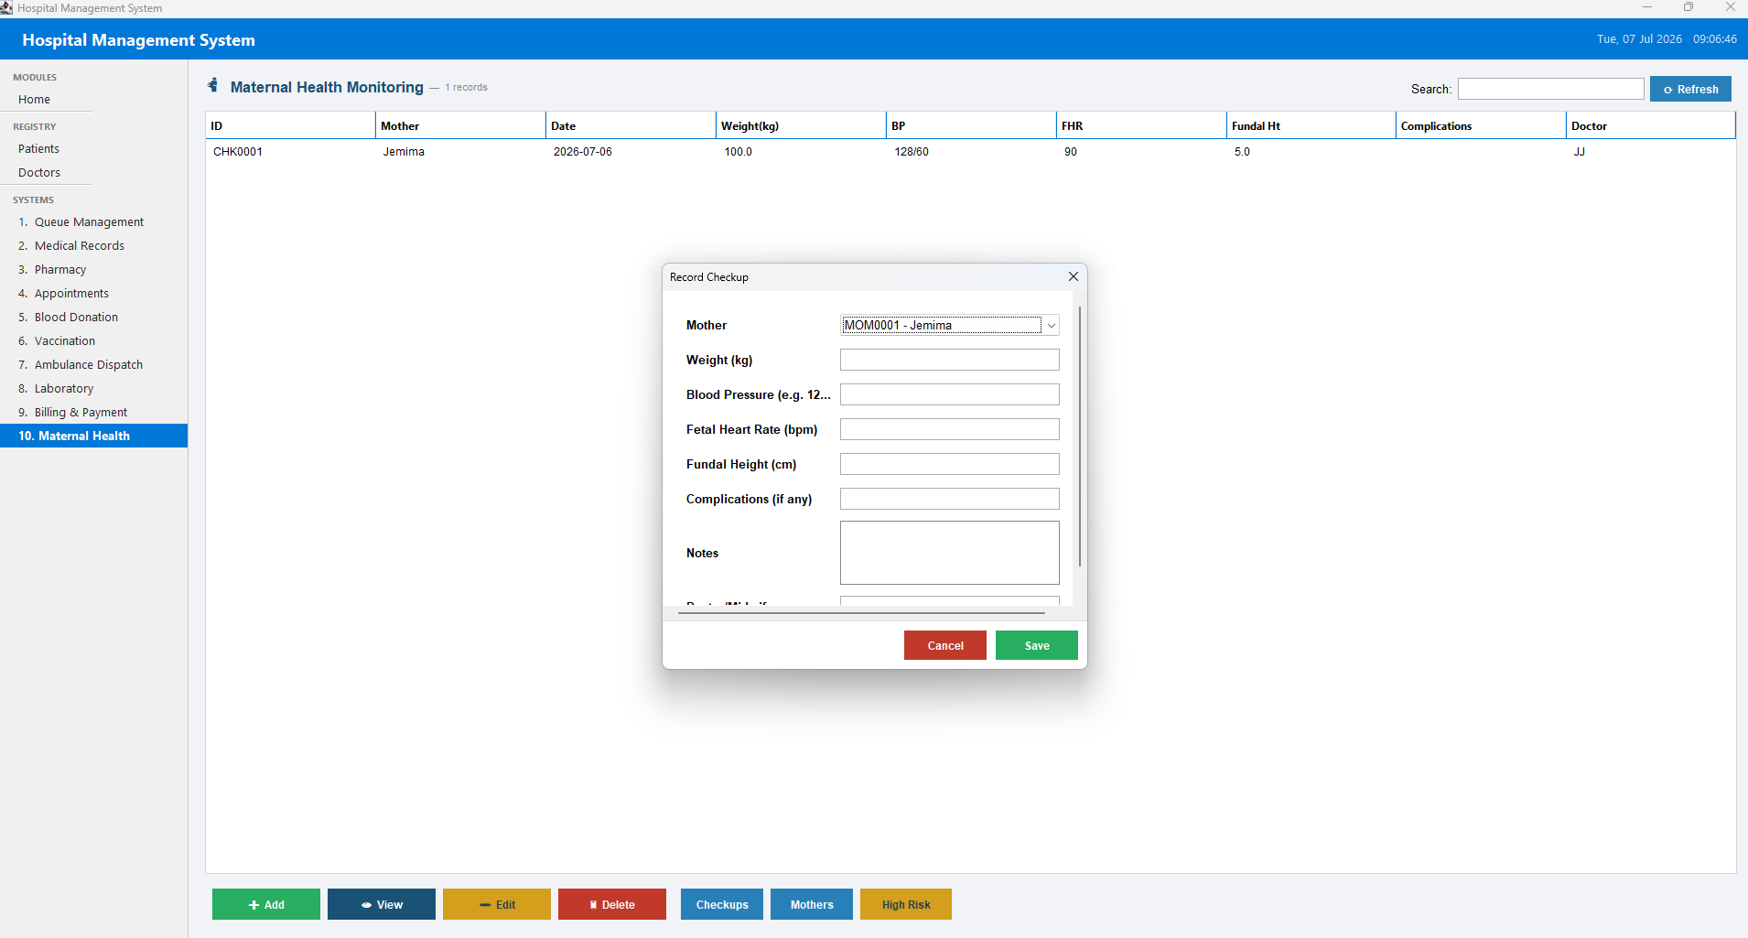
Figure 13: Maternal Health records

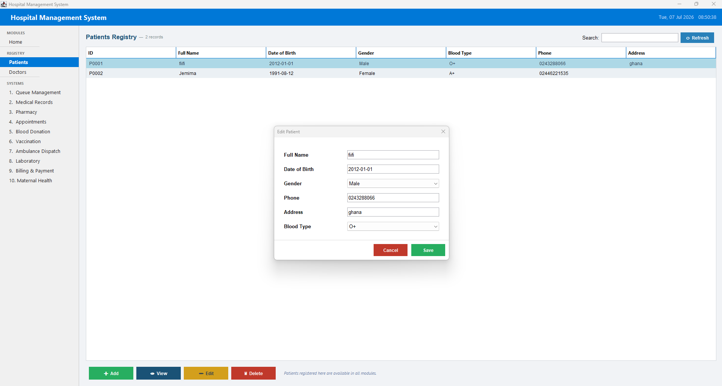
Figure 14: Edit Patient dialog (FormDialog reused in edit mode)

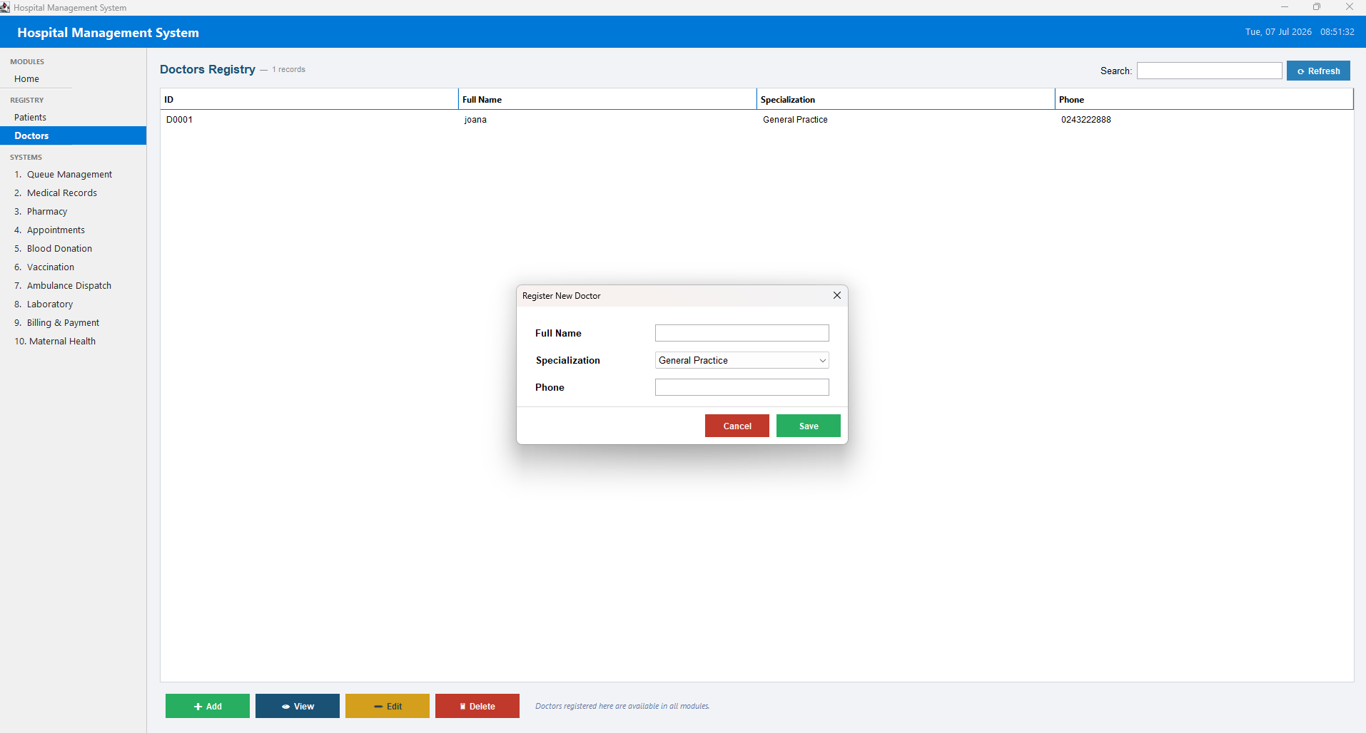
Figure 15: Register New Doctor dialog (FormDialog reused across modules)

11. GITHUB REPOSITORY LINK
Repository: https://github.com/bdodoo-ops/Hostital
The HospitalGUI source is organised under HospitalGUI/src, with parallel bin/ and out/ compiled-output directories and an IntelliJ IDEA project configuration (.idea/), reflecting standard incremental desktop-application development within an IDE.

12. CHALLENGES ENCOUNTERED
- Designing a single generic Manager<T> flexible enough to serve more than twenty structurally different entity types (patients, medicines, bills, lab tests, vaccination records, and more) while still preserving compile-time type safety and a simple, predictable CRUD contract.
- Keeping one shared BasePanel abstraction usable across ten modules that are not all alike - some are purely tabular record-keepers (Pharmacy stock, Blood stock), some are workflow-driven (Queue's priority-based 'serve next'), and some coordinate several related entities at once (Billing's services/bills/payments/pending charges) - which required the abstract hook methods in BasePanel to stay general enough for all of them without leaking module-specific logic into the shared base class.
- Coordinating cross-module billing correctly: ensuring Pharmacy sales, Lab tests, Vaccinations and Queue services all raise pending charges consistently through BillingManager, and that floating-point rounding on partial payments reliably flips a Bill's status to 'Paid' rather than leaving it perpetually 'Partial' because of tiny floating-point residues.
- Choosing a persistence strategy without a database: flat, pipe-delimited text files are simple and dependency-free, but every add/update/remove rewrites the entire file for that entity type, and Manager.loadFromFile() must silently skip any malformed or corrupted line to avoid crashing the application on start-up.
- Building a single-window, multi-module desktop UI with plain Swing/AWT (no external UI framework) - including a custom alternating-row table renderer, a live search-as-you-type filter, a home dashboard whose clickable cards must keep the sidebar's active-button highlight synchronised, and a reusable dialog builder general enough to cover text, numeric, date, dropdown, multi-line and read-only fields.

13. CONCLUSION
HospitalGUI demonstrates that a small, carefully designed set of abstract base types - Entity, the generic Manager, BasePanel, and the Displayable interface - can be reused across ten structurally different hospital modules to produce a single, internally consistent desktop application. Beyond its practical purpose of digitising queueing, records, pharmacy, appointments, blood donation, vaccination, ambulance dispatch, laboratory, billing and maternal health for a small hospital or clinic, the project serves as a clear, working demonstration of encapsulation, abstraction, inheritance, composition, polymorphism and generics within a non-trivial Java Swing application.

14. RECOMMENDATIONS
- Replace flat-file persistence with an embedded or networked database (for example SQLite or MySQL via JDBC) to gain referential integrity, safer partial updates, and support for concurrent access as the system scales beyond a single user.
- Introduce user authentication and role-based access control, since the current application has no login screen and any user who can run it has full access to every module and every patient's records.
- Add an automated unit test suite (for example JUnit) covering Manager<T>'s CRUD behaviour and each manager's business rules - billing rounding, stock checks, and queue priority ordering - to reduce reliance on manual, exploratory UI testing.
- Add reporting and export capability (CSV or PDF) for bills, stock levels and medical records, since data currently exists only inside local flat text files with no built-in export path.
- Consider replacing direct manager-to-manager calls (such as Pharmacy pushing pending charges straight into Billing) with an explicit event or observer mechanism, to reduce coupling as more modules are added.
- Add pagination or lazy loading within Manager<T> if record volumes grow substantially, since the entire file for an entity type is currently loaded into memory and rewritten on every save.

15. REFERENCES
Oracle Corporation (2026). The Java Tutorials - Creating a GUI with JFC/Swing. https://docs.oracle.com/javase/tutorial/uiswing/
Oracle Corporation (2026). Java Platform, Standard Edition Documentation - Generics and the Collections Framework. https://docs.oracle.com/en/java/javase/
Gamma, E., Helm, R., Johnson, R., and Vlissides, J. (1994). Design Patterns: Elements of Reusable Object-Oriented Software. Addison-Wesley. (Template Method and Singleton patterns.)
Horstmann, C. (2019). Core Java, Volume I - Fundamentals (11th ed.). Prentice Hall.
Oracle Corporation (2026). javax.swing.table and javax.swing.JTable API Documentation. https://docs.oracle.com/javase/

