**Name: S M RAHID HAQUE ID: 17-33107-1 Section F Subject: CN Assignment**

**Network Design:**

There will be 3 routers, 3 switches, 6 pcs and 3 servers in the network

* Pc0, Pc1, Pc2 are connected with switch 0. Switch 0 is connected with Router 0.
* Pc3, Pc4, Pc5 & a dhcp server are connected with switch 1. Switch 1 is connected with Router 1.
* A DNS & a http servers are connected to Switch 2,Switch 2 is connected with Router 2.
* Router 0 to Router 1-1.1.1.0/24
* Router 1 to Router 2- 2.2.2.0/24

**Router 0**

* VLSM (IP- 172.20.0.0/16)

Vlan 4 (Host -1800), Vlan 8 (Host - 480), Vlan 12 (Host - 28)

* Default gateway – 1st valid ip
* Configure encapsulation
* OSPF autonomous number 375

**Switch 0**

Vlan 4 (MKT) –f0/2 –f0/8

Vlan 8 (FIN)- f0/9 –f0/16

Vlan 12 (ADMIN)- f0/17-f0/24

Trunk – f0/1

**Router 1**

* VLSM (IP- 10.0.0.0/18),Host-950
* Default gateway – 1st valid ip
* Add a DHCP Server.
* OSPF autonomous number 425
* Apply Dynamic Natting

**Router 2**

IP – 192.168.10.0/27

* Default gateway – 1st valid ip
* DNS Server & a http server named www.aiub.edu
* OSPF autonomous number 450
* Apply static Nat

**Solution:**

Please Zoom in MS Word for Viewing Clearly

**For Router 0 Configuration:**

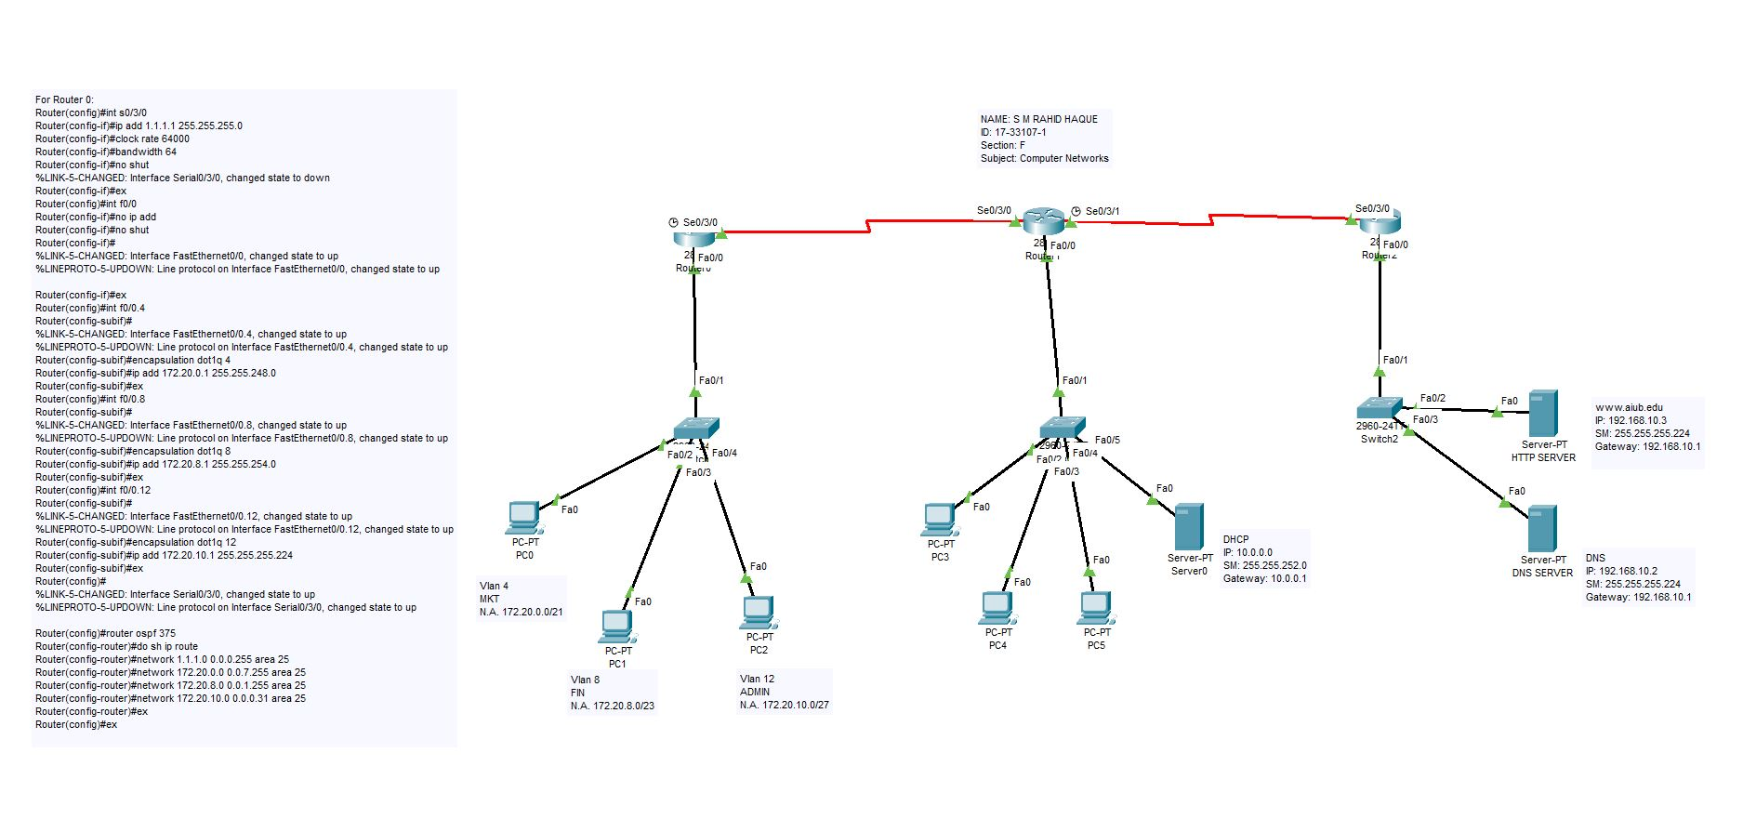

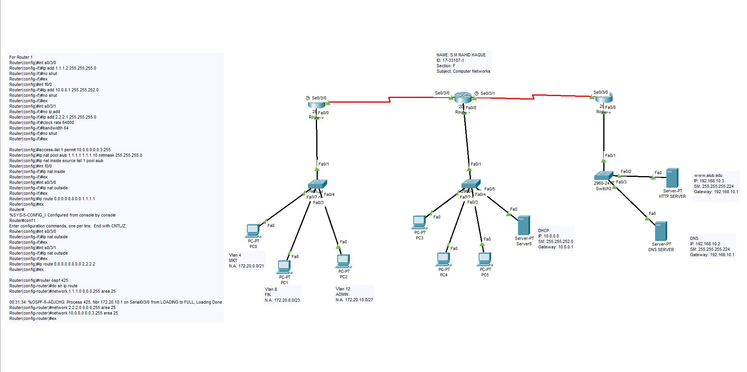**For Router 1 Configuration:**

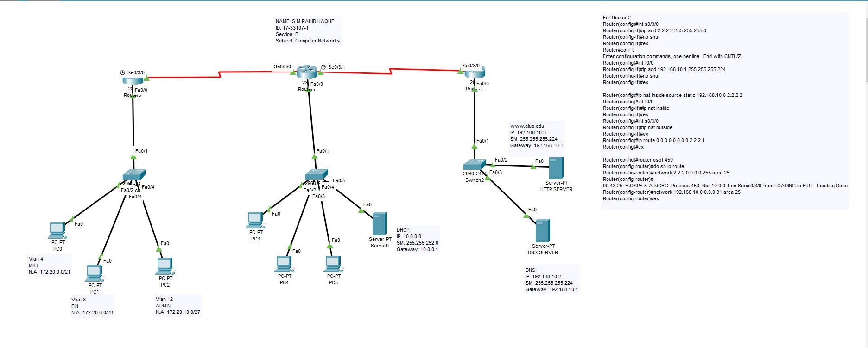**For Router 2 Configuration:**

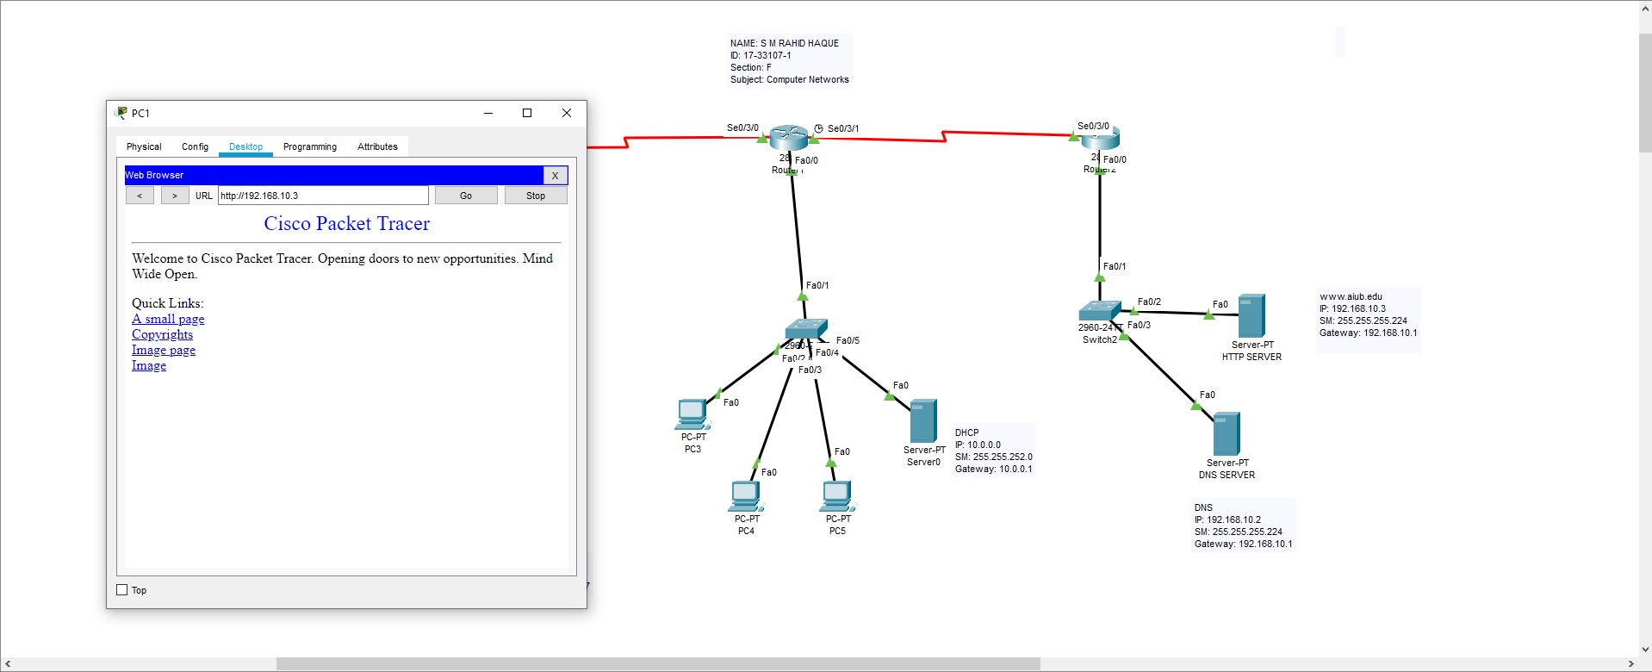**For Browsing Web Server from HTTP and DNS configuration:**

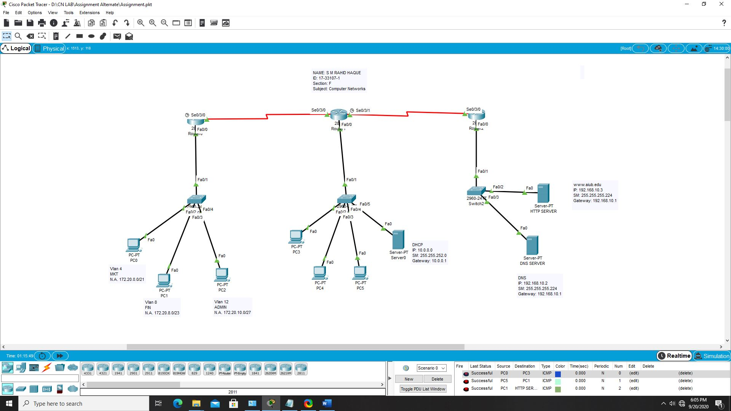**Message Transfer From Several PC’s and server:**