LSMS Research Impact Tracking Pipeline
Full documentation and user guide

1. Project Description
This pipeline is a fully automated Python program. It finds every research paper that uses an LSMS-produced dataset, checks how strong the evidence is for each match, and exports a structured Excel workbook. The entire process, including discovery, validation, and export, takes about five minutes with no manual work required. The program runs through a custom-built interface. A user enters a free API key, clicks one button, and receives a finished excel workbook with the list of all Papers.

1.1 Original Goal
The original goal of this project was to collect more objective metrics on the impact of LSMS. Primarily, to replace manual tracking with a fast, repeatable process that reliably measures the three requested metrics: TOTAL, FLOW, and SHARE.
Metric | Definition
TOTAL | The full count of papers using an LSMS dataset, across all years.
FLOW | The number of new papers per World Bank fiscal year (FY = July 1 to June 30).
SHARE | The percentage of papers with an African-affiliated author.

1.2 Final Version
The final output goes beyond the three requested numbers. Every run produces a complete workbook that includes:
- A full paper-by-paper record (Papers excel sheet), including:
  - title, DOI, authors, institutional affiliations, and publication date (with FY categorization) for every paper,
  - several (30+) other collected metrics.
- A confidence breakdown showing how each paper was matched and how strong its relevance score is.
- Automatically created analysis and visualization (Analysis excel sheet), including:
  - metrics and charts on Total, Flow and Share,
  - a chart about publication-type breakdown: peer-reviewed papers, working papers, and reports.
- A full audit trail of every search run and what it returned.
- A custom interface that makes the program easy to run for anyone.
- All this using an API configuration that makes it possible to run the program free up to twice a day.

2. Documentation

2.1 Data source
The pipeline searches OpenAlex, a free, comprehensive scholarly index that covers journal articles, working papers, preprints, and grey literature (arXiv, SSRN, NBER, and similar repositories).

2.2 The keyword list and the three-tier matching system
Every search term comes from the exact original keyword list the LSMS team already used in its Google Alerts tracker (the “Keywords ISA” and “Keywords HFPS” tabs), 121 terms in total, categorized into 10 survey families.
These 121 keywords vary enormously in how ambiguous they are on their own. A phrase like “Uganda National Panel Survey” cannot reasonably appear outside LSMS-related work. A bare acronym like “IHS” appears in thousands of unrelated papers (health plans, hospital systems, and so on). Applying one filter to both extremes either throws away real papers or lets irrelevant papers in--so every keyword is classified into one of four tiers, each with its own rule:
Tier | Terms | Example | Matching rule
A | 65 | “Uganda National Panel Survey”, “Living Standards Measurement Study” | Full-text match accepted (i.e. no title/abstract requirement, no discipline filter). These phrases are specific enough that they can't plausibly be false positives.
B | 15 | “LSMS-ISA”, “Tanzania NPS”, “GHS-Panel” | Must appear in the title or abstract specifically (not just anywhere in the full text).
C | 25 | “IHPS”, “ESS1”, “UNPS”, “HFPS” | Case-sensitive, word-boundary match, plus a required country-context word nearby, plus a relevant-discipline check.
AND | 16 | “HFPS” and “Burkina Faso” | Split into a boolean query; both the acronym and the country name must be present.

2.3 Validation: relevance scoring
Matching a keyword is necessary but not sufficient: the pipeline then scores each matched paper's relevance from 0 to 3 based on how strongly the paper's title, abstract, and match context indicate genuine dataset use (as opposed to, say, a passing citation). Papers scoring 0 or 1 are excluded and written to a separate Not Relevant (Backup) sheet.

2.4 Deduplication
Before anything is counted, candidate papers are checked against each other by normalized title and, where available, DOI. Exact matches are merged automatically.

2.5 Fiscal year and geography
- Rows on the Papers sheet are sorted by World Bank Group fiscal year (July 1 – June 30) in descending order (two-digit FY are sorted accounting for the fact that years 80-99 come before 01-27). Then, the papers are sorted alphabetically within each FY.
- Author geography is inferred from each author's institutional affiliation data returned by OpenAlex, mapped to country codes and checked against the eight ISA countries and the wider Sub-Saharan Africa list.

2.6 What it outputs
A single Excel workbook with the following sheets, in this order:
Sheet | Contents
Papers | One row per discovered paper: title, DOI, authors, institutional affiliations, publication year/FY, dataset country, research topic, peer-reviewed / working paper, match tier, and relevance score, etc. Papers are sorted by fiscal year descending, then alphabetically within each FY.
Analysis | The headline FLOW and Africa-SHARE numbers, a breakdown by match tier and relevance score, and the summary charts. Charts sit near the top of the sheet, next to the data, so they're the first thing visible.
FY Trend | A bar chart and a line-with-markers chart of papers per WBG fiscal year, both with data labels. The current, still-open FY is excluded so the trend isn't distorted by a partial year.
Keywords | All 121 original keywords, each with its tier, the matching rule applied, and the exact OpenAlex query sent, so any result can be traced back to the search that found it.
Search Log | An audit trail: every query that was run, when, and how many raw results it returned, before filtering.
Not Relevant (Backup) | Papers that matched a keyword but scored 0 or 1 on relevance. Kept for reference, but excluded from every headline count and chart. Always the last sheet.

3. Program Interface (when running “LSMS Impact Analysis.bat”)
Starting screen
Where the OpenAlex API key is entered and the analysis is started.
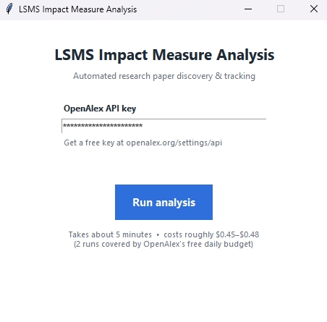
While it's running
A blue spinner runs while the program searches OpenAlex and builds the workbook (about 5 minutes).
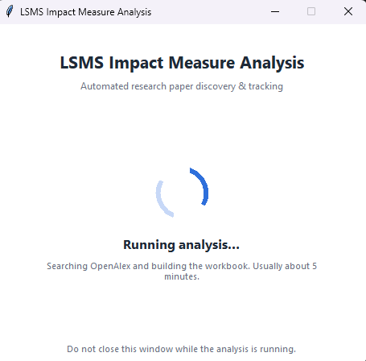
When it's finished
A green checkmark appears with the name of the finished workbook and an Open File button.
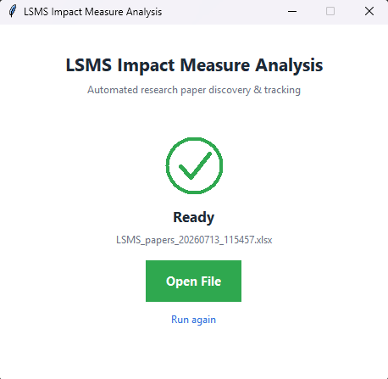

4. Output Excel
Analysis
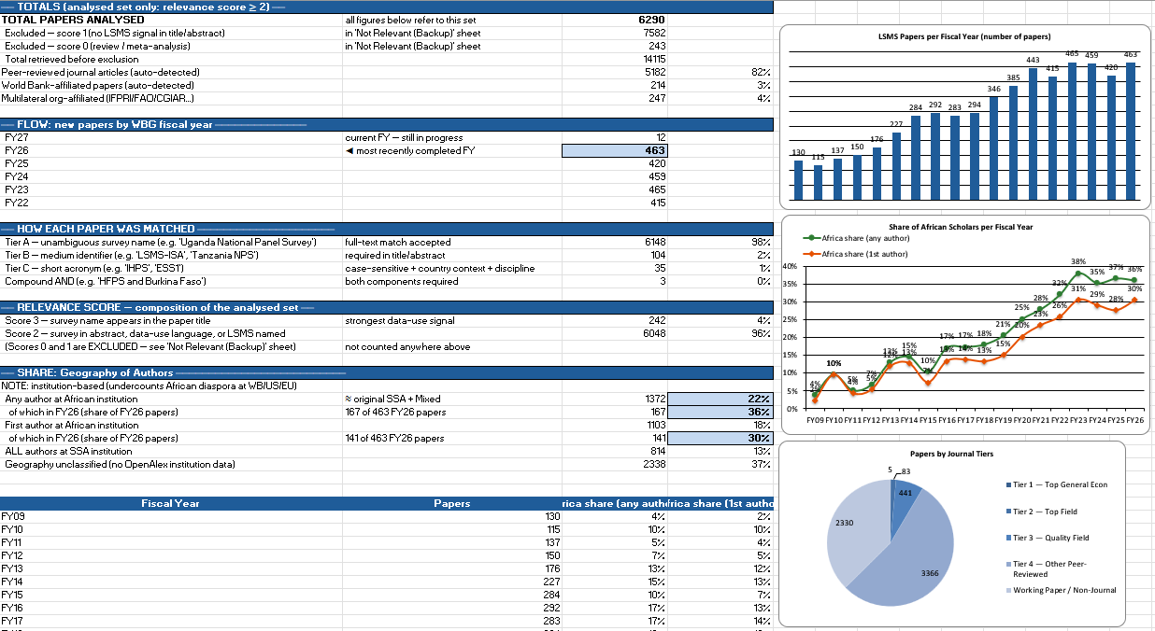
Papers
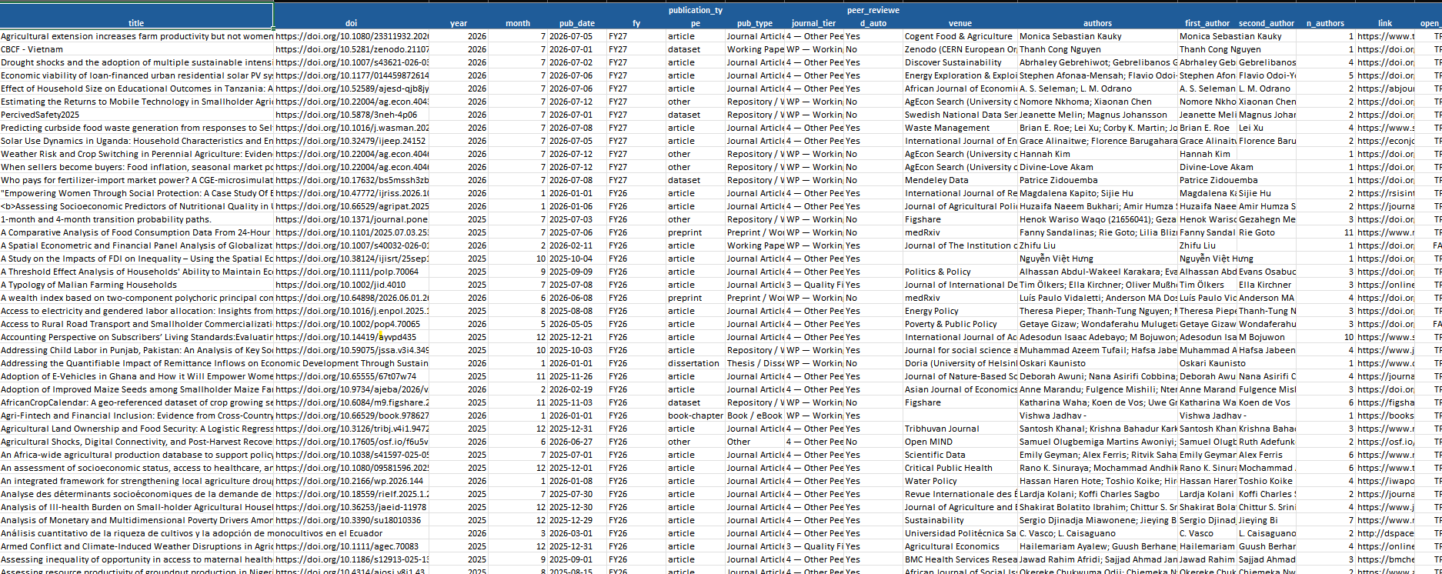

5. User Guide -- Setup Instructions
This is the full path from receiving the zip file to opening a finished workbook. It only needs to be done in full once per computer; after first use, just follow Step 4.

Step 1: Unzip the folder
Extract the zip file anywhere convenient (Desktop or Documents both work). Keep all the files together in the same folder.

Step 2: Run “Initial Setup.bat” (once)
If you don’t have Python installed, run Initial Setup.bat. This is a one-time step that prepares the computer to run the pipeline:
- It checks whether Python is already installed.
- If not, it downloads Python 3.12 directly from python.org and installs it in the background.
- It then installs the handful of Python packages the pipeline needs (from requirements.txt).
- When it says “Setup Complete,” you can close the window.
This step needs an internet connection and usually takes one to two minutes (longer if Python itself has to be downloaded and installed).

Step 3: Get a free OpenAlex API key
- Go to openalex.org and create a free account (any email works, including a WBG email).
- Once logged in, go to openalex.org/settings/api and copy your personal API key.
- Keep it somewhere safe, you need to paste it into the program once, and it will remember it for every run after that.
Note: No credit card or payment method is required for normal use. A free OpenAlex API key comes with a $1.00 per day free usage allowance, and one runs cost just about $0.45. If you need to run it more than twice a day, register and connect a new API key or buy usage credits on the OpenAlex API website.

Step 4: Run “LSMS Impact Analysis.bat”
- Double-click LSMS Impact Analysis.bat
- The first time, paste your OpenAlex API key into the field and click Run analysis.
- A blue spinner shows while the analysis runs--usually about 5 minutes. Leave the window open.
- When it finishes, a green checkmark appears with the name of the new Excel file and an Open File button. click it to open the workbook directly.

