1. **What is Waterfall methodology in software testing?**

* The Waterfall Methodology is a project management approach that emphasizes a linear progression from beginning to end of a project. This methodology, often used by engineers, is front loaded to rely on careful planning, detailed documentation, and consecutive execution.
* It is very simple to understand and use. In Waterfall Model, each phase must be completed fully before the next phase can begin.
* Waterfall is used for small projects with uncertain requirements.
  + Example of Waterfall Model: in olden days waterfall model was used to develop enterprise application like Customer Relationship Management (CRM), Human Resource Management Systems (HRMS), Supply Chain Management Systems, Inventory Management Systems, Point of Sales (POS), System of Retail chains.
  + Overview of Waterfall Model
    - **Requirement gathering and analysis🡪 System Design🡪Implementation🡪Testing🡪Deployment of System🡪 Maintenance.**

1. **What is software development methodologies?**

* Software development methodology refers to structured processes involved when working on a project. It is a blend of design philosophies and pragmatic realism that stretches back to early days of computing. The goal is to provide a systematic approach to software development.
* **Pragmatic** definition – dealing with things sensibly and realistically in a way that is based on practical rather than theoretical considerations.
  + E.g., of Software development methodologies:
    - **Agile, Waterfall, Scrum, Lean**

1. **What is build software development?**

* The process of building a computer program is usually managed by a build tool, a program that coordinates and controls other programs.
  + Examples: Gradle, Meister, Maven

1. **Where can we use Agile methodologies?**

* Teams handling fast- changing deliverables, such a technology product. Teams working on projects that evolve or do not have clear scope and requirements at the beginning. Teams working closely with customers and other external parties throughout a project.

1. **What is Agile Scrum?**

* Agile scrum methodology is a project management system that relies on incremental development. Each iteration consists of two-to-four-week sprints. Where the goal of each sprint is to build the most important features first and come out with potentially deliverable product.

1. **What is Agile Kanban?**

* **Kanban** is a framework used to implement agile and DevOps software development. It requires real-time communication of capacity and full transparency of work. Work items are represented visually on a Kanban board, allowing team members to see the state of every piece of work at a time.

1. **How does a SOftware Development Team Looks like?**

* 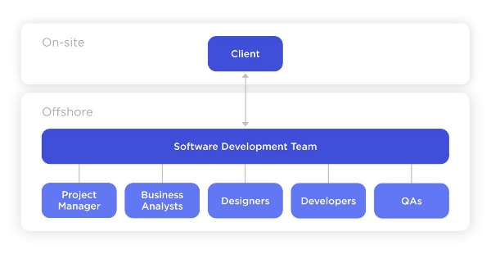
* **Client🡪 Software Development Team🡪 Project Manager (PM)🡪 Business Analyst (BA)🡪 Designers🡪Developers🡪 QAs.**

1. **What is Incremental Development?**

* Incremental Development in software engineering is a process methodology that emphasizes the virtue of taking small steps toward the goal.
  + Common use of **Incremental Development:**
    - It is very advantageous because of its progressive growth which makes it easy to revisit different compartmentalized stages.
    - There are different completion times for different sections of the same project
    - It is easy to group developmental stages, as there is a general division of the entire project.

1. **What is the difference between a test plan and a test strategy?**

* A **test plan** is a document that compasses the scope and different activities involved in the testing process, it has a goal to define how to test a product, what to test it on, when to test it, who will test, and who will verify the results. The purpose of test plan is to identify possible inconsistencies in the final product and mitigate them through the testing process. Test plan is used by one project and rarely repeated. Test Plan is used on a project level.
* A **test strategy** is a high-level document that encompasses guidelines and principles involved in carrying out the testing process. The goal is to define the principles to be followed during the testing process. It is a plan of action of the testing process on a long-term basis. Test Strategy is used on an organizational level.

1. **Explain bug life cycle?**

* Bug life cycle also known as defect life cycle is a process in which defect goes through different stages in its entire life. This life cycle starts as soon as a bug is reported by the tester and ends when a tester ensures that the issue is fixed and won’t occur again.