PLANS FOR
FOLDING KAYAK

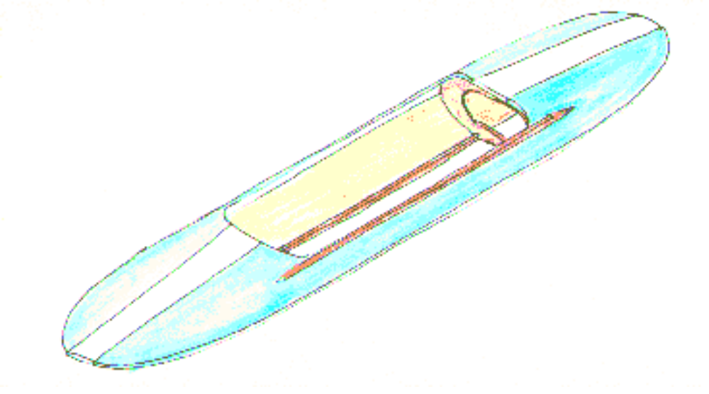

CONSTRUCTION INSTRUCTIONS
FOR FOLDING KAYAK

These plans and instructions developed from plans of Jess Rathburn, Coordinator of Industrial Arts, San Francisco School District (Initial plans dated 1968, cost/instructions updated in 1972, 1984, 1997).

This kayak weighs less than 40 pounds and will carry a full-sized man. The cost of materials varies between $90 and $130 (1985 prices). This design is for a ten foot model. The same basic principles have proven successful in 8, 12, and 14 foot models, both one and two man models. Everything in the boat is held together with contact cement (contact cement is waterproof).

MATERIALS

Plywood: Use AC-Exterior (good one side). Marine plywood is too expensive and differs from AC-Exterior only in that it has no voids.

Canvas: Canvas is sold according to two methods of specification. Some is listed as so many ounces per yard while duck canvas is given a number (a smaller number means heavier canvas). Canvas from 10 to 18 ounces per yard has been used satisfactorily. In duck canvas, a number 10 can be used to reduce costs. For maximum durability and life, use number 4 duck canvas. Canvas is most easily cut by laying it on a board and cutting it with a razor blade or a very sharp pocket knife.

Contact Cement: GRIP brand and US Plywood (Weldwood) brand have both been used successfully. If you plan to varnish the outside of the kayak rather than paint it, don't use GRIP. GRIP is green while Weldwood is brown. Don't buy treated canvas unless you first test to make certain your cement will stick to it.

Paint: Any water-based paint or varnish can be used. Be sure to give boat one coat of primer before applying finish coats. Over canvas the paint should be the flexible type. Exterior latex works well, but is not essential. Some paint solvents will dissolve contact cement through penetration of the canvas. Reglue if the canvas is loosened. A latex primer guards against this.

LIST OF MATERIALS FOR 10 FOOT KAYAK (All measurements in inches)

Body panels 4 pcs. 1/4 x 11-7/8 x 120 AC-exterior Plywood
Floor board 1 pc. 1/4 x 11 x 48 AC-exterior Plywood
Back rest 1 pc. 1/4 x 11 x 14 AC-exterior Plywood
Paddle Blades 2 pcs. 1/4 x 8 x 15 AC-exterior Plywood
Spreader Boards 2 pcs. 1/2 x 11 x 24 AC-exterior Plywood
Paddle Bar 1 pc. 1-1/4 dia. x 72 Pine/Fir Clothes Rod
Inside panel strips 4 pcs. 5/16 x 3/4 x 60 Douglas Fir
Cockpit Edging 2 pcs. 3/4 x 3/4 x 48 (clear)
Bottom Outside Runners 2 pcs. 5/16 x 3/4 x 117 (clear)
Canvas End strips Bias Cut 2 pcs. 2-1/2 x 46 #4 Duck Canvas
Canvas Side strips Straight Cut 2 pcs. 2-1/2 x 96 #4 Duck Canvas
Canvas Center Piece Straight Cut 1 pc. 10 x 16' 6" #4 Duck Canvas
Back Rest Hinges 2 pcs. 1 x 3 Leather scrap
Contact Cement 2 qts. (careful workers)
3 qts (Boy Scouts)
Lacquer Thinner 1 pt.
Paint brush 1" (cheap) Several

LIST OF TOOLS REQUIRED/RECOMMENDED

Razor Blade Knife or SHARP Pocket Knife for cutting canvas
C-Clamps (4 or 5)
Marking Pen or Pencil
Power Sabre Saw or Key Hole Saw for cutting curved edges
Sandpaper (60 grit) for rounding edges and smoothing curves
Wood Rasp for rounding edges and smoothing curves
Hammer and Pounding Block for insuring full contact of glue joints
Cutting Board (scrap plywood) for backing canvas while cutting
Saw Horses to hold kayak pieces at a working level

INSTRUCTIONS

1. Cut out the basic materials.

Cut the 4' x 10' plywood sheet into four body panels, 11-7/8" x 10'. Also cut pieces for paddle blades, back rest, floor board, and spreader boards. If bottom runners, panel strips, and cockpit edging are to be cut from 1" x 2" material do this now also. One piece, 1" x 2” x 117" can be ripped to provide the two bottom runners, and another piece, 1" x 2" x 60" will make four panel strips. The 1" x 2" x 117 " piece also provides material for the cockpit edging. (Remember that the 1" x 2" nominal material has actual dimensions of 3/4" x 1-5/8") If you do not want to rip out these pieces buy molding of approximately the same size. This is more expensive and you may want to omit the top inside panel strips to reduce the cost.

2. Shape panels.

Using C-clamps, clamp together the top and bottom panels for the right and left sides respectively. The inside of the panels should be marked right and left for future reference. Make sure that the best side of each panel is on the outside. Draw freehand the outline of the outside of the kayak on one corner of one panel, copying approximately the shape shown in plan "A". Start the curved section 1-1/2" from the center edge of the panel. This leaves the front end of the kayak square so that the center strip of canvas can be applied without wrinkling. Using a sabre saw or hand saw, carefully cut the curve on one panel corner. Using the piece you have cut off as a pattern (to insure all corners are the same), draw the curve on the remaining three corners and cut them out. While the two pairs of panels are still clamped together, sand the edges. Rounding the edges with a rasp or sander reduces the chance of the canvas wearing through at the edges of the wood.

Remove the clamps and clamp the two top panels together. Following plan "A", cut out the cockpit opening and sand the edges. DO NOT CUT THE COCKPIT OPENING IN THE BOTTOM PANELS.

3. General Contact cementing procedures.

The next step involves cementing some of the pieces together with contact cement. The following instructions should be followed for all such gluing operations throughout the entire construction of the kayak.

Use cheap 1" brushes and keep them in lacquer thinner between coats. Plan to throw them away when you are finished. Lacquer thinner and similar solvents are very toxic. Be careful with them. Keep cement can covered whenever possible. Solvent evaporates rapidly.

b. Follow cementing instructions on the can. Avoid gluing in cold weather (below 60 degrees). Work with adequate ventilation.

c. First coat. Apply thin sealer coat to both surfaces to be joined. This coat must be dry before applying the second coat. Drying time is usually at least 10 minutes. This sealer coat may be allowed to dry overnight or even for several days. To test if the glue is dry, place a piece of paper on the surface of the glue. The paper should peel off without sticking if the cement is dry.

d. Second coat. Apply the glue liberally to both surfaces and let dry. Surfaces must be joined WITHIN FOUR HOURS after second coat. If longer assembly period occurs, apply a third coat and join pieces within four hours of the third coat.

e. Making contact. Once the glue surfaces "grab" each other, they can not be shifted or moved, so line up the pieces carefully before making contact. When gluing two pieces of wood, pound with a hammer and pounding block to firmly set the joint. When gluing canvas, rub the joint firmly with a hard object such as a hammer head or C-clamp. This sets the joint and also can be used to remove small wrinkles. If possible, let the glue joints dry overnight before subjecting to any strain. This is not absolutely necessary, but is recommended.

f. Regluing. If any joints loosen after use they can be reglued with one coat of glue. They can also be repaired by rubbing with a hot iron. Place a sheet of paper between the iron and the canvas to protect the iron.

4. Assemble the cockpit edging and panel strips.

Assemble the cockpit edging and the inside panel strips with contact cement as shown in plan "B". Be sure to measure carefully so that the small 3" blocks are all the same distance from the ends of the kayak. If desired, small screws or nails can be put in the ends of the cockpit edging (with the nails clinched over on the inside). This guarantees that the edging will not pull loose under tension.

5. Varnish or paint inside surfaces of the body panels.

This should be done now, as inside painting is difficult once the kayak is assembled. Spar varnish is durable and looks nice but any exterior paint or polyurethane varnish will be satisfactory. One coat is adequate but two give a nicer job.

6. Glue the canvas end and edge strips.

Clamp the top and bottom panels together for the right and left sides respectively. Use the 3-1/2" spacer blocks shown in plan "C" to hold the panels the right distance apart. It is easy to apply the canvas if the panels are set on two saw horses or benches with the ends overhanging. With a pencil, draw a line 1" from the edge of the plywood all the way around the boat, top and bottom. This serves as a guide when applying the glue. Apply two coats of contact cement to the wood and the canvas, as explained in instruction 3. Two persons should work together.

Apply the bias cut end strips first. First glue the center of the canvas strip to the end of the kayak. Once it has grabbed for a distance of several inches, pull hard on the end of the canvas. One person should pull on the end of the canvas while the other makes sure the canvas is centered and pressed firmly in place. It is important to pull hard on the canvas so that no wrinkles are left. Small wrinkles can be rubbed out with a hammer head or a C-clamp.

Next apply the side strips. Depending upon how pointed your kayak is, these side strips may be a few inches too long. Allow enough length for a 2" overlap at joints, and cut off excess. When gluing end bias strips, be sure to glue both sides for a distance of 2" from the ends to provide for overlap joints.

7. Cut out spreader boards.

Cut out the spreader boards according to plan "D", and put them in place. Note that the bottom of the spreaders are curved up-wards 1/2" to reduce wear on the bottom canvas. Since the tension in the canvas seems to shift each time the boat is set up, do not strive for perfection in fitting the spreaders. They will fit fairly well, but a 1/4" variance is acceptable.

8. Install center canvas.

Make sure spreader boards are installed prior to installing center strip. Cut center canvas according to plan "E". Glue center strip pieces together (with 2" overlap) prior to gluing center strip to kayak. Apply two coats of cement to the canvas and to the boat as explained in step 3. Plan "E" indicates where cement should be applied to the canvas. Be sure to apply cement to the bias cut end strips where the center strip will cover them. To apply the canvas, turn kayak upside down. Mark the midpoint of the kayak and the midpoint of the long, canvas center piece. Lay newspapers over the glue on the bottom of the boat except for a 12" space at the middle. Two or three persons together can most easily do this job. Press the canvas down onto the glue at the center after making sure the canvas is carefully lined up and centered. The midpoint of the canvas must line up with the midpoint of the boat. Working from the center to the ends, remove one newspaper at a time and press the canvas in place. Next turn the boat over and press the canvas into place on the top deck, folding the ends under at the cockpit. Let dry overnight.

9. Install bottom runners.

Collapse the kayak by removing the spreaders. Cement bottom runners on top of canvas just over inside edge of plywood panels. The ends of the runners should be 1-1/2" from the ends of the kayak. These runners protect the canvas when beaching the boat or when paddling in shallow water. There is a tendency for the ends of the runners to pull loose when the spreader boards are put in place. If this happens, reglue using clamps or weights on the runners to get a stronger joint. Another method is to drill a small hole through the end of each runner and fasten with a small nail. The nail must be coated with glue and clinched over on the inside. This is difficult to do because the inside ends of the kayak are relatively inaccessible, but it can be done.

10. Make the paddles and seat.

Cut out the paddle blades. A useful design is shown in plan "F". 1" or 1-1/8" dowel (clothes rod) works well for the handle. Cut an 8" long slot in each end of the handles. Glue blades in with waterproof glue or contact cement. If contact cement is used, assemble while the glue is wet. Drive small nails through the dowel and blade and bend over the ends. The "hook" design on the paddle blades helps to keep water from running down the paddle into the boat. It is also handy for hooking trees on the shore and other kayaks. A few turns of sash cord attached 3" from the blades also helps keep the paddler dry.

The backrest is best attached to the floor board with two small leather hinges made from and old belt or shoe. They are attached with rivets or small screws and nuts.

11. Waterproof and Paint.

The canvas should be treated so that it is waterproof and flexible. A preliminary coat of Thompson's Waterseal on the bottom center strip is recommended. (This is not absolutely necessary) Other similar products can be used. Be careful in painting and waterproofing that the glue is not lifted. Coat all wood and canvas with a primer coat. W.P. Fuller water thinned exterior latex primer #7079 works well. Paint the canvas with a paint that dries with a flexible finish. However, almost any exterior paint can be used. Exterior latex, enamel, and house paint have all been used successfully. A primer should be used however, or the paint chips off. A primer coat plus two finish coats gives the best results on the wood surfaces. On the canvas, a primer coat plus one coat of finish is enough. Don't forget to paint or varnish the paddle, seat, and spreader boards also. Painting the canvas a contrasting color to that used on the wood gives a handsome look to the boat.

MISCELLANEOUS NOTES AND COMMENTS:

A cockpit cover of nylon, attached with gripper snaps, can be used to cover the front of the cockpit and reduce the amount of water taken in rough water. For safety, the cover should come off easily if the boat capsizes.

Paddle into big waves at a 45 degree angle to reduce the amount of water splashed into the cockpit.

Place a beachball or innertube in the ends of the kayak to provide additional buoyancy if the boat capsizes.

In building the 12 foot kayak, make the cockpit 4 or 5 feet long. In the 8 foot model, make the cockpit 42" long. The 8 foot model is easy to maneuver, but fishtails more than the longer models in long paddles. For an adult, a 7 foot paddle works well.

A boy scout can build one of these kayaks in about 12-15 hours. In Troop 37, it was found that boys 11 years old could carry out all construction from step #2 on, with an adult present. Step #1 which requires use of a circular or arbor saw, should be done by an older person. Groups of 6 to 8 boys working in pairs can build these boats with essentially no help. For the best results they should carry the project to completion, including painting, working together. It is usually not necessary to buy paint; any old exterior paint around the home can be used as a rule.
