Supplementary Material
The Neurotech EEG Dataset: A Large Clinical Scalp EEG Corpus Dominated by Multi-Day Ambulatory Recordings
Morgan et al.
Supplementary Tables
Supplementary Table 1. Recording duration categories. The majority of segments represent ambulatory or short-term monitoring.
Category | Duration | N segments (%) | Likely clinical setting
Routine | < 1 hour | 8,545 (36%) | Outpatient EEG
Short monitoring | 1 - 24 hours | 12,572 (53%) | Ambulatory or short-term
Prolonged monitoring | > 24 hours | 2,490 (11%) | Multi-day ambulatory

Percentages computed over 23,607 EDF segments containing recoverable signal data.
Supplementary Table 2. Annotation categories. Technician clips and spike markers are the most frequent categories.
Category | Events | Description
Technician clips | 53,469 | Segments selected for physician review
Spike markers | 50,482 | Interictal epileptiform discharge detections
Neurotech free-text comments | 24,267 | Free-text EEG finding descriptions
Sharp waves | 21,330 | Sharp wave or sharp-slow-wave complexes
Slowing | 19,401 | Focal or diffuse slowing
Activation procedures | 15,746 | Eyes open/closed, photic, hyperventilation
Generalized patterns | 12,345 | Generalized discharges
Spike-wave | 10,439 | Spike-wave complexes
Seizure markers | 6,892 | Electrographic seizure events
Posterior dominant rhythm | 5,535 | PDR frequency notations
Artifact | 4,881 | Technical or physiological artifacts
Burst-suppression | 3,350 | Burst-suppression pattern
Focal | 1,928 | Focal patterns
Normal | 505 | "Normal" notations
Epileptiform | 164 | Other epileptiform
Periodic | 139 | Periodic discharges (LPDs/GPDs)

Categories are not mutually exclusive; a single annotation may contribute to multiple categories. Total annotation events: 226,486 across 14,517 segments with annotation files.
Supplementary Table 3. De-identification example. Header field transformation and annotation scrubbing for a representative recording.
Field | Original | De-identified
Patient identification | 12-34567 X 15-MAR-2023 Doe_Jane | X X X X
Recording identification | Startdate 15-MAR-2023 Record_stopped... | Startdate 22-JUN-2023 X X X
Start date | 15.03.23 | 22.06.23 (shifted +99 days)
Start time | 14.32.08 | 14.32.08 (preserved)
Annotation text | Patient event Jane had a blank stare | Patient event [NAME] had a blank stare
Annotation timestamp | 2023-03-15T14:33:45 | 2023-06-22T14:33:45 (shifted)

Names and dates shown are fictitious. Actual date shifts are random per patient (uniform integer in [-365, +365] days) and applied consistently across all files for that patient.
Supplementary Table 4. Detailed EEG findings. Breakdown of posterior dominant rhythm (PDR), interictal epileptiform discharges, slowing, seizures, and patient-reported events extracted from technologist scan reports (n=10,726 studies with extractable reports).
Finding | Value | Notes
Posterior dominant rhythm
PDR extractable | 8057 | of 10726 studies
PDR frequency, median (IQR) | 9.0 (8.5-10.0) | Hz
Normal range (8-13 Hz) | 6816 | (85%)
Slow (<8 Hz) | 1146 | (14%)
Interictal epileptiform discharges | 6345 | of 10726 studies (59%)
Morphology
Spike | 3342
Sharp wave | 1755
Spike-and-wave | 1669
Polyspike | 502
Distribution
Generalized | 1691
Focal | 1364
Multifocal | 277
Bilateral independent | 97
Laterality
Left / Right / Bilateral | 1770 / 1611 / 709
Region (temporal/frontal/central/parietal/occipital) | 1940 / 1261 / 878 / 329 / 404
Abnormal slowing | 4524 | of 10726 studies
Electrographic seizures | 2379 | of 10726 studies
Patient-reported events | 5119

Morphology, distribution, laterality, and region were extracted from free-text descriptions using regex pattern matching. Categories are not mutually exclusive.
Supplementary Table 5. Hourly EEG monitoring data. Summary of technician monitoring activity extracted from monitoring logs in technologist scan reports.
Metric | Value
Studies with monitoring data | 6413
Total logged hours | 296,948
Hours recording active | 273,796 (92%)
Distinct days/study, median (IQR) | 3.0 (2.0-4.0)
Monitoring events | 173,096
EEG reviewed / General notes / Equipment failures | 134,875 / 37,704 / 517

Each monitoring hour was documented individually by the assigned technician, including impedance, recording status, battery level, and free-text observations.
Supplementary Figures
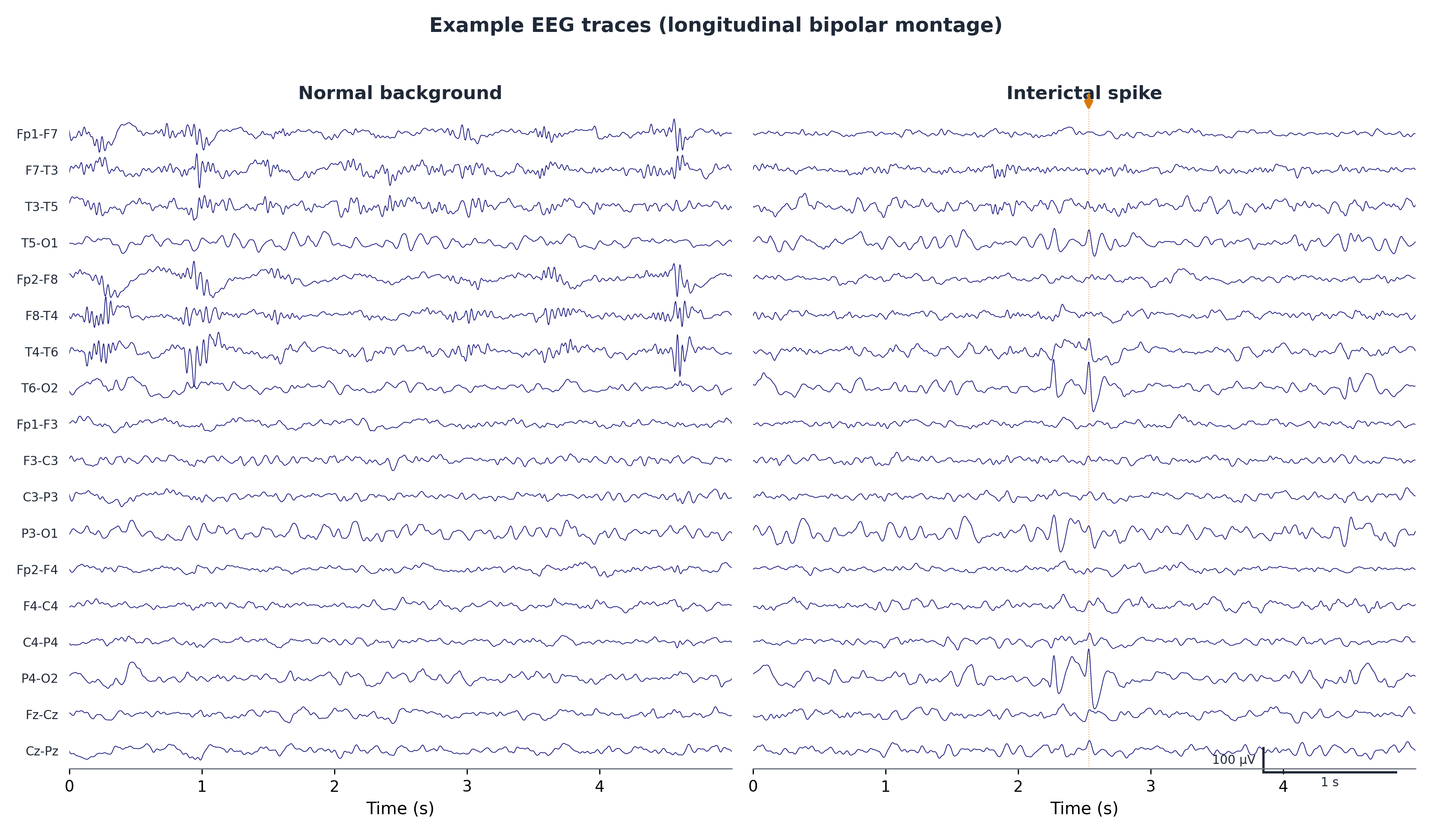
Supplementary Figure 1. Example EEG traces from a representative recording in standard bipolar montage showing normal background activity (left) and an interictal spike (right). Channels from the standard 10-20 montage are displayed; scale bars indicate 100 microvolts and 1 second.
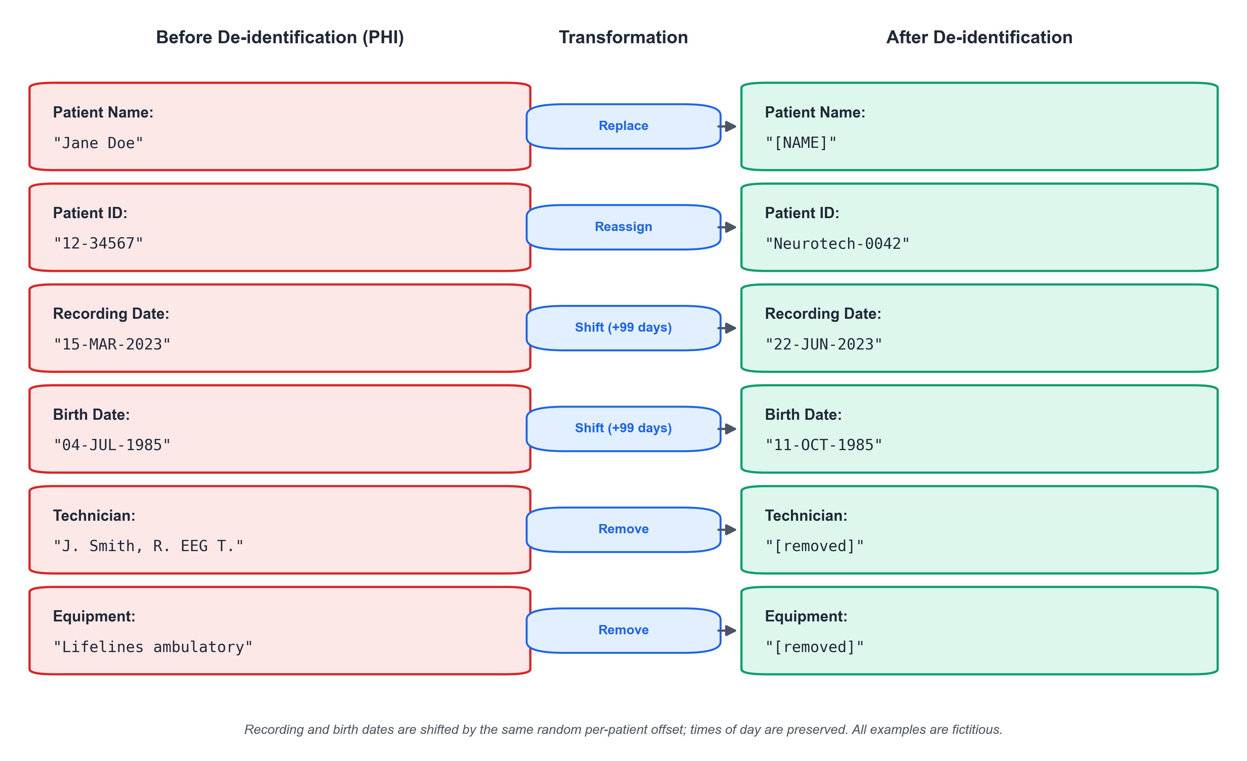
Supplementary Figure 2. De-identification of EDF header fields. Each row shows a header field before (containing protected health information) and after de-identification. Patient names are replaced with placeholders, identifiers are reassigned, dates are shifted by a consistent per-patient random offset, and technician and equipment identifiers are removed. All examples shown are fictitious.
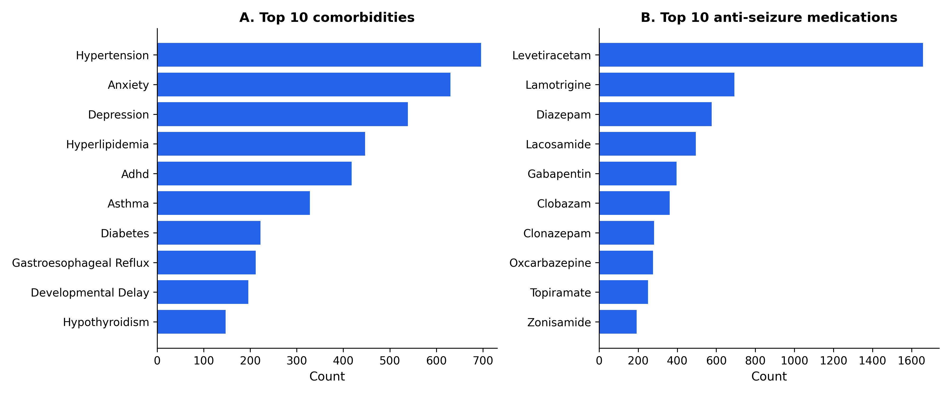
Supplementary Figure 3. Comorbidities and anti-seizure medications. (A) Ten most frequent comorbidities extracted from clinical progress notes, excluding seizure-related diagnoses. (B) Ten most frequently prescribed anti-seizure medications. Levetiracetam is the most common, consistent with its status as a first-line agent.
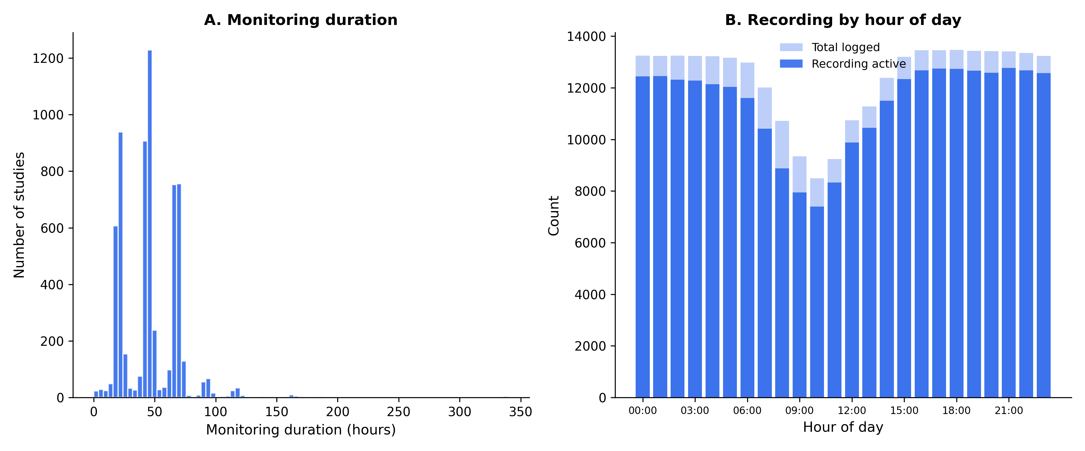
Supplementary Figure 4. Monitoring characteristics. (A) Distribution of total monitoring duration across 6413 studies with hour-by-hour monitoring data. Peaks at 24 and 48 hours reflect standard ordered monitoring durations. (B) Recording activity by hour of day across all 296,948 documented monitoring hours. Light shading shows total hours logged; dark shading shows hours with active recording.

