Supplementary Materials
Seizure Forecasting and Crash Risk Analysis
September 7, 2026

1 Overview
This appendix states the model, derives its parameters, reports the main result and three sensitivity analyses, and gives reproduction instructions. All calculations are closed-form; the accompanying Jupyter notebook crashes_vs_TiW.ipynb reproduces every figure and number below.
We quantify the trade-off between seizure-forecasting accuracy (AUC), driving exposure, and the driving restrictions needed to hold fatal crash risk at or below a safety threshold of about $6×$ baseline. That threshold corresponds to a blood alcohol concentration (BAC) of roughly $0.05$–$0.07\%$ for adult drivers, aligning with the $0.05\%$ standard used in Utah and most European countries and is more conservative than the $0.08\%$ limit in $49$ U.S. states.
Relative fatal crash risk on forecast-safe days is computed from a per-hour fatal-crash baseline $λ_{f}≈4.5×{10}^{−7} {\text{hr}}^{−1}$ and a conditional probability $q_{f}=P(\text{fatal crash}∣\text{seizure while driving})=0.02$ (central estimate; range $0.005$–$0.05$). The chance that a seizure coincides with driving scales as $D/24$ for daily driving duration $D$, but because seizure-related and baseline risk both scale with exposure, the relative-risk benchmark is nearly invariant to $D$ (Section 2.4).
Patients with infrequent seizures ($≤1$/year) approach unrestricted driving even at low AUC, while patients with frequent seizures need AUC $≥0.90$ to drive meaningfully. At AUC $0.90$ and $1$ hr/day of driving, weekly seizures permit about $53$ days/year, monthly seizures about $183$, and yearly seizures about $365$. The results depend little on driving duration, moderately on $q_{f}$, and substantially on the shape of the ROC curve at fixed AUC (Section 4).

2 Model and Methods

2.1 Forecast Scores and ROC Geometry
We model the forecasting algorithm’s output as a scalar score $S$ drawn from one of two normal distributions according to whether the day is a seizure day:
$$S∼N(0,1) \text{on a non-seizure day}, S∼N(d^{′},1) \text{on a seizure day}. \text{(2.1)}$$
The separation $d^{′}$ is the standard discriminability index of signal detection theory. The algorithm warns unsafe to drive when $S>t$ and forecasts safe to drive when $S≤t$, for an operating threshold $t$. Writing $Φ$ for the standard normal CDF and $Φ^{−1}$ for its inverse, $d^{′}$ relates to AUC by
$$d^{′}=\sqrt{2} Φ^{−1}(AUC), \text{(2.2)}$$
so AUC $0.90$ corresponds to $d^{′}≈1.81$.
Two conditional probabilities carry the entire analysis: the false-negative rate $FNR(t)=P(S≤t∣\text{seizure})$, the chance the algorithm calls a seizure day safe, and the true-negative rate $TNR(t)=P(S≤t∣\text{no seizure})$, the chance it correctly calls a non-seizure day safe. Under (2.1) these are
$$FNR(t)=Φ(t−d^{′}), TNR(t)=Φ(t). \text{(2.3)}$$
Sensitivity is $1−FNR$ and the false-positive rate is $1−TNR$. Figure S1 shows the geometry. Section 4.3 tests robustness to alternative ROC shapes, which replace (2.3) while leaving everything downstream unchanged.
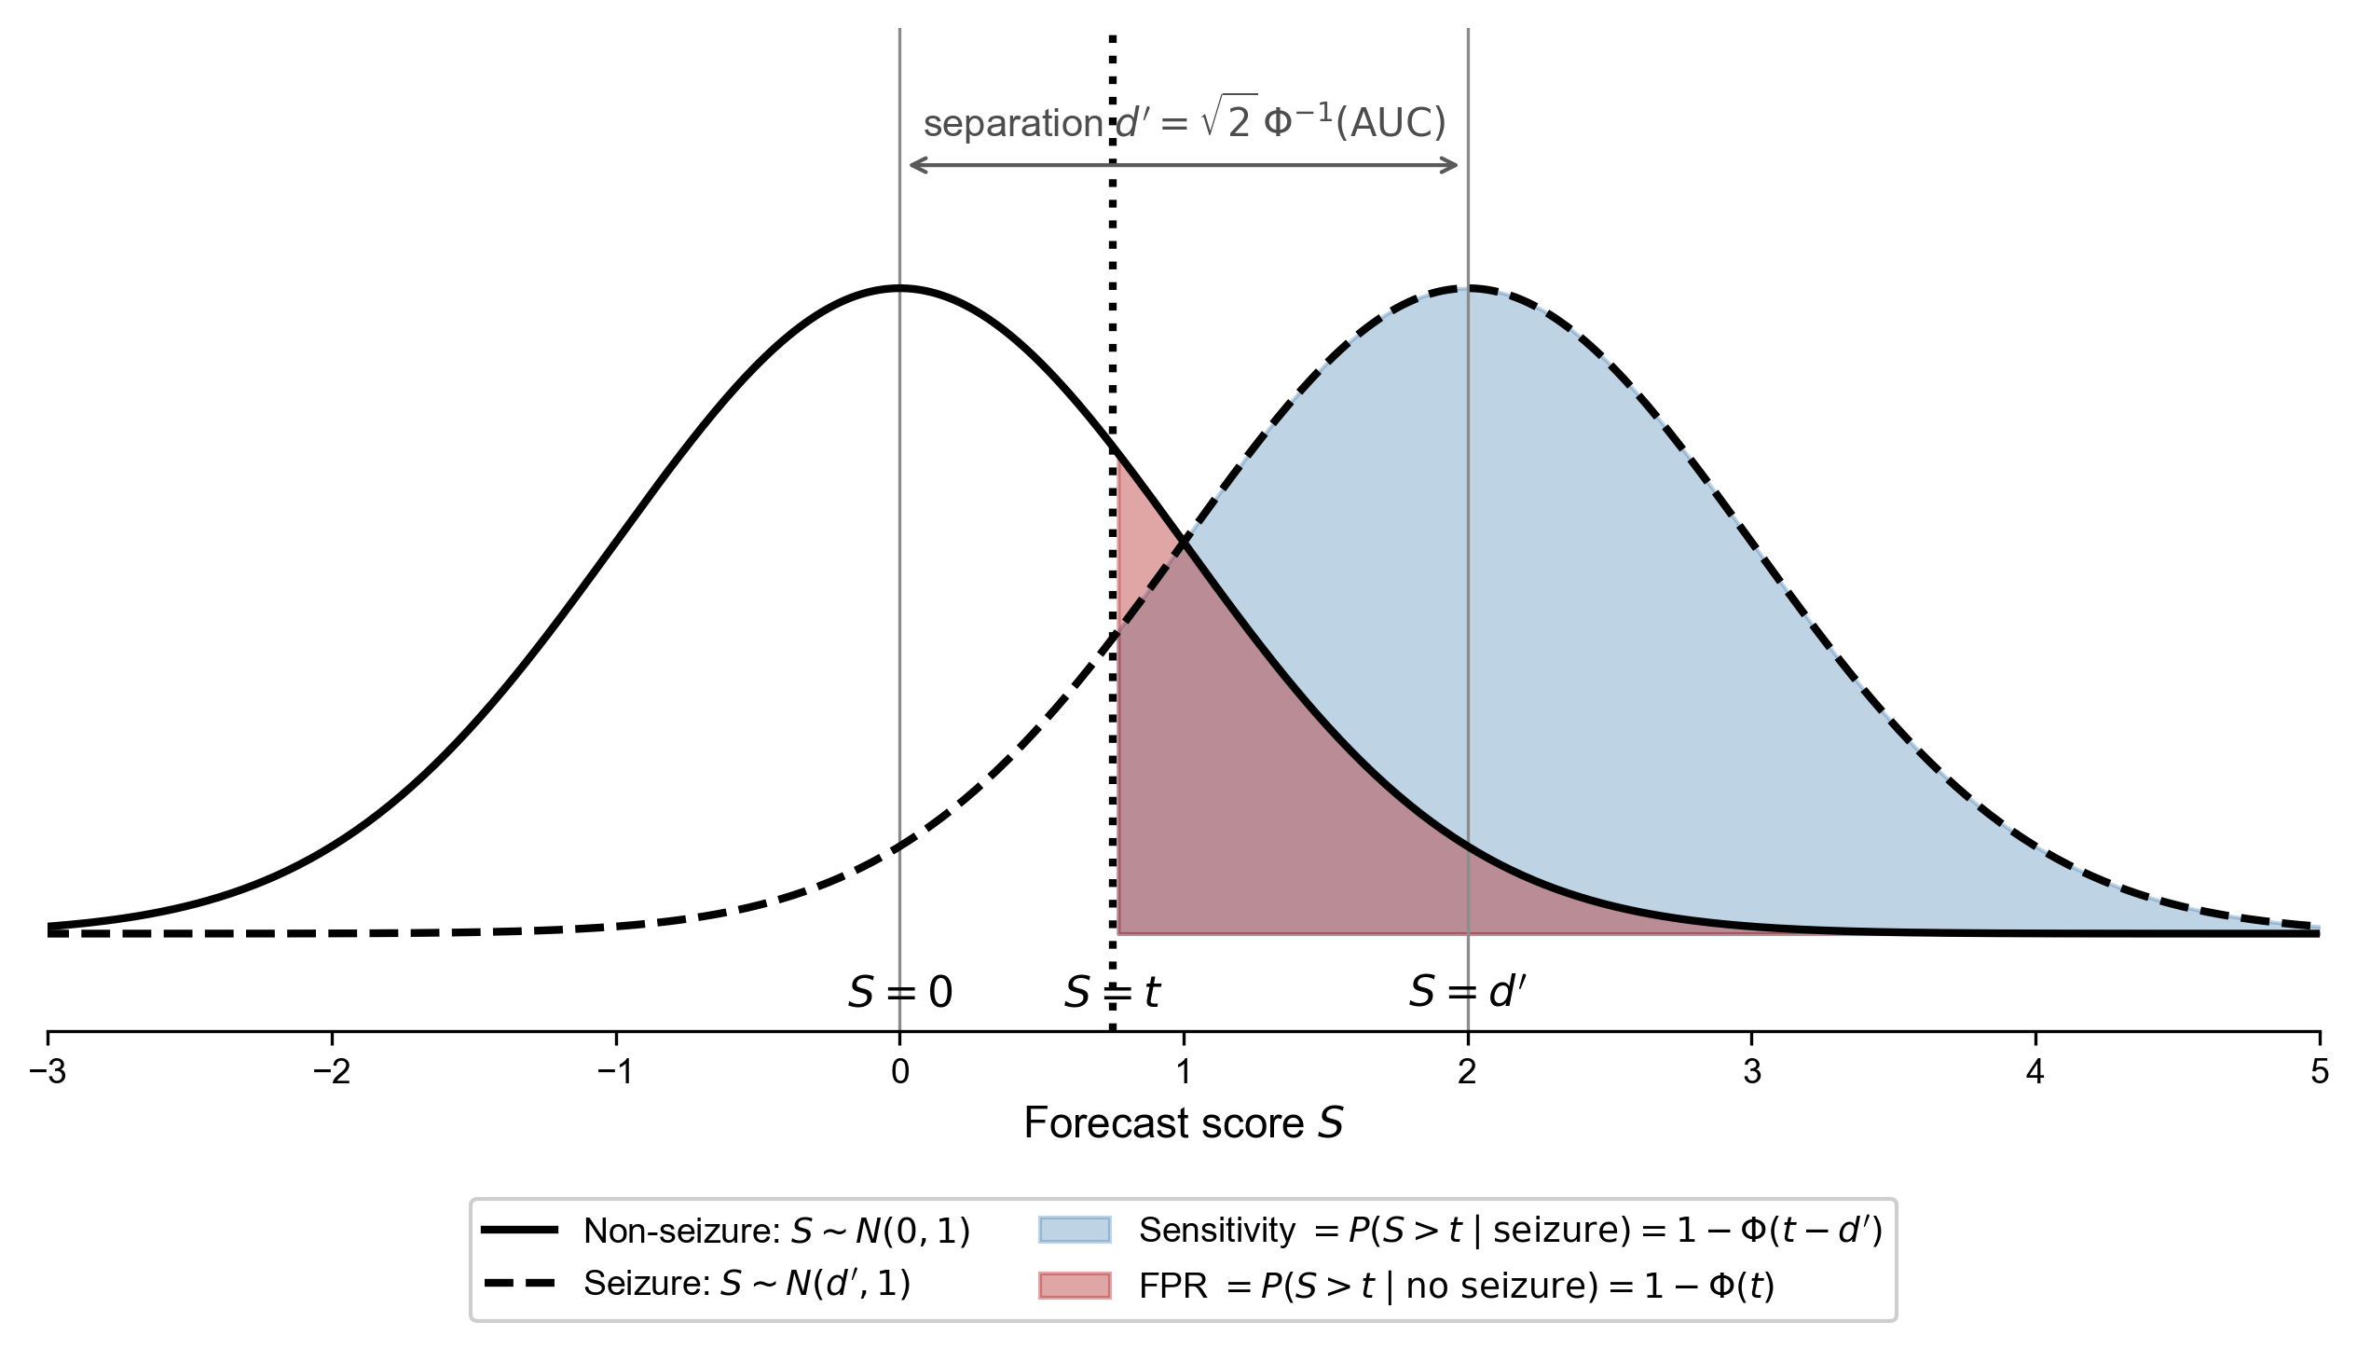
Figure S1. Binormal forecast model. Score distributions on non-seizure days ($S∼N(0,1)$, solid) and seizure days ($S∼N(d^{′},1)$, dashed). The threshold $t$ (dotted vertical) defines the decision boundary. Shaded areas right of $t$ are sensitivity (blue) and the false-positive rate (red); the complementary areas left of $t$ are $FNR$ and $TNR$. The separation $d^{′}$ relates to AUC via Equation (2.2).

2.2 Daily Seizure Probability
For a patient with average seizure rate $R$ (seizures per day), the daily seizure probability under a Poisson process is
$$p_{d}=1−e^{−R}. \text{(2.4)}$$
Frequency | $R$ | $p_{d}$
1 seizure / week | $1/7$ | $0.1331$
1 seizure / month | $1/30$ | $0.0328$
1 seizure / year | $1/365$ | $0.0027$
This mapping translates an average rate into a daily probability; the analysis is otherwise agnostic to the temporal structure of seizure risk.

2.3 Residual Seizure Probability on Forecast-Safe Days
When a patient drives on a forecast-safe day, the residual crash risk is governed by $p_{res}$, the probability that a seizure occurs despite the safe forecast. By Bayes’ theorem,
$$p_{res} = P(\text{seizure}∣\text{forecast safe}) = \frac{FNR p_{d}}{FNR p_{d}+TNR (1−p_{d})}. \text{(2.5)}$$
The denominator is itself the probability that any given day is forecast safe,
$$P(\text{forecast safe}) = FNR p_{d}+TNR (1−p_{d}), \text{(2.6)}$$
so driving days per year are $365×P(\text{forecast safe})$ and warning days per year are the complement. Substituting (2.3) gives the closed forms used in the code; every later expression depends on the score model only through (2.5) and (2.6).

2.4 Fatal Crash Risk and Relative Risk
Table 1. Crash-risk model parameters.
Symbol | Meaning | Value | Source
$λ_{f}$ | Baseline fatal-crash rate per hour of sober driving | $4.5×{10}^{−7} {\text{hr}}^{−1}$ | NHTSA Passenger Vehicles 2023 + FHWA Highway Statistics 2023 + AAA American Driving Survey 2023 (derived below)
$q_{f}$ | $P(\text{fatal crash}∣\text{seizure while driving})$ | $0.02$ central; range $0.005$–$0.05$ | Inferred severity parameter; Section 4.1
$D$ | Driving hours per day | $0.5, 1, 2$ | —
$p_{res}$ | $P(\text{seizure}∣\text{forecast safe})$ | Equation (2.5) | —
Baseline per-day risk. Given $D$ hours of driving per day, a sober driver faces a per-day baseline fatal-crash risk of
$$B(D) = D⋅λ_{f}. \text{(2.7)}$$
Derivation of $λ_{f}$. NHTSA Passenger Vehicles 2023 reports about $44,000$ passenger vehicles involved in fatal crashes; FHWA Highway Statistics 2023 Table VM-1 reports about $2.88$ trillion light-duty vehicle-miles traveled. The ratio is about $1.5$ passenger-vehicle fatal-crash involvements per ${10}^{8}$ miles. Converting per-mile to per-hour requires a driving speed: the AAA American Driving Survey 2023 reports about $29.1$ miles over about $60.7$ minutes per driver per day, i.e. about $29$ mph. Then
$$λ_{f} ≈ 1.5×{10}^{−8} {\text{mile}}^{−1}×29 \text{mph} ≈ 4.5×{10}^{−7} {\text{hr}}^{−1}. \text{(2.8)}$$
Because this baseline already includes all non-seizure causes of fatal crashes, the model conservatively charges it to every driving day regardless of seizure status.
Seizure-day risk. On a day when a seizure occurs, assuming uniform seizure timing across the $24$-hour day,
$$P(\text{fatal crash}∣\text{seizure day}) = \frac{D}{24}⋅q_{f} + \left(1−\frac{D}{24}\right)⋅B(D), \text{(2.9)}$$
where the first term covers seizures during driving and the second the baseline risk when the seizure falls outside driving hours.
Forecast-safe-day risk. On a forecast-safe day, residual fatal-crash risk is
$$P(\text{fatal crash}∣\text{forecast safe}) = p_{res}⋅P(\text{fatal crash}∣\text{seizure day}) + (1−p_{res})⋅B(D). \text{(2.10)}$$
Relative risk and exposure invariance. Substituting (2.9) into (2.10) and dividing by $B(D)$ defines the relative risk:
$$RR(D) = \frac{P(\text{fatal crash}∣\text{forecast safe})}{B(D)} = \frac{p_{res}​\left[\frac{D}{24} q_{f}+\left(1−\frac{D}{24}\right)B(D)\right]+(1−p_{res}) B(D)}{B(D)}. \text{(2.11)}$$
Distributing the numerator and dividing each term by $B(D)=Dλ_{f}$,
$$RR(D) = p_{res}⋅\frac{(D/24) q_{f}}{D λ_{f}} + p_{res}​\left(1−\frac{D}{24}\right) + (1−p_{res}). \text{(2.12)}$$
The $D$ in the first term cancels, and $p_{res}$ cancels against $−p_{res}$, leaving the exact expression
$$\boxed{ RR(D) = 1+p_{res}​\left[ \frac{q_{f}}{24 λ_{f}}−\frac{D}{24}\right] }. \text{(2.13)}$$
Under our parameters $q_{f}/(24λ_{f})≈1852$, while $D/24≤0.083$ for $D≤2$ hours, so the $D/24$ term is negligible and
$$RR(D) ≈ 1+p_{res}⋅A, A ≡ \frac{q_{f}}{24 λ_{f}}, \text{(2.14)}$$
where $A$ is the amplification factor. Absolute fatal-crash risk still scales with driving exposure through $B(D)$, but relative risk against the BAC-anchored threshold does not. Section 4.2 confirms this numerically.

2.5 Safety Threshold and Operating Point
Under the doubling-per-$0.02$-BAC model of Zador et al. and Compton & Berning, the relative fatal-crash risk at BAC $0.05\%$ is
$$T = 2^{ 0.05/0.02} ≈ 5.66. \text{(2.15)}$$
We refer to this as the “$6×$ threshold” for readability; the code uses $T=2^{0.05/0.02}$ exactly. Combining (2.13) with $RR≤T$ gives a ceiling on the residual seizure probability,
$$p_{res} ≤ p_{res}^{max} = \frac{T−1}{A−D/24}, \text{(2.16)}$$
which equals $0.00251$ at $q_{f}=0.02$ and $D=1$ hr. Because $p_{res}$ is increasing in $t$ under the equal-variance model, the least restrictive admissible operating point is the largest $t$ satisfying (2.16). We solve for it by root-finding rather than by scanning a grid of thresholds.

3 Main Result
Table 2 reports the driving restrictions required to meet the safety threshold, at $1$ hr/day driving, $q_{f}=0.02$, and $λ_{f}=4.5×{10}^{−7} {\text{hr}}^{−1}$.
Table 2. Driving restrictions required to meet the safety threshold, by seizure frequency and forecasting performance ($1$ hr/day driving). Driving days below $1$ are shown in scientific notation: the safety threshold is met, but only by driving essentially never. Some restriction is required at every seizure frequency considered: even at one seizure per year, driving every day gives a relative risk of 6.07, above T = 5.66.
Seizure freq. | AUC | Warning days/yr | Driving days/yr | Avg. days between drives
1/week | 0.60 | 365.0 | $6×{10}^{−27}$ | effectively never
 | 0.70 | 365.0 | $9×{10}^{−5}$ | effectively never
 | 0.80 | 363.5 | $1.5$ | $236$
 | 0.90 | 311.8 | $53.2$ | $6.9$
 | 0.95 | 219.7 | $145.3$ | $2.5$
 | 0.99 | 91.0 | $274.0$ | $1.3$
1/month | 0.60 | 365.0 | $7×{10}^{−10}$ | effectively never
 | 0.70 | 364.3 | $0.7$ | $495$
 | 0.80 | 323.2 | $41.8$ | $8.7$
 | 0.90 | 181.8 | $183.2$ | $2.0$
 | 0.95 | 91.3 | $273.7$ | $1.3$
 | 0.99 | 23.0 | $342.0$ | $1.1$
1/year | 0.60 | 33.4 | $331.6$ | $1.10$
 | 0.70 | 8.1 | $356.9$ | $1.02$
 | 0.80 | 2.0 | $363.0$ | $1.01$
 | 0.90 | 0.33 | $364.7$ | $1.001$
 | 0.95 | 0.12 | $364.9$ | $1.000$
 | 0.99 | 0.08 | $364.9$ | $1.000$
Figure S2 shows the mechanism: how crash risk on forecast-safe days falls as the algorithm spends more days in warning, and where each AUC curve crosses the safety threshold.
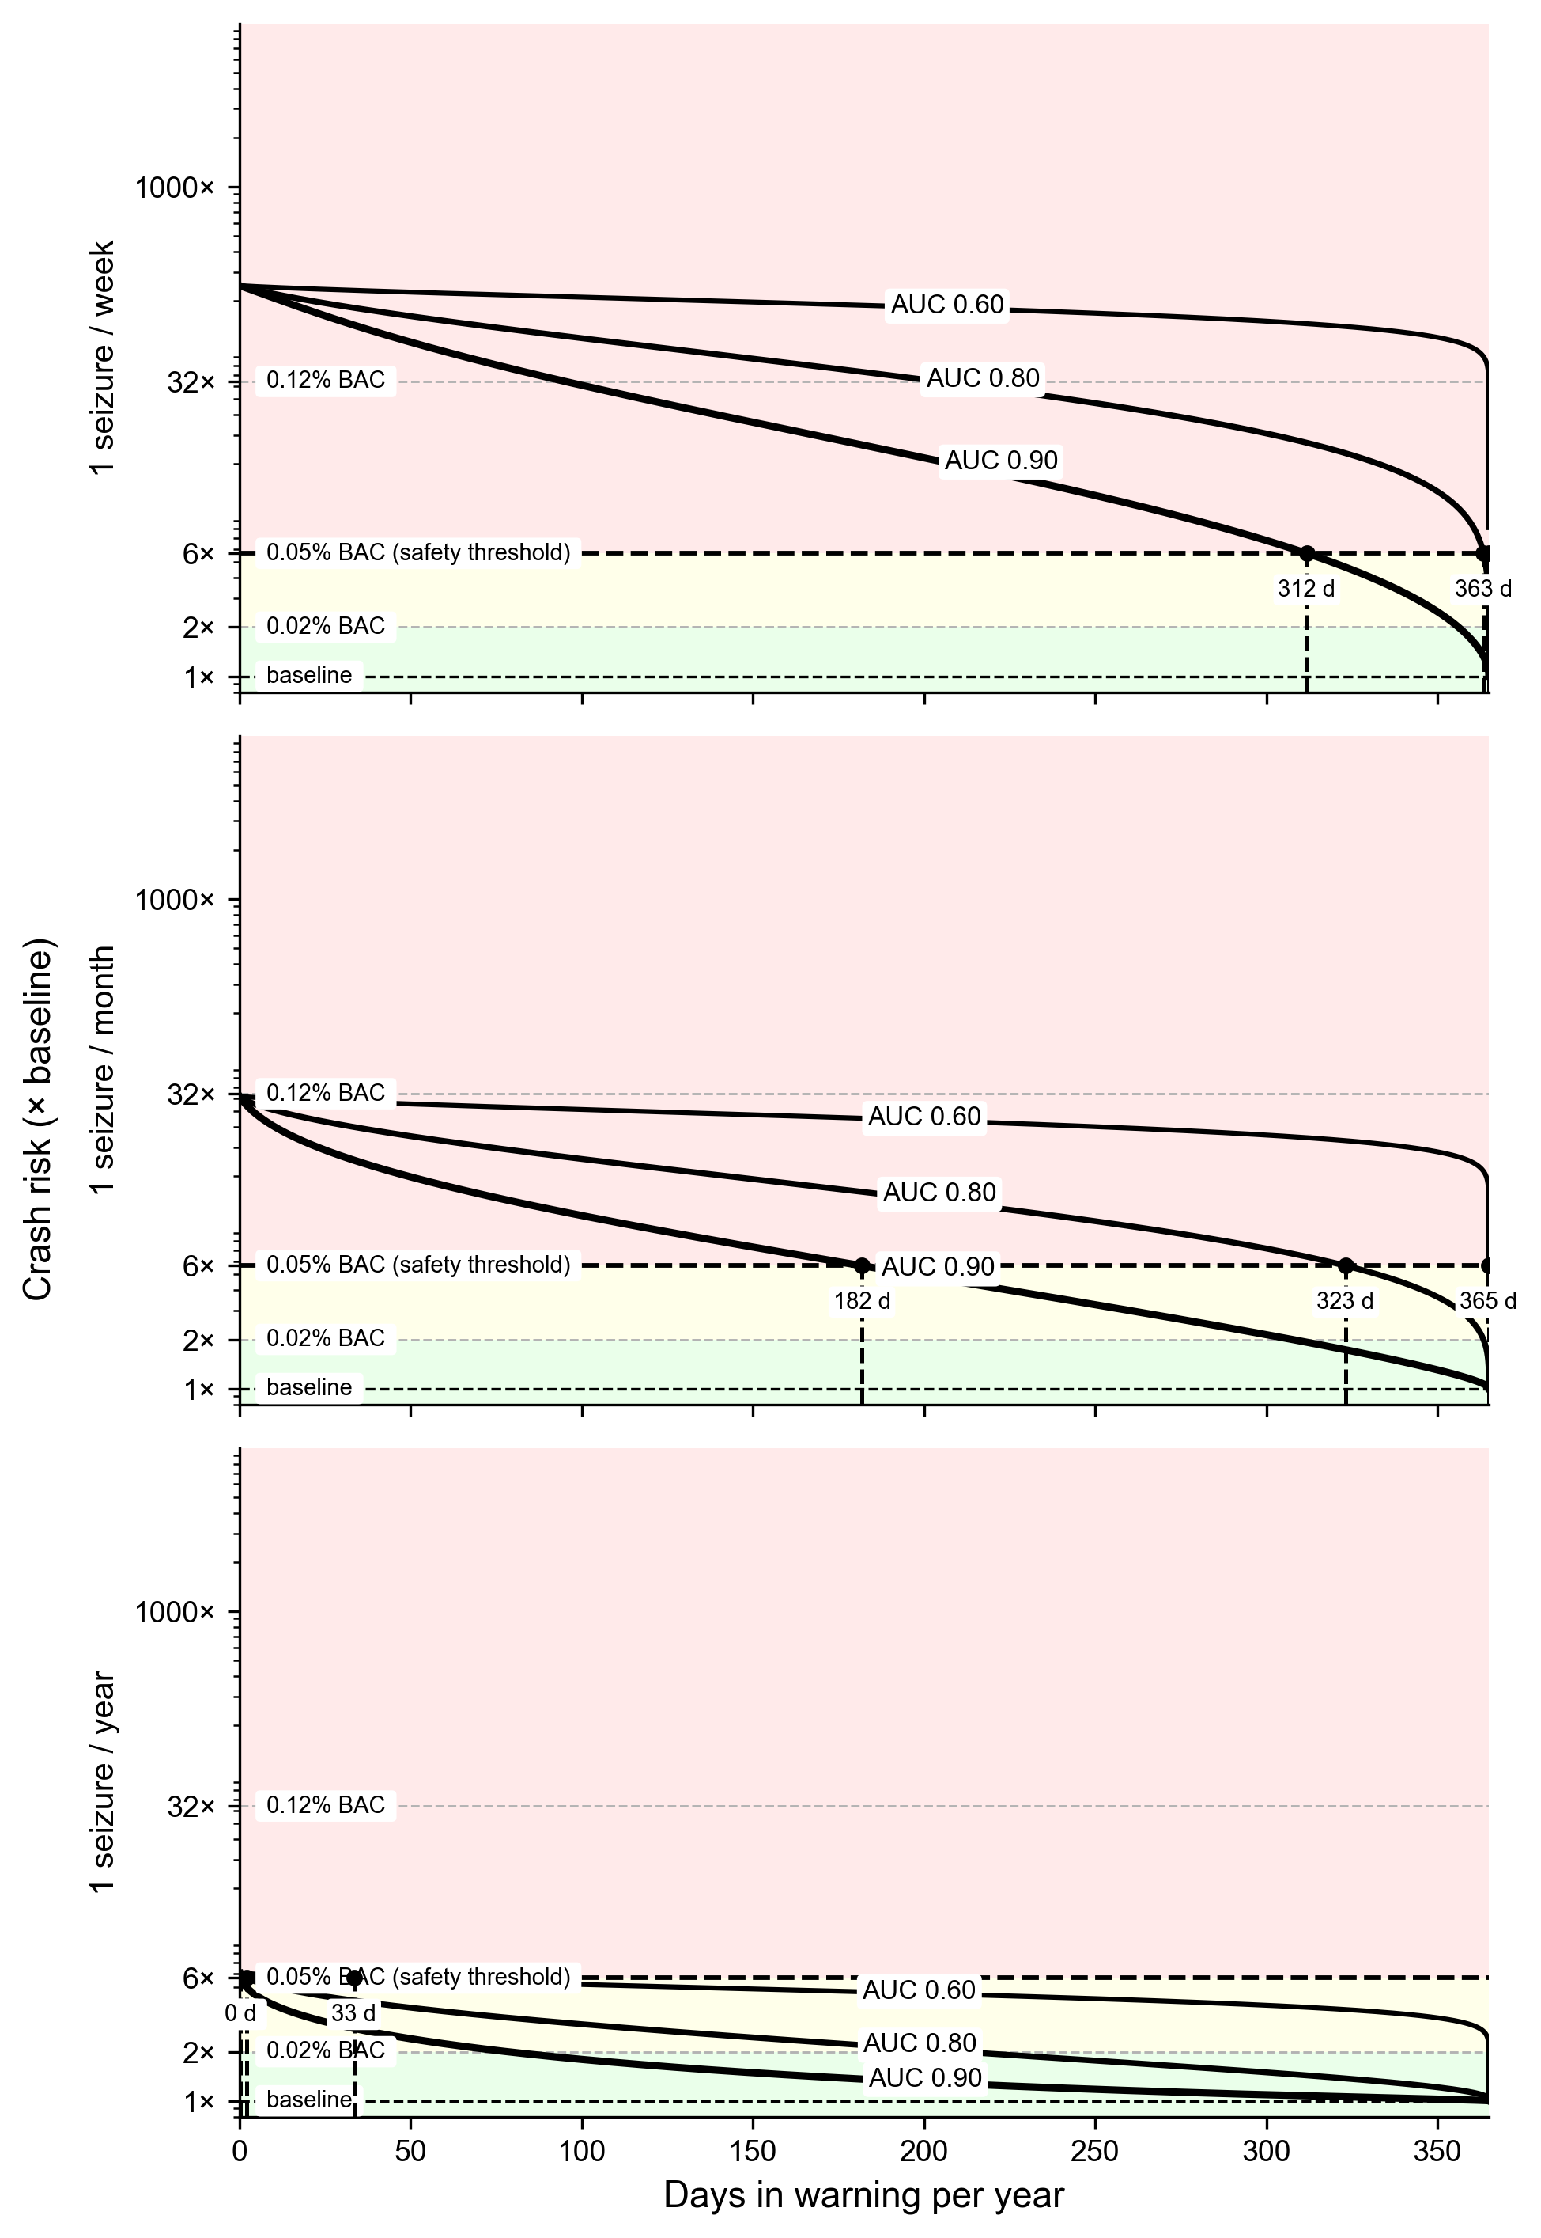
Figure S2. Crash risk versus days in warning. Rows are seizure frequencies ($1$/week, $1$/month, $1$/year), at $1$ hr/day driving. Black curves are AUC $0.60$, $0.80$, $0.90$ (thicker lines indicate higher AUC). Shaded bands and dashed lines mark BAC-equivalent risk levels ($0.02\%$, the $0.05\%$ safety threshold, $0.12\%$). Black circles mark the minimum days in warning needed to reach the threshold.

Key insights.
- High AUC is the binding constraint. Algorithms need AUC $≥0.90$ to provide meaningful driving days for patients with weekly or monthly seizures.
- Patients with rare seizures ($≤1$/year) are at or near unrestricted driving even at low AUC ($≈332$ days/year at AUC $0.60$), though not literally always-safe.
- Monthly seizure patients benefit greatly: AUC $0.90$ permits $≈183$ days/year; AUC $0.95$ permits $≈274$.
- Weekly seizure patients face significant restrictions: even AUC $0.90$ permits only $≈53$ days/year; AUC $0.80$ is essentially insufficient ($≤2$ days/year).

4 Sensitivity Analyses

4.1 Conditional Fatal-Crash Probability $q_{f}$
The parameter $q_{f}=P(\text{fatal crash}∣\text{seizure while driving})$ is the model’s most uncertain component. No study reports it directly, so we treat it as an inferred severity parameter and examine the defensible range $[0.005, 0.05]$:
- Lower bound, $q_{f}=0.005$: a moderate crash rate given a seizure while driving ($∼0.30$) combined with moderate case-fatality ($∼0.02$), closer to baseline fatal-crash severity.
- Central, $q_{f}=0.02$: the Gastaut & Zifkin 1987 observed crash rate ($∼0.55$) combined with case-fatality of seizure-related crashes ($∼3$–$5\%$, inferred from Sheth et al. 2004 and Drazkowski et al. 2003).
- Upper bound, $q_{f}=0.05$: counting near-misses as effective crashes (Gastaut reports a further $∼38\%$ near-miss rate) with upper-bound severity.
Table 3. Sensitivity of driving days/year to $q_{f}$ at AUC $=0.90$, $1$ hr/day.
Seizure frequency | $q_{f}=0.005$ | $q_{f}=0.02$ (central) | $q_{f}=0.05$
$1$/week | $154.8$ | $53.2$ | $19.8$
$1$/month | $314.3$ | $183.2$ | $99.1$
$1$/year | $365.0$* | $364.7$ | $334.5$
*The only cell in this analysis where the threshold is met with no restriction at all: at $q_{f}=0.005$ the unrestricted relative risk for a yearly-seizure patient is $2.3×$ baseline, below $T$.
The amplification factor $A=q_{f}/(24λ_{f})$ runs from $463$ (lower) through $1852$ (central) to $4630$ (upper), so the ceiling $p_{res}^{max}$ falls from $1.01\%$ to $0.10\%$. Across this range the qualitative finding holds: weekly-seizure patients remain heavily restricted at AUC $0.90$ (20 to 155 driving days/year across this range), and yearly-seizure patients stay near unrestricted driving. The allowance for monthly seizures spans about a factor of three; a policy that errs toward caution should use $q_{f}=0.05$ until empirical data anchor the parameter better.
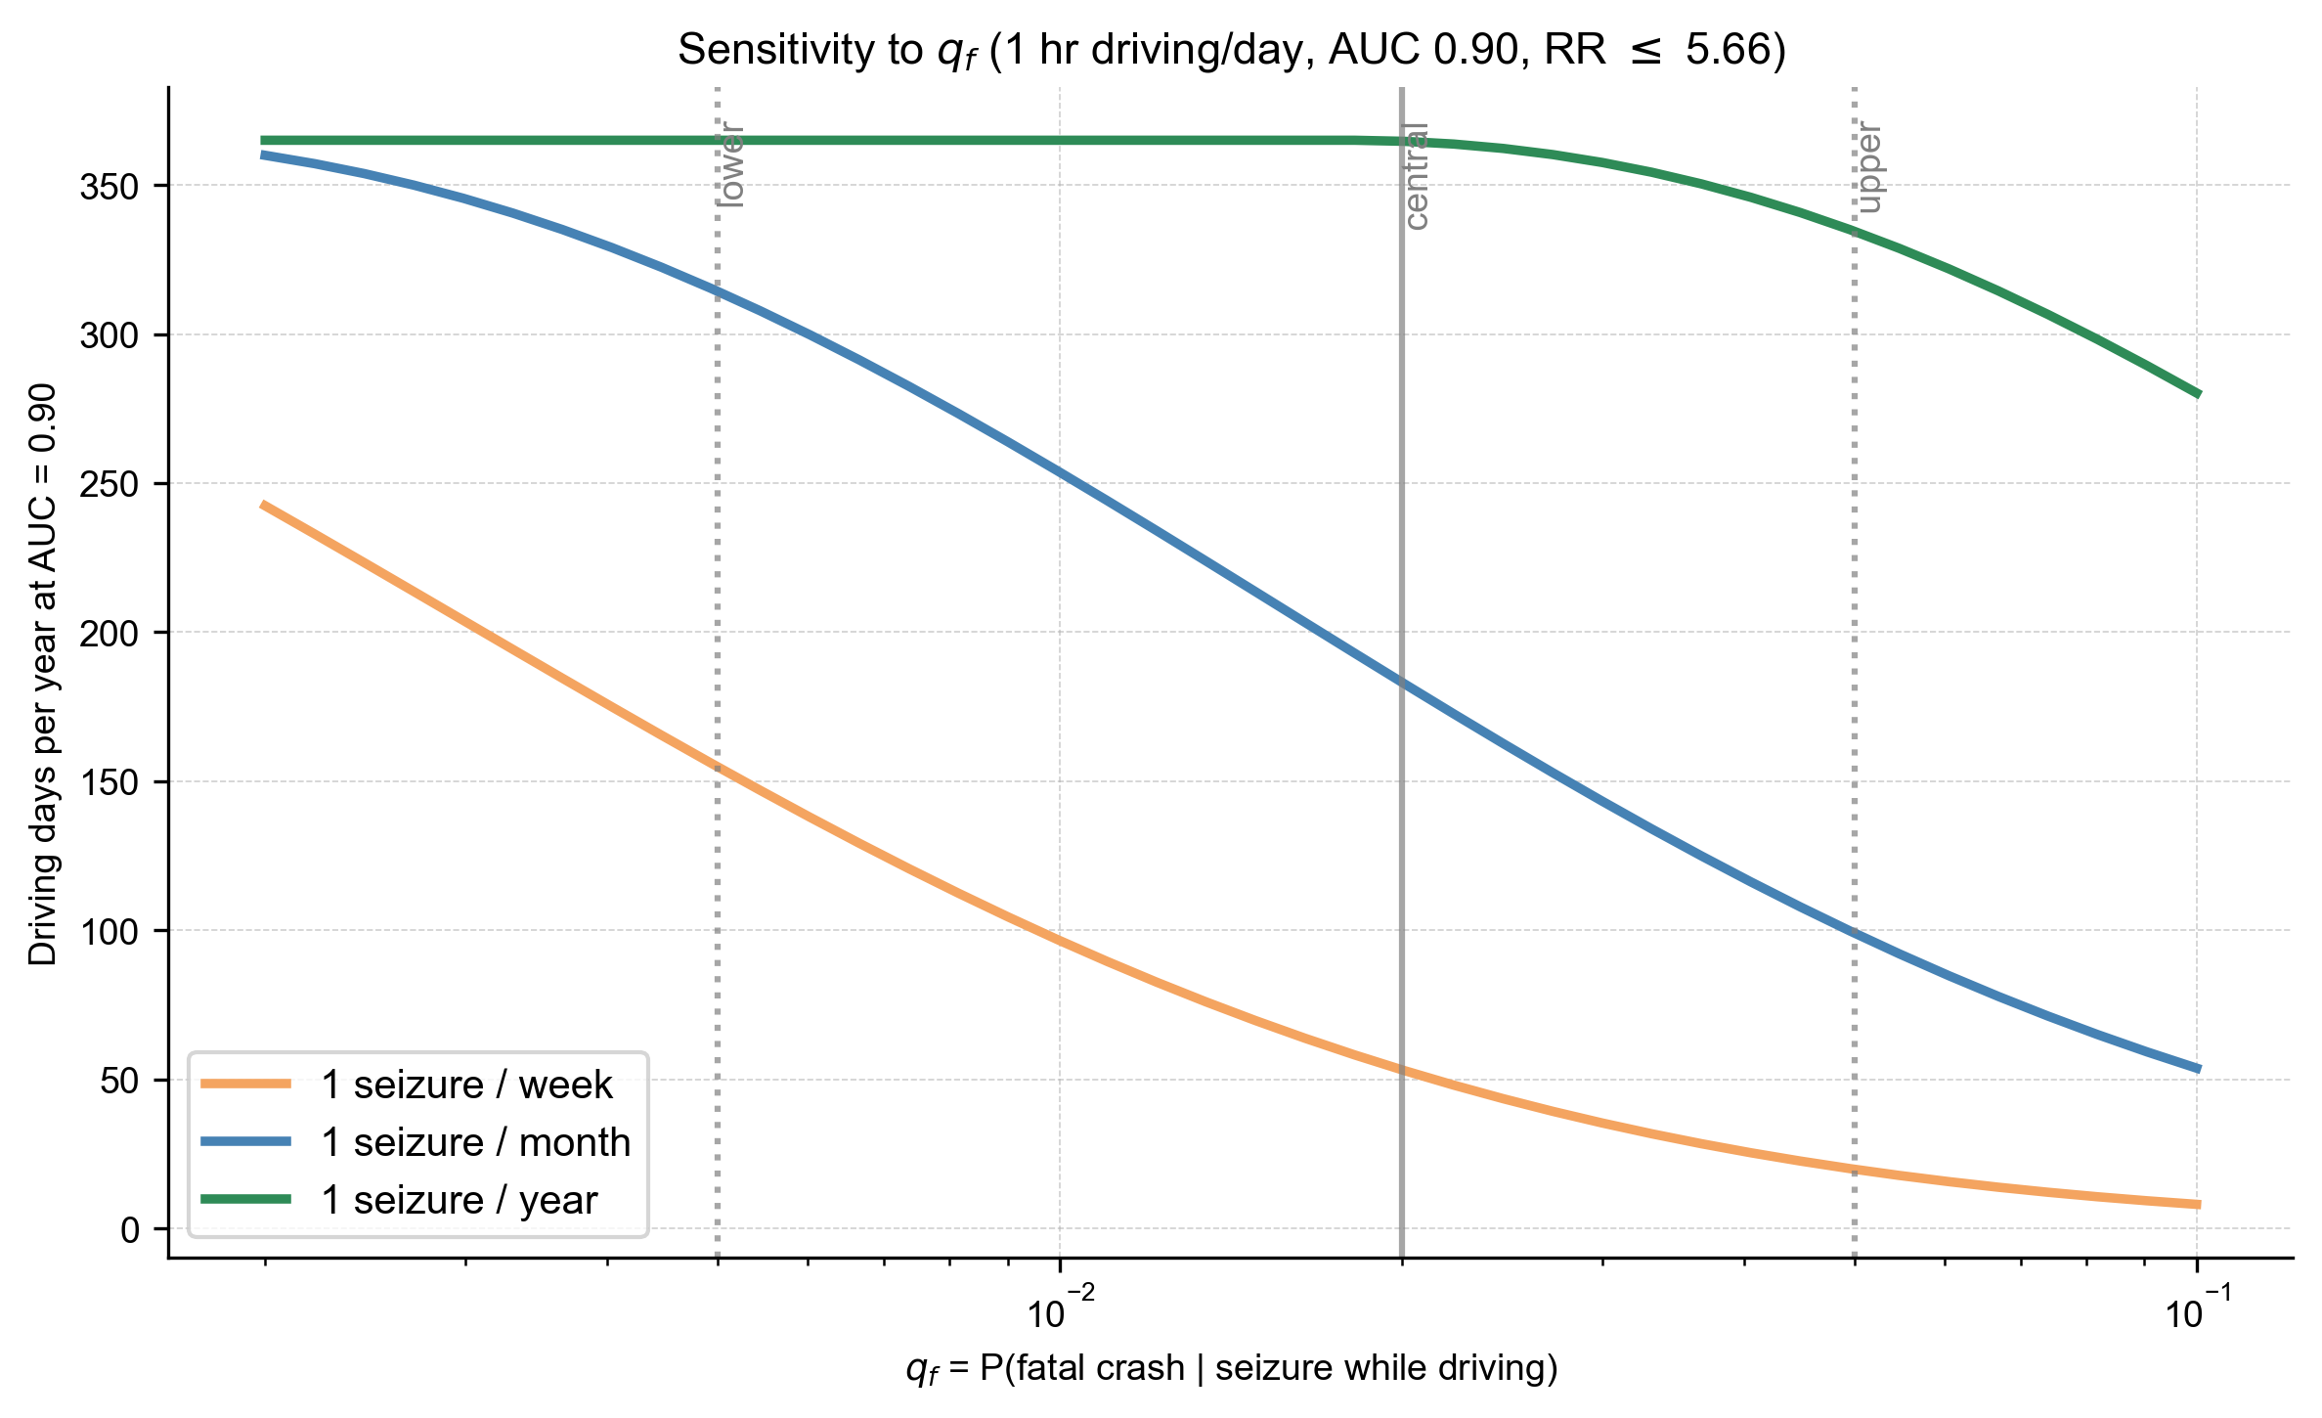
Figure S3. Sensitivity of driving days to $q_{f}$. Driving days per year at AUC $=0.90$ and $1$ hr/day, as a function of $q_{f}$. Vertical guides mark the lower bound ($0.005$), the central estimate ($0.02$), and the upper bound ($0.05$).

4.2 Driving Duration
Section 2.4 shows analytically that relative risk is nearly invariant to driving duration $D$, because seizure-related and baseline fatal risk both scale with exposure. Table 4 confirms this numerically. At the reported precision of whole days, the results are identical across $0.5$, $1$, and $2$ hours of driving per day; the largest difference anywhere in the table is $0.003$ days per year, about five minutes.
Table 4. Driving days/year across exposure levels at AUC $=0.90$, shown to three decimals to make the residual $D$-dependence visible.
 | Driving exposure
Seizure frequency | $30$ min/day | $1$ hr/day | $2$ hr/day
$1$/week | $53.174$ | $53.175$ | $53.176$
$1$/month | $183.163$ | $183.164$ | $183.167$
$1$/year | $364.674$ | $364.674$ | $364.674$
Absolute fatal-crash risk does scale with driving duration, and an absolute-risk benchmark would depend directly on exposure. Under the relative-risk benchmark used here, driving duration is not a material determinant of allowable driving days.

4.3 ROC Curve Shape
Real ROC curves deviate from the equal-variance form because of unequal variances (S-shaped) or mixture distributions (hooked, when some seizures are easier to predict than others). We compare three score-generating models, all calibrated to AUC $=0.90$ exactly so that the comparison isolates shape. Table 5 lists their parameters and Figure S4 shows the resulting curves.
Table 5. Parameters of the three ROC models. Non-seizure scores are $N(0,1)$ in all three. Each parameter set is calibrated to AUC $=0.90$ exactly.
Model | Seizure-day score distribution | $FNR(t)=P(S≤t∣\text{seizure})$
Equal-variance binormal | $N(d^{′},1)$, $d^{′}=1.812$ | $Φ(t−d^{′})$
Unequal-variance (S-shaped) | $N(μ_{1},σ_{1}^{2})$, $μ_{1}=2.205$, $σ_{1}=1.4$ | $Φ​\left((t−μ_{1})/σ_{1}\right)$
Mixture (hooked) | $w N(μ_{\text{easy}},1)+(1−w) N(μ_{\text{hard}},1)$, $w=0.7$, $μ_{\text{easy}}=2.716$, $μ_{\text{hard}}=0.869$ | $w Φ(t−μ_{\text{easy}})+(1−w) Φ(t−μ_{\text{hard}})$
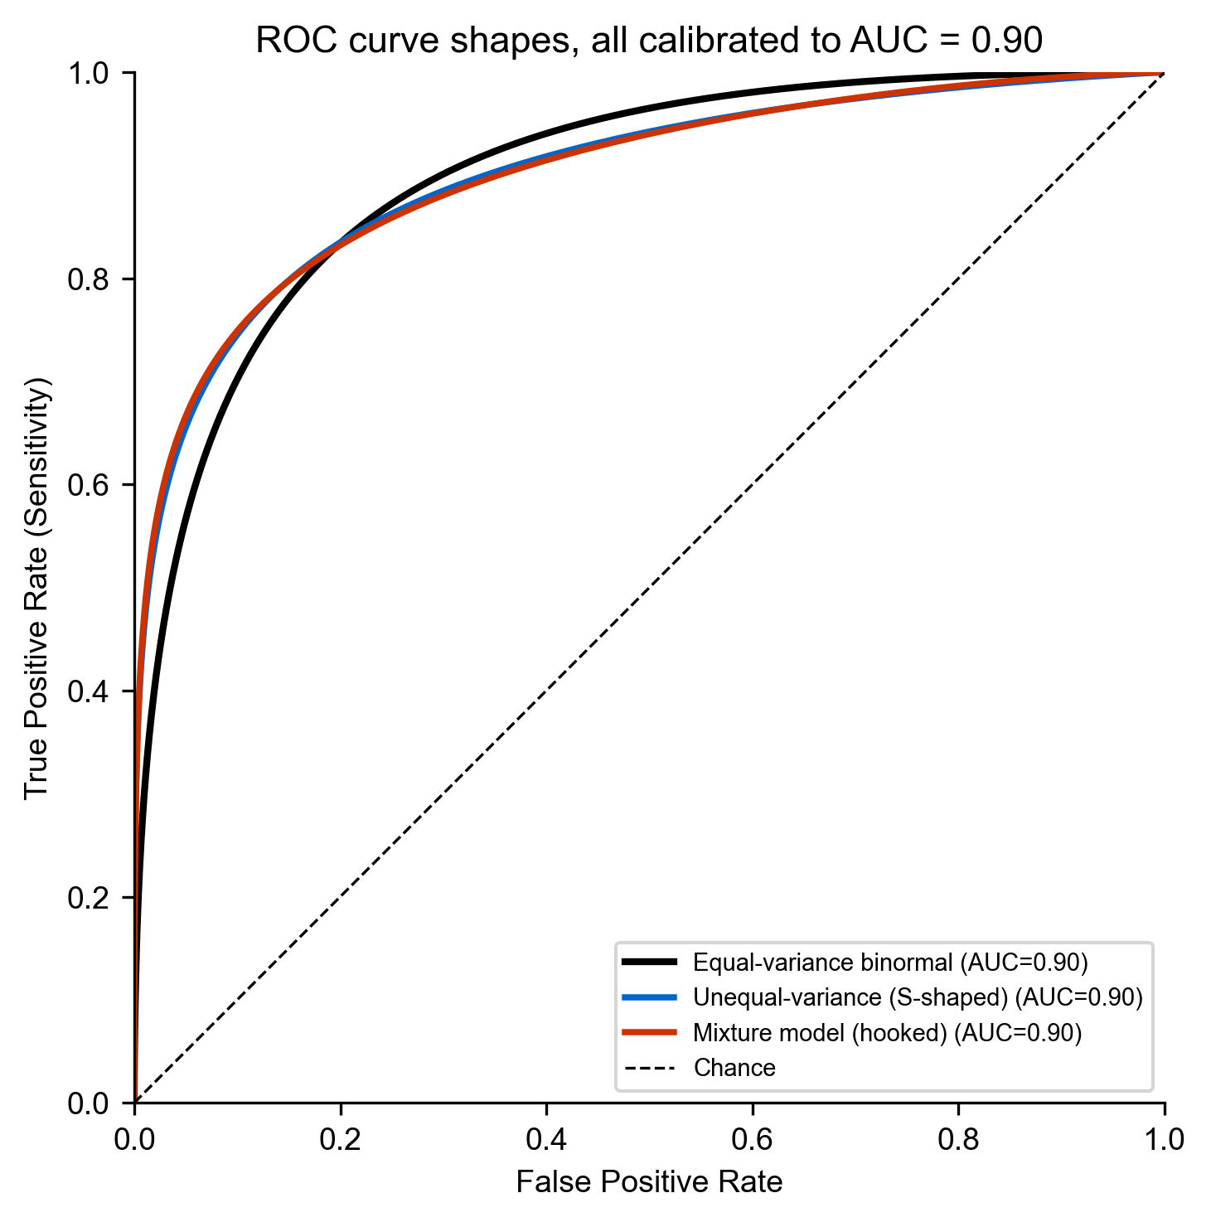
Figure S4. Three ROC curve shapes, all at AUC $=0.90$. Equal-variance binormal (black), unequal-variance/S-shaped (blue), and hooked mixture (red).
Only the $FNR$ column of Table 5 changes between models; $TNR(t)=Φ(t)$ throughout, and Equations (2.5) and (2.6) carry through unchanged. Table 6 reports the resulting driving days, and Figure S5 the corresponding risk curves.
Table 6. Driving days/year at AUC $=0.90$, $1$ hr/day, by ROC shape.
Seizure frequency | Equal-variance binormal | S-shaped (unequal var.) | Hooked (mixture)
$1$/week | $53.2$ | not achievable | $1.4$
$1$/month | $183.2$ | $72.4$ | $88.1$
$1$/year | $364.7$ | $364.9$ | $364.9$

Why the S-shaped model can fail outright. Unlike the near-zero entries in Table 2, which meet the threshold by driving almost never, the “not achievable” entry has no admissible operating point at all. This is a property of the unequal-variance model: because $σ_{1}>1$, seizure-day scores have the heavier lower tail, so lowering the threshold past $t≈−1.94$ raises rather than lowers the residual seizure probability on forecast-safe days. The resulting floor, $0.0089$ for weekly seizures, exceeds the ceiling $p_{res}^{max}=0.0025$, so no threshold meets the constraint. The same tail behavior is why the S-shaped curve in Figure S5 turns upward at the far right, where nearly every day is in warning.
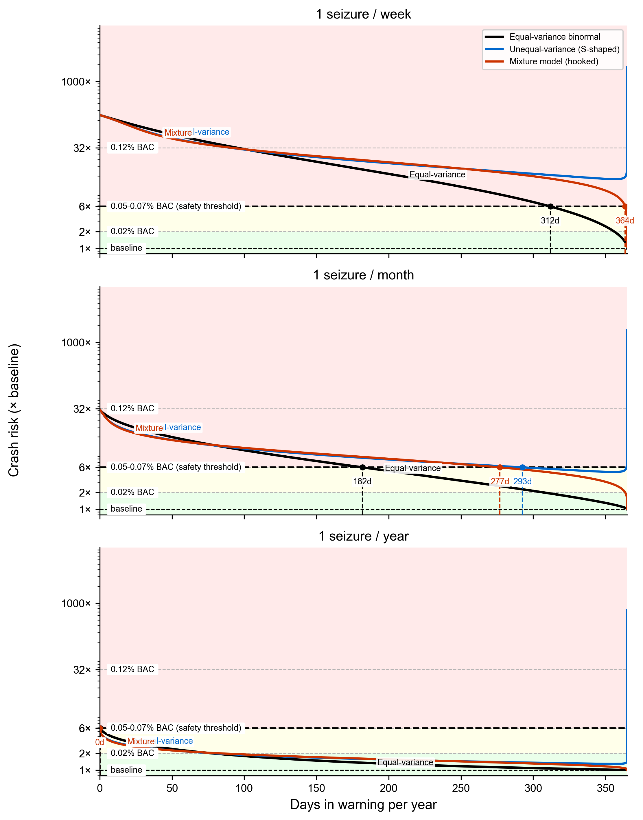
Figure S5. Crash risk versus days in warning for three ROC shapes, by seizure frequency, at $1$ hr/day and AUC $=0.90$. Equal-variance binormal (black), S-shaped (blue), and hooked mixture (red). Black dashed line: safety threshold.
At high seizure frequencies, shape matters as much as AUC. The equal-variance binormal is the most optimistic of the three; at one seizure per month the allowance falls from $183$ days/year to $88$ (hooked) or $72$ (S-shaped), and at one per week the S-shaped model admits no safe operating point at all. At one seizure per year all three shapes permit essentially full-year driving, because the prior seizure probability is already low enough that the posterior clears the threshold under any of them. Since equal-variance binormal is the most optimistic case, real-world ROCs at the same AUC will generally permit fewer driving days than Table 2 suggests. Reporting AUC alone therefore overstates clinical utility for patients with frequent seizures, while the qualitative conclusion, that high AUC is necessary and that even AUC $0.90$ is borderline for weekly seizures, holds under all three shapes.

5 Assumptions and Limitations
Why the binormal model is a reasonable base case. It is standard in diagnostic testing and signal detection theory, it is tractable in closed form, and for a given AUC it offers near-best-case sensitivity–specificity trade-offs, which gives the forecasting algorithm the benefit of the doubt. The question here is what level of performance is needed for safe driving decisions, not how one specific empirical ROC curve performs. Section 4.3 quantifies what happens when the assumption fails: departures reduce the allowable driving days rather than increasing them, so the assumption is optimistic and the reported allowances are upper bounds.
Driving-exposure assumptions.
- Seizure timing is uniform over the $24$-hour day. Many patients have circadian patterns such as nocturnal epilepsy or morning clustering. The model is conservative for seizures concentrated outside driving hours and optimistic for daytime clustering.
- Driving duration is constant across days. Real driving varies; the $30$ min/day to $2$ hr/day range brackets typical commuter and heavy-driver patterns, and per Section 4.2 the choice barely affects the relative-risk result.
- $q_{f}=0.02$ is an inferred severity parameter (range $0.005$–$0.05$), decomposing as $P(\text{crash}∣\text{seizure while driving})≈0.55$ (Gastaut & Zifkin 1987) times case-fatality $≈3$–$5\%$ (inferred from Sheth et al. 2004 and Drazkowski et al. 2003). It depends on seizure type, aura, and road and vehicle conditions; Section 4.1 reports the sensitivity analysis.
- A single fixed operating threshold is used year-round. Adaptive thresholds, or policies that condition on recent seizure history, are outside the scope of this model.

6 Recommendations

6.1 For algorithm developers

- Aim for AUC $≥0.90$ as a minimum for driving applications.
- Report the empirical ROC shape, not only its area. At minimum, report sensitivity and specificity at the operating points a driving policy would actually use, which are in the high-specificity region far from the curve’s midpoint.

- For patients with frequent seizures, even AUC $0.90$ may be insufficient for practical driving policies.

6.2 Clinical and policy implications
- Counsel patients using seizure frequency and driving pattern together, since the same algorithm yields very different allowances across frequencies (Table 2).
- For patients with rare seizures, forecasting adds little to driving safety, and its value should be judged on other quality-of-life grounds.

- Any policy built on these numbers inherits the uncertainty in $q_{f}$, which spans a factor of three in allowance for monthly-seizure patients (Table 3).

7 Reproducibility
All calculations use closed-form expressions implemented with NumPy, SciPy (scipy.stats.norm for the Gaussian CDF and its inverse), and Matplotlib. Operating points are located with a bracketed root-find on (2.16) rather than by scanning a threshold grid. The distinction is not cosmetic: a grid both quantizes the reported allowance by about one day and truncates the extreme operating points, which is what produces spurious “cannot reach threshold” results at low AUC.
pip install numpy matplotlib scipy
jupyter notebook crashes_vs_TiW.ipynb # interactive
# or run all cells programmatically:
jupyter nbconvert --to notebook --execute crashes_vs_TiW.ipynb
Table 7. Notebook cell layout and outputs.
Cell | Produces
0 | Shared exact solver for the operating point
1 | Figure S2 — crash risk vs. days in warning ($3$ frequencies, $1$ hr/day)
2 | Figure 1 — driving days vs. AUC (main result)
3 | Figure S1 — binormal model schematic
4 | Figures S4 & S5 — ROC shape geometries and sensitivity
5–6 | Extended AUC table (tab-delimited, all frequencies and durations)
7 | Figure S3 — $q_{f}$ sensitivity
Figure files are produced as PDF and PNG: Figure_1, Figure_S1–Figure_S5.

