Seizure forecasting and driving safety: a quantitative framework for defining minimum performance requirements

Running title: Seizure forecasting and driving safety:
Daniel M. Goldenholz*, MD, PhD^{1,2}; Rosalind Picard, SM, ScD³; M. Brandon Westover, MD, PhD^{1,2}
1. Beth Israel Deaconess Medical Center, Boston MA. 2. Harvard Medical School, Boston MA 3. Massachusetts Institute of Technology, Cambridge, MA
* Corresponding author. daniel.goldenholz@bidmc.harvard.edu
330 Brookline Ave, Baker 5, Boston MA 02215. Phone: 617 6328930
Word count: Abstract (max 200): 176 Body (max 1800): 1573
Refs (max 18): 20 Figures/Tables: (max 2): 0 Tables, 1 Figure

Keywords: epilepsy, driving, epidemiology, statistics, seizure forecasting

ABSTRACT
Seizure forecasting algorithms with performance better than chance have raised interest in clinical applications, but it’s unclear whether it’s safe to rely on them to decide whether to drive. We developed a quantitative framework to clarify how accurate a seizure forecast needs to be to support safe driving. By analyzing the forecasting algorithms’ area under the receiver operating characteristic curve (AUC) and using Bayes’ theorem, we estimate the risk of a fatal crash risk on days when a seizure forecasting algorithm says it is safe to drive. To be safe, we suggest that the risk of a fatal crash must be no more than six times the population baseline risk, which is the risk of driving with a blood alcohol concentration in the 0.05–0.07% range. Forecasts with AUC 0.60 never met this threshold for people with weekly or monthly seizures. Even at AUC 0.90, weekly seizures only only 53 driving days per year, whereas monthly seizures allow about 182; for yearly seizures, modeled risk is near the benchmark even with modestly accurate forecasts. Forecast AUC metrics along are therefore insufficient to determine safety.

Introduction
Recent work using wearable data, self-reported seizures, and intracranial EEG suggests that seizure risk exhibits temporal structure in many patients^{1,2}. This has motivated efforts to forecast seizures^{3–6} with several algorithms performing "better than chance," typically with an area under the receiver operating characteristic curve (AUC) of about 0.6, (AUC 0.5 indicates random chance and 1.0 indicates perfect forecasts). These results have led some authors to suggest that seizure forecasts are ready for clinical use.

However, most seizure-forecasting studies stop short of defining the forecasting accuracy required for safety-critical actions. Yet, driving restrictions⁷ are among the most burdensome consequences of epilepsy, and patients may interpret a “low risk” forecast as permission to drive. Without guidance, such tools may encourage undue risk-taking.

These concerns motivated our analysis. If seizure forecasts are to inform driving decisions, our community must define the operating characteristics—sensitivity and specificity—required to achieve acceptable crash risk. Crucially, "acceptable" performance depends on seizure frequency: an operating point adequate for someone with yearly seizures may be dangerous for someone with weekly seizures. We therefore asked: Under what conditions might seizure forecasting allow safe driving, and how many driving days would safe forecasts permit?

Methods
The Safety Standard
We choose to rely on risk standards developed for driving based on blood-alcohol content (BAC). Large epidemiologic studies show that fatal single-vehicle crash risk increases with BAC, with age-specific risks. For adults aged ≥21—the lowest-risk demographic—a six-fold increase in baseline fatal crash risk corresponds to BAC ≈0.06–0.07%; younger drivers reach this risk level at lower BACs^{8,9}. We adopt the 6× baseline fatal crash risk as a pragmatic benchmark, aligned with the 0.05% BAC standard used in Utah and most European countries. This benchmark refers to the relative risk of fatal single-vehicle crashes, not legal permissibility, and is more conservative than the legal threshold of 0.08% BAC used in 49 USA states. We ask: At what operating point can relying on a seizure forecast keep fatal crash risk below a 6× baseline threshold?

Analysis
We modeled daily seizure forecasting using a receiver-operator-characteristic (ROC) framework, which specifies the tradeoff between sensitivity (the rate of predicting seizures on true seizure days) and false-positive rate (the rate of predicting seizures on non-seizure or “safe” days). Details about our model and comparison with alternative models are given in the Appendix.

When a patient drives on a “low-risk” day, the fatal crash risk depends on the algorithm’s false-negative rate. Using Bayes’ theorem, we computed this probability for algorithms with AUC from 0.60 to 0.99 and seizure frequencies of once per week, per month, and per year. We set the probability of a fatal crash given a seizure while driving to 0.02 based on published crash statistics [REF 18, 19, 20], and varied it from 0.005 to 0.05 in sensitivity analyses (Appendix).
In our analysis, a forecasting tool outputs a probability, which is then compared to a threshold: above the threshold, the patient is warned that driving that day is unsafe, while below that threshold the patient is told that driving is safe. An algorithm that warns “unsafe” every day would achieve perfect sensitivity (1.0) but zero possible days to drive. We thus examine the minimum number of days that must be declared high risk: the “time-in-warning”.

Our model relies on a patient’s average seizure rate; it is agnostic to the temporal structure of seizure risk. For example, '1 seizure per week' is an average rate such that on any given day the probability of having a seizure is ~13.3%. We assume 1 driving hour per day (a US population average¹⁰), but tested others as well (Appendix). We assume individual crash risk is modulated by the probability of the unpredicted seizure occurring within the driving period (Appendix). Allowable driving days are only weakly sensitive to daily driving duration under this relative-risk benchmark (Appendix).

Results
Figure 1 shows our central finding. Here we see the number of days per year the patient might be allowed to drive, and how this is reduced with higher seizure frequency and increased with higher forecasting AUC.
For weekly seizures, forecasting AUC 0.90 permits ~53 driving days/year, AUC 0.80 permits ~2 driving days/year, and AUC 0.60 never reaches the safety threshold.

Patients with monthly seizures fare better. AUC 0.90 allows ~182 driving days per year. AUC 0.80 permits ~42 days. AUC 0.60 cannot reach the safety threshold.

Patients with yearly seizures fare best. AUC 0.60 permits ~331 driving days/year, AUC 0.80 permits ~363, and AUC 0.90 permits essentially the full year.

Discussion
Seizure risk forecasting that “better than chance” is not good enough for safe driving. A forecasting AUC of 0.6 cannot reach the safety threshold for patients with frequent seizures (weekly or monthly). For a patient with approximately one seizure/year, AUC 0.60 permits near-full-time driving (~331 days/year) because seizure risk is already very low. Seizure frequency remains crucial with more performant forecasting algorithms: An algorithm with AUC=0.9 allows driving on approximately 50% of days for a patient with monthly seizures, but only 15% for someone with weekly seizures.

Additional considerations are relevant for real-world use. Our model does not explicitly consider other risk-modifying factors such as weather, road conditions, sleepiness, distraction¹¹, medication or substance use¹², risk-reduction strategies (e.g., assisted or automated driving¹³), driver experience, or reduced driving exposure. Also, while an average AUC is what is usually reported, forecast accuracies vary for individuals, with mixed findings in the literature, based on limited samples^{1,5}. Additionally, different approaches to risk are available (e.g., mileage-based, non-fatal, etc.), but for this the present analysis, we appeal to state laws and standards, which are based on fatal crashes. Moreover, we treat ‘seizure while driving’ as a high-severity impairment state; in reality, risk varies by seizure type (focal preserved vs. impaired consciousness vs. tonic–clonic), and ability to pull over. Therefore, our parameter can be interpreted as a tunable severity-weighted average.

The specific numbers in our analysis depend on assumptions about acceptable risk and benchmark choice that will vary across patients and contexts. We chose the Utah BAC=0.05 alcohol risk as a conservative American safety standard; BAC legal limits are reduced further for truck drivers and to nearly zero for drivers under the age of 21. We assume 1 hour/day of driving (typical for the U.S.) and provide supplementary analyses in the appendix for 30 minutes and 2 hours. In all cases, the core message holds: AUC alone cannot determine whether a forecast is "good enough". Seizure frequency, driving exposure, and risk tolerance must all be specified. If a tool displays “low seizure risk,” it does not automatically mean that driving is safe. If stakeholders wish to trade autonomy vs. risk with explicit utilities, this framework can be extended¹⁴; here we intentionally use a hard safety constraint and report the resulting driving days.

Our results show that driving-related forecasts must achieve both high sensitivity (low false-negative rates) and high specificity (high true negative rates) to offer enough “low risk of seizure” driving days to be practical. The real question is “how good is good enough to drive?” For patients with frequent seizures (monthly or more), the answer likely requires AUC ≥ 0.9¹⁵. Patients with infrequent seizures (approximately yearly or less) may already fall below the safety threshold without forecasting. We recommend that patients not drive when given “low risk of seizure” forecasts until satisfactory performance metrics are met for their seizure frequency and the metrics are independently validated and deemed acceptable by their community. Also, patients should validate forecasts for their own seizures, as population results do not apply to every individual. Until such safety-related requirements are achieved, population-based seizure-free interval policies (though imperfect) provide a more conservative and reliable foundation for driving regulation.
Data Availability
Code to produce the results and Figure 1, and analysis technical details, are available here: https://github.com/bdsp-core/seizure_forecasting_crash_analysis

Potential Conflicts of Interest
MBW is a co-founder, serves as a scientific advisor and consultant to, and has a personal equity interest in Beacon Biosignals. DMG was an unpaid advisor for Epilepsy AI and Eysz. He is on the EFNE Professional advisory board (unpaid). He has been provided speaker fees from AAN, AES, ACNS, NNS, AI in Epilepsy and Neurology, Florida Epilepsy Alliance, and UT-Austin. He also previously has been a paid consultant for Neuro Event Labs, IDR, LivaNova, Health Advances, Duke University, and Bloom Insights. He has received grants from NIH, ABPN, BIDMC and the Lions Club. Dr. Picard is a co-founder, serves as chief scientist and consultant to, and has a personal equity interest in Empatica, Inc. She has been a paid consultant for Apple, Samsung, Alphainsights and Guidepoint Global Consulting and received speaker fees from Amazon, Amicus Rx, and KBTG.

Funding
DMG receives research funding from the NIH (K23NS124656). MBW receives research funding from the NIH (RF1AG064312, RF1NS120947, R01AG073410, R01HL161253, R01NS126282, R01AG073598, R01NS131347, R01NS130119, R01NS131347). RP receives research funding from NIH (R01MH118274, NEC, Kenvue, and Samsung).

Author Contributions
DG, RP and MBW all contributed to the conception of the project.
MBW performed the analysis.
DG, RP and MBW all contributed to the interpretation and editing of the manuscript.

Ethical statement
We conﬁrm that we have read the Journal’s position on issues involved in ethical publication and aﬃrm that this report is consistent with those guidelines.

References

1. Xiong W, Stirling RE, Payne DE, et al. Forecasting seizure likelihood from cycles of self-reported events and heart rate: a prospective pilot study. EBioMedicine 2023;93
2. Stirling RE, Brinkmann BH, Freestone DR, Karoly PJ. Tracking seizure cycles beats a prospective moving average: Commentary on “Rigorous evaluation of five e-diary alone seizure forecasting tools.” Epilepsia 2026;67(4):1582–1586.
3. Nasseri M, Stirling RE, Viana PF, et al. Forecasting epileptic seizures with wearable devices: A hybrid short- and long-horizon pseudo-prospective approach. Epilepsia 2025;66(9):3293–3308.
4. Cook MJ, O’Brien TJ, Berkovic SF, et al. Prediction of seizure likelihood with a long-term, implanted seizure advisory system in patients with drug-resistant epilepsy: a first-in-man study. Lancet Neurol. 2013;12(6):563–571.
5. Cheng JC, Goldenholz DM. Seizure prediction and forecasting: a scoping review. Curr. Opin. Neurol. 2025;38(2):135–139.
6. Chang C-Y, Moss R, Westover MB, Goldenholz DM. Rigorous evaluation of five models for e-diary-only seizure forecasting: Retrospective and prospective datasets do not outperform the Napkin method. Epilepsia 2026;67(2):753–761.
7. Tolchin B, Krauss GL, Spanaki MV, et al. Seizures, Driver Licensure, and Medical Reporting Update: An AAN Position Statement. Neurology 2025;104(7):e213459.
8. Zador PL, Krawchuk SA, Voas RB. Alcohol-related relative risk of driver fatalities and driver involvement in fatal crashes in relation to driver age and gender: an update using 1996 data. J. Stud. Alcohol 2000;61(3):387–395.
9. Fell JC, Voas RB. The effectiveness of a 0.05 blood alcohol concentration (BAC) limit for driving in the United States: Effectiveness of 0.05 BAC Limit. Addiction 2014;109(6):869–874.
10. Zhang X, Steinbach R. American Driving Survey: 2023 (Research Brief) [Internet]. Washington, D.C.: AAA Foundation for Traffic Safety.; 2024.[cited 2026 Feb 6 ] Available from: https://aaafoundation.org/american-driving-survey-2023/
11. Redelmeier DA, Tibshirani RJ. Association between cellular-telephone calls and motor vehicle collisions. N. Engl. J. Med. 1997;336(7):453–458.
12. Simmons SM, Caird JK, Sterzer F, Asbridge M. The effects of cannabis and alcohol on driving performance and driver behaviour: a systematic review and meta-analysis. Addiction 2022;117(7):1843–1856.
13. Abdel-Aty M, Ding S. A matched case-control analysis of autonomous vs human-driven vehicle accidents. Nat. Commun. 2024;15(1):4931.
14. Van Calster B, Wynants L, Verbeek JFM, et al. Reporting and Interpreting Decision Curve Analysis: A Guide for Investigators. Eur. Urol. 2018;74(6):796–804.
15. Ferastraoaru V, Goldenholz DM, Chiang S, et al. Characteristics of large patient-reported outcomes: Where can one million seizures get us? Epilepsia Open 2018;3(3):364–373.
16. National Highway Traffic Safety Administration. Passenger Vehicles: 2023 Data (DOT HS 813 723). Washington, DC: U.S. Department of Transportation; May 2025.
17. Federal Highway Administration. Highway Statistics 2023, Table VM-1: Annual Vehicle Distance Traveled in Miles. Washington, DC: U.S. Department of Transportation; 2024.
18. Gastaut H, Zifkin BG. The risk of automobile accidents with seizures occurring while driving: relation to seizure type. Neurology. 1987;37(10):1613–1616.
19. Sheth SG, Krauss G, Krumholz A, Li G. Mortality in epilepsy: driving fatalities vs other causes of death in patients with epilepsy. Neurology. 2004;63(6):1002–1007.
20. Drazkowski JF, Fisher RS, Sirven JI, et al. Seizure-related motor vehicle crashes in Arizona before and after reducing the driving restriction from 12 to 3 months. Mayo Clin Proc. 2003;78(7):819–825.

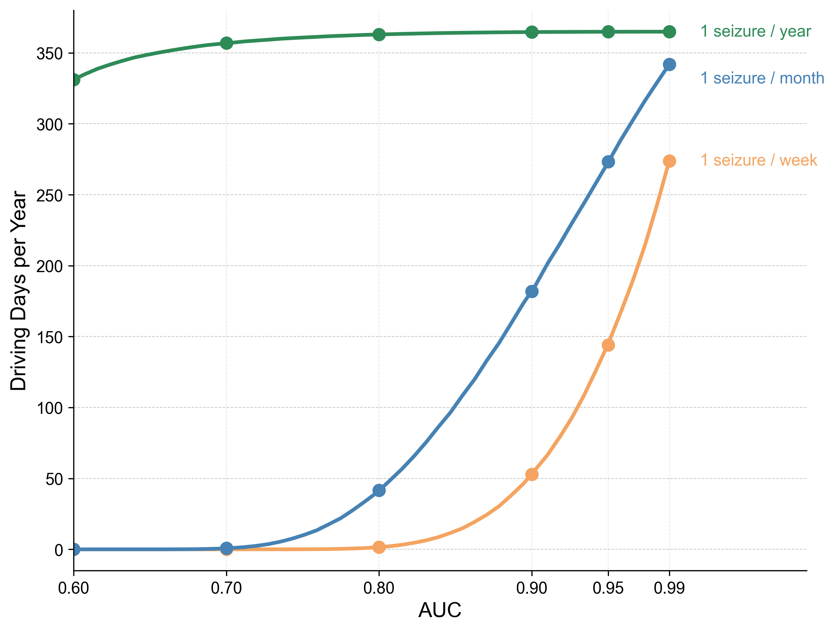
Figure 1. Annual driving days (assuming 1 hr driving/day) permitted under a forecasting-based driving policy that maintains fatal crash risk below a safety threshold (6× baseline), a level corresponding to legal standards for adult drivers at approximately 0.05–0.07% blood-alcohol-content. Curves show the relationship between forecasting algorithm performance (AUC) and the number of days per year a patient can safely drive for three seizure frequencies (1/week, 1/month, 1/year). Filled circles mark key AUC values (0.60, 0.70, 0.80, 0.90, 0.95, 0.99). Curves are calculated analytically using the equal variance binormal ROC model with Bayes' theorem. Even high-performance algorithms (AUC = 0.90) require substantial driving restrictions for patients with frequent seizures: weekly seizures permit ~53 days/year, monthly seizures permit ~182 days/year, and yearly seizures permit 365 days/year.

