Seizure Forecasting and Driving Safety
Daniel M. Goldenholz*, MD, PhD^{1,2}; Rosalind Picard, SM, ScD³; M. Brandon Westover, MD, PhD^{1,2}
1. Beth Israel Deaconess Medical Center, Boston MA. 2. Harvard Medical School, Boston MA 3. Massachusetts Institute of Technology, Cambridge, MA
* Corresponding author.
330 Brookline Ave, Baker 5, Boston MA 02215. Phone: 617 6328930
Word count: Abstract (max 100): 99 Body (max 1500): 1297
Refs (max 20): 16 Figures/Tables: 1

Keywords: epilepsy, driving, epidemiology, statistics, seizure forecasting

ABSTRACT
Seizure forecasting algorithms performing “better than chance” have prompted suggestions of clinical use, yet their safety for driving remains unexamined. We examine crash risk on days forecast as “low risk” using a simulated framework across forecasting accuracies and seizure frequencies, benchmarking against alcohol-related fatal crash safety thresholds. At an area under the curve of 0.60, the safety threshold was never reached for people with weekly or monthly seizures. Even at 0.90, weekly seizures permitted only 68 driving days per year. Algorithm accuracy alone is insufficient; seizure frequency, driving exposure, and risk tolerance must be specified before forecasts guide driving.

Introduction
Recent work using wearable data, self-reported seizures, and intracranial EEG provides converging evidence that seizure risk exhibits temporal structure in many patients^{1,2}. This has motivated efforts to forecast seizures^{3–6}, with several algorithms achieving discrimination "better than chance," typically with an area under the receiver operating characteristic curve (AUC) of about 0.6, a measure where 0.5 would indicate random and 1.0 would indicate perfect forecasts. These results have prompted suggestions that such forecasts might be ready for real-time clinical use.

Advocates have generally avoided specifying how patients should act on forecasts; however, driving restrictions⁷ are among the most burdensome consequences of epilepsy, and patients may interpret a “low risk” forecast as permission to drive. Without explicit guidance, such tools may encourage undue risk-taking.
These concerns motivated our analysis. If seizure forecasts are to inform driving decisions, the community must define the operating characteristics—sensitivity and specificity—required to achieve acceptable crash risk. Crucially, "acceptable" performance depends on seizure frequency: an operating point adequate for someone with yearly seizures may be dangerously misleading for someone with weekly seizures. We therefore asked: Under what conditions might seizure forecasting be deemed sufficiently safe to allow driving, and how many driving days would such forecasts permit?
Methods
The Safety Standard
We choose to rely on the widely-accepted risk standards adopted for driving with non-zero blood-alcohol content (BAC). Large epidemiologic studies using parametric risk models show that fatal single-vehicle crash risk increases exponentially with BAC, with age-specific slopes. For adults aged ≥21—the lowest-risk demographic—a six-fold increase in baseline fatal crash risk corresponds to BAC ≈0.06–0.07%; younger drivers reach this risk level at even lower BACs^{8,9}. We adopt the 6× baseline fatal crash risk as an accepted benchmark, aligned with the 0.05% BAC standard used in Utah and most European countries. This benchmark refers specifically to relative risk of fatal single-vehicle crashes, not legal permissibility, and is slightly more conservative than the legal threshold of 0.08% BAC used in 49 USA states. At what operating point can a seizure forecast reduce fatal crash risk to or below a 6× baseline threshold, corresponding to adult drivers at approximately 0.05–0.07% BAC in established traffic-safety models?

Analysis
We modeled seizure forecasting using a binormal receiver-operator-characteristic (ROC) framework, which specifies the tradeoff between sensitivity (the rate of predicting seizures on true seizure days) and false-positive rate (the rate of predicting seizures on non-seizure or “safe” days). In the binormal approximation: forecast scores on seizure vs non-seizure days are Gaussian with equal variance (Appendix). This is a best-case stylized ROC for a given area-under-the-curve (AUC); sometimes ROC can be jagged or ‘hooked’ and can reduce usable operating points (Appendix).
When a patient drives on a “low-risk” day, crash risk is driven by the residual seizure probability after a negative forecast—the algorithm’s false-negative rate. Using Bayes’ theorem, we computed this probability for algorithms with AUC from 0.60 to 0.95 across seizure frequencies of once per week, per month, and per year. The computation of fatal crash risk on a 'forecasted safe' day combines three probabilities: P(seizure despite negative forecast) × P(seizure occurs during driving) × P(fatal crash given seizure while driving), combined with the baseline risk of a fatal crash for average sober drivers.
An algorithm that warns every day that you have a high seizure risk would achieve perfect sensitivity (1.0) but a maximal “time in warning” –resulting in zero possible days to drive. We thus examine the total number of days forecast to have a seizure—the time in warning.
Because population-wide baseline crash risk is assumed, we implicitly include non-seizure causes for crashes as a conservative approximation. We use a population-wide baseline fatal crash probability of 1.5 × 10⁻⁵ per trip, derived from national fatal crash statistics for sober drivers. Because this baseline includes all non-seizure causes of fatal crashes (e.g., distraction, weather, other drivers), our model conservatively attributes this background risk to all driving days regardless of seizure status.
Seizure occurrence was modeled as a Poisson process: for example, '1 seizure per week' corresponds to an average rate, meaning on any given day there is a ~13.3% probability of a seizure, rather than seizures occurring at fixed 7-day intervals. Our modelled forecasting tool outputs a probability, which we then optimally threshold to obtain a “drive” or “do not drive” recommendation. We assumed 1 driving hour per day (a US population average¹⁰), but tested others as well (Appendix). We assume individual crash risk is modulated by the probability of the unpredicted seizure occurring within the driving period (Appendix).
Results
Figure 1 shows our central finding for a patient assumed to be driving 1 hour per day. Here we see the number of days per year the patient might be allowed to drive, how this is reduced with higher seizure frequency, and increased with higher forecasting AUC.
For weekly seizures, AUC 0.90 permits ~68 driving days/year, AUC 0.80 permits ~3 driving days/year, and AUC 0.60 never reaches the safety threshold.
Patients with monthly seizures fare better. AUC 0.90 may allow 212 driving days per year. AUC 0.80 permits 64 days. AUC 0.60 cannot reach the safety threshold.
Patients with yearly seizures are already below the chosen safety threshold. Even AUC 0.60 permits driving every day of the year because the joint probability of the combination of seizure occurring, seizure while driving and crash during seizure while driving is already lower than the safety threshold.
Discussion
These results carry important implications. Forecasting that works “better than chance” requires additional considerations before allowing safety-critical behaviors like driving. An AUC of 0.6 for patients with frequent seizures (weekly or monthly) cannot reach the safety threshold. For a patient with frequency of one seizure/year, AUC 0.60 permits full-time driving only because baseline risk is already very low. Seizure frequency remains a crucial factor: The same algorithm (assuming excellent AUC=0.9) that permits daily driving for someone with one seizure/year allows only intermittent driving (e.g., 1 hr/day, 68 days/year) for someone with weekly seizures.
Limitations and future work
Our assumptions do not explicitly consider other risk-modifying factors such as weather, road conditions, sleepiness, distraction¹¹, medication or substance use¹², risk-reduction strategies (e.g., assisted or automated driving¹³), driver experience, or reduced driving exposure. Also, while an average AUC is what is usually reported, forecast accuracies vary for individuals, with mixed findings in the literature, all on limited sample sizes^{1,6,14}. In addition, different mileage-based approaches to risk are available, but for this first analysis, we are appealing to existing widely-accepted state laws and standards, which are based on fatal crashes. Moreover, we treat ‘seizure while driving’ as a high-severity impairment state; in reality, risk varies by seizure type (focal aware vs. impaired consciousness vs. tonic–clonic), and ability to pull over—so our parameter can be interpreted as a tunable severity-weighted average.
It is worth considering the interpretation of seizure forecasts in the context of driving – they could be considered a “safe to drive in the next X hours” prognosis. This implicit meaning of forecasts may merit explicit consideration by regulators.
The specific numbers in our analysis depend on assumptions about driving duration and acceptable risk that will vary across patients and contexts. We chose the Utah BAC=0.5 alcohol risk as a conservative American safety standard; BAC legal limits are reduced further for truck drivers and to nearly zero for <21-year-old drivers in the US. We assume 1 hour/day of driving (typical for the U.S.) and provide supplementary analyses in the appendix for 30 minutes and 2 hours, as longer exposure increases risk. Nevertheless, the core message holds: AUC alone cannot determine whether a forecast is "good enough"—seizure frequency, driving exposure, and risk tolerance must all be specified. If a tool displays “low seizure risk,” it does not necessarily mean that driving is safe. If stakeholders wish to trade autonomy vs. risk with explicit utilities, this framework can be extended into a decision-analytic or decision-curve formulation¹⁵; here we intentionally use a hard safety constraint and report the resulting driving days.
Our results quantify how driving-related forecasts must achieve both high sensitivity (low false-negative rates) and high specificity (high true negative rates) to offer enough “low risk of seizure” driving days to be practical. The real question is “how good is good enough to drive?” For patients with frequent seizures (approximately monthly or more), the answer likely requires AUC ≥ 0.9, and even then, practical driving days depend heavily on seizure frequency and daily driving duration.¹⁶, Patients with infrequent seizures (approximately yearly or less) may already fall below the safety threshold without forecasting, depending on driving exposure. We recommend that patients not drive when given “low risk of seizure” forecasts until satisfactory performance metrics are met for their seizure frequency and the metrics are independently validated and deemed acceptable by their community. Also, it is prudent for patients to validate that the automated forecasts work for their seizures, as “average population” results do not apply to every individual patient. Until such safety-related requirements are achieved, population-based seizure-free interval policies—though imperfect— may provide a more conservative and reliable foundation for driving regulation.
Data Availability
Code to produce the results and Figure 1, and analysis technical details, are available here: https://github.com/bdsp-core/seizure_forecasting_crash_analysis

Potential Conflicts of Interest
MBW is a co-founder, serves as a scientific advisor and consultant to, and has a personal equity interest in Beacon Biosignals. DMG was an unpaid advisor for Epilepsy AI and Eysz. He is on the EFNE Professional advisory board (unpaid). He has been provided speaker fees from AAN, AES, ACNS, NNS, AI in Epilepsy and Neurology, Florida Epilepsy Alliance, and UT-Austin. He also previously has been a paid consultant for Neuro Event Labs, IDR, LivaNova, Health Advances, Duke University, and Bloom Insights. He has received grants from NIH, ABPN, BIDMC and the Lions Club. Dr. Picard is a co-founder, serves as chief scientist and consultant to, and has a personal equity interest in Empatica, Inc. She has been a paid consultant for Apple, Samsung, Alphainsights and Guidepoint Global Consulting and received speaker fees from Amazon, Amicus Rx, and KBTG.

Funding
DMG receives research funding from the NIH (K23NS124656). MBW receives research funding from the NIH (RF1AG064312, RF1NS120947, R01AG073410, R01HL161253, R01NS126282, R01AG073598, R01NS131347, R01NS130119, R01NS131347). RP receives research funding from NIH (R01MH118274, NEC, Kenvue, and Samsung).

Author Contributions
DG, RP and MBW all contributed to the conception of the project.
MBW performed the analysis.
DG, RP and MBW all contributed to the interpretation and editing of the manuscript.

References

1. Xiong W, Stirling RE, Payne DE, et al. Forecasting seizure likelihood from cycles of self-reported events and heart rate: a prospective pilot study. EBioMedicine 2023;93
2. Stirling RE, Brinkmann BH, Freestone DR, Karoly PJ. Tracking seizure cycles beats a prospective moving average: Commentary on “Rigorous evaluation of five e-diary alone seizure forecasting tools.” Epilepsia 2025;
3. Nasseri M, Stirling RE, Viana PF, et al. Forecasting epileptic seizures with wearable devices: A hybrid short- and long-horizon pseudo-prospective approach. Epilepsia 2025;66(9):3293–3308.
4. Chang C-Y, Moss R, Westover MB, Goldenholz DM. Rigorous evaluation of five models for e-diary-only seizure forecasting: Retrospective and prospective datasets do not outperform the Napkin method. Epilepsia 2025;
5. Cook MJ, O’Brien TJ, Berkovic SF, et al. Prediction of seizure likelihood with a long-term, implanted seizure advisory system in patients with drug-resistant epilepsy: a first-in-man study. Lancet Neurol. 2013;12(6):563–571.
6. Cheng JC, Goldenholz DM. Seizure prediction and forecasting: a scoping review. Curr. Opin. Neurol. 2025;38(2):135–139.
7. Tolchin B, Krauss GL, Spanaki MV, et al. Seizures, Driver Licensure, and Medical Reporting Update: An AAN Position Statement. Neurology 2025;104(7):e213459.
8. Zador PL, Krawchuk SA, Voas RB. Alcohol-related relative risk of driver fatalities and driver involvement in fatal crashes in relation to driver age and gender: an update using 1996 data. J. Stud. Alcohol 2000;61(3):387–395.
9. Fell JC, Voas RB. The effectiveness of a 0.05 blood alcohol concentration (BAC) limit for driving in the United States: Effectiveness of 0.05 BAC Limit. Addiction 2014;109(6):869–874.
10. Zhang X, Steinbach R. American Driving Survey: 2023 (Research Brief) [Internet]. Washington, D.C.: AAA Foundation for Traffic Safety.; 2024.[cited 2026 Feb 6 ] Available from: https://aaafoundation.org/american-driving-survey-2023/
11. Redelmeier DA, Tibshirani RJ. Association between cellular-telephone calls and motor vehicle collisions. N. Engl. J. Med. 1997;336(7):453–458.
12. Simmons SM, Caird JK, Sterzer F, Asbridge M. The effects of cannabis and alcohol on driving performance and driver behaviour: a systematic review and meta-analysis. Addiction 2022;117(7):1843–1856.
13. Abdel-Aty M, Ding S. A matched case-control analysis of autonomous vs human-driven vehicle accidents. Nat. Commun. 2024;15(1):4931.
14. Stirling RE, Brinkmann BH, Freestone DR, Karoly PJ. Tracking seizure cycles beats a prospective moving average. medRxiv 2025;2025–11.
15. Van Calster B, Wynants L, Verbeek JFM, et al. Reporting and Interpreting Decision Curve Analysis: A Guide for Investigators. Eur. Urol. 2018;74(6):796–804.
16. Ferastraoaru V, Goldenholz DM, Chiang S, et al. Characteristics of large patient-reported outcomes: Where can one million seizures get us? Epilepsia Open 2018;3(3):364–373.

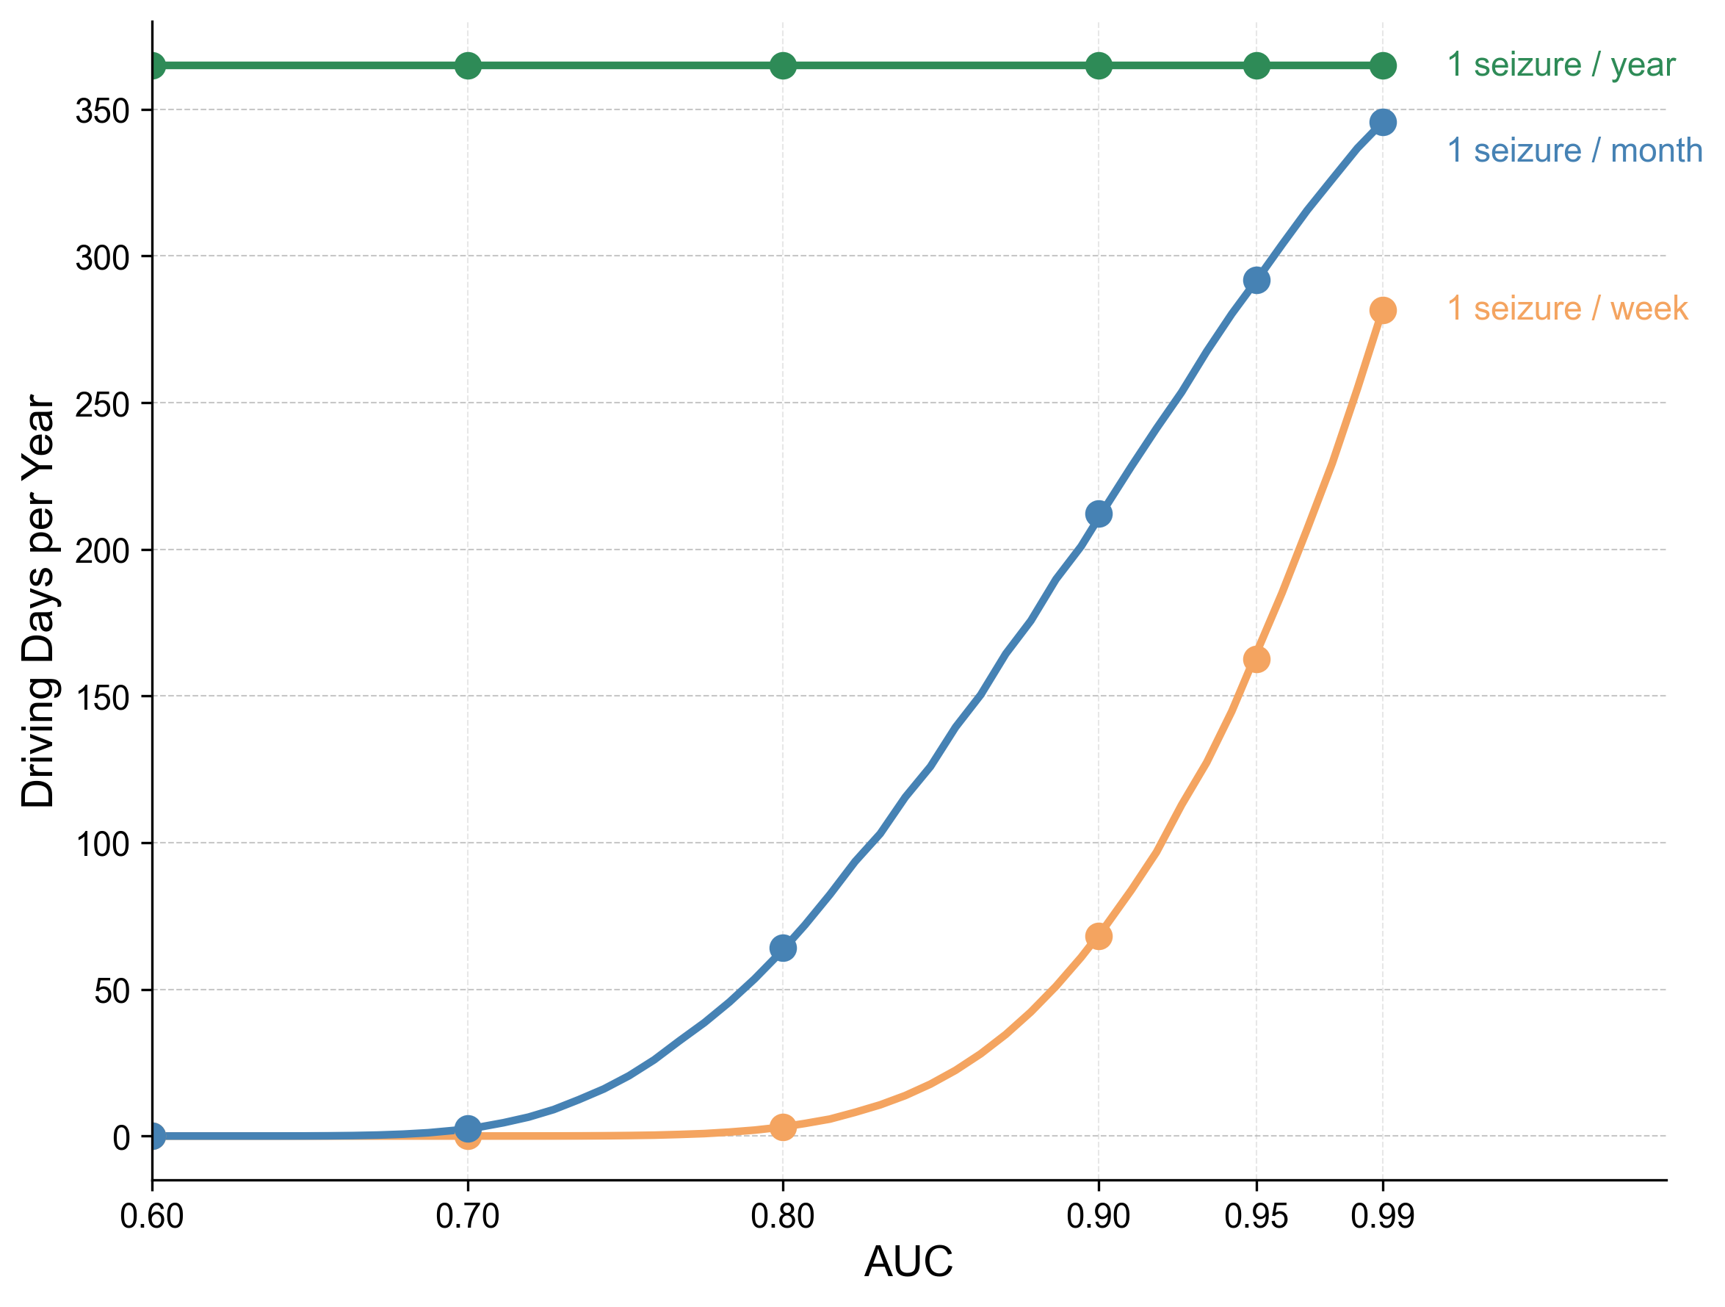
Figure 1. Annual driving days (assuming 1 hr driving/day) permitted under forecasting-based driving policy to maintain fatal crash risk below a safety threshold (6× baseline), a level chosen because it corresponds to legal standards for adult drivers at approximately 0.05–0.07% blood-alcohol-content. Curves show the relationship between forecasting algorithm performance (AUC) and the number of days per year a patient can safely drive for three seizure frequencies (1/week, 1/month, 1/year). Filled circles mark key AUC values (0.60, 0.70, 0.80, 0.90, 0.95, 0.99). Curves are calculated analytically using the equal variance binormal ROC model with Bayes' theorem. Even high-performance algorithms (AUC = 0.90) require substantial driving restrictions for patients with frequent seizures: weekly seizures permit ~68 days/year, monthly seizures permit ~212 days/year, and yearly seizures permit 365 days/year.

