1. Install “Anaconda” (includes Python):  
   <https://docs.anaconda.com/anaconda/install/windows/>

When you’ll come to this window, check the “Add Anaconda3 to my PATH environment variable”.

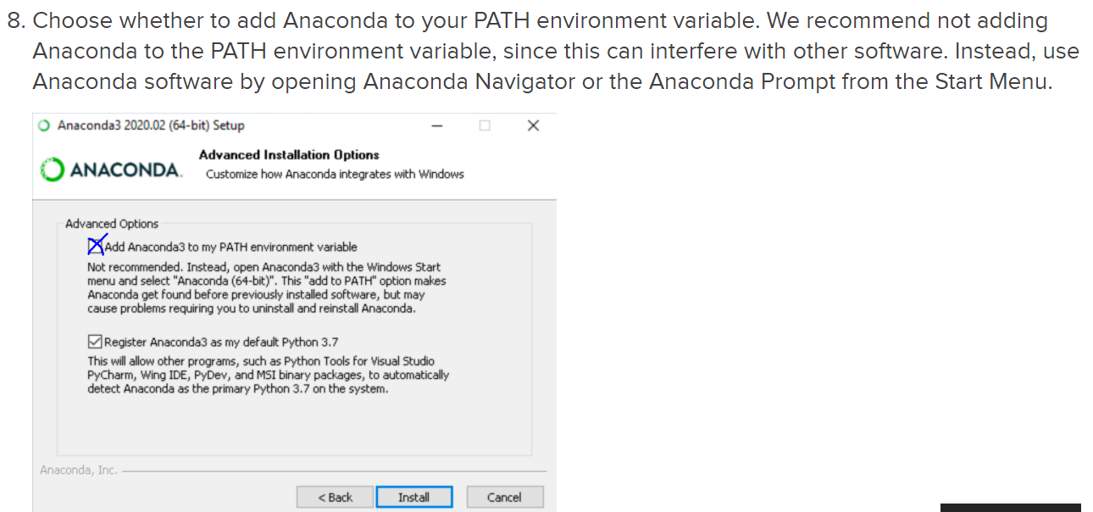

1. Open “Command Prompt” in Windows and type:  
   pip install mne  
   hit “Enter” and now the mne-package gets installed.  
     
   🡪 I think now all dependencies should be installed. We can proceed with the actual self similarity code.
2. Download the.py file here and put it into some folder (I call it “self-sim-folder” for now):  
   <https://www.dropbox.com/sh/011taqfc4k6vya8/AADGQFcPMWfifSB8C2Ut4UxVa?dl=0>  
     
   If the .py file is downloaded in a .zip or .rar compressed file, extract it, i.e. make sure you have the actual.py file in your folder.
3. Put any EDFs you want to analyze in the same “self-sim-folder”.  
     
   I.e. you should have a folder now that contains a .py file and any number of .edf files, like this:  
   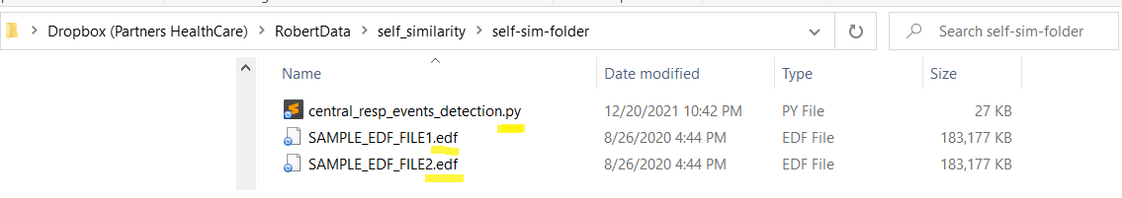
4. Open the “Command Prompt” **IN THIS FOLDER.** You can do this by clicking on the Windows explorer folder-path/search bar, this one:   
     
   then type “cmd” and hit Enter.



Then type “python central_resp_events_detection.py” and the code will start analyzing all EDFs that are in the self-sim-folder.