Evaluating Synthetic Data Quality of WISCONSIN Cancer dataset

- Univariate Analysis
Univariate analysis evaluates how closely each synthetic model matches the distribution of individual features in the real dataset.
We have applied different key metrics such as KS complement, Wasserstein, JS divergence.
  - KS Complement (Kolmogorov–Smirnov Complement)
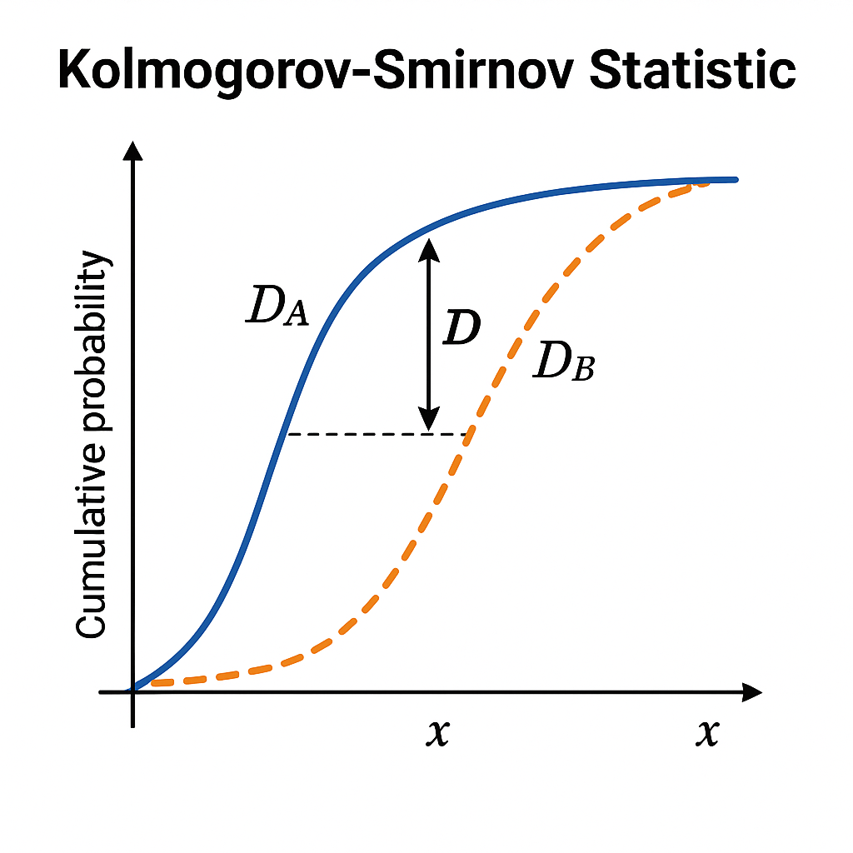
KS measures the maximum difference between the cumulative distribution function (CDFs of real vs. synthetic data.

KS = max |CDF_real – CDF_synth|
KS Complement = 1 – KS (Higher is better)
Interpretation
1.0: Perfect alignment
0.8+: Very good
<0.6: Poor match

Example
If real radius_mean values accumulate differently from synthetic values, KS will be high → KS Complement low. We computed four models namely CTGAN, Copula GAN, Gaussian Copula and TVAE
Feature | CTGAN | Copula GAN | Gaussian Copula | TVAE
diagnosis | 0.8926 | 0.8886 | 0.9814 | 0.9756
radius_mean | 0.8922 | 0.8702 | 0.9477 | 0.8226
texture_mean | 0.7221 | 0.8064 | 0.9618 | 0.7963
perimeter_mean | 0.6562 | 0.5896 | 0.9428 | 0.9141
area_mean | 0.6900 | 0.7058 | 0.9444 | 0.8776
smoothness_mean | 0.8324 | 0.8249 | 0.9621 | 0.8742
compactness_mean | 0.8195 | 0.8877 | 0.9642 | 0.9274
concavity_mean | 0.8938 | 0.5326 | 0.9530 | 0.9256
concave points_mean | 0.7611 | 0.4617 | 0.8931 | 0.9346
symmetry_mean | 0.5346 | 0.5613 | 0.9716 | 0.9375
fractal_dimension_mean | 0.9173 | 0.5905 | 0.9287 | 0.8822
radius_se | 0.6855 | 0.6394 | 0.9454 | 0.8314
texture_se | 0.6112 | 0.6692 | 0.9642 | 0.8911
perimeter_se | 0.5606 | 0.6939 | 0.9393 | 0.8916
area_se | 0.8085 | 0.6865 | 0.8751 | 0.8868
smoothness_se | 0.8169 | 0.4663 | 0.9243 | 0.8854
compactness_se | 0.9016 | 0.6671 | 0.9506 | 0.9140
concavity_se | 0.7391 | 0.6087 | 0.9511 | 0.9428
concave points_se | 0.8529 | 0.4551 | 0.8998 | 0.8308
symmetry_se | 0.5643 | 0.5124 | 0.8355 | 0.7793
fractal_dimension_se | 0.7020 | 0.6064 | 0.9477 | 0.8886
radius_worst | 0.6907 | 0.7737 | 0.9468 | 0.9428
texture_worst | 0.5976 | 0.8470 | 0.9725 | 0.8757
perimeter_worst | 0.6224 | 0.8851 | 0.9509 | 0.8734
area_worst | 0.7685 | 0.5932 | 0.9335 | 0.8988
smoothness_worst | 0.3991 | 0.7620 | 0.7521 | 0.8718
compactness_worst | 0.5643 | 0.8921 | 0.9501 | 0.8823
concavity_worst | 0.6514 | 0.7324 | 0.9432 | 0.9514
concave points_worst | 0.9062 | 0.7437 | 0.9237 | 0.9242
symmetry_worst | 0.8716 | 0.5733 | 0.8665 | 0.9225
fractal_dimension_worst | 0.7519 | 0.7365 | 0.9074 | 0.8355

  - Jensen–Shannon Divergence (JS)
Definition:
A symmetric measure of difference between real and synthetic probability distributions.
- Values range: 0 to 1
- Lower is better
- 0 = identical distributions
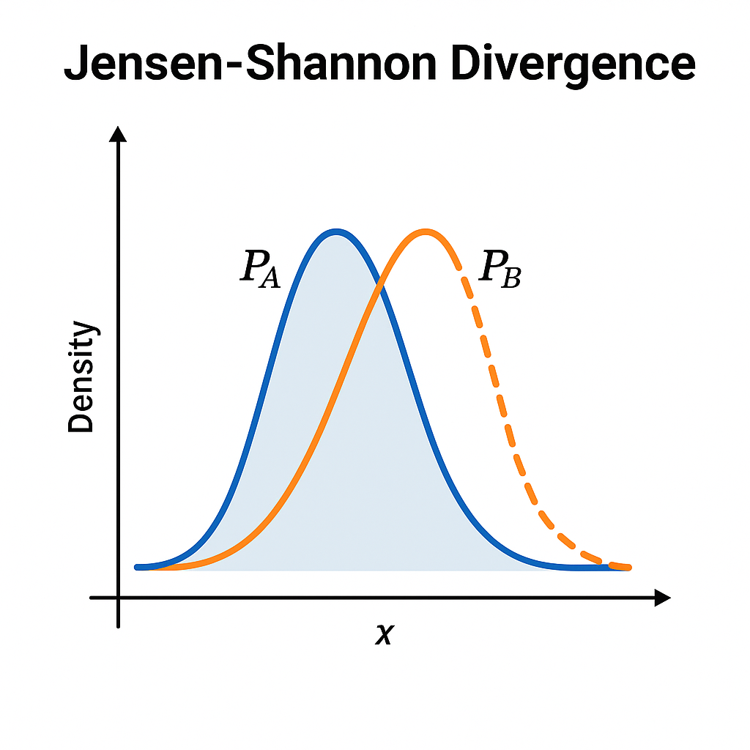

Intuition:
JS measures how "surprising" the synthetic distribution would look if generated under the real distribution. For instance, if real concavity_mean is concentrated around small values but synthetic has a long tail, JS increases.
Feature | CTGAN | Copula GAN | Gaussian Copula | TVAE
diagnosis | 0.0085 | 0.0092 | 0.0003 | 0.00045
radius_mean | 0.0400 | 0.0389 | 0.0187 | 0.0548
texture_mean | 0.0817 | 0.0663 | 0.0149 | 0.0494
perimeter_mean | 0.1333 | 0.1834 | 0.0168 | 0.0354
area_mean | 0.0982 | 0.0948 | 0.0278 | 0.0317
smoothness_mean | 0.0443 | 0.0583 | 0.0215 | 0.0273
compactness_mean | 0.0527 | 0.0381 | 0.0168 | 0.0290
concavity_mean | 0.0284 | 0.2128 | 0.0136 | 0.0244
concave points_mean | 0.0829 | 0.2751 | 0.0336 | 0.0244
symmetry_mean | 0.2147 | 0.1849 | 0.0185 | 0.0234
fractal_dimension_mean | 0.0437 | 0.1730 | 0.0150 | 0.0402
radius_se | 0.1279 | 0.1392 | 0.0201 | 0.0419
texture_se | 0.1779 | 0.1162 | 0.0166 | 0.0331
perimeter_se | 0.2073 | 0.1400 | 0.0226 | 0.0393
area_se | 0.0581 | 0.1181 | 0.0631 | 0.0466
smoothness_se | 0.1136 | 0.2913 | 0.0244 | 0.0624
compactness_se | 0.0505 | 0.1223 | 0.0213 | 0.0448
concavity_se | 0.0914 | 0.1573 | 0.0196 | 0.0277
concave points_se | 0.0505 | 0.2941 | 0.0519 | 0.0821
symmetry_se | 0.1906 | 0.2293 | 0.0681 | 0.0917
fractal_dimension_se | 0.1348 | 0.1896 | 0.0200 | 0.0663
radius_worst | 0.1272 | 0.0797 | 0.0188 | 0.0307
texture_worst | 0.1931 | 0.0445 | 0.0103 | 0.0286
perimeter_worst | 0.1674 | 0.0402 | 0.0173 | 0.0240
area_worst | 0.0634 | 0.1630 | 0.0284 | 0.0460
smoothness_worst | 0.3326 | 0.0628 | 0.1783 | 0.0377
compactness_worst | 0.2248 | 0.0290 | 0.0142 | 0.0297
concavity_worst | 0.1882 | 0.0766 | 0.0232 | 0.0201
concave points_worst | 0.0307 | 0.0856 | 0.0194 | 0.0230
symmetry_worst | 0.0379 | 0.1739 | 0.0677 | 0.0345
fractal_dimension_worst | 0.0667 | 0.0951 | 0.0294 | 0.0464

  - Wasserstein Distance (Earth Mover's Distance)
Measures the minimum effort needed to transform one distribution into another.
- Lower is better
- Captures differences in location, spread, shape
- More sensitive than KS to gradual differences

Intuition:
Imagine reshaping one histogram into another by “moving probability mass”. For instance, if synthetic texture_worst is slightly shifted compared to real, Wasserstein captures the amount of shift required.
Feature | CTGAN | CopulaGAN | Gaussian Copula | TVAE
diagnosis | 0.1074 | 0.1114 | 0.0186 | 0.0244
radius_mean | 0.0283 | 0.0329 | 0.0115 | 0.0483
texture_mean | 0.1038 | 0.0510 | 0.0065 | 0.0428
perimeter_mean | 0.1074 | 0.2218 | 0.0111 | 0.0187
area_mean | 0.1119 | 0.1022 | 0.0126 | 0.0308
smoothness_mean | 0.0399 | 0.0456 | 0.0071 | 0.0283
compactness_mean | 0.0631 | 0.0352 | 0.0074 | 0.0144
concavity_mean | 0.0157 | 0.1307 | 0.0114 | 0.0178
concave points_mean | 0.0715 | 0.1569 | 0.0165 | 0.0196
symmetry_mean | 0.1758 | 0.1766 | 0.0075 | 0.0193
fractal_dimension_mean | 0.0236 | 0.1050 | 0.0161 | 0.0307
radius_se | 0.0327 | 0.0438 | 0.0085 | 0.0196
texture_se | 0.1660 | 0.1167 | 0.0062 | 0.0215
perimeter_se | 0.0903 | 0.0288 | 0.0082 | 0.0171
area_se | 0.0200 | 0.0241 | 0.0119 | 0.0200
smoothness_se | 0.0389 | 0.0916 | 0.0137 | 0.0242
compactness_se | 0.0379 | 0.0651 | 0.0096 | 0.0231
concavity_se | 0.0293 | 0.0386 | 0.0073 | 0.0101
concave points_se | 0.0338 | 0.1731 | 0.0225 | 0.0344
symmetry_se | 0.1288 | 0.2018 | 0.0280 | 0.0464
fractal_dimension_se | 0.0435 | 0.0412 | 0.0095 | 0.0206
radius_worst | 0.0858 | 0.0563 | 0.0136 | 0.0183
texture_worst | 0.1616 | 0.0629 | 0.0041 | 0.0232
perimeter_worst | 0.1084 | 0.0346 | 0.0126 | 0.0322
area_worst | 0.0689 | 0.1698 | 0.0135 | 0.0227
smoothness_worst | 0.2372 | 0.0708 | 0.0660 | 0.0307
compactness_worst | 0.2119 | 0.0214 | 0.0100 | 0.0221
concavity_worst | 0.1993 | 0.0557 | 0.0178 | 0.0126
concave points_worst | 0.0314 | 0.0857 | 0.0194 | 0.0281
symmetry_worst | 0.0316 | 0.1128 | 0.0326 | 0.0216
fractal_dimension_worst | 0.0633 | 0.0483 | 0.0176 | 0.0319

Bivariate Analysis

1. Objective
The objective of this experiment is to evaluate the quality and realism of synthetic data generated from the Wisconsin Breast Cancer dataset using statistical analysis. Unlike univariate methods, which assess individual feature distributions, bivariate analysis examines relationships between feature pairs — ensuring that synthetic data preserves structural and diagnostic relationships present in real data.
2. Background Theory
Synthetic Data
Synthetic data are artificially generated samples that imitate real data patterns without directly exposing sensitive information. In healthcare, they enable model development while maintaining privacy.
Univariate vs. Bivariate Evaluation
Univariate analysis assesses each feature’s individual distribution (e.g., means, histograms). Bivariate analysis tests whether the relationships between variables — correlations or class-conditional structures — are preserved. If synthetic data distort these relationships, downstream models will behave inconsistently with the real data.
3. Metrics Used
Relationship Type | Metric | Description
Numeric ↔ Numeric | Δρ (Delta Correlation) | Absolute difference in Pearson correlations between real and synthetic data for each feature pair.
Numeric ↔ Categorical | ΔW (Delta Wasserstein Distance) | Difference in class-separation strength (malignant vs benign) between real and synthetic distributions.
High |Δρ| or |ΔW| values indicate a loss of structural or diagnostic fidelity.
4. Methodology
1. Dataset Preparation: Both the real and synthetic datasets were aligned to have identical feature columns. The 'diagnosis' column was treated as categorical (M = malignant, B = benign).
2. Metric Computation: For numeric–numeric pairs: Pearson correlation matrices were computed, and |Δρ| calculated. For numeric–categorical relationships: class-conditional Wasserstein distances were computed and their absolute difference |ΔW| recorded.
3. Ranking and Visualization: Feature pairs were ranked by |Δρ| and individual features by |ΔW|. KDE and scatter plots were used for interpretability.
5. Results
(a) Correlation Structure (Numeric ↔ Numeric)
Large |Δρ| values (>0.9) indicate that correlation patterns among tumor size features (radius, area, perimeter) were not preserved in the synthetic data. In real data, these features exhibit strong positive correlations, while the synthetic data failed to replicate these relationships accurately.
(b) Diagnosis Separation (Numeric ↔ Categorical)
The features with the highest ΔW (area and perimeter measures) show that the difference between malignant and benign distributions in the synthetic dataset deviates substantially from the real data. In particular, 'area_worst' and 'area_mean' — both key diagnostic indicators — lost much of their real-world separation, explaining the extremely high ΔW values.
6. Visualization Highlights
- Correlation Heatmaps: Showed strong, consistent correlations among geometric features in real data but irregular or weaker ones in synthetic data.
- Scatter Plots: Example: perimeter_mean vs area_mean — the real dataset showed a near-linear trend, while the synthetic dataset displayed greater dispersion.
- KDE Plots (Class-Conditional): The distributions of malignant and benign samples overlapped significantly in the synthetic data, confirming diagnostic drift.
7. Discussion
The results reveal that the synthetic dataset replicates individual feature distributions reasonably well but fails to preserve pairwise dependencies and class separations critical for diagnostic accuracy. Features related to tumor size and shape were the most affected, leading to high Δρ and ΔW values. This suggests that the synthetic generator lacked conditional awareness — producing data that appear realistic but are structurally inconsistent.
8. Recommendations
1. Conditional Synthesis: Train the generator conditioned on diagnosis to maintain class-dependent feature structures.
2. Correlation-Aware Models: Implement copula-based or correlation-constrained synthesis (e.g., CopulaGAN, CTGAN).
3. Post-Generation Calibration: Adjust the synthetic correlation matrix to better align with real-world relationships.
4. Extended Validation: Incorporate multivariate fidelity checks and TSTR experiments to assess model behavior.
9. Conclusion
Bivariate analysis demonstrates that while the synthetic dataset maintains reasonable univariate fidelity, it fails to preserve pairwise and class-conditional relationships. The loss of correlation among tumor geometry features and the collapse of diagnostic separation highlight a limitation in current synthesis quality. Further refinement is required before the synthetic dataset can serve as a reliable proxy for diagnostic modeling.
10. Key Takeaways
Concept | Description
Δρ (Delta Correlation) | Measures loss of relationship strength between numeric features.
ΔW (Delta Wasserstein) | Measures change in malignant–benign class separation for each feature.
High Δρ / ΔW | Indicates structural or diagnostic drift in synthetic data.
Goal | Achieve low Δρ and ΔW to preserve both realism and relational integrity.
Appendix A — How ΔWasserstein is Calculated
For each numeric feature (e.g., area_worst):
1. Separate real data into two classes (malignant, benign).
2. Compute Wasserstein distance between the two class distributions in the real data.
3. Compute the same distance in the synthetic data.
4. Calculate the absolute difference ΔW = |W_real - W_synthetic|.
5. The result (e.g., 661.37 for area_worst) represents how much the class separation changed between real and synthetic datasets.
Appendix B — Figure Interpretation
Figure: area_mean by Diagnosis — Real vs Synthetic
The solid curves represent real data, while dashed curves represent synthetic data. Blue curves correspond to one diagnosis group (benign) and orange curves to the other (malignant). In the real dataset, the two distributions are clearly separated — benign tumors have smaller mean areas, and malignant tumors have larger mean areas. In the synthetic dataset, both curves overlap heavily, indicating that the model failed to replicate diagnostic separation. This overlap explains the large ΔWasserstein value (338.02), reflecting a loss of clinical signal fidelity in the synthetic feature distribution.

