More are less followed these instructions but instead of using the command line, used phpmyadmin:

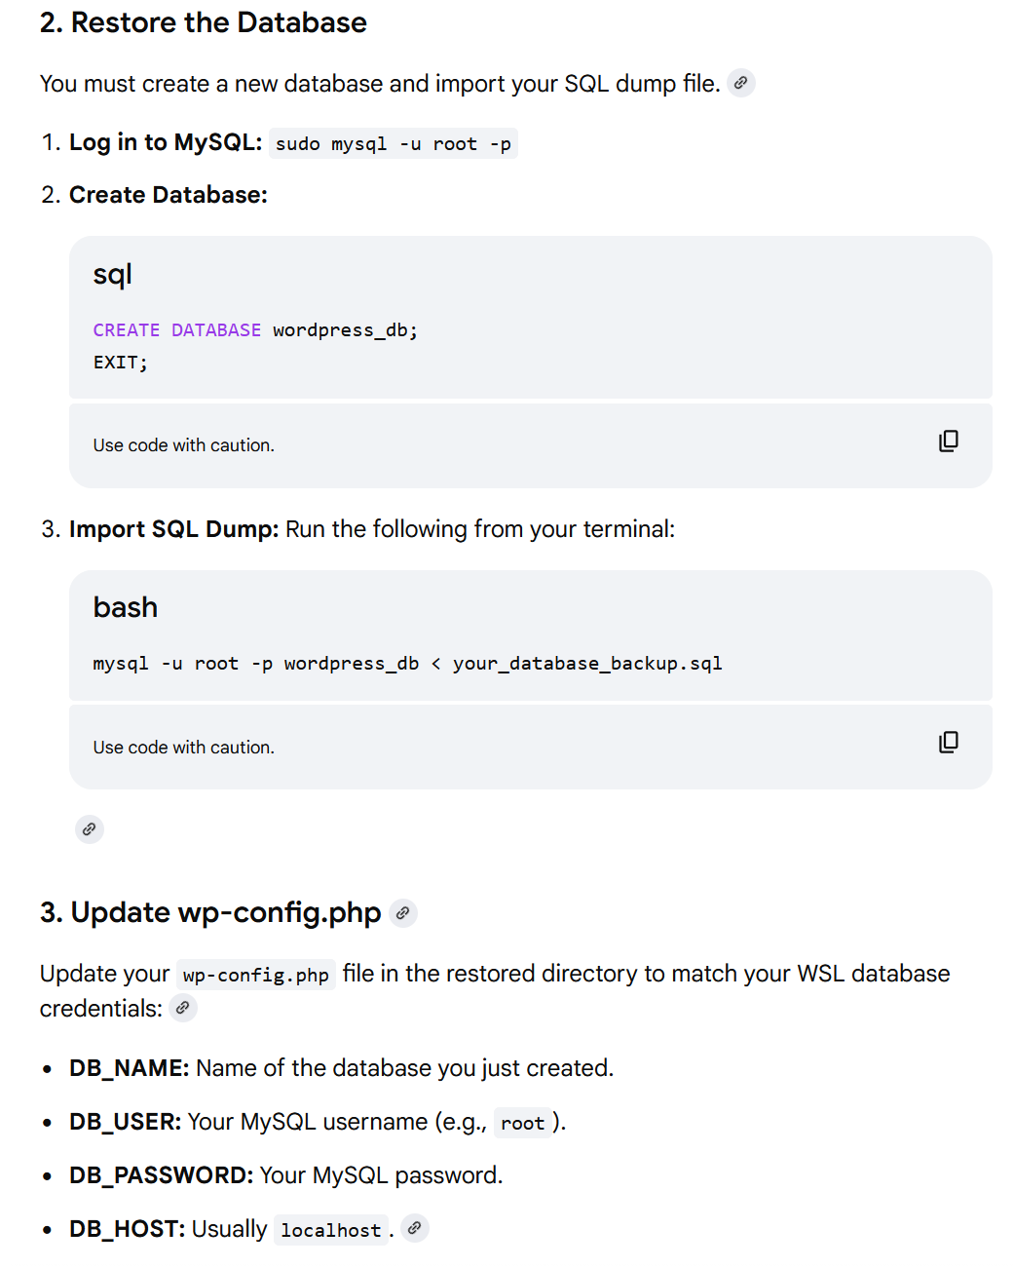
Tried to access site at localhost/bramblewood_guitars but got a 500 server error. AI said that I need to go back to an older version of php.

Note: Based on the version.php wordpress file, I thought that my wordpress site requires php version 5.2.4 and mysql version 5.0. This is not correct though. Also note, my site uses wordpress version 4.8.4 and the Customizr theme verision 4.0.12. version.php can be found at "\\wsl.localhost\Ubuntu\var\www\html\bramblewood_guitars\wp-includes\version.php". Site runs on php version 7.4 just fine and all the following steps worked. AI highly recommended not downgrading to php 5.2.4 as this could cause other things to break in WSL. It also said that the info that I was looking at in version.php does not mean that those versions are required. It highly recommended running version 7.4.

Downgraded to php 7.4 (note: this is no longer necessary now that wordpress has been updated and runs fine on php 8.3):

Ran sudo add-apt-repository ppa:ondrej/php
Ran sudo apt update
Ran sudo apt install php7.4 php7.4-mysql php7.4-curl php7.4-gd php7.4-mbstring php7.4-xml

Got this error:

The following packages have unmet dependencies:
php-common : Breaks: php-mcrypt (< 3:1.0.7-5~)
E: Error, pkgProblemResolver::Resolve generated breaks, this may be caused by held packages.

Ran sudo apt-get purge php-mcrypt
Ran sudo apt --fix-broken install
Ran sudo apt-get autoremove
Ran sudo add-apt-repository ppa:ondrej/php -y
Ran sudo apt-get update
Ran sudo apt-get install php7.4 php7.4-common php7.4-mysql php7.4-xml php7.4-mbstring php7.4-curl

This appears to have been successful this time.
Ran sudo update-alternatives --set php /usr/bin/php7.4 to switch the cli version of php to 7.4

Ran php -v to confirm that I'm running 7.4

Ran sudo a2dismod php8.3
Ran sudo a2enmod php7.4
Ran sudo systemctl restart apache2

Ran echo "<?php phpinfo(); ?>" | sudo tee /var/www/html/bramblewood_guitars/test.php This creates a test.php file in bramblewood_guitars folder. Will want to go back and delete after next step.

Went to http://localhost/bramblewood_guitars/test.php to verify that server is now running php 7.4

Went to http://localhost/bramblewood_guitars/. Site nows runs!

To access wordpress dashboard go to http://localhost/bramblewood_guitars/wp-login

Tried logging in but my credentials wouldn't work.

Note: account appears to be linked to btripp1990@hotmail.com

Changed the password for admin in the database

Ran USE bramblewood_guitars
Ran UPDATE wp_users SET user_pass = MD5('new password goes here') WHERE user_login = 'admin';
Now I was able to login with new credentials

When I navigate to other pages on my site, it goes to the incorrect URL.

Commented out all lines in .htaccess file so it looks like this:

# BEGIN WordPress
# <IfModule mod_rewrite.c>
# RewriteEngine On
# RewriteBase /cas111w/final/
# RewriteRule ^index\.php$ - [L]
# RewriteCond %{REQUEST_FILENAME} !-f
# RewriteCond %{REQUEST_FILENAME} !-d
# RewriteRule . /cas111w/final/index.php [L]
# </IfModule>
# END WordPress

Added these lines:

<IfModule mod_rewrite.c>
RewriteEngine On
RewriteBase /bramblewood_guitars/
RewriteRule ^index\.php$ - [L]
RewriteCond %{REQUEST_FILENAME} !-f
RewriteCond %{REQUEST_FILENAME} !-d
RewriteRule . /bramblewood_guitars/index.php [L]
</IfModule>

Ran sudo a2enmod rewrite
Ran sudo nano /etc/apache2/apache2.conf
Typed ctrl + w to search for <Directory /var/www/>
Changed AllowOverride None to AllowOverride All
Ran sudo systemctl restart apache2
Went to dashboard and to Settings > Permalinks
Clicked save changes at the bottom (you don't need to change any settings)
Links work correctly now! ...except when I click “Home”
Went to Appearance > Menus in wordpress dashboard
Went to the “Home” item in the menu structure. Expanded it and changed the URL from the old domain to /bramblewood_guitars/.
Now it works.
Notes for additional setup after updating Wordpress and Customizr theme to newest versions
Note: The following is not exhaustive of everything that I did. Only including things that I may need to do again and things that may not be so obvious.
Go to Tools > Site Health and Fix any issue that are found there

