**CS 471 Team Project Final**

**Nine Mens Morris Game**

**Team DMQ**

**Brian Dunn, Brendon McCoy, Adam Quarnstrom**

CS471/571 Team Project

* **Section I. Team Organization and Buddy Rating**

1. Team Organization

Brendon is in charge of the GUI, Adam is in charge of the Logic, and Brian is in charge of Testing and AI. We split the project up this way during our first meeting. Brendon was most comfortable working on the GUI, whereas Adam really wanted to get into figuring out the logic needed for the game, and Brian felt that he wanted to become more skilled in testing and AI development so he wanted to focus on that. All that being said, the majority of this project was programmed during pair programming sessions that we had every week, so we all got a chance to work on different parts of the project together.

1. Buddy Ratings

|  |  |  |  |
| --- | --- | --- | --- |
| **Team Members** | **Brian Rating** | **Adam Rating** | **Brendon Rating** |
| Brian Dunn | N/A | 1 | 1 |
| Adam Quarnstrom | 1 | N/A | 1 |
| Brendon McCoy | 1 | 1 | N/A |

1. Provide a list of your team meetings, including time, place, and meeting minutes.

|  |  |  |  |
| --- | --- | --- | --- |
| **Meeting #** | **Time/place** | **Participants** | **Topics and decisions** |
| 1 | 9/15, 6:00 – 6:15, Engineering Bldg | Brian, Brendon, Adam | User Stories, Basic Design, Deciding meeting place |
| 2 | 9/24,6:00-6:15,  Metageek Lab | Brian, Brendon, Adam | Basic Board/GUI development. Board class and functions created. |
| 3 | 10/1,6:00-6:15,  Metageek Lab | Brian, Adam | Logic/GUI development.  Logic constructor, place pieces, beginning of move pieces function. GUI displays board, uses current functions. |
| 4 | 10/8,6:00-6:15,  Metageek Lab | Brian, Brendon, Adam | Finished move pieces, began check moves, and remove pieces, and check for win. GUI can use added functions. |
| 5 | 10/15,6:00-6:15,  Metageek Lab | Brian, Brendon, Adam | Finished check moves, remove, check win. GUI finished. |
| 6 | 10/22,6:00-6:15,  Metageek Lab | Brian, Brendon, Adam | Bugfixes, GUI beautification. |
| 7 | 10/29,6:00-6:15,  Metageek Lab | Brian, Brendon, Adam | Discuss AI implementation. Decided on a priority based system. |
| 8 | 11/5,6:00-6:15,  Metageek Lab | Brian, Brendon, Adam | Discuss extras for GUI, like displaying remaining pieces during placement phase. Also decided to have an easy and a hard version of the AI |
| 9 | 11/12,6:00-6:15,  Metageek Lab | Brian, Brendon, Adam | Discuss final report and state of testing. |
| 10 | 12/3,6:00-6:15,  Metageek Lab | Brian, Brendon, Adam | Finish going over testing, finalizing report. |

* **Section II. Design**

1. Summarize the user-interface design of your program, using a combination of screenshots and textual descriptions.

Our user interface is a single page design which two components each created as a JPanel. These include a panel for the game board itself and a panel for the game controls and information. A third JPanel acts as a wrapper and displays the other two side-by-side, controls the interaction between those two panels, and handles resizing of the window.

The game board panel uses Java’s basic graphic components to draw lines and circles to create the board, game pieces, and display valid moves. It includes setting functions to update all of these as the game is played. The board panel also has an event listener to handle when the board is clicked and determine what spot on the game board was just clicked. It then passes this information to the wrapper panel to be handled accordingly.

The controls panels contains labels for display the current player, dynamic game play instructions, and how pieces each player has left to place during phase 1 of the game. It also contains three buttons for starting new games. One for a two player game, one for the easy AI, and one for the hard AI. Like the board panel, it containers setting for updating the information for the labels and event listeners for when the buttons are pressed which it passes up to the wrapper panel to be handled. -Brendon

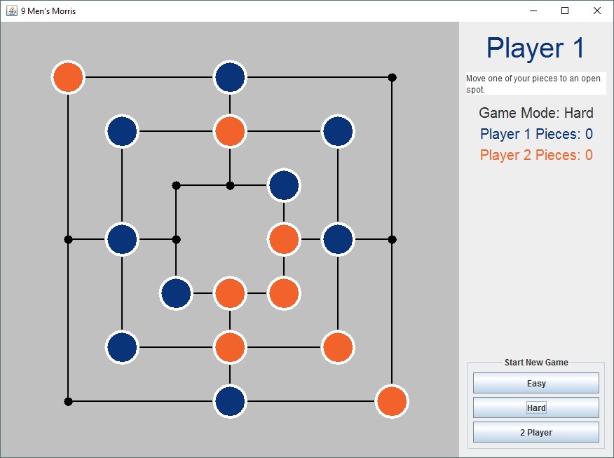

1. Provide a class diagram that captures the main classes and their relationships in your final program

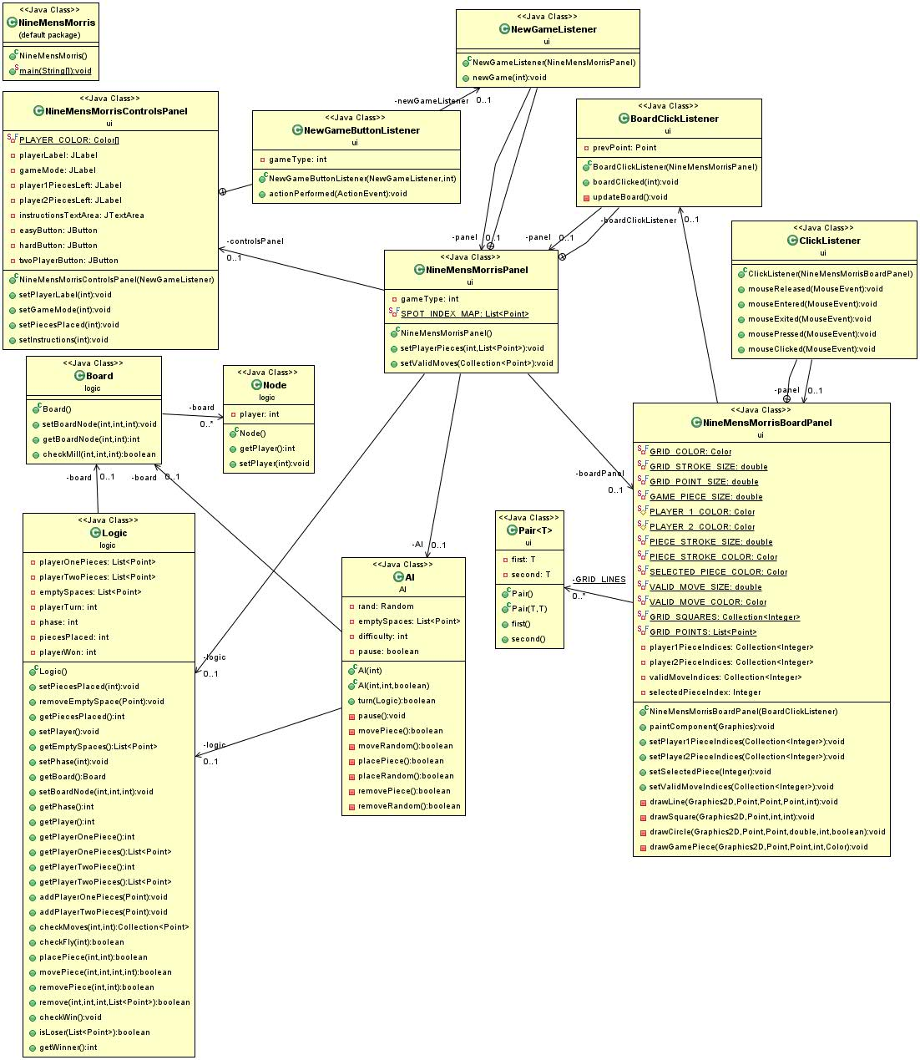

1. Describe the algorithm for determining when a mill is formed based on the data structures used in your program.

The checkMill algorithm takes in the ordered pair (Square, Point) of which space you're checking in the 2D array used to hold the board spaces, and the player who created the mill. The algorithm simply checks that if the spaces on either side(using modulus to wrap around) to see if the three nodes match the given player, and if so it returns true, otherwise it returns false. Since the odd numbers correspond to the middle spaces on the board, only when an odd point is given, will it check the column it is in for a mill, otherwise it checks the row it is in. -Adam, Brendon

1. Describe the algorithm for determining when the game is over and who is the winner based on the data structures used in your program.

The checkWin algorithm passes the list of player pieces of whoever is the current player to a small function that was refactored to it's own function as it was duplicated in the original checkWin method. The isLoser function checks two conditions: if the current player has less than three pieces, or if the current player has no possible moves left. The latter is checked by iterating through the player's pieces and calling the check moves function and checking if, for each piece, the returned list of possible moves is empty. If it is for all pieces, then the function returns true, setting the game phase and playerWon variables to 4 and the winning player respectively. -Adam

1. Describe the detailed design of the computer opponent in your program.

We designed the computer opponent (AI) using a priority system, broken down by 3 phases, placing pieces, moving pieces, and removing pieces. For placing pieces, the first priority is to place a piece where it will create a mill for the AI. The next priority if a mill can't be created is to block a player from creating a mill, if possible. The next priority is to then attempt to place a piece next to one of the AI's existing pieces in the hope of being able to create a mill on the next turn. If none of those placements are possible, then just place piece in a random spot.

For moving pieces, the first priority is to move a piece into position to create a mill. If not possible, then next priority is to move to a position that will block the player from forming a mill. If not possible, then attempt to move a piece that is already within a mill so that it may be possible to create that mill again on the next turn. Finally, if none of those moves were possible, then just move randomly.

Finally, for removing pieces, the first priority is to remove a player's piece that is blocking the AI from creating a mill. If that is not the case, then the next priority is to remove a player piece that, if moved next turn, would possibly create a mill for the player. The final priority is to remove a random player piece. -Brian

The AI tests for placing pieces is similar to the test criteria for moving pieces. The tests are done with a seeded AI since the first placement of a piece is random no matter what, as all the other criteria the AI looks at aren't available, so it defaults to random. The tests cover the AI placing a piece first at random, then it prioritizes the following in descending order of priority: Creating mills, Blocking opponent's mills, Placing Adjacent, and finally at Random. A couple of test cases to show that it does do these. We have it place a single piece, test that it places a mill if it can, if it blocks an opponent's mill if it can, adjacent to it's own pieces if it can. The priority is tested by having both a mill to be blocked, and a mill that can be formed, and the AI does make the mill over blocking an opponent. -Adam

* **Section III. System Testing**

1. Describe the test requirements for the implementation of the computer opponent.

The testing of the computer opponent was difficult due to some random behavior that it has. We started testing by playing the game with each part of the AI implemented. For example, the first implementation was where the AI places pieces on the board in the first phase at random. We then played the game and verified that the AI succeeded in placing pieces in available spaces on the game board. We then tested random move and random removing of pieces by the AI, again by playing the game. It wasn't until later that we designed automated testing for the AI methods.

We needed to create tests for each of the priority cases laid out in our design of the computer opponent. So there needed to be tests where during the placing pieces phase where the AI will create a mill, block a player from forming a mill, place a piece next to one of their own, and places a piece at random. Also, the priority needed to be tested, where if it is possible for the AI to place a piece to create a mill or could place a piece to block a player mill, it should create a mill. -Adam

For testing of moving pieces, we have tests for AI moving a piece to form a mill, block player from creating mill, moving a piece from within its mill, or randomly. Again the priority needed to be tested, to where if it is possible to block the player from creating a mill, it gets done instead of moving randomly. -Brain

Finally, we needed tests for the AI's removing of pieces. Like the other tests, there are individual tests for AI removing a player piece that is blocking it from forming a mill, close to forming a player mill, and removing random player pieces. Also, like the other tests, the priority was tested as well. -Brendon

1. Describe the detailed steps of two system tests where a human player plays against the computer player.

Of course we were not able to create an automated test using a human, although I have asked people to play our game on the hard difficulty without knowing anything about how the AI was implemented. The AI proved to be formidable, especially for those who were unfamiliar with the game.

However, as far as trying to create automated testing, we created an easy AI that moves randomly and a hard AI that actually moves with reasoning. So we decided to create tests to play the two types of AIs against each other, one with the hard AI representing a smart human player and the easy AI representing the computer. The other test represents a dumb human with the easy AI and the smart computer with the hard AI. In the first test the “human” won and in the second test the “AI” won, which were the results we hoped to achieve. -Brian

* **Section IV. Lessons Learned**

**Brian Dunn**

(1) What did you personally gain from the project?

I have gained a better understanding of a group development process. Many of my past computer science classes contained little or no group assignments, so I have gotten into a routine of how I go about solving a given problem. From having to adapt to agile development and the group setting I feel like I now have the ability to become part of a larger development team and be able to tackle larger and more difficult projects.

(2) What does your program do well, and what could your program do better?

Our program is very robust and has no known errors. The hard AI setting works very well given the priority order that we designed. The GUI has a pleasing layout with color coordination and detailed instructions for the player(s). The code for the program is written in such a way that the GUI and Logic are loosely coupled, in that the Logic class does all of the game logic and the GUI just updates based on data Logic. By doing so, it was very easy to add in the AI class without making many changes to the GUI.

As far as what our program could do better, I would say we could add sound effects, like some type of error sound when attempting to do an illegal move or fanfare when the player wins. As far as the design of the classes go, we could probably refactor some methods still and do away with some of the data structures being used to track pieces. Also, it would be nice to have a save game state feature.

(3) How could you improve your development process if you develop a similar game from scratch?

One way to improve would be to have more time set aside to work on it. Since this semester we really only had one day a week for just a couple hours to work on this project. This made us keep things as simple and basic as possible, whereas with more time we probably could have added things like sound effects, animations, or even a save game state feature.

Another way to improve would be to have a more organized structure to the meeting and pair programming sessions to make sure everyone is on task and on the same page. We didn’t really know what to expect in the beginning. We can up with a loose, basic plan and then proceeded from there. I think with more structure we could have completed parts of the project faster.

**Adam Quarnstrom**

1. What did you personally gain from the project?

I have gained a good understanding of AGILE development, and a good experience of working with a team on a project, which isn't something you get a lot of in the CS program here. I also gained a better understanding of testing. I was a little bit lacking in that department, but I am much better at it now.

1. What does your program do well, and what could your program do better?

I think our program is pretty solid. I know the UI could probably be better but I think it's good as is. Otherwise, the only thing I can think of that could be way better is either the AI or the finding moves function. The finding move function is a bit of a mess, a lot of if/then statements, but we couldn't think of a better way to do it, and at least it works. The AI is pretty simple as far as AI goes. It works, and can win, especially if you're not playing well, but I know we could make a better AI if we had to, as this one only looks at the board as is to make decisions, it doesn't try to think ahead.

1. How could you improve your development process if you develop a similar game from scratch?

I think the development process could be improved just by the fact that we now have some Agile experience. It was difficult to get into at first, because it's not at all how you do projects up until this point. Now that we all have done it, it would be easier to do again, easier to get started and not be fairly slow, or not falling back on the development process we are normally used to using.

**Brendon McCoy**

1. What did you personally gain from the project?

The big thing I gained from this project was experience working on a team using the Agile development method. I learned how to use user stories and task to figure out what all needed to be done and how to effectively divide the work amongst our team members. I also gained experience creating Java GUIs and writing unit tests.

1. What does your program do well, and what could your program do better?

Our program fully functions and meets all of our acceptance criteria, as well as having a couple extra niceties. The UI functions well and will dynamic display useful information during the course of a game, although it could be made prettier. Our AI could also be improved to plan multiple moves in advance.

1. How could you improve your development process if you develop a similar game from scratch?

Now being more finally with the Agile process, we could fully utilize it from the start of the project. We could create a full list of user stories at the very beginning of the project and also do a better job using test driven development from the start.

__________________________________________________________________________