**INTRODUCTION**

THIS PROJECT, TITLED “MEASURING SUCCESS IN TALENT MANAGEMENT” identify and track relevant Key Performance Indicators (KPIs) for each aspect of talent management. KPIs could include metrics such as employee turnover rates, time-to-fill positions, training completion rates, and employee satisfaction scores.

It provides a way for HR professionals and business leaders to track and analyze key performance indicators (KPIs) related to workforce planning, recruitment, retention, and development.

rapid allocation of talent—that is, being able to move people among strategic projects quickly as priorities emerge and fade. HR's involvement in creating a positive employee experience. a strategically minded HR



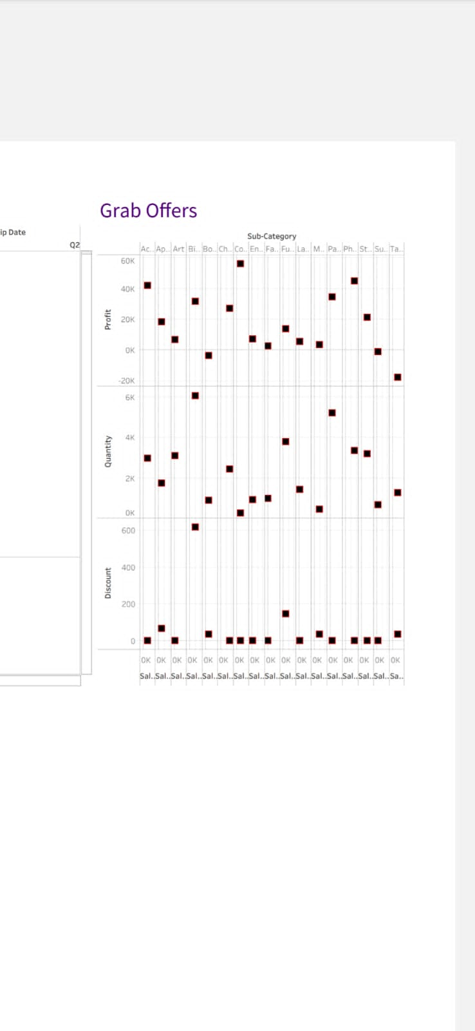

ADVANTAGES

* Talent mobility. Talent mobility is a metric that keeps track of the mobility of employees. ...
* Talent distribution. Talent distribution is another insight that you want to keep track of
* High-potential talent.
* Time to hire.
* Time to full productivity per FTE. .... 

.

DISADVANTAGES

The implementation of talent management program could be expensive in terms of time, resources and financial costs. Lack of support from line mangers can impede the level of commitment from employees.

CONCLUSION

 At the end can say that talent management process has provide new ways to Human Resource department to handle problems faced in hiring talent. By the help of talent management process companies are hiring right person for the right job as per their job requirement and description.