**The Tableau HR Scorecard: Measuring**

**Success in Talent Management**

**1. INTRODUCTION**

This project, titled "Unveiling Market Insights," aimed to analyze spending behavior and identify opportunities for growth through the use of Tableau. The HR function has evolved over the years, from a mere administrative function tasked with payroll and other similar work to becoming key in determining an organization’s approach and strategy. It is vital to understand how effective this function is in executing tasks, and the HR Scorecard gives management insights into the HR department’s success or failures..

**1.1 Overview**

***1.1.1 Objectives:***

* HR Scorecard is a report that you conduct to calculate the success rate of human resource employees and the overall department.
* Any HR professional looking to judge and assess the business performance and productivity rate can start making use of this report to get valuable insights into the work progress.

***1.1.2 Methodology:***

* **Data Collection:** There are many ways to collect data for HR consulting projects, depending on the type, quality, and quantity of data you need. Some of the most common methods are surveys, interviews, focus groups, observations, assessments, and document reviews.
* **Data Cleaning and Integration:** Data cleaning involves identifying and correcting errors, inconsistencies, and missing values in the data, while data integration involves combining data from different sources and formats into a coherent and consistent whole.
* **Data Analysis:** Allows you to prep, analyse, collaborate, and share your big data insights.
* **Insights Generation:** Understand how well the company hires, manages and maintains employees.

**2. PROBLEM DEFINITION & DESIGN THINKING**

***2.1 Empathy Map***

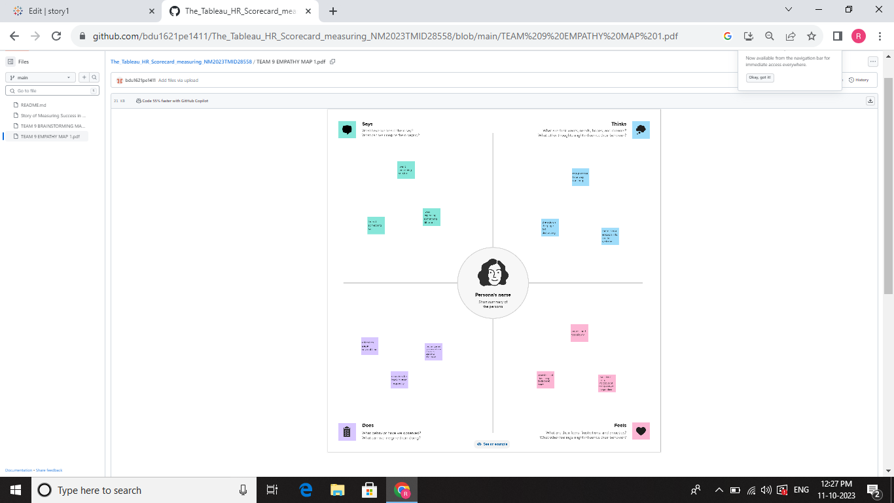

***2.2 Ideation & Brainstorming Map***

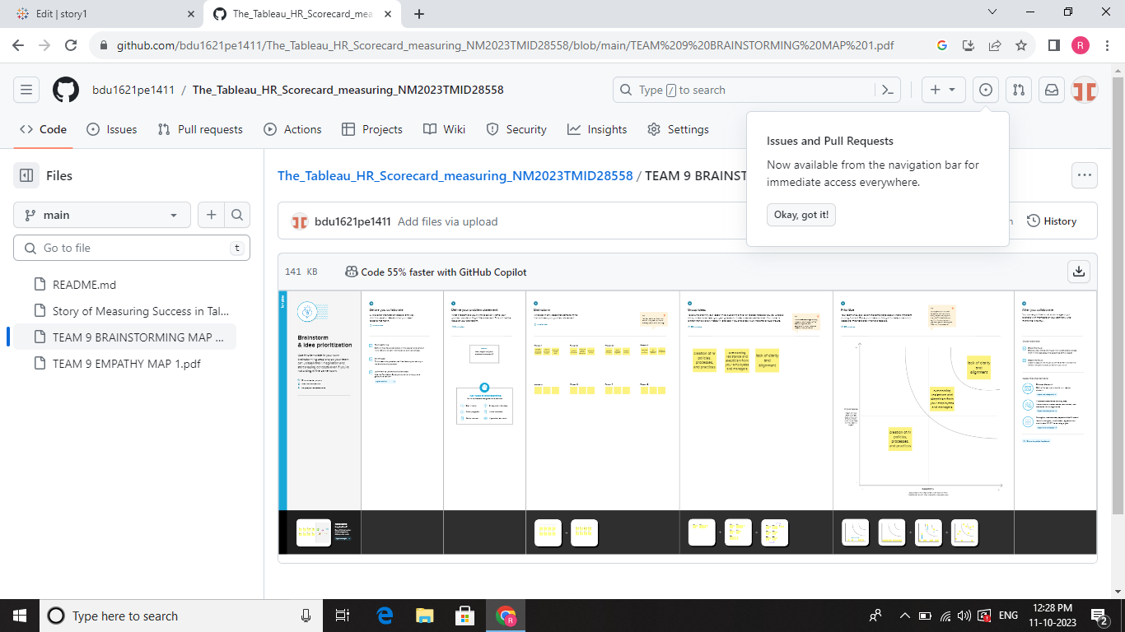

**3. RESULT**

The available dataset opens the door to an array of unique visual depictions. Employing diverse visualization techniques like bar charts, line charts, heat maps, scatter plots, pie charts, maps, and others, provides a versatile toolkit for delving into project performance and efficiency. These visual representations serve multiple functions, including performance comparison, temporal trend analysis, and showcasing the distribution and relationships between variables.

***3.1 Visualizations***

***Stacked bars the tableau HR Scorecard***

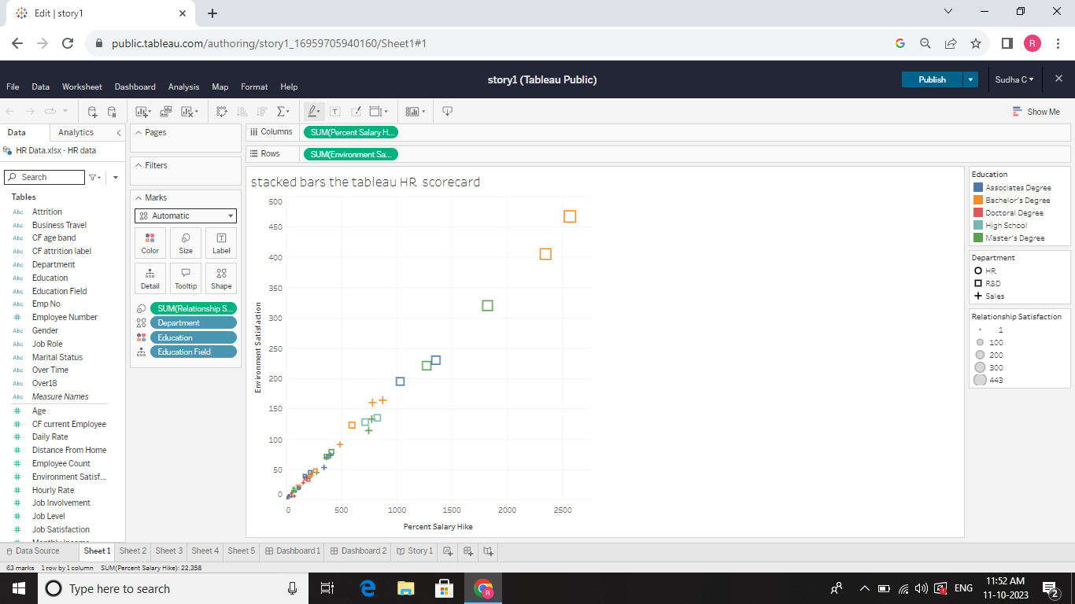

***Education***

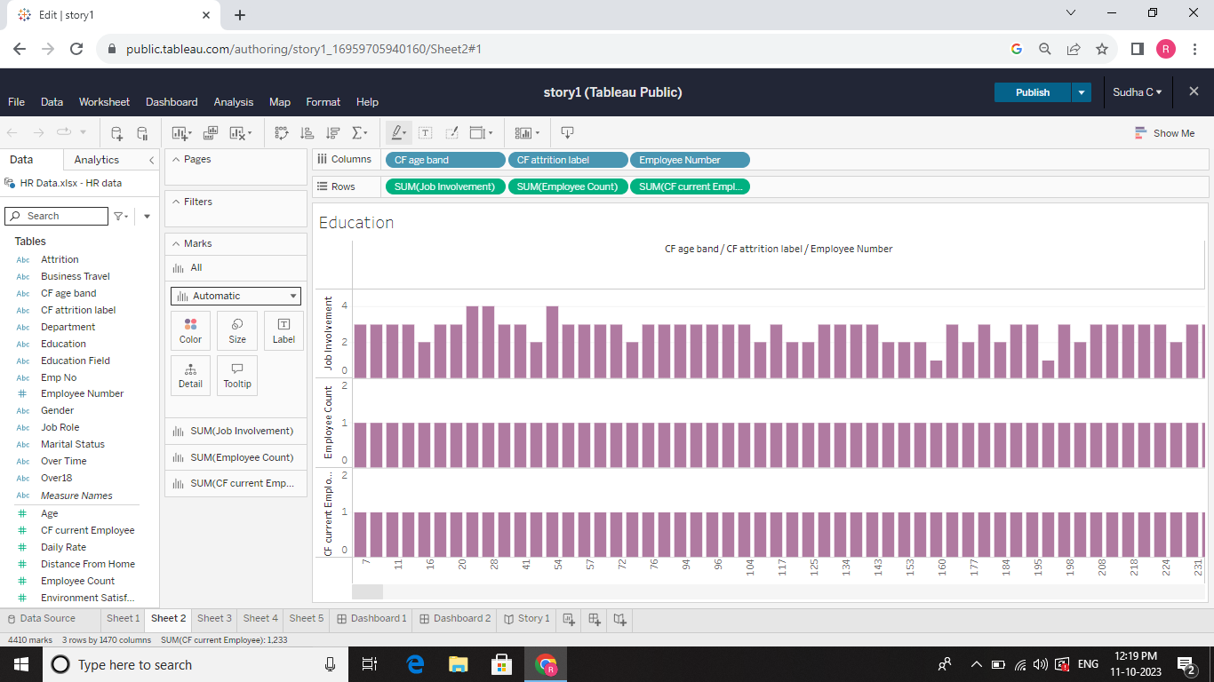

***HR Scorecard***

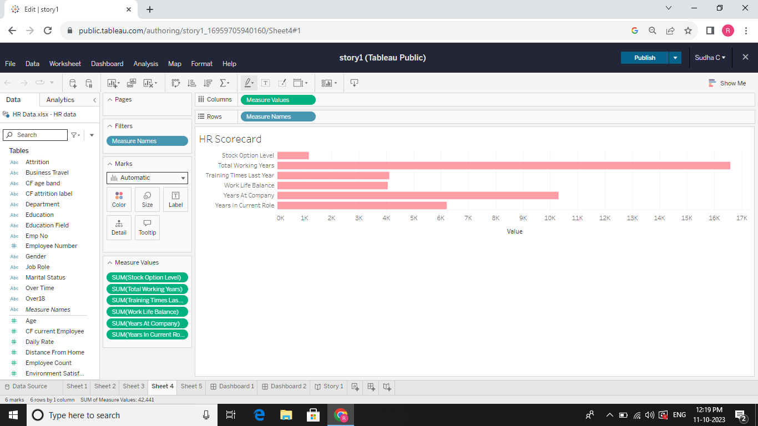

***HR Data***

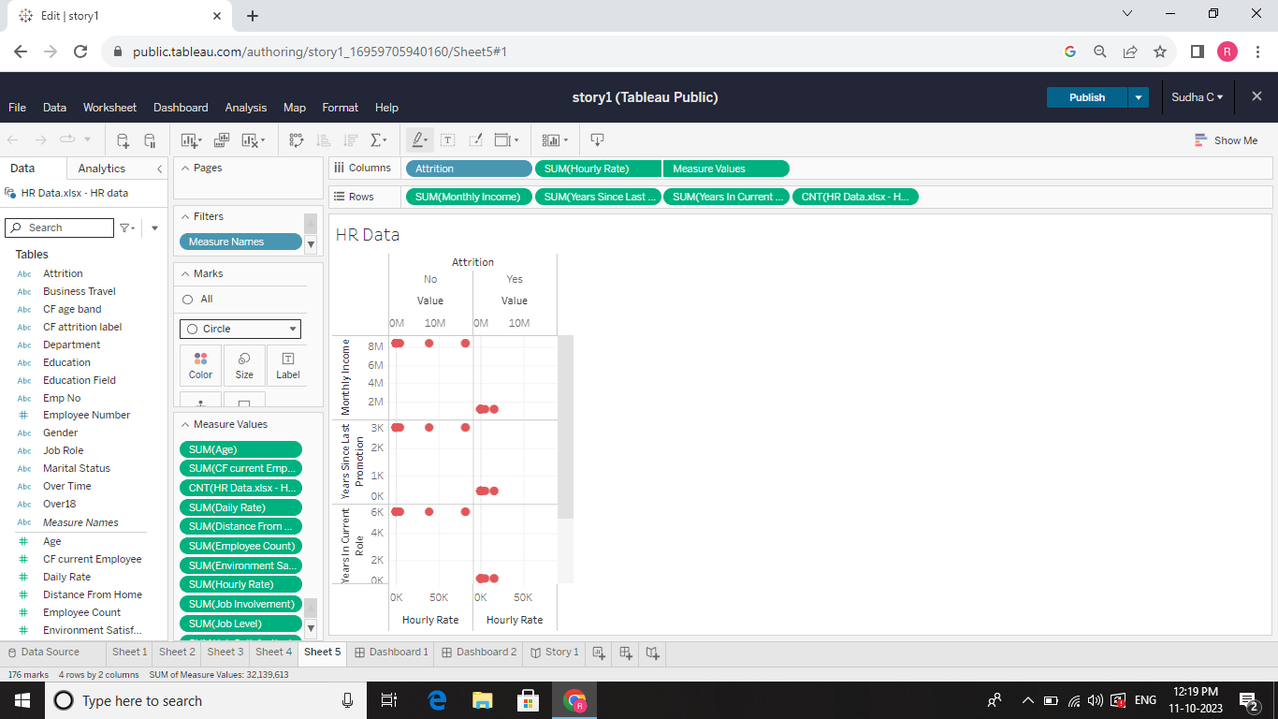

***DASBOAD***

***Education***

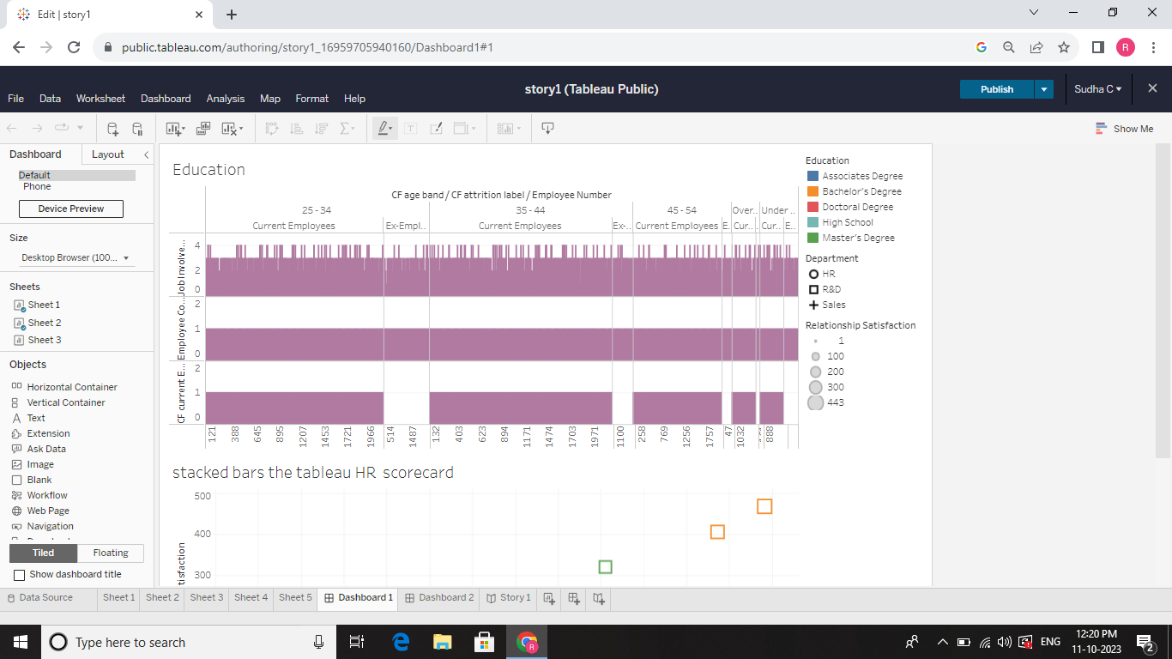

***HR Scorecard & Talent Management***

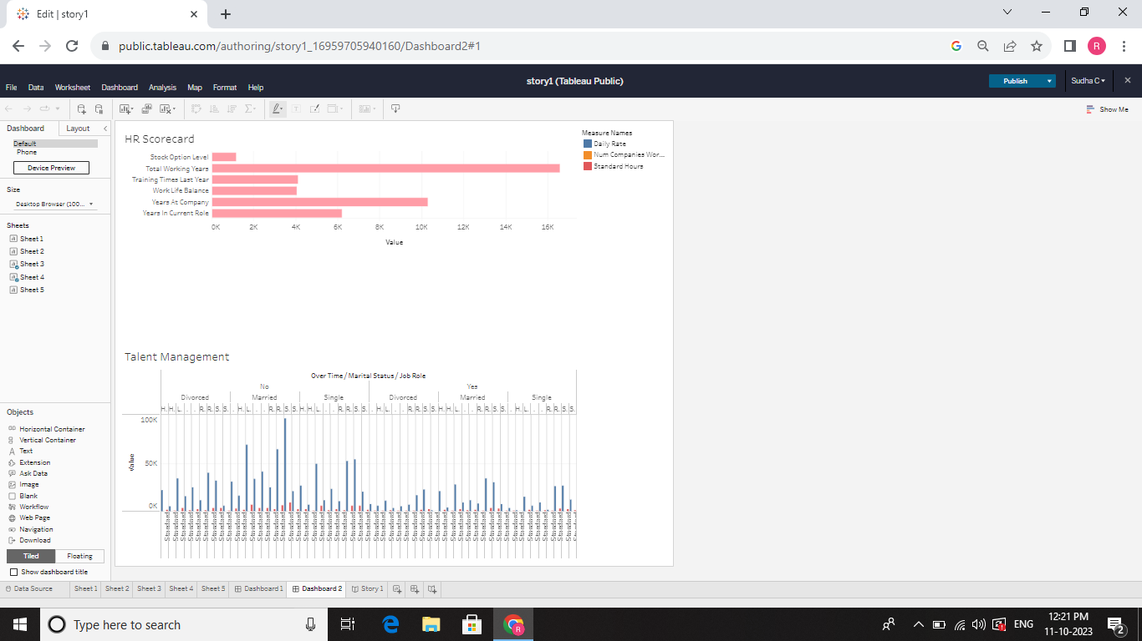

***Story***

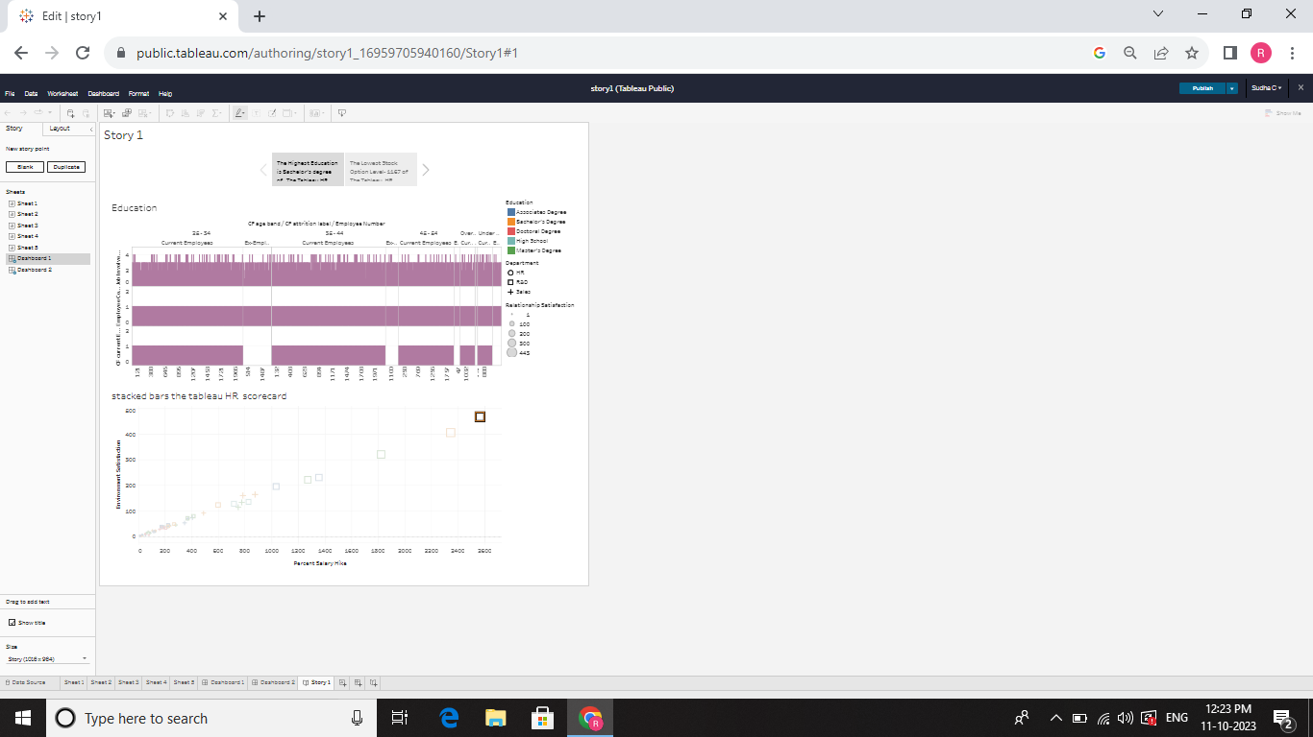

***3.4Performance Testing***

* **Amount of Data Rendered to Tableau:**

The volume of data presented in Tableau is directly influenced by the dimensions of the dataset.

* **Utilization of Data Filters:**





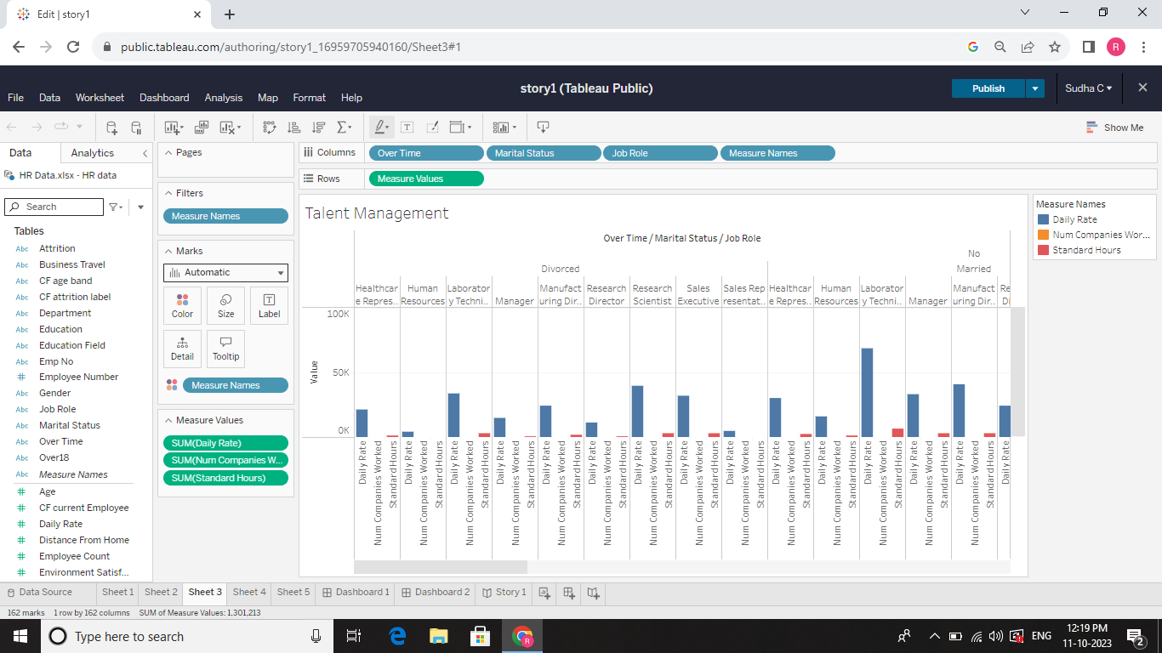



* **No of Visualizations/ Graphs:**

1. **Stacked bars the tableau HR Scorecard**
2. **Education**
3. **Talent Management**
4. **HR Data**

**4. ADVANTAGES & DISADVANTAGES**

***4.1Advantages***

* .Gives structure to the strategy.
* Improves performance reporting.
* Makes it easier to communicate the strategy.
* Connects every HR employee to organizational goals.
* Define your goals and objectives.
* Identify HR deliverables.
* Fetch data and ready your HR system.

***4.2 Disadvantages***

* + ***Even though there are many HR scorecard templates you can use, the framework must be customized to suit your business requirements.***
  + ***This can be time-consuming and tedious-especially for first-time users.***
  + ***HR scorecards can be overly complicated to understand despite there being many case studies and resources to read from.***
  + ***HR scorecards usually require managers to report information, which can cause some resistance and even delays.***

**5. APPLICATIONS**

* + **Scorecards are business intelligence tools that provide a perfect a way to monitor, measure, and manage business performance.**
  + .InetSoft’s scorecards centralize a list of key performance indicators ( KPIs) that compare current performance data against goals, quotas, and target trends.
  + Scorecard applications also include analytic information about what to do when goals or quotas are not met.
  + In this case, scorecards are n invaluable asset to any enterprise.

**6. CONCLUSION**

The HR Scorecard is a great tool when used right. To ensure that it is used right, HR teams have to ensure that the data they collect is accurate and that they are consistent in their measurement of the KPIs.

Keep in mind that the template above is meant as an easy-to-understand example. HR departments need to design suitable scorecards relevant to their organizations. Implemented correctly, the HR scorecard can be an invaluable tool.

.

**7. FUTURE SCOPE**

**Human resource managements is the strategic approach to nurturing and supporting employees and ensuring a positive workplace environment. Its functions vary across different businesses and industries, but typically include recruitment, compensation and benefits, training and development, and employee relations.**

**8. APPENDIX**

A. **Source Code:**