Predicting Traffic Incident Density Using Equity Indicators
By: Bhuvan Dubey (30139765), Andrew Gellner (30027843), Tony Steere (10077801), Lovette Daminabo (30138106)

Introduction
We have been trying to find out if we can predict the occurrence of traffic accidents in different Community Service Areas (CSAs) of Calgary by analyzing factors such as population, and other indicators of equity. Rather than merely counting the total number of incidents, we have now switched our attention to a new concept called "Incident Density," which signifies the amount of incidents that happened in a square kilometer over a year. This method is considered a much better way to represent the actual situation and also connects very well to some past work we have done together. To clarify the situation even more, we have brought in data from several previous years. The purpose of this analysis is to investigate the link between different socioeconomic factors and the traffic accidents' distribution in certain areas.

A model that accurately predicts the places where incidents will be most concentrated is what we are looking for as the ideal outcome, which can be a great help in the selection of security measures and distribution of resources.

The main question is: Can we fit a model of traffic incident density in the different Community Service Areas (CSAs) of Calgary based on a variety of demographic and equity measures?

Methods
Our data sources are from the City of Calgary's Open Data Portal. One dataset details traffic incidents from the year 2022 to the year 2024, including geometric point data. The other dataset details various equity indicators as identified by the 2021 Census, sorted by Community Service Area (CSA). Insofar as both the City of Calgary's traffic incident records and the 2021 Census are considered complete and accurate, both these datasets should be considered accurate and reliable data sources.

This will be a supervised learning problem since we have a single target variable that we are interested in estimating ('Incident Density') and a set of features (demographic and equity indicators) that we will train the model on. More specifically, this will be a regression problem because our target variable ('Incident Density') is a continuous numerical variable. We will be using a Random Forest Regressor model to solve this problem; the Random Forest algorithm is particularly suited for continuous outcome predictions and is adept at capturing the complex relationships between the predictor variables and the target variable.

Data Wrangling Steps:
Initial Load:
- Each of the two datasets (Incidents and Equity) are downloaded in chunks of 25000 records. This is to avoid any unexpected truncation that typically occurs around 50000 records. Limiting to 25000 per pull helps ensure that our process will be requesting well below the website's limit per request
- To ensure consistency, the same procedure get_data() is used to retrieve both datasets, which are then saved into distinct dataframes

General Cleanup:
- Refine_incidents and refine_equity contain all the unique treatments required for each respective dataset
- Each procedure includes standards functions like dropping nulls, unnecessary columns, reordering columns, and renaming
- Each procedure also projects into epsg=3395 to ensure the datasets are join compatible

Incidents Specialized Cleanup:
- Add a calculated column for year. Only 2022, 2023, 2024 will be used for the model so this column is important to filtering and aggregation

Equity Specialized Cleanup:
- Filter to area_type = 'CSA' (as various other disparate geographic groupings exist in the dataset, and our model level is based on the CSA level)
- Retain csa and geometry, pivoting all the attributes and values across columns (initially all attributes exist in a stack where each record is a different attribute)
- After pivoting, convert again to a GeoDataFrame as its geographic status will be lost during the pivot
- Define a list of the metrics which are truly rates, and divide them by 100 so the format is more intuitive (initially values like 10.5% would have a value of 10.5 - setting them to a format like 0.105 helps later interpretation)
- Calculate the Square Kilometer Area (Sq KM Area) of each CSA based on its geometry.area value
- Calculate the Population Density (Population Per Sq KM) by dividing population count by [Sq KM Area]
- Filter to only the middle 90% of data based on Population Density (exclude below the 5th percentile and above the 95th percentile). There are some extremely dense and extremely sparse CSAs which are not suitable for training the model to predict for typical CSAs
- The count of CSAs excluded is reported by the print functions, for reference purposes

Join the datasets:
- First, df_equity is joined to df_incidents to derive the CSA geography, so that incidents can be aggregated to Incident Year and CSA instead of the Incident's geographic point
- Next, df_incidents is left joined to df_equity based on matching csa. Left Join ensures that CSAs with zero traffic incidents are not excluded. If any such CSAs exist, they are populated with an Incident Count of zero via fillna(0)
- After joining, the variable of greatest interest can now be calculated: "Incident Density", based on the number of incidents per year per Square Kilometer. This variable is the target of prediction in our model.

Model
Random Forest Regressor was the model chosen for this particular prediction task. The first point is that we explicitly stated our target, which was 'Incident Density', and gathered those possible predictors through equity data.

The data was divided into two main components, a set for training the model (about 80% of the data), and a separate set for testing the model (20% of the data). The performance of the model can be quantified with new data which will serve as a proper measure of the model's usefulness in real-life instances.

The `RandomForestRegressor` model was then set up for training after the training data had been prepared. We modified a few hyperparameters to achieve the desired model and exposed the model to the training data. The R-squared scores for both training and testing sets were checked because they show the amount of variation in Incident Density which can be attributed to our model. Moreover, as a form of cross-validation, training data was subjected to mini-testing which is similar to allowing the model to go through a series of tests to confirm that it is not merely overfitting the particular training data but rather has learned to generalize well. To have a glimpse of the potential discrepancies in our predictions, we worked out the Mean Squared Error and the Root Mean Squared Error.

A scatter plot was generated to compare the model's predictions to the actual Incident Density visually. Finally, we calculated the permutation importance in order to get an idea of the predictor variables' importance in the model's predictions. This helped identify the factors that were the most critical for the model when it made its predictions.

Results
Our Random Forest Regressor model achieved a Test R-squared value of 0.9242, with a mean cross-value R-squared value of 0.88 ± 0.10, and a root mean squared error of 1.21 (Table 1). The primary change in our model, replacing our variable of interest, Incidents Rate, with a new measure, Incidents Density, significantly increased our model's accuracy, and we further expanded our datasets with data from previous years to provide a greater base of records on which to train and test the data.

Table 1
Model Performance Metrics
Metric | Value
Train R² | 0.9808
Test R² | 0.9242
Mean CV R² | 0.88 ± 0.10
MSE | 1.46
RMSE | 1.21
R² (Overall) | 0.92
Note. R² = Coefficient of determination; CV = Cross-validation; RMSE = Root Mean Squared Error; MSE = Mean Squared Error

Figure 1

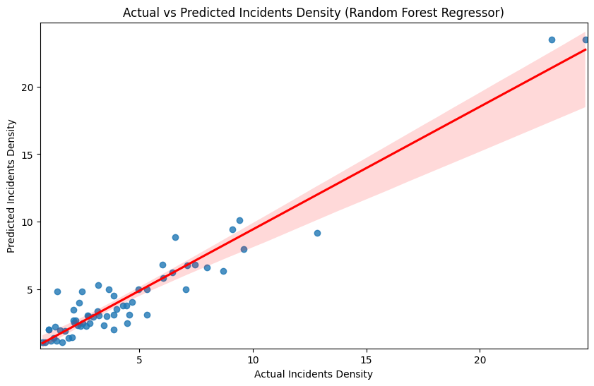
The graph above of linear regression is a visual representation of the correlation between the predicted and actual incident densities from the Random Forest Regressor. The data points are represented by blue dots, where the y-axis refers to the predicted values and the x-axis to the actual values. The red line indicates the perfect scenario where predictions equal actual values and the shaded red area shows the confidence interval. The majority of the points are positioned near the red line which means that the predictions are very close to the actual values. So the Random Forest Regressor model was competent in approximating incident densities to their true values when assessed through the small errors in the performance depicted in the visualization.

Figure 2
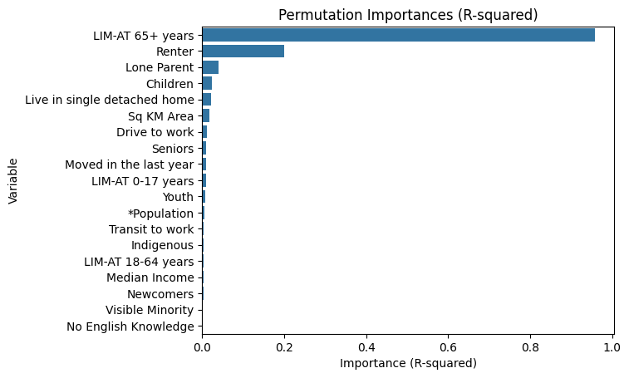

This graph displays the permutation importance of various variables in predicting incident density, measured using the R-squared metric. Each bar represents how much the model’s accuracy decreases when that specific variable is randomly shuffled, indicating its relative importance. The results show that the proportion of individuals aged 65 and older living below the low-income measure (LIM-AT 65+ years) is by far the most influential factor, followed by renter status and lone-parent households. The impacts of other factors, mainly the presence of children, the size of the area, and work or housing characteristics, are very small as far as the model's performance is concerned. So the graph shows the fact that at the top of the list of variables explaining the variance in incident density are the socioeconomic ones, especially income and housing status.
Figure 3
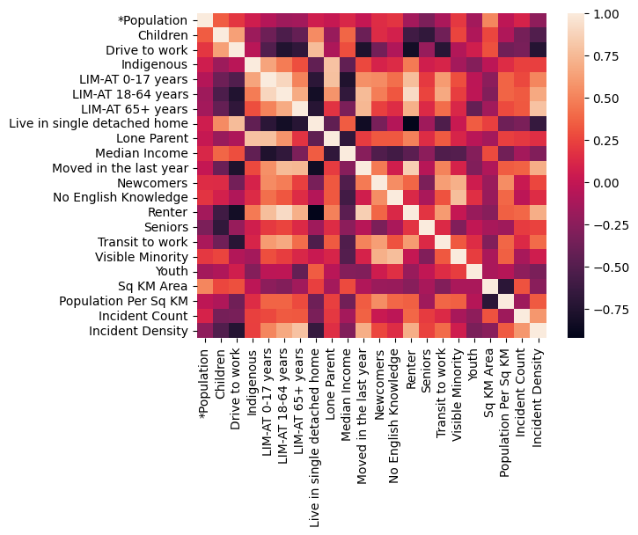
The heatmap shown above indicates correlations between different variables within the combined dataset. Our target variable, Incident Density, indicates relatively strong correlations with a few different predictor variables, including positive correlations with LIM-AT 65+ years, Moved in the last year and Renter, and negative correlations with Drive to work and Live in single detached home. Our model will very likely weigh variables with strong correlations highly (whether they be positive or negative correlations), which would likely indicate that these variables will play a significant role in how the model estimates Incident Density.

Discussion
As our heatmap above indicated, after analyzing the model's performance, some of the variables with strong correlations have strong permutation importance scores, with the strongest scores belonging to LIM-AT 65+ years and Renter. In particular, the former provides an R-squared importance of approximately 0.95, which indicates a very strong importance in the model's performance, while the latter provides an R-squared importance of approximately 0.25. As we indicated in the heatmap above, both of these variables have positive correlations with Incident Density, indicating that higher values in these variables provide a correspondingly higher value in Incident Density.

Despite other variables with strong correlations placing relatively high in the list of predictor variables sorted by permutation importance, none have an R-squared importance higher than 0.05, indicating that these variables play a comparatively small part in the model's predictive performance. In particular, the third most important predictor variable (after the two strongest mentioned above) was Lone Parent, which according to the heatmap has a very weak positive correlation. This indicates that while a few variables with strong correlations may play a large role in the model's predictive performance, after the model takes those variables into account, the next one that the model uses may have a very weak correlation, but combined with the initial variables has a greater predictive performance.

Based on the analysis we've done using the Random Forest Regressor model, we were able to predict Incident Density with a pretty good degree of accuracy. We hit a Test R-squared of 0.9242, which feels quite promising. What this really tells us is that the equity indicators we decided to look at, especially 'LIM-AT 65+ years' and 'Renter', seems to be genuinely significant when it comes to predicting where we see more traffic incidents across Calgary's different Community Service Areas. It's interesting how those two indicators popped out as being so important.

Our main goal with this was to build a model that could actually predict Incident Density using these demographic equity indicators. Looking at the results, I think it's fair to say we managed to achieve that with a reasonable level of success. The numbers from the model's performance suggest that it holds up pretty well when we feed it new data, as long as that data falls within the population density range we focused on during the training.

So, when considering what's next, one option could be to investigate more deeply the cause of the very strong relationship between 'LIM-AT 65+ years' and 'Renter', which is one of the most important factors in the model. It will also be good to look at and try to find other factors that could push the model's performance even further. Different modeling techniques are, as mentioned earlier, for instance, the Ridge Regression, will certainly help in revealing the worth of each predictor. Furthermore, it will be advantageous to look into the areas of the model's prediction where it was quite far off, to see if there are unique characteristics of those CSAs that we are not capturing in the data or modeling process. Lastly, it will be of immense help to get in touch with the municipal officials responsible for urban planning and traffic control, so that we can not only talk about but also actually implement the research findings in practice through interventions focusing or resources distribution in high incident density locations or in areas that have a larger share of the demographic groups we have identified.

References
City of Calgary. (n.d.). Traffic Incidents [Data set]. City of Calgary Open Data Portal. https://data.calgary.ca/Transportation-Transit/Traffic-Incidents/35ra-9556
(Accessed October 16, 2025)
City of Calgary. (n.d.). Calgary Equity Index Overlay Statistics [Data set]. City of Calgary Open Data Portal. https://data.calgary.ca/Demographics/Calgary-Equity-Index-Overlay-Statistics/7g5f-dkmi
(Accessed October 16, 2025)

