DATA 611 Predictive Analysis
Group Assignment 2
Semester: Winter 2026
Date: Feb 26th, 2026
Group: Group 3
Group Members: Bhuvan Dubey (30139765) and Andrea Abenoja (30021197)

1. Principal Components Analysis (PCA)
a) Considering feature selection filter methods.
What method would you use to evaluate variables to remove?
I would use a correlation or variance-based filter to check which features are weakly related to the target or have very low variance.
If any, which variables would you filter out?
I would filter out features with little variation or no clear relationship to the target. For example, features that are almost always the same for all images.
Why?
Removing these features reduces noise and speeds up modeling without losing useful information.
b) Considering feature selection wrapper methods. Assume you will be running a k NN where k=5 after reducing the dimension of your data.
What method would you use to evaluate variables to remove?
I would use the Sequential Forward Selection (SFS) with a k NN where k = 5 classifier. This is a wrapper method that tests different combinations of features and keeps only the ones that give the best model accuracy. I would use accuracy as the scoring metric and perform 2-fold cross-validation.
Use accuracy as your scoring attribute. Run the code for 10 features and show your results.
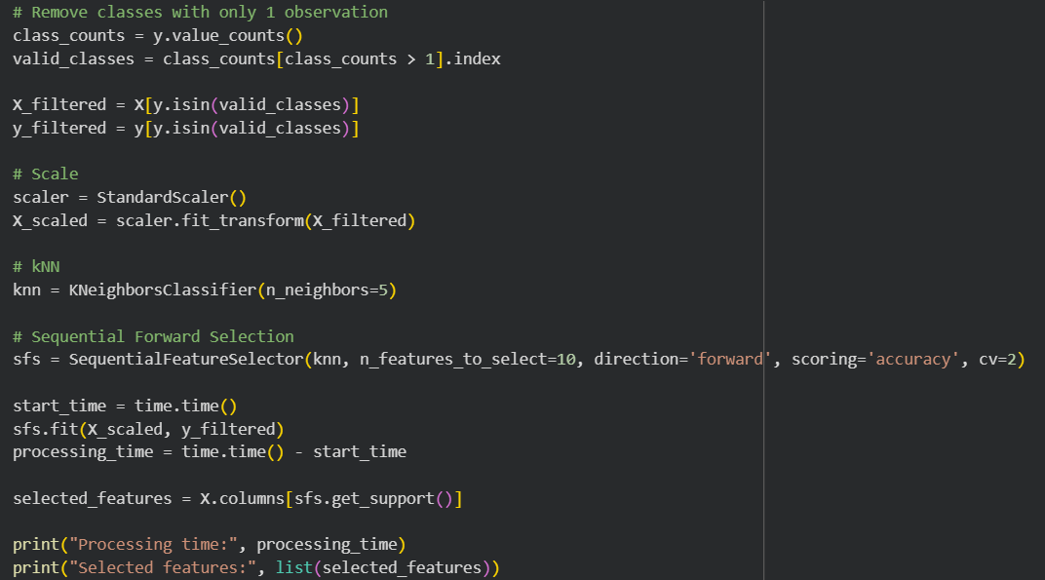
Processing time: 196 seconds (rounded to the nearest whole number)
Selected features: ['Male', 'Asian', 'White', 'Youth', 'Senior', 'Bald', 'No Eyewear', 'Bushy Eyebrows', 'No Beard', 'Strong Nose-Mouth Lines']
How long did it take and why do you think this happened?
It took 3 minutes and 16 seconds to run (196 seconds).
It took this long because SFS tests many different feature combinations. For each step, the model is trained multiple times using cross-validation. Since we started with 73 features and selected 10, the code had to evaluate hundreds of models. This repeated training increases processing time. Even though it takes longer, wrapper methods usually give better feature selection because they choose features based on actual model performance.
c) Assuming your predicting variables are all the 73 characteristics (every column except “person” and “imagenum”. What is the linear relationship between your predicting variables and your target variable? Is this information relevant to us if we are running PCA? Why?
If we use all 73 characteristics as predictors, the target variable “person” is categorical (it represents different people). So there is no clear linear relationship between the predictors and the target. Linear relationships apply to continuous outcomes, not to class labels like names. The predictors may be linearly related to each other, but not directly to the “person” variable in a linear way.
No, this information is not important for PCA because PCA does not use the target variable. PCA is an unsupervised method which only looks at the relationships and variance among the predictor variables to reduce dimensions. It does not consider the “person” column at all.
d) Partition your data into 30% testing data and 70% training data. Use a ‘random_state’ value of 100.
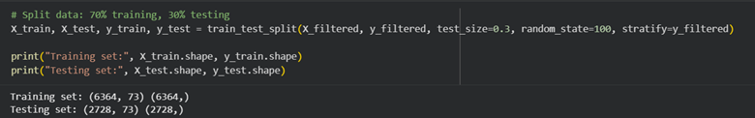
e) Does your data need to be normalized? Why?
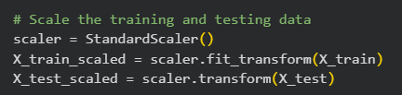
Yes, this needs to be normalized. The 73 features are on different scales, and both kNN and PCA are sensitive to feature magnitude. If not normalized, features with larger values would dominate distances and variance, which could bias the results.
f) Using all 73 characteristics run a PCA. Show your code.
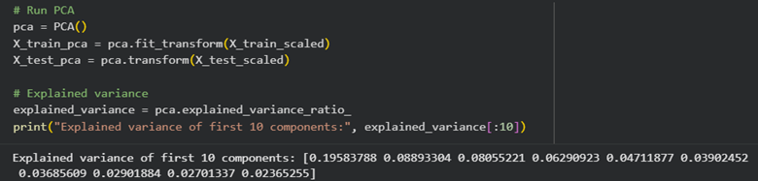
g) Which principal components should you keep to explain at least 80% of the data? Why? (Show the appropriate plot to support your answer)
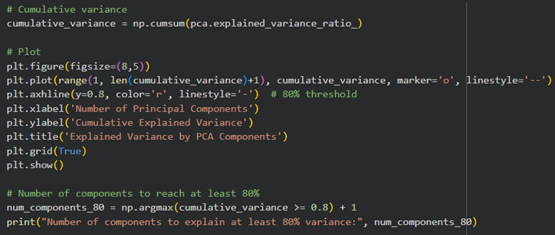
To explain at least 80% of the data, you should keep the first 21 principal components.
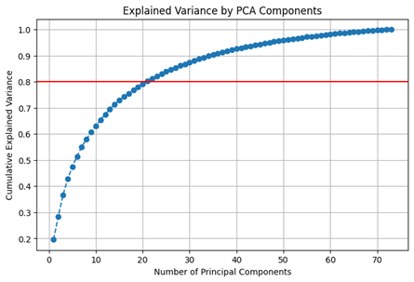
The cumulative explained variance plot shows these components capture 80% or more of the total variance. This reduces the number of features while preserving most of the important information.
h) What would be the % of data explained be if you used only the first 2 principal components?
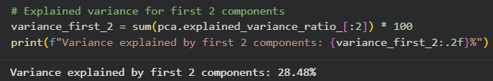
The first two principal components capture about 28.48% of the total variance in the data.
i) Show the eigen values and eigen vectors for the first two PCs.
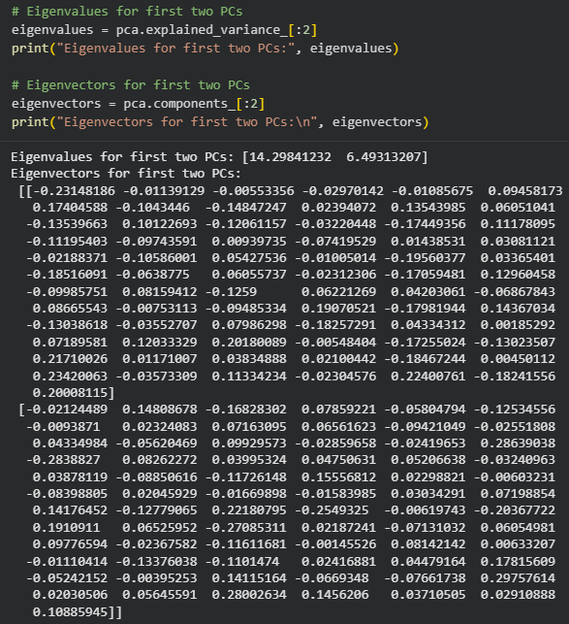
j) Calculate the loads for the first 2 PCs for each variable and show them below
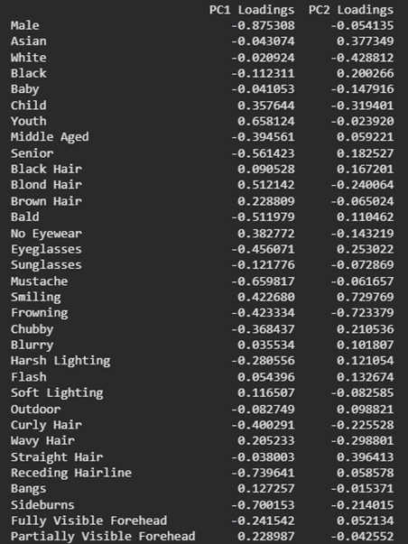
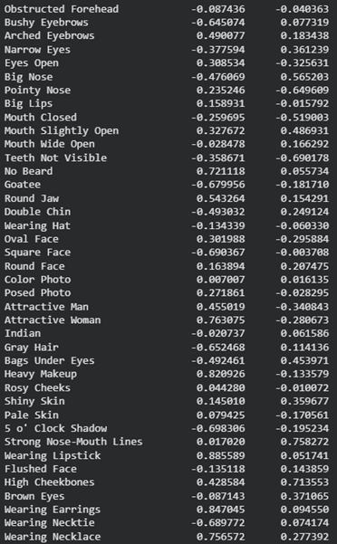
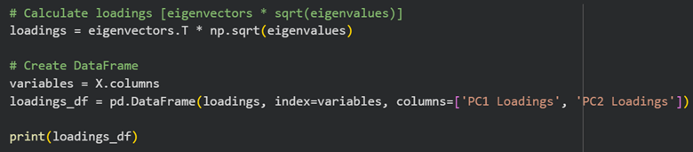
k) Describe each PC based on what can be observed in the loadings’ chart.
PC1 separates faces mainly by gender and appearance. Features like Wearing Lipstick, Heavy Makeup, Wearing Earrings, Attractive Woman, and No Beard are positive which represents feminine traits. Features like Male, Receding Hairline, Sideburns, Goatee, Square Face, and Mustache are negative which represent masculine traits.
PC2 separates faces by facial structure and expressions. Features like Strong Nose-Mouth Lines, High Cheekbones, Smiling, and Bags Under Eyes are positive which represents facial shape, expression, and age. Features like Pointy Nose, Mouth Closed, Teeth Not Visible, and Attractive Woman are negative which shows contrasting facial traits.
l) Plot the values for the first 2 PCs as a scatterplot. Include the PCs’ loads as vectors. What can be concluded from this visual?
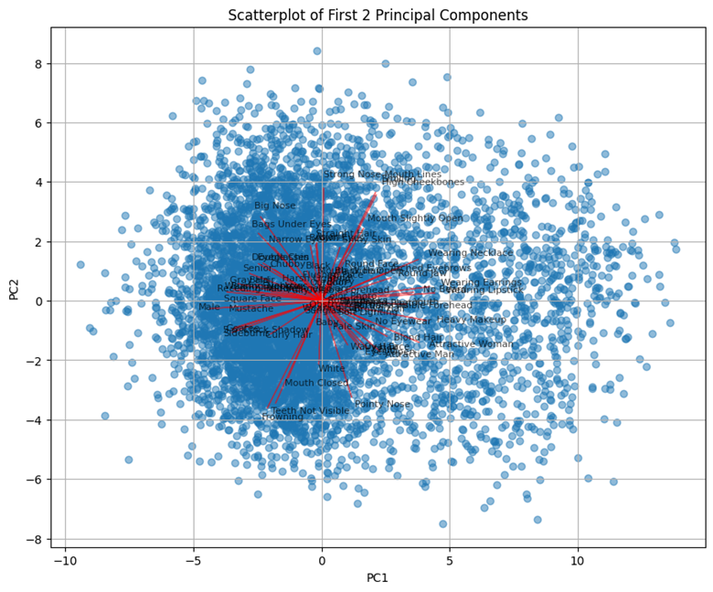
The scatterplot shows how the data spreads along the first two principal components, showing patterns/groups. The red vector point to the most important features, with longer arrows means a stronger influence. Vectors pointing the same way show features that are related and affect the data similarly. For example, "Attractive Woman" and "Heavy Makeup" point together, meaning they often appear together. This plot helps us see which features explain most of the differences in the data and how they connect.
2. K-means Clustering
a) Write In the Q2_kmeans.py file, complete the error() part in the Kmeans class (see the “YOUR CODE HERE” part in the file). error() takes as input the data used in fit (X), the indices of each examples’ nearest mean (y), and the current value of means (means). It returns the value of this above objective function. Submit this code. What trend do you observe if you print the value of this error after each iteration of the k-means algorithm?
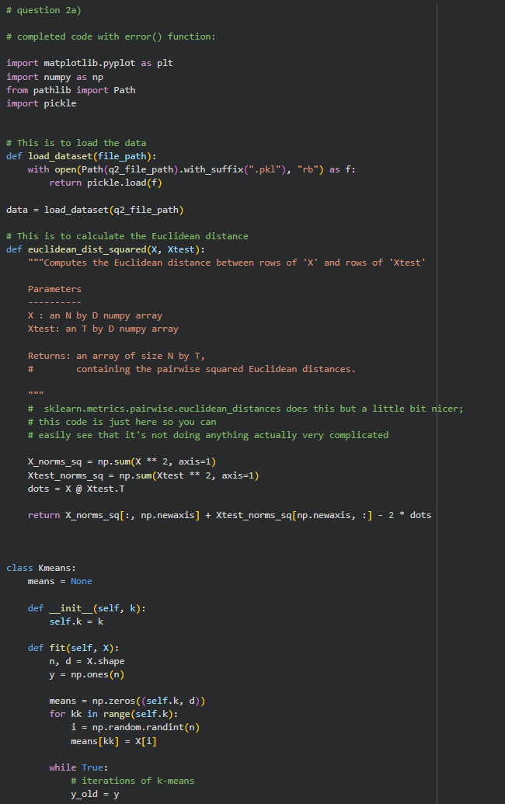
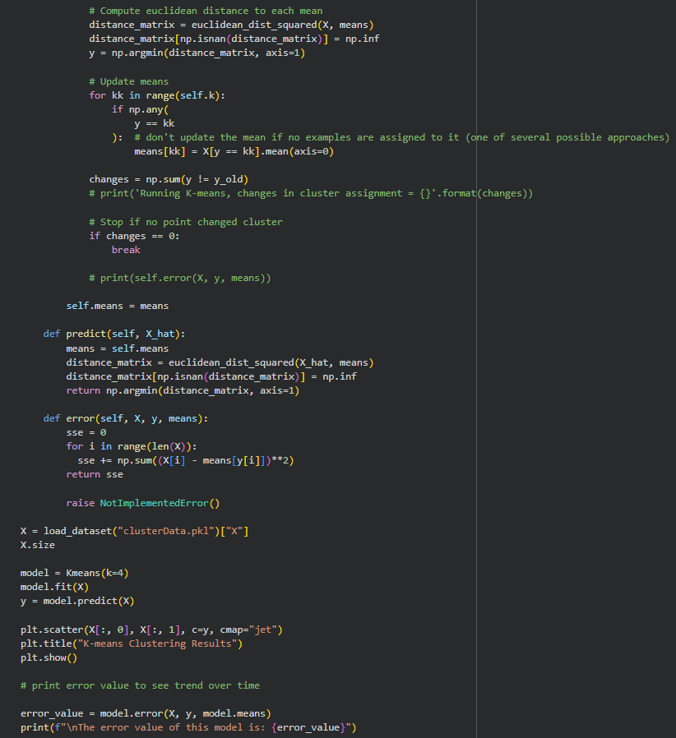
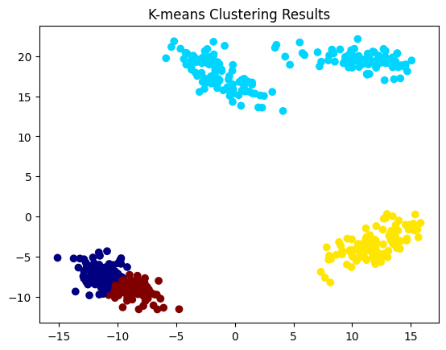
The error value after running the model 5 times was:
- 3071.4680526538546
- 9370.487700095811
- 3071.4680526538546
- 9526.611137118103
- 9370.487700095811
The trend observed after running the model 5 times is that the SSE value changes with each run due to the random initialization of cluster centres as mentioned in the question. The error value mainly fluctuates between ~3000 and ~9000. This suggests that the clustering algorithm sometimes gets trapped in a suboptimal position due to where the cluster was randomly centered. This provides evidence that the initialization step is extremely important to ensuring that SSE is minimized in the model.
b) Run k-means 50 times (with k = 4) and take the one with the lowest error. Report the lowest error obtained. Visualize the clustering obtained by this model and show your plot.
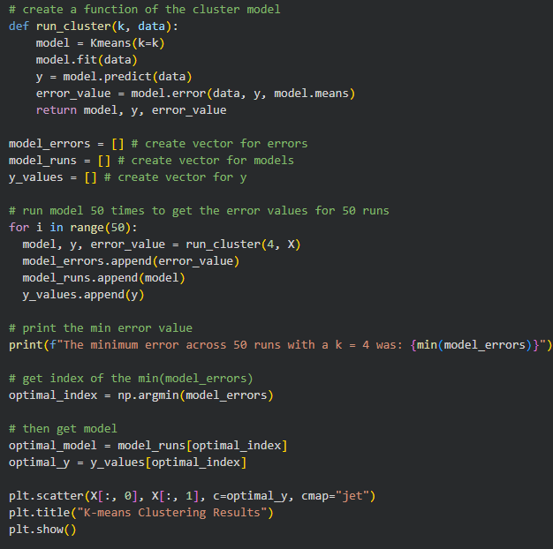
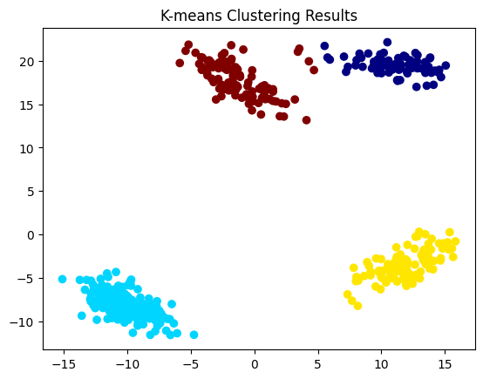
c) We now turn to the task of choosing the number of clusters k. Explain why we should not choose k by taking the value that minimizes the error value.
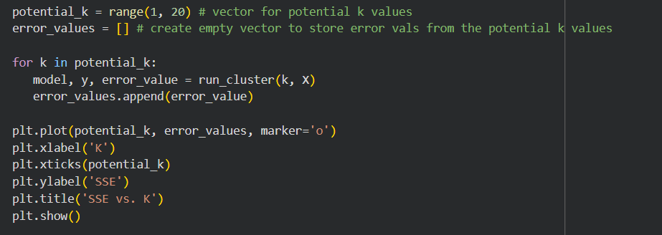
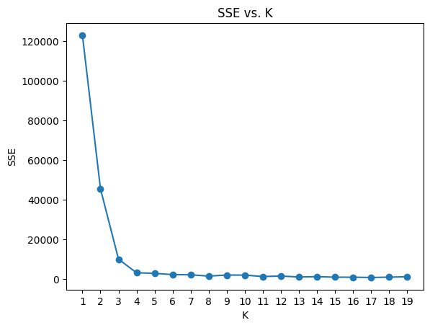
In theory, we should not choose k by taking the value that minimizes the error value because as you increase k (which is the number of clusters), error will always decrease. For example, if your dataset contains 50 points and k is increased to 50, error decreases because each point becomes a cluster. However, plotting the SSE vs k in an elbow plot, such as above, can help us determine the best k to use. For example, the elbow point for the plot is k = 4, meaning the optimal number of clusters for this model would be k = 4. Beyond this point, clustering quality will not significantly improve.
d) Is evaluating the error function on validation (or test data) a suitable approach to choosing k?
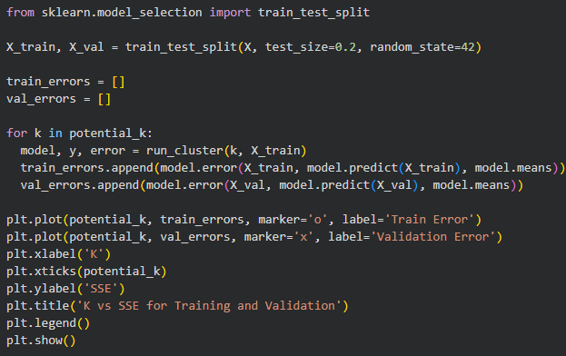
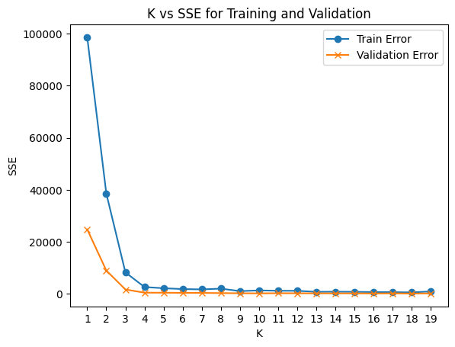
Utilizing the error function on validation data will give a similar result to utilizing the error function on test data for the same purposes written in 2c. In the plot above, the elbow point for both the train and validation data is k = 3.
e) Show a plot of the minimum error found across 50 random initializations, as a function of k, taking k from 1 to 10.
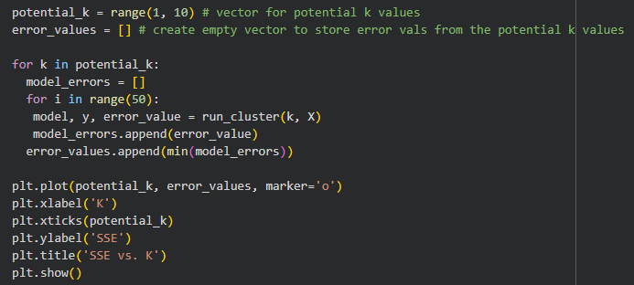
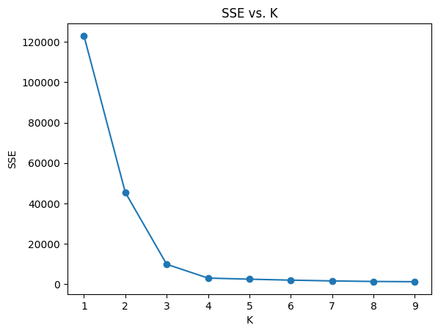

f) The elbow method for choosing k consists of looking at the above plot and visually trying to choose the k that makes the sharpest “elbow” (the biggest change in slope). What values of k might be reasonable according to this method? (Note: there is not a single correct answer here; it is somewhat open to interpretation and there is a range of reasonable answers.)
The elbow plot in question 2e shows the elbow at k = 3. At k = 3, the rate of decrease in SSE is no longer as steep and as k increases, the slope of the SSE becomes more flat. This means that after this point, adding more clusters, or increasing k, will not drastically improve SSE within the model.
3. Short Answer Questions. Write a short one or two sentence answer to each of the questions below.
a) Among L0-regularization, L1-regularization, and L2-regularization: Which yield sparse solutions (zero coefficients)?
L0-regularization and L1-regularization can give sparse solutions (zero coefficients). L2-regularization is not likely to give sparse solutions.
b) How does the hyper-parameter affect the shape of the Gaussian RBFs bumps? How does it affect the fundamental tradeoff?
The hyper-parameter determines how wide the Gaussian RBFs will be where small values lead to narrow bumps that capture fine detail (may overfit), while large values lead to wide bumps that create a smoothing effect for the data. This trade-off affects the balance between bias and variance.
c) Describe a dataset with k clusters where k-means cannot find the true clusters.
For a situation where there are overlapping clusters or non-separated clusters, k-means clustering may fail to identify the actual clusters. This is because it is based on distance and assumes spherical clusters.

d) Why do we need random restarts for k-means but not for density-based clustering?
Random restarts are required for k-means clustering because it can get stuck in local optima depending on the initial centroid choices. However, density-based clustering is not very sensitive to starting points and can therefore be run with a single initialization, without the need for multiple restarts.
e) Can hierarchical clustering find clusters with “peculiar shapes”?
Whether hierarchical clustering can find clusters with "peculiar shapes" depend on a few factors. There are 2 main methods of hierarchical clustering: agglomerative and divisive. For peculiar shapes like the one shown, agglomerative hierarchical clustering may be a better method to properly cluster data with peculiar shapes as each point starts with its own cluster and is then merged step by step by distance, as opposed to divisive, where each point will start with one cluster and are later split depending on variance and not distance. To elaborate, splitting clusters by variance, such as in divisive hierarchical clustering, assumes clusters are compact and roughly spherical, which is why splitting utilizing this method is not ideal for spiral shapes like the example provided.
While agglomerative hierarchical clustering may be a better method of finding clusters with peculiar shapes due to the utilization of distance instead of variance, agglomerative hierarchical clustering also relies on specifying a linkage criterion. Agglomerative hierarchical linkage methods include single linkage and complete linkage. Single linkage agglomerative hierarchical clustering is the best method to find peculiar shapes as it merges clusters based on distance between each cluster as the difference between their two closest points, allowing the cluster to follow the natural flow of data and can chain along unusual shapes.
f) Are neural networks mainly used for supervised or unsupervised learning? Are they parametric or nonparametric?
Neural networks are primarily supervised learning as the goal of neural networks is to map out the relationship between the model inputs (X) and the pre-defined outputs (Y). For example, use cases of supervised learning neural networks includes image classification algorithms, like correctly classifying an image of an animal to the animal type.
Neural networks are also parametric as these models have a fixed number of parameters/weights that are pre-defined when developing the model. Therefore, the introduction of new data would not affect the number of parameters.
g) What is the significance of choosing k = 2 (k = 2 is after PCA) for visualizing with PCA.
If you were to choose k = 2 after conducting PCA, you are utilizing only 2 principal components. In other words, you choose to reduce the data to 2 dimensions, which allow for easier visualization. Most visual plots are in two dimensions, the x and y axis. PCA orders components by how much variance each component captures. Usually, the first two components capture the most variance in the dataset, which allow these two components to retain data structure information, while reducing noise. These two principal components can then be easily plotted in a 2D graph where the first principal component is plotted on the x axis and the second principal component is plotted on the y axis.
h) Why doesn't it make sense to do PCA with k > d? (d is the number of features in the original data, k is what we obtain after PCA)
It is not possible to do PCA with k > d as k cannot exceed d. If k is obtained after PCA, then k is the number of principal components. Principal components are linear combinations of the original features and are weighted sums of the original variables. Therefore, we only have as many components as we have features to combine. For example, if there are only 4 features (d), there will only be 4 principal components (k), as those 4 components will capture all the variance in the dataset.

