Insights into Suncor (TSX:SU) Stock Prices from January 2015-January 2026

DATA 611 Predictive Analysis
Group Project 1: Data Visualization

Semester: Winter 2026
Date: January 28, 2026
Group: Group 3
Group Members: Bhuvan Dubey and Andrea Abenoja

Introduction
As one of Canada’s highest revenue industries, the oil and gas sector is a key contributor to the country’s energy and economic output. As of 2026, gasoline and petroleum bulk stations, wholesaling, oil drilling and gas extraction, and petroleum refining comprises the top 10 industries by revenue in Canada¹. Suncor, an energy company founded in Canada, has operations across all of these sectors and continues to play a major role in the country’s energy landscape. In November 2025, Suncor released their third-quarter financial results during which Suncor CEO, Rich Kruger, announced that he “strongly believes in buying our stock is our best investment”².

To examine this claim, this project will explore key trends from Suncor’s stock (TSX:SU) performance using data visualization to identify patterns, shifts, and periods of volatility that reflect how the market has valued the company from January 2, 2015 to January 21, 2026. As a publicly traded stock, examining trends in Suncor’s performance can offer useful insight and inform investment decisions to prospective investors by highlighting patterns in price movement, risk, and market activity. This analysis aims to address three questions: how have Suncor’s stock prices evolved over time, how volatile and extreme its returns have been and whether trading activity or seasonal patterns influence market behaviour.

Data Summary
Source:
The Suncor Stock (TSX:SU) was extracted using Google Sheet’s GOOGLEFINANCE() function, which serves as a data retrieval interface with Google Finance and allows programmatic access to publicly available financial market data. More specifically, a combination of 3 formulas were utilized (see Key Variables section) which output 3 independent datasets to retrieve the Date, Closing Price, the Highest Price, the Lowest Price and the Daily Trading Volume. The dataset was further prepared through manual data wrangling by joining the 3 datasets together in 1 table, using Date as the primary key value. Date was further prepared using the TEXT() function to format as “yyyy-mm-dd”.

Dimensions & Key Variables:
The dataset’s shape consists of 2770 rows and 5 columns (2770 x 5). More specifically, there are 2769 observations, with 1 being the header.

The 5 key variables in this dataset include date (in the format “yyyy-mm-dd”), closing price (closing_price), high, low and daily trading volume (daily_trading_volume). As mentioned previously, these variables were obtained using the following GOOGLEFINANCE() formulas in Google Sheet:
- closing_price: =GOOGLEFINANCE("TSE:SU","price",DATE(2015,1,1),TODAY(),"DAILY")
- high: =GOOGLEFINANCE("TSE:SU","high",DATE(2015,1,1),TODAY(),"DAILY")
- low: =GOOGLEFINANCE("TSE:SU","low",DATE(2015,1,1),TODAY(),"DAILY")
- daily_trading_volume: =GOOGLEFINANCE("TSE:SU","volume",DATE(2015,1,1),TODAY(),"DAILY")
where closing_price is the closing price of the specified day, high is the specified day’s highest price, low is the specified day’s lowest price, and daily_trading_volume is the total shares traded for that specified day.

Results and Key Takeaways
A total of 7 figures were created to explore the price movement, risk, and market activity of Suncor stock and provide insight to answering the three questions: how have Suncor’s stock prices evolved over time, how volatile and extreme its returns have been and whether trading activity or seasonal patterns influence market behaviour.

A line chart was utilized to illustrate the long-term price trend from January 2, 2015 to January 21, 2026 (Appendix 1). From the chart, there is a steep drop in price (about 45%) beginning in 2020 and lasts until 2022. From 2022, the price steeply increases, returning back to the price they were before 2020. The extreme decline in price over this period coincides with the onset of COVID-19, which significantly disrupted the energy market³. The price stagnates from 2022 to 2024, but gradually increases. As of 2025-2026, Suncor stock prices appear to be steadily rising, reaching an all time high in January 2026.
To analyze the distribution of the daily returns, a frequency histogram was used (Appendix 2). The histogram shows that most daily returns are clustered near 0%, which is indicative of small day-to-day price movements. However, the histogram is right-skewed which suggests that, although most trading days have modest price changes, there are occasional periods of unusually large positive returns.

With further analysis on return volatility by year (Appendix 3), the box plot demonstrated that Suncor’s daily returns are generally not highly volatile as the interquartile ranges are relatively narrow for most years. An exception occurs during 2020-2022 where the wider spread may have been due to the same reasons mentioned earlier. Several outliers are also observed in 2016, 2023 and 2024, which is expected in financial return data due to the occasional extreme market movements. However, there are notably high outliers present in 2020 on the upper end of the distribution, indicating an unusually high positive daily return. This suggests that although stock prices declined sharply during this time, the market also experienced strong rebounds and rapid shifts in investor sentiment.

Beyond price and volatility, three different visualizations were used to investigate whether fluctuations in trading volume and recurring calendar patterns can help explain variations in Suncor’s daily returns. To examine monthly fluctuations, the average monthly return and trading volume were visualized through bar charts (Appendix 4 and 5, respectively). Overall, the average monthly return remained close to zero across most months and, similar to our previous observations, the greatest variation in monthly average was again observed between 2020 and 2022, reflecting the heightened volatility during this time. As discussed earlier, despite the sharp price declines in early 2020, the stock also experienced strong rebounds: January 2020 showed the largest decrease in average monthly return, followed by an upward swing in the beginning of February and peaking in August 2020.

A distinct pattern emerges when turning to trading volume. The average monthly trading volume remained relatively consistent from 2015 to 2019; however, during the market crash in 2020, volume increased dramatically and remained elevated through 2025. This sustained rise suggests that investor activity and market participation stayed unusually high well beyond the initial shock of the pandemic period.

The two bar graphs in Appendix 4 and 5 show unique seasonal patterns in both returns and trading volume. Building on these observations, a scatter plot was created to determine whether a relationship could exist between daily return and trading activity (Appendix 6). Overall, the scatter plot shows that trading volume greatly varies despite returns remaining close to zero. This suggests that there is a weak association between market activity and the magnitude of daily returns. Extending on these analyses, a heat map was used to determine any seasonality patterns in the average return by month and day of week (Appendix 7). Most values were close to zero, which indicates that there are no strong seasonal patterns that exist through the year.

Altogether, these seven visualizations summarize Suncor’s stock performance through the analysis of the price movement, daily return and volume. Despite the sharp decline during the COVID period from 2020 to 2022, the price trend shows a strong recovery and steady growth into 2026. Daily returns were generally small and close to zero, but extreme movements were observed during COVID, which is to be expected as this was a period of heightened volatility and sharp rebounds. While trading volume increased substantially during the market disruption in 2020 and remained elevated afterwards, the scatter plot and heat map suggests that neither volume nor seasonal timing consistently predicts daily returns. To conclude, Suncor’s stock behaviour appears to be more strongly driven by major market events and industry conditions than predictable seasonal patterns.

Appendix
Appendix 1. Line Chart — Price Trend
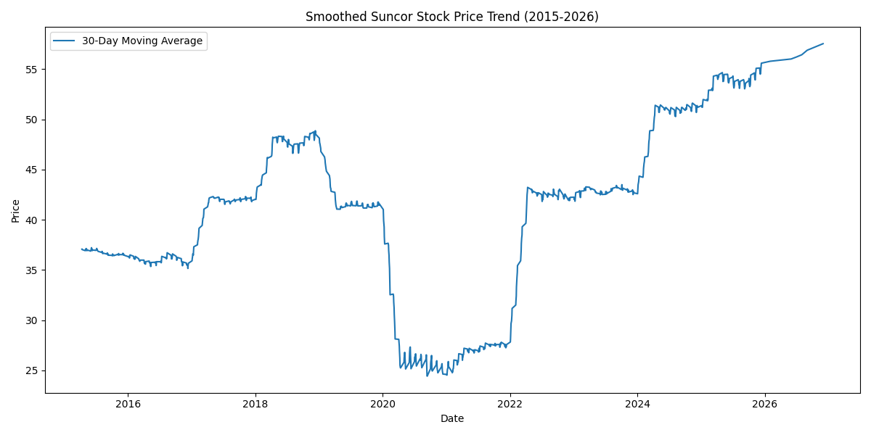

Appendix 2. Histogram — Return Distribution
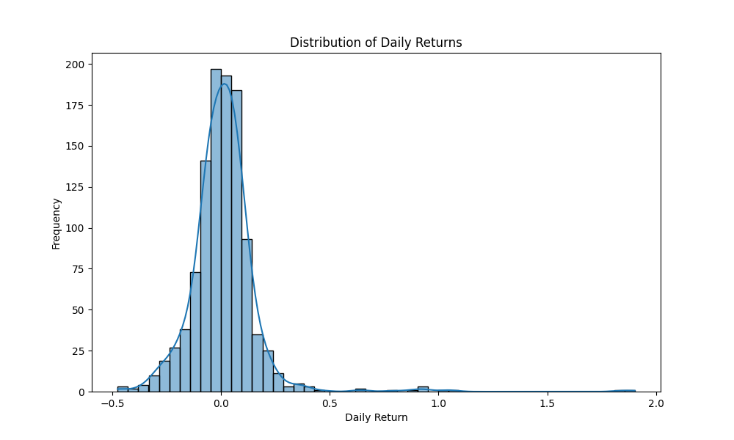

Appendix 3. Box Plot — Return Volatility by Year
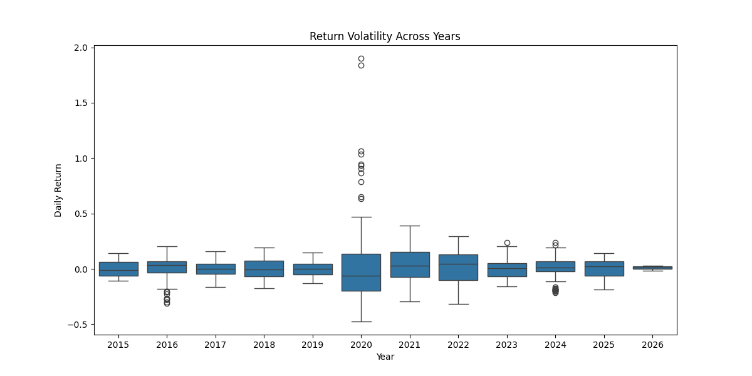
Appendix 4. Bar Chart — Monthly Average Return
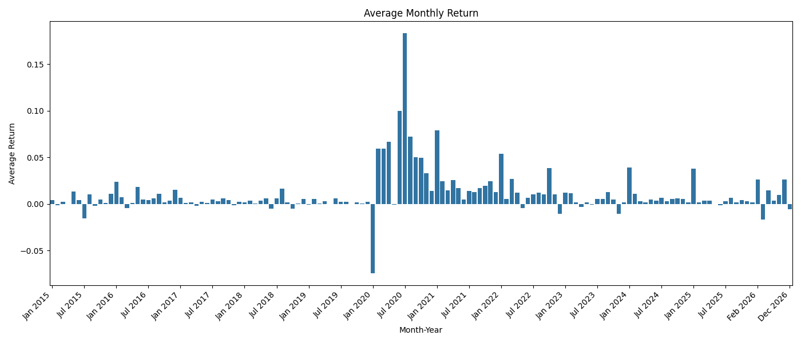

Appendix 5. Bar Chart — Average Volume per Month
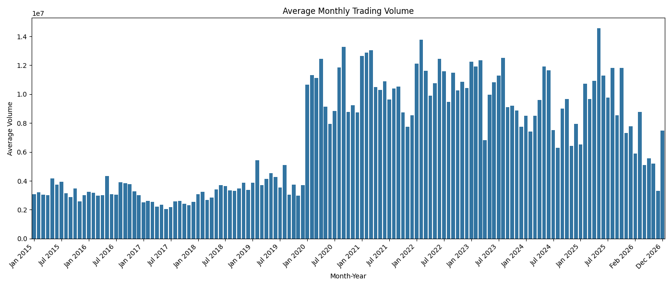

Appendix 6. Scatter Plot — Return vs Volume
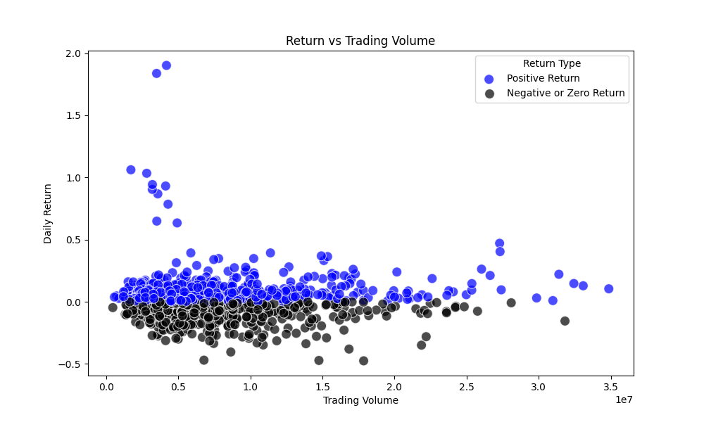

Appendix 7. Heat Map — Seasonality (Average Return by Month and Day of Week)
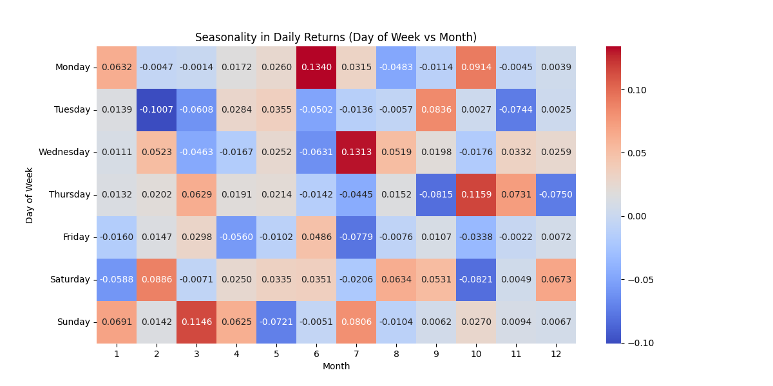

References
- IBIS World. (2023). IBISWorld - Industry Market Research, Reports, and Statistics. Www.ibisworld.com. https://www.ibisworld.com/canada/industry-trends/biggest-industries-by-revenue/
- Suncor Energy Third Quarter 2025 financial results call. (n.d.). https://www.suncor.com/-/media/project/suncor/files/investor-centre/transcripts/2025-q3-suncor-energy-financial-results-call-transcript-en.pdf?modified=20251113152919&created=20251113152919
- Government of Canada, Canada Energy Regulator. (2020). CER – Canada’s Energy Future 2020 - Energy Supply and Demand in a Pandemic: Effects of COVID-19. Cer-Rec.gc.ca. https://www.cer-rec.gc.ca/en/data-analysis/canada-energy-future/2020/covid/index.html

