WHEN DO COLLEGE TUITION DISCOUNTS STOP PAYING OFF?
Prescriptive Analytics Project Proposal

Isabella Pastorino
Ben Dupey
DATA 511
13 November 2026

Abstract
Colleges are spending more than ever on tuition discounts to convince admitted students to enroll, but more discounting doesn’t always mean more students. At some point, schools end up giving discounts to students who would have come anyway, and that money is lost revenue. This is a real problem for schools like Grand View that rely on tuition to operate. We are using public IPEDS data on 1,211 private nonprofit four-year colleges from 2018 to 2022 to look at how price and discounts affect yield, the share of admitted students who enroll. Our initial analysis shows schools are admitting more students but enrolling a smaller share of them: median yield dropped from 26.3% to 21.9%, even as the median discount rose from 51.4% to 54.5%. Yield also levels off once discounts pass about 50% of tuition. Next, we will build models that predict yield and use them to find the discount level where bigger discounts stop paying off.
Table of Contents
Introduction 4
Data 5-7
Data Dictionary 6
Initial Exploratory Questions 7
Exploratory Data Analysis 8-9
Limitations & Next Steps 1
References 11

Introduction
Tuition discounting is when a college lowers its price for a student, usually through a grant or scholarship from the school. It is one of the main ways private colleges compete for students. Schools like Grand View need to know how far to discount before they start giving up tuition revenue without gaining more students.
Discounts only help if they change a student’s decision. A school that discounts too little loses students to other colleges, and a school that discounts too much gives money to students who would have enrolled anyway. We want to find the point where bigger discounts stop paying off.
For this project, we are using public data on private nonprofit colleges to look at how price and discounts affect whether admitted students decide to enroll. From there, we will recommend how much a school should discount to bring in students without losing revenue it didn’t need to give up.

Data
The data is publicly available from IPEDS (Integrated Postsecondary Education Data System), covering the years 2018-2022. Five different sources within IPEDS were joined on unitid and put into one CSV with information on private nonprofit four-year institutions in the U.S. and its territories that report admissions data. Schools missing from any of the other four sources have blanks for those columns. Each row represents one institution in one fall. The target variable, yield, is not a column in the raw data; it is calculated as enrolled divided by admits.
Source | Description
Directory: HD | Basic profile of every institution, including name, state, campus setting, enrollment size, and sector. Used to limit the data to private nonprofit four-year schools.
Admissions: ADM | Number of first-time applicants, admitted students, and enrolled students each fall. This is the source of the target variable, yield.
Tuition & Fees: IC_AY | Published tuition and required fees for the academic year, before any financial aid.
Student Financial Aid: SFA | Grant aid for first-time, full-time students, including the share receiving grants, average grant amounts, and the average net price after grants.
Finance: F_F2 | Financial data from the form private nonprofit schools submit, including tuition revenue and the discounts and institutional grants the school gave.

Summary of Data
In total, the combined CSV includes:
- 5,662 rows & 22 columns
- 1,211 private nonprofit four-year institutions (1,059 appear in all five years, 152 in one to four years)
- 16 numeric, 3 categorical, 1 time (fall_year), 1 identifier (unitid), and 1 text (institution_name) column
- No duplicate entries
Missing counts are listed in the Data Dictionary. Ten tuition values recorded as “.” were converted to blanks. We will drop the two allowances columns (not collected in 2018), remove rows missing admits or enrolled, and fill remaining gaps with that year’s median.
Data Dictionary
Variable | Type | Source | Description | Missing
unitid | Identifier | HD: UNITID | Unique IPEDS ID for institution | 0
fall_year | Time | Added in build | Fall term the row describes (2018–2022) | 0
institution_name | Text | HD: INSTNM | Institution name reported that year | 0
state | Categorical | HD: STABBR | Two letter state or territory code | 0
locale | Categorical | HD: LOCALE | Type of area: city, suburb, town, or rural (see note below) | 0
size_category | Categorical | HD: INSTSIZE | Total enrollment, coded 1-5 (see note below) | 0
applicants | Numeric | ADM: APPLCN | First-time undergrad applicants | 0
admits | Numeric | ADM: ADMSSN | Applicants offered admission | 38 (0.7%)
enrolled | Numeric | ADM: ENRLT | Admitted students who enrolled | 46 (0.8%)
sticker_tuition_fees | Numeric | IC_AY: CHG2AY3 | Published tuition and required fees | 27 (0.5%)
average_net_price | Numeric | SFA: NPGRN2 | Average cost to first-year students after grant aid | 192 (3.4%)
first_time_percent_any_grant | Numeric (%) | SFA: AGRNT_P | % of first-year students awarded any grant aid | 150 (2.6%)
first_time_average_any_grant | Numeric | SFA: AGRNT_A | Average grant aid per first-year recipient | 185 (3.3%)
first_time_percent_institutional_grant | Numeric (%) | SFA: IGRNT_P | % of first-year students awarded an institutional grant | 150 (2.6%)
first_time_average_institutional_grant | Numeric | SFA: IGRNT_A | Average institutional grant per first-year recipient | 318 (5.6%)
first_time_total_institutional_grant | Numeric | SFA: IGRNT_T | Total institutional grant $ to first-year students | 150 (2.6%)
tuition_fee_revenue | Numeric | F_F2: F2D01 | Tuition & fee revenue for fiscal year | 138 (2.4%)
allowances_applied_to_tuition | Numeric | F_F2: F2C08 | Total discounts applied to tuition & fees | 138 (2.4%)
institutional_grants_funded | Numeric | F_F2: F2C05 | Institutional grants paid from endowment & gifts | 138 (2.4%)
institutional_grants_unfunded | Numeric | F_F2: F2C06 | Institutional grants paid from general funds | 138 (2.4%)
allowances_endowment_gifts_tuition | Numeric | F_F2: F2C161 | Tuition discounts funded by endowment & gifts (not collected in 2018) | 1,251 (22.1%)
allowances_other_institutional_tuition | Numeric | F_F2: F2C171 | Tuition discounts from other institutional sources (not collected in 2018) | 1,251 (22.1%)

Code | 1 | 2 | 3
1 City | 11 Large city | 12 Midsize city | 13 Small city
2 Suburb | 21 Large suburb | 22 Midsize suburb | 23 Small suburb
3 Town | 31 Town near a city | 32 Distant town | 33 Remote town
4 Rural | 41 Rural near a city | 42 Distant rural | 43 Remote rural
- locale: First digit is the area type (1 city, 2 suburb, 3 town, 4 rural). Second digit is size for cities and suburbs (1 large, 2 midsize, 3 small) or distance from a city for towns and rural areas (1 close, 2 distant, 3 remote).
- size_category: 1 = under 1,000 students, 2 = 1,000 to 4,999, 3 = 5,000 to 9,999, 4 = 10,000 to 19,999, 5 = 20,000 or more, -1 = not reported.
Initial Exploratory Questions
- Do schools with higher discount rates have higher yield?
- Does yield go up as sticker tuition goes down, or does it level off at some point?
- How does yield differ by school size and location?

EDA
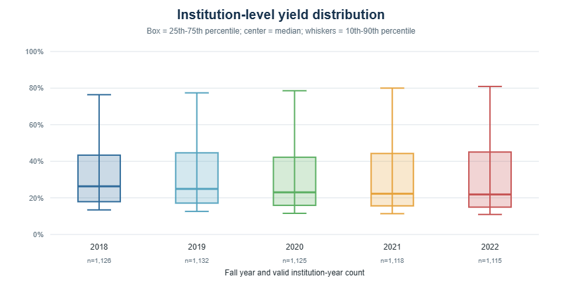
Figure 1: Institution-Level Yield Distribution
Yield is computable for 5616 of the 5662 rows due to missing enrolled counts, admits, and applicants. Most schools enroll between about 15% and 45% of the students they admit. 220 rows show 100% yield, mostly small schools, and 693 rows have fewer than 50 admits, so we will set a minimum school size before modeling.
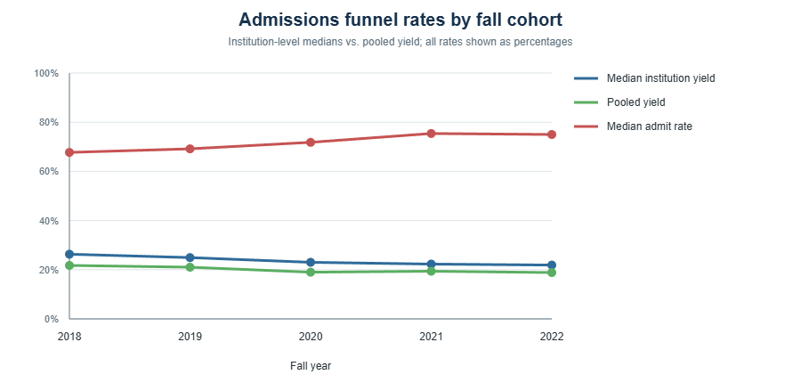
Figure 2: Admission Rates over Time
Median yield dropped every year, from 26.3% in 2018 to 21.9% in 2022, while median admit rate rose from 67.7% to 75.0%. Schools are accepting more students but enrolling a smaller share of them. The drop holds when looking only at schools in all five years (26.2% to 21.1%), and about 70% of schools had lower yield in 2022 than in 2018.
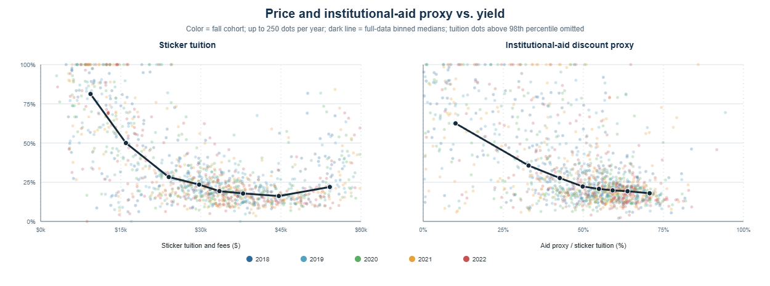
Figure 3: Price and Institutional Aid vs. Yield
Each dot is a school in one year, and the dark line shows median yield across price levels. Yield drops sharply as sticker tuition rises to about $25,000, then levels off around 15 to 20%. Yield also falls as discounts rise, but past about a 50% discount the line nearly flattens. This doesn’t mean discounts lower yield, since schools that struggle to enroll may discount more because of it, but it suggests a point where bigger discounts stop making a difference.
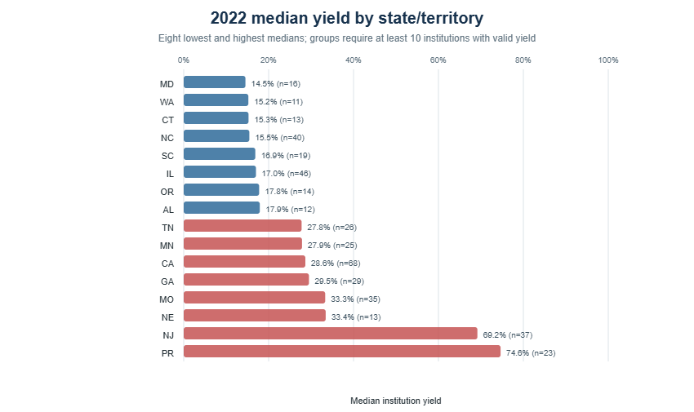
Figure 4: Median Yield by State/U.S. Territory
Among states with at least 10 schools, median yield in 2022 ranged from 14.5% in Maryland to 74.6% in Puerto Rico. These numbers aren’t adjusted for school size or selectivity.
Limitations & Next Steps
- Admissions records are an inclusion condition in the source build, so this is not a census of all private nonprofit four-year institutions.
- Confirm the 19 high discount-proxy observations and negative net price against IPEDS source files and variable definitions; do not winsorize or drop them without a documented rule.
- Select a defensible minimum-admits threshold, decide whether to retain territories, verify numeric locale/size codes against the dictionary, and pre-specify missing-data handling.
- For a model, use a fixed institution cohort or institution/year controls and account for changing cohort composition; do not interpret pandemic-era differences as causal from these summaries alone.

References
https://nces.ed.gov/ipeds/datacenter/DataFiles.aspx?sid=adfc7eda-54ba-4d1e-b035-cd757b6b47d2&rtid=3

