ACADEMIC WRITING IN THE AGE OF AI
Natural Language Processing Project Proposal

Ben Dupey
Isabella Pastorino
DATA 549
13 November 2026

Abstract
This project stems from curiosity about how academic writing has changed in the new age of artificial intelligence. ChatGPT was released only four years ago and is still in its crawling stages, but it is already deeply integrated into many industries, including in academia. We are looking at whether academic writing changed after ChatGPT’s release in November 2022. We are using 60,000 sample arXiv abstracts from math, astrophysics, and computational linguistics, split evenly between papers posted before and after ChatGPT. Computational linguistics serves as a comparison field, since its topics shifted toward AI while math and astrophysics did not. Our initial analysis shows abstracts got longer after ChatGPT and used longer words, especially in computational linguistics and astrophysics. AI terms more than doubled in computational linguistics but stayed low in the other two fields. Next, we will build models that classify abstracts as pre- or post-ChatGPT based on how they are written.

Table of Contents
Introduction 4
Data 5-6
Data Dictionary 6
Initial Exploratory Questions 7
Exploratory Data Analysis 7-10
Limitations & Next Steps 11
References 12

Introduction
Since ChatGPT’s release in November 2022, AI tools have become an integral part of how people write emails, reports, and research. Academic writing is a useful place to study this change because it follows a standard formal format, backed with evidence, and is posted publicly with clear dates. Researchers have always written abstracts in a similar basic way: a short summary of the problem, the method, and the results. If AI tools are changing how people write, abstracts are one of the first places it should show up.
This project asks whether the writing in academic abstracts changed after ChatGPT, and how. We focus on two parts of writing style: lexical diversity, or how varied the words are, and word complexity, measured by word length. The main challenge is separating a change in writing from a change in topic. After 2022, many researchers started studying AI, so their abstracts mention AI more because of what they research, not how they write. To handle this, we focus on math and astrophysics, where topics stayed mostly the same, and use computational linguistics as a comparison field where the topic shifted. The goal is to build a model that can tell pre- and post-ChatGPT abstracts apart based on writing style alone.

Data
The data comes from the arXiv metadata dataset on Kaggle by Cornell University. It is a free online archive where researchers post their papers. The dataset doesn’t include the entire papers, just each paper’s title, authors, abstract, categories, and version dates. Each row represents one paper. The target variable is label, which marks whether the paper was first posted before or after ChatGPT’s release in November 2022. The data covers papers first posted from 2019 to 2026.
The full file has one paper per line and is large to load at once, so our script (build_arxiv.py) read it line by line and saved a smaller sample that we are using. First, we did a field filter to keep papers whose primary category is math, computational linguistics, or astrophysics. Next, each paper was labeled by the date of its first version: pre-ChatGPT is January 1, 2019 to November 29, 2022, and post-ChatGPT is March 1, 2023 and on. Papers from November 30, 2022 to February 28, 2023 were removed, since it’s unclear which period they belong to. To further clean the data, papers without an abstract and papers the authors withdrew were removed, and extra spaces and line breaks were dropped. Last, the script randomly sampled 10,000 papers per field per period with a fixed seed of 549, so reruns give the same rows.
Summary of Data
In total, the sample includes:
- 60,000 rows and 16 columns
- Sampling 10,000 papers per field per period (30,000 pre and 30,000 post)
- 3 fields (categories) made up of 37 primary categories
- 3 numeric, 5 categorical, 1 time (first_version_date), 1 identifier (id), and 6 text columns
- No duplicate IDs. One abstract appears twice under two different IDs.
Missing counts are listed in the Data Dictionary. Only comments, journal_ref, and doi have missing values, which is expected since many papers have no comments or haven’t been published in a journal. None of the three will be used in the model. We will drop the repeated abstract before modeling.

Data Dictionary
Variable | Type | Description | Missing
id | Identifier | Unique arXiv ID for each paper | 0
title | Text | Paper’s title | 0
abstract | Text | Summary of the paper | 0
authors | Text | Authors’ names listed on the Kaggle | 0
author_count | Numeric | Number of authors | 0
categories | Categorical | All categories papers are listed by | 0
primary_category | Categorical | First listed category that assigns field | 0
category_count | Numeric | Number of listed categories | 0
field | Categorical | math, astrophysics, or computational_linguistics | 0
comments | Text | Author notes | 16,305 (27.2%)
journal_ref | Text | Journal where paper was published | 50,175 (83.6%)
doi | Text | Journal DOI | 42,357 (70.6%)
license | Categorical | License paper was posted under (6 types) | 0
first_version_date | Time | Date first version was posted | 0
version_count | Numeric | Number of versions posted | 0
label | Categorical (target) | pre_chatgpt or post_chatgpt | 0

Initial Exploratory Questions
- What time range does the data cover, and how many papers fall before and after ChatGPT?
- Which subfields make up the most papers in each field?
- Did titles and abstracts get longer after ChatGPT?
- Did abstracts use more complex words after ChatGPT?
- Is the change just because more papers are about AI now?
- Which variables move together?

EDA
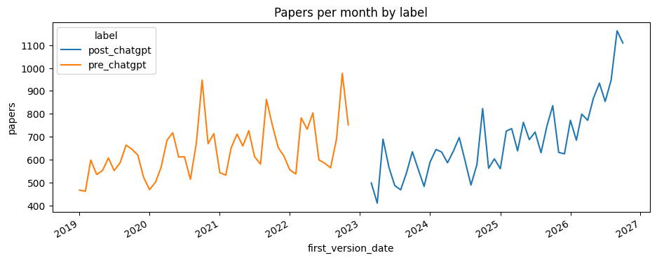
Figure 1: Papers per Month by Period
The sample pre-ChatGPT papers range from about 450 to 950 per month, with spikes each fall. The gap between December 2022 to February 2023 shows where papers were removed as it is unclear which period they belong to. Post-ChatGPT papers count climb steadily and peak in 2026. Since the post group leans toward recent papers, the model could pick up on changes over time that have nothing to do with ChatGPT.
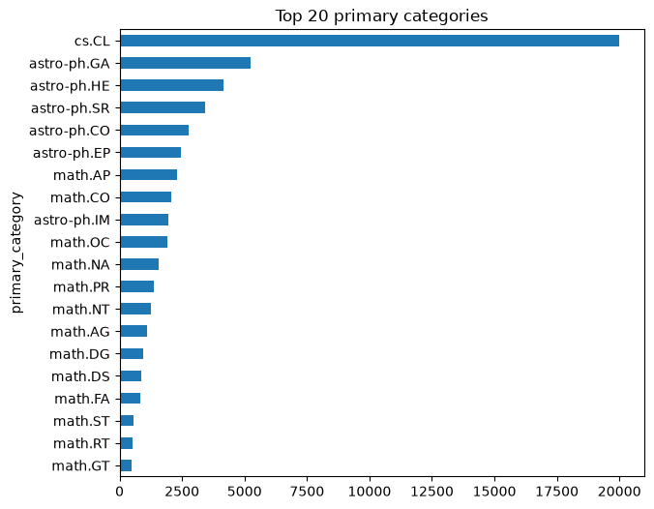
Figure 2: Top 20 Primary Categories
Computational linguistics is one category (cs.CL) with all 20,000 of its papers, while math and astrophysics are spread across many subfields. The largest are astro-ph.GA (5,226) and math.AP (2,301). Because math and astrophysics come from many subfields, a change in their writing isn’t driven by any one research area.
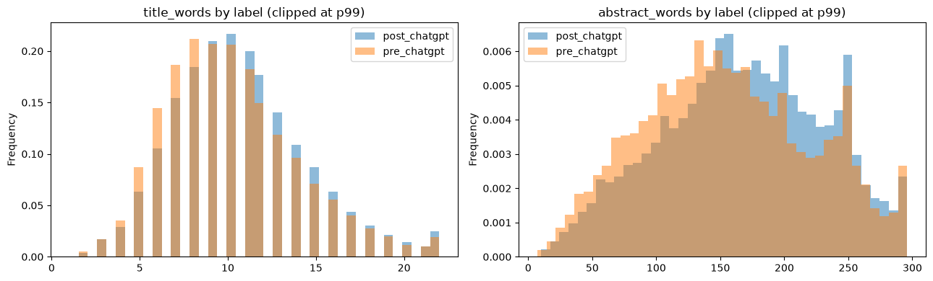
Figure 3: Title and Abstract Length by Period
Titles did not stray much in length from each other, with a median of 10 words in both periods. Abstracts got longer, with the median going from 153 to 169 words, and the post-ChatGPT distribution shifts to the right. Length is a simple style difference the model can use, but it should be checked within each field.
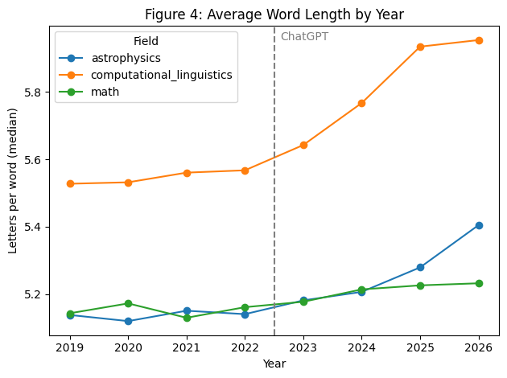
Figure 4: Average Word Length by Year
Average word length was flat from 2019 to 2022, then rose after ChatGPT. Computational linguistics went from 5.57 letters per word in 2022 to 5.95 in 2026, and astrophysics went from 5.14 to 5.40. Math barely changed. The rise in astrophysics matters most, since its topics didn’t shift toward AI.
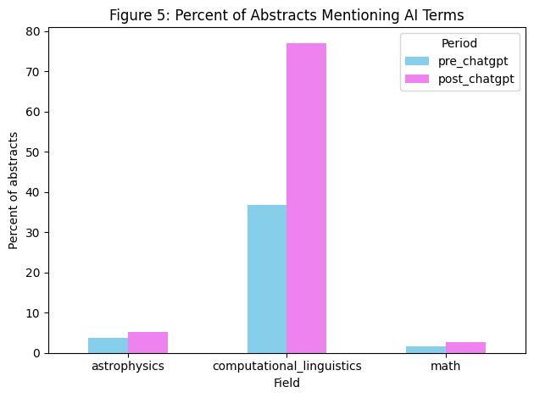
Figure 5: Percent of Abstracts Mentioning AI Terms
AI terms more than doubled in computational linguistics, from 36.8% to 77%. They stayed low in astrophysics (3.6% to 5.1%) and math (1.6% to 2.6%). This confirms the topic shift is mostly in computational linguistics, so math and astrophysics are the better test of writing style.
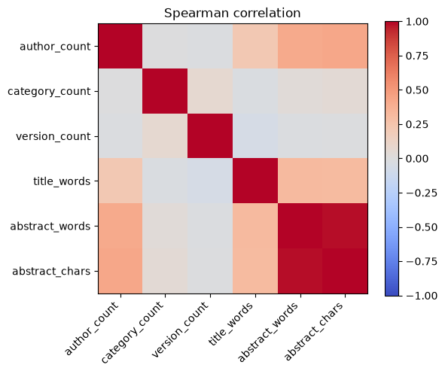
Figure 6: Spearman Correlation
Abstract words and characters are almost the same measure (0.98), so the model only needs one. Papers with more authors tend to have longer abstracts (0.41) and longer titles (0.22). Category and version counts aren’t related to anything. Most of these columns describe the paper, not the writing, so the model will focus on the abstract text.
Limitations & Next Steps
- Abstracts were sampled from three fields on arXiv, so this is not a picture of all academic writing or of full papers.
- Research topics shift over time even in math and astrophysics, so remove AI-related terms and compare against computational linguistics before treating any change as a writing style change.
- The post-ChatGPT group leans toward recent papers, and word length was already rising gradually. Check results by year before linking any change to ChatGPT.
- The data shows when a paper was posted, not whether AI helped write it. We cannot interpret differences as caused by ChatGPT from these summaries alone.
- Drop the repeated abstract, clean LaTeX formatting, and build style features (lexical diversity, word length, sentence length, word frequencies) before training a baseline logistic regression model.

References
Cornell University. (n.d.). arXiv dataset [Data set]. Kaggle. https://www.kaggle.com/datasets/Cornell-University/arxiv

