**ALL OF MY CODE IS AT THIS LINK, answers in this document:**<https://github.com/bdupey/STAT-341A_Appplied_Regression_Analysis_Modeling/blob/main/hw_2.ipynb>

1. **Section 2.7 – use this data to answer these questions: Use the variable Severity vs Satisfaction**
2. Display a scatter plot with the regression lineA graph with red line and blue dots

   Description automatically generated
3. Computer the regression lineA screenshot of a computer

   Description automatically generated
4. Compute the ANOVA table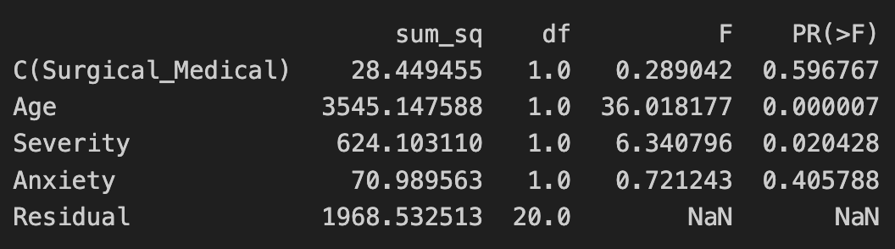
5. Do a hypothesis test for the existence of an indirect linear relationship. Show al the steps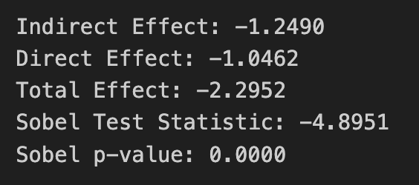
6. Is the value of the y-intercept meaningful in the context of this problem? Justify!

The y-intercept, in this context, doesn't provide meaningful information because setting the Age variable to zero is often not meaningful or realistic.

1. Compute and interpret the meaning of the coefficient of variation in the context of this problem.A black background with white text

   Description automatically generated

Continued…

1. Compute the 98% confidence interval for the slope . Interpret its meaning. Is the slope of your regression equation inside this interval? Justify!A computer screen with white text

   Description automatically generated
2. Computer the 98% confidence interval for the average y value given . Interpret its meaning.A black screen with white text

   Description automatically generated

Continued….

1. Compute the 99% prediction interval for the y value given . Interpret its meaning.

1. **Section 2.8 – use this data to answer these questions: Use the variables Era vs Wins**
2. Display a scatter plot with the regression lineA graph with a red line and blue dots

   Description automatically generated
3. Computer the regression lineA black background with white text

   Description automatically generated
4. Compute the ANOVA table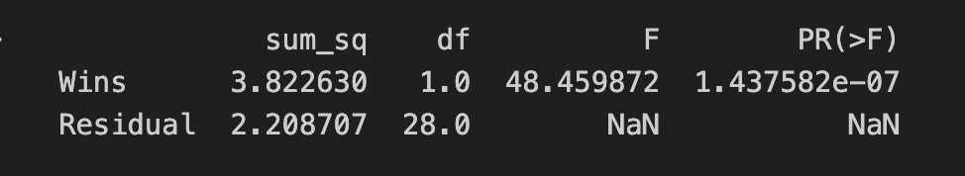
5. Do a hypothesis test for the existence of an indirect linear relationship. Show al the steps.A screenshot of a computer

   Description automatically generated
6. Is the value of the y-intercept meaningful in the context of this problem? Justify!

For each additional win, 'ERA' decreases by approximately 0.0340. This coefficient provides a more interpretable understanding of the relationship between 'Wins' and 'ERA'

1. Compute and interpret the meaning of the coefficient of variation in the context of this problem.A black background with white text

   Description automatically generated
2. Compute the 97% confidence interval for the slope . Interpret its meaning. Is the slope of your regression equation inside this interval? Justify!

With 97% confidence, we can say that there is a statistically significant negative linear relationship between the number of wins and earned run average.

1. Computer the 97% confidence interval for the average y value given . Interpret its meaning.



Setting 'Wins' to 3.8, you can be 97% confident that the average 'ERA' falls between 6.1660 and 7.4503 units

1. Compute the 97% prediction interval for the y value given . Interpret its meaning.



If a baseball team achieves 3.8 wins, we can be 97% confident that the average 'ERA' for teams with this level of performance will fall within the range of 5.9384 to 7.6778 units.