2002

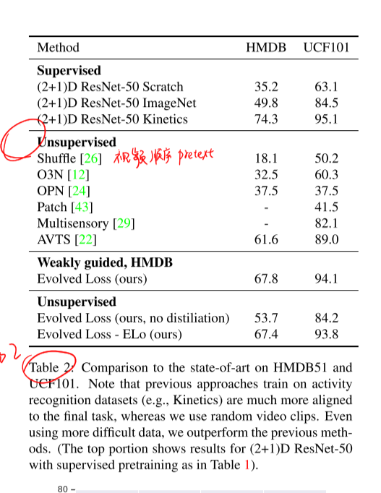

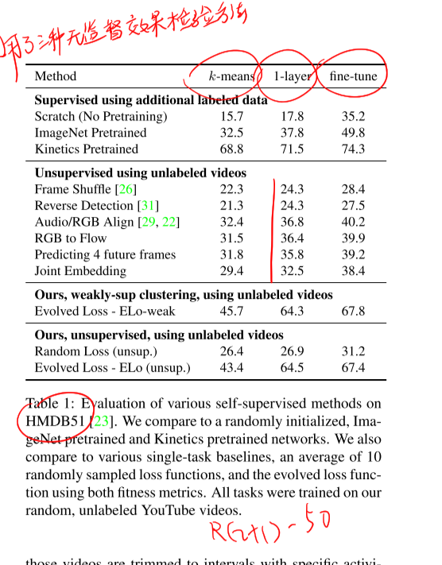

26 12 24 31 43 29 22

**26 Martial Hebert. Shuffle and learn: unsupervised learning using temporal order**

**verification.**

**12 Self-supervised video representation learning with odd-one-out networks**

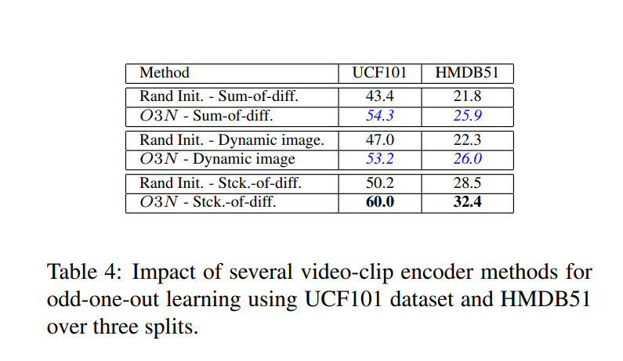

24 **Unsupervised representation learning by sorting sequences**

31 Lyndsey C Pickup, Zheng Pan, Donglai Wei, YiChang Shih, Changshui Zhang, Andrew Zisserman, Bernhard Scholkopf,

and William T Freeman. Seeing the arrow of time.

**43 Xiaolong Wang and Abhinav Gupta. Unsupervised learning of visual representations using videos. In Proceedings ofthe**

**IEEE International Conference on Computer Vision (ICCV),**

29 Andrew Owens and Alexei A Efros. Audio-visual scene analysis with self-supervised multisensory features. In Proceedings of European Conference on Computer Vision

(ECCV), 2018

22 Bruno Korbar, Du Tran, and Lorenzo Torresani. Cooperative learning of audio and video models from self-supervised synchronization. In Advances in Neural Information Processing

Systems (NIPS), pages 7774–7785, 201

自监督

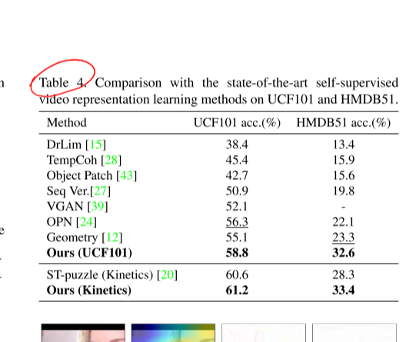

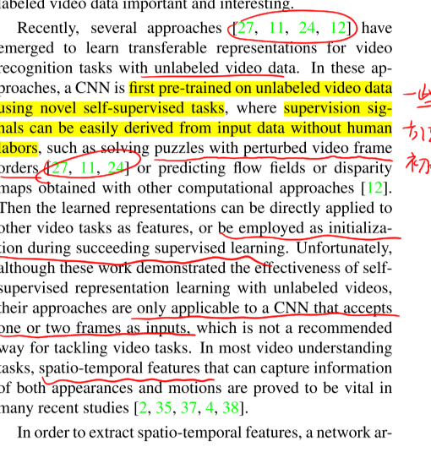

15 28 43 27 39 24 12

DrLim15 Dimensionality reduction by learning an invariant mapping.

将高维数据点映射到低维流形

28 Deep learning from temporal coherence in video.

**43 Xiaolong Wang and Abhinav Gupta. Unsupervised learning of visual representations using videos. In ICCV, 2015. 2, 7,**

**27 Shuffle and learn: unsupervised learning using temporal order**

**verification.**

39 Carl Vondrick, Hamed Pirsiavash, and Antonio Torralba. Generating videos with scene dynamics. In NeurIPS, 2016.

2, 7

**24 Unsupervised representation learning by sorting sequences**

12 Chuang Gan, Boqing Gong, Kun Liu, Hao Su, and Leonidas J Guibas. Geometry guided convolutional neural networks for self-supervised video representation learning.

In CVPR, 2018. 1, 2

