**Idle active matter: excavation by confined and crowded task-oriented collectives**

D. Monaenkova1*, J. Aguilar2*, V. Linevich2, B. Dutta1, W. Savoie1, M. A. D. Goodisman3, D. I. Goldman1*.

1 School of Physics, Georgia Institute of Technology, Atlanta, GA, USA

2School of Mechanical Engineering, Georgia Institute of Technology, Atlanta, GA, USA

3School of Biological Sciences, Georgia Institute of Technology, Atlanta, GA, USA

*Correspondence to: [daniel.goldman@physics.gatech.edu](mailto:daniel.goldman@physics.gatech.edu)

†Additional author notes should be indicated with symbols (for example, for current addresses).

**Abstract (100-150)**: Ensembles of self-propelling elements, like colloidal surfers, active liquid crystals, bacterial biofilms, social insects, and robot swarms can spontaneously form clusters, clogs and jams. In many “task-oriented” collectives, avoiding formation of such structures is paramount for task completion, for example, during subterranean nest formation by social insects. Through the study of tunnel excavation by fire ants, autonomous robots, and cellular automata models, we demonstrate the importance of appropriate social behaviors in facilitating collective excavation in crowded, confined conditions. In particular, tools from the study of glass formation reveal how congestion, jams and even arrest due to high-density traffic can be mitigated via global social behaviors (a distribution of idleness) and local interactions (selective retreats). A particular combination of the above strategies emerges from optimization algorithms, (and is utilized by the ants), achieving effective and efficient excavation without the need for sophisticated sensing, planning and global control of the collective.

**One Sentence Summary (150):** Experiments and simulations of social insects and robots reveal how workforce heterogeneity governs the successful organization of confined collectives.

Active materials – ensembles of self-propelling elements – generically form patterns and structures (*1**,* *2*) in a diversity of artificial (*3*) and living systems: from colloidal surfers (*3*) to organismal collectives (*4*). In many biological systems (e.g. fish schools (*5*) or bird flocks (*6*)), such large scale ordering has beneficial biological functions (*7**,* *8*). For example, schooling behavior in fish is associated with defense against predators and foraging success, while clusters of bacteria exhibit quorum-sensing, promoting migration or the development of new growth modes.

However, structure formation in active matter systems can also have deleterious consequences, particularly in confined systems like pedestrian/vehicular traffic jams (*9*), competing bacteria biofilms (*10*), high density cell migration (*11*), jammed herds (*12*), ROBOTS CITE MATARIC and confined systems where flow rate is vital for proper colony function. In these situations, cluster formation may lead to clogging, preventing task completion or leading to substantial failure of the system.

MAKE ABOUT ROBOT WORK: We studied how clogs can be mitigated or managed in “task oriented” active matter—systems composed of elements which must work together to perform a task without central coordination. For example, clogs can form in biological systems like soil excavating ants and robot teams (*13-16*) which work in crowded, confined environments (Fig. 1). Some of the best examples come from ant and robot studies. While robotic swarms (*16*) have demonstrated how interactions with confining boundaries can produce organized collective motion, the challenges of extreme confinement are exemplified by our previous (*17*) and current (*Fig. 1C*, *Fig. 4, supplementary materials*) experiments with autonomous devices, which reveal how large groups of congested robots that excavate pellets in narrow tunnels without central command or social behaviors (defined as cooperation strategies among individuals) underperform single excavators due to traffic jams. XX MAKE SURE TO DISCUSS TASK ALLOCATION VS INTERFERENCE (FROM ROBOT LIT) But our work is different because we find and set up a distribution of labor pattern BLAH

Fire ant colonies (*S. invicta*) rapidly excavate and build elaborate nests (*Fig. 1A*) (*18*), despite being subjected to collisions among individuals and the confined spaces therein. We hypothesize that insect societies, which comprise 30% of global biomass *(**19**)*, engage in social behaviors which minimize clogging. For example, we recently discovered that fire ants moving bi-directionally through a confined tunnel minimize their interaction times to maintain smooth traffic flow (*20*). We studied nest excavation of *S. invicta* to understand the social behaviors that improve performance either through reactive mechanisms that adapt to traffic or proactive measures that avoid traffic disruptions (*Fig. 1B*)*.*

Ant experiments: Small groups (~30) of *S. invicta* workers were placed in transparent containers of wetted glass particles (*Fig. 2A*) with a soil moisture content of 1 or 10 percent of total particle weight (3 trials each). Ants excavated for 48 hours (with a single ant entering the tunnel as much as 426 times) along the container wall and used a variety of techniques to collect grains, form a pellet, and ascend the tunnel for deposition (*21*). A camera mounted to a motorized linear stage tracked the tunnel face as it was excavated (*Fig. 2A, supplementary materials*). We distinguished individual ant activity by marking ant abdomens with different colors (*Fig. 1B*). We logged the presence and behavior of each worker that entered the tunnel when they were in view of the camera (*Fig. 2C*). Ants exhibited a variety of social behaviors, from workload inequality (i.e. idleness) to a likelihood of giving up and retreating the tunnel without pellets (reversals), which seemed to be associated with successful collective excavation.

Idleness was characterized by workload inequality in the population, whereby a significant portion of ants (27 ± 17%) never entered the tunnel to excavate during the 48-hour period of observation. Lorenz curves (*Fig. 2D*) illustrate workload inequality by linking the cumulative share of workers in the population (ranging from the least to the most active individuals) to the cumulative share of activity by the group, whereby an ant is defined as active while present in the tunnel. The Gini coefficient (*22*) indicates the deviation of the workload from either perfectly shared (G = 0, all workers work equally) to completely unequal (G = 1, a single worker performs all work). Regardless of soil moisture, Lorenz curves were approximated by power law relationships (*Fig. S2*) with an average G = 0.7 ± 0.1.

Workload inequality has been observed in other social animals during foraging (*22*), whereby activity levels are not necessarily related to worker roles or specialization (*22*) and may change depending on the colony needs (*23*). We divided experiments into 12-hour “epochs” and found that the activity level of individual ants changed over time(*Fig. S3*), but the collective workload inequality remained consistent (*Fig. S1*). The Gini coefficient was affected neither by the soil moisture content (one-way chi-square, χ2 = 0.005, p = 0.95), the epoch of the experiment nor the colony (2-way ANOVA, F11, 24 = 0.3, p = 0.72 and p = 0.99)). Furthermore, when the most active excavators were removed from the group, other workers increased their activity and compensated for the loss, preserving the shape of the Lorenz curve (*Fig. 2D inset,* *supplementary materials*). Thus, given the consistency of the workload distribution, we hypothesize that idleness may play an adaptive role in modulating the crowded conditions of confined tunnels.

We also observed ant reversals during excavation, whereby an ant descended the tunnel but then retreated without excavating a pellet. Such behaviors were often associated with local crowding (*Fig. 2E*) at the excavation face (16.2 ± 11.9% of observations in 1% soil moisture and 9.7 ± 2.2% of observations in 10% soil moisture). Reversal behavior in crowded conditions occurs on foraging trails (*24*), and similar phenomena have been observed in swarming bacteria (*10*). The frequency of this seemingly unproductive behavior increased with increasing overall activity of ants (*Fig. S4*). We posit that such behavior serves as a feedback mechanism for controlling congestion during excavation.

*Ant simulations:* To examine the effect of experimentally observed social behaviors on large groups of excavating agents, we developed a cellular automata (CA) excavation model (*Fig. 3A, supplementary materials*), useful in elucidating the dynamics of ant tunnel traffic (*20*). The CA model consisted of a tunnel lattice with a width of two cells occupied by soil, empty space, an ascending ant, or a descending ant (*Fig. 3A*). Simulated ants could walk, excavate, deposit a pellet, or rest. We implemented reversals and unequal workload distributions on populations of 2 to 100 ants. Reversal behavior was implemented by a simple scheme, which designated a probability to abandon digging when an ant’s path to the excavation site was blocked by traffic for more than a pre-defined duration. While direct control of output workload distributions was not implemented, we modulated workload inequality by setting individual probabilities to return to the excavation site after pellet deposition (work probability).

The work probability distribution was determined with a genetic algorithm (GA) (*Fig. 3B*) on a 30-ant CA model, changing the work probability distribution to optimize excavation rate with each generation (*supplementary materials*). Regardless of the initial population, the simulation converged to an unequal workload distribution within a few generations (*Fig. 3C*). Notably, this theoretically optimized distribution resembled the experimentally observed workload distributions (*Fig. 2D, green*), suggesting that an unequal workload distribution is a robust mechanism and biological adaptation for improving excavation rate.

We found that populations greater than 3 ants resulted in irresolvable clogs, regardless of the workload distribution, unless ants were capable of reversal behaviors. Thus, we simulated both equal (Active ants) and GA work probability distributions (Lorenz ants) with an identical probability to reverse. Reversal probability, along with other simulation parameters, were selected such that 30 Lorenz ants produced experimentally observed ant digging rates (*Fig. 2B*).

Even with reversal behaviors, active ants performed poorly for populations of greater than 5 ants, whereas Lorenz ants were able to maintain relatively high excavation rates with large populations (*Fig. 3D*). Such a phenomenon, whereby the system performs worse when the individual system components attempt to maximize their own performance, is common for various multi-particle systems including vehicle and pedestrian traffic (*25*). Consequently, CA ant traffic resembles characteristics of vehicle traffic flow (*26*), whereby the mean flow rate (, defined as the rate of successfully depositing ants over time) of excavators in the tunnel is maximal at an intermediate tunnel density (, ratio of average number of ants in the tunnel to tunnel size) (*Fig. 3E*). This trend in v (the fundamental diagram) has been attributed to the transition between laminar flow and propagating traffic jams as density increases (*27*). Thus, we attribute the increased flow rate in higher populations of Lorenz ants to a reduction in overall tunnel densities afforded by an unequal workload distribution, thereby reducing the frequency of traffic jams for large ant populations. Not only do reversals and unequal workloads improve excavation rate, but a selective pressure for digging efficacy may robustly lead to an embedded idleness in populations of underground excavators.

*Robotic Experiments:* While CA simulations provide some insight into how various social behaviors affect excavation efficacy; simple simulation interactions cannot easily account for how real world complexities such as friction, particle geometry, maneuverability, and the nonexistence of traffic lanes affect system dynamics. Thus, we developed a system of excavating robots (*Fig. S10*) inspired by traversal strategies of ants to undertake “physical simulations” (*Fig. 4A-D*) in order to explore collective behavior during excavation. Rather than using centralized control, intelligent planning or communication, ants navigate confined spaces with local cues like head-on contact and pheromone feedback (*24*). Similarly, the robots “diggybots” FOR PRESS followed simple movement instructions triggered by onboard sensory feedback of the surrounding environment (*supplementary materials*). For example, rather than using collision avoidance schemes (*14*), the robots detected collisions with push switches on their outer shell, which triggered reactive clog resolution and navigation strategies such as steering away and reversing. Further, we constructed the tunnel to have a width of 3 robot widths (or 1.5 robot lengths), emulating the challenge of turning around in confined spaces. XXHYPOTHESIS: LAZY ANTS AND LAZY ROBOTS ARE LAZY BY DESIGN, NOT BY LOCAL INTERACTIONS…COMMENT ON MATARIC STRATEGIES

The effects of reversals and idleness on robot performance were examined individually with three behavioral strategies tested on groups of two to four robots. The first strategy (Active, *Fig. S7*) designated that all diggers be equally active and perform to their maximum ability: after soil deposition, each robot immediately returned to the tunnel to excavate. In the second protocol (Reversal, *Fig. S8*), the robots were similarly programmed to immediately resume excavation after deposition and were additionally given a reversal probability. In the third protocol (Lorenz, *Fig. S9*), we implemented an unequal probability to excavate derived from experimental ant workload inequalities.

We analyzed the global traffic dynamics of the robots in the main tunnel area using position tracking (*supplementary materials*, *Fig. S11*, see *Fig. 4B-D* for sample space-time overlap maps of robot positions). We found that traffic flow of robotic ants was similar to that obtained in the CA model and sensitive to the tunnel density, T (NT/LT, where NT is the average number of robots in the main tunnel area), maximal at an intermediate T, followed by a gradual decline at higher T (*Fig. S12 A*). Each digging strategy produced distinct trends in tunnel density and energy expenditure (*Fig. S12 B*). The Reversal strategy exhibited peak excavation performance with 2 robots, and monotonically increasing density and energy cost for trials with more diggers. The Lorenz strategy consistently resulted in low tunnel density and energy cost. Whereas, for the Active strategy, the addition of a fourth robot resulted in a dramatic decrease in density and increase in energy expenditure.

To understand these global traffic dynamics, we examined the dynamics of local robot clusters. We identified aggregations, defined as clusters of robots within a robot length’s proximity of each other, at each video frame. Multi-robot aggregations were common among all strategies and particularly frequent at the excavation site (histograms in *Fig. 4B-D*). To understand how clusters dissolved at the excavation site, we measured the mobility of each aggregation with a density overlap correlation function, Q(). This technique has been applied to the analysis of ant traffic (*20*), but is more traditionally used to examine dynamic heterogeneities in non-active matter such as soft matter systems (*28*). The metric Q(), derived here from image correlation algorithms used in PIV (*29*) (*Fig. 4G inset*, *Fig. S13*, *supplementary materials*), Q() compares the spatial overlap of an aggregation at a specific time to the overlap of the aggregation’s original lateral segment at a later time, . We calculated the relaxation time, *, of aggregations of a specific number of diggers, N, by fitting a stretched exponential function, , to a Q curve averaged over aggregations of the same N. For 3-robot trials, all strategies produced relatively low * regardless of N (Fig. 4F). However, the addition of a fourth robot dramatically changed the relative dynamics of the three strategies.

The Active strategy revealed how aggregation dissolution was sensitive to the confinement caused by the tunnel. In particular, larger N jams resulted in increasingly higher *. Thus, 2-robot aggregations led to 3-robot aggregations, which consequently led to catastrophic 4-robot jams that spanned the tunnel width. Such jams were difficult to resolve with the robots' limited library of maneuvers. Unlike ants, which can climb over each other and self-deform, the robots were limited to turning and reversing maneuvers, leading to collisions that were exacerbated by the robots' rigid oblique shape (*Fig. 4E*). We posit that this decreased maneuverability increased the penalty of congestion.

Surprisingly, the Reversal and Lorenz strategies generated unique mechanisms for mitigating catastrophic jamming despite the locomotive limitations of the robots. Due to the robots giving up excavation and returning to the tunnel exit after some time in a jam, the Reversal strategy established an upper limit on *, breaking the cascading chain-reaction effect observed in Active trials. The unequal workload distribution of the Lorenz strategy also avoided 4-robot aggregations, resulting in similarly low * as 3-robot trials. An analysis of relaxation times for clusters with similar aggregation density,  (N/L), during 4-robot experiments (*Fig. 4H*) revealed a sharp increase in * for the Active strategy past a local density of 1, reminiscent of glassy arrest in soft-matter systems (*30*). The Reversal strategy did not exhibit this glass forming characteristic, and a distribution of aggregation frequency vs  (*Fig. 4G*) revealed how the Lorenz strategy largely avoided high densities where catastrophic jams occur. In particular, robot inactivity under the Lorenz strategy actually resulted in overall increased efficiency of the collective. We argue that task-oriented active matter systems at high density must utilize similar social strategies to mitigate catastrophic long-time flow disruption.

Our robophysical experiments in concert with ant observations and CA simulations revealed how workload distributions and reversal behaviors of individual diggers resulted in emergent high-level regulation of density and traffic flow in the tunnel. Notably, the robots possessed no centralized controls. Instead, pre-programmed workload distributions served as feedforward prescriptions for controlling both local and global robot densities, whereby embedded idleness of individuals allowed the collective active matter system to reduce the occurrence of compromising clogging scenarios. The reversal strategy served as a simple feedback mechanism for controlling density by enabling the system to handle clogging scenarios more effectively. XX MAKE SURE WE CITE COUZIN + GARNIER PNAS 2015…THEY HAVE REFS TO TRAFFIC DENSITY OPTIMZASTION …OURS HAS GLASSY,,

For large population systems, the control templates discovered here may serve as effective bases for robust excavation, useful for future robotic systems that will aid in tasks like smooth caravans and carpools in autonomous vehicles, debris excavation and removal, mapping of complex terrain as well as lunar and asteroid mining(*15*). Even in the absence of complex protocols and sophisticated modes of locomotion, these classes of high-level strategies form a simplified syntax for engineers to modulate traffic in complex swarming systems, which can then be improved with refined protocols, body geometry, compliance and maneuverability. We posit that such a simplified language for collective control is crucial to traffic stabilization across physical and biological task-oriented systems, and particularly to the evolution of confined social colonies MAYBE CITE APPROPRIATE GORDON, PRATT PAPERS HERE.

**Acknowledgements:** Authors acknowledge the support of National Science Foundation grants number NSF PoLS 0957659, PHY-1205878 and also ARO W911NF-13-1-0347 and The National Academies Keck Futures Initiative. Authors would also like to acknowledge Dr. Nick Gravish for insight and fruitful discussions.

**References:**

1. M. C. Marchetti *et al.*, Hydrodynamics of soft active matter. *Reviews of Modern Physics* **85**, (2013).

2. S. Ramaswamy, in *Annual Review of Condensed Matter Physics, Vol 1,* J. S. Langer, Ed. (Annual Reviews, Palo Alto, 2010), vol. 1, pp. 323-345.

3. J. Palacci, S. Sacanna, A. P. Steinberg, D. J. Pine, P. M. Chaikin, Living Crystals of Light-Activated Colloidal Surfers. *Science* **339**, 936-940 (2013).

4. A. Okubo, Dynamical aspects of animal grouping: Swarms, schools, flocks, and herds. *Advances in Biophysics* **22**, 1-94 (1986).

5. Y. Katz, K. Tunstrom, C. C. Ioannou, C. Huepe, I. D. Couzin, Inferring the structure and dynamics of interactions in schooling fish. *Proceedings of the National Academy of Sciences of the United States of America* **108**, 18720-18725 (2011).

6. W. Bialek *et al.*, Statistical mechanics for natural flocks of birds. *Proceedings of the National Academy of Sciences of the United States of America* **109**, 4786-4791 (2012).

7. A. Cavagna *et al.*, Scale-free correlations in starling flocks. *Proceedings of the National Academy of Sciences* **107**, 11865-11870 (2010).

8. M. Ballerini *et al.*, Interaction ruling animal collective behavior depends on topological rather than metric distance: Evidence from a field study. *Proceedings of the National Academy of Sciences* **105**, 1232-1237 (2008).

9. D. Helbing, Traffic and related self-driven many-particle systems. *Reviews of Modern Physics* **73**, 1067-1141 (2001).

10. N. C. Darnton, L. Turner, S. Rojevsky, H. C. Berg, Dynamics of Bacterial Swarming. *Biophysical Journal* **98**, 2082-2090 (2010).

11. E. Méhes, T. Vicsek, Collective motion of cells: from experiments to models. *Integr. Biol.* **6**, 831-854 (2014).

12. A. Garcimartín *et al.*, Flow and clogging of a sheep herd passing through a bottleneck. *Physical Review E* **91**, (2015).

13. L. G.-B. Yash Mulgaonkar, Anurag Makineni, and Vijay Kumar, Bio-inspired Swarms of Small Aerial Robots (submitted). *Interface Focus*, (2017).

14. L. Wang, A. Ames, M. Egerstedt, paper presented at the 2016 American Control Conference (ACC), 2016/07 2016.

15. P. T. Metzger, Space development and space science together, an historic opportunity. *Space Policy* **37**, 77-91 (2016).

16. L. Giomi, N. Hawley-Weld, L. Mahadevan, in *Proc. R. Soc. A*. (The Royal Society, 2013), vol. 469, pp. 20120637.

17. V. Linevich, D. Monaenkova, D. I. Goldman, Robophysical study of excavation in confined environments. *Artificial Life and Robotics* **21**, 460-465 (2016).

18. D. Cassill, W. R. Tschinkel, S. B. Vinson, Nest complexity, group size and brood rearing in the fire ant, Solenopsis invicta. *Insectes Sociaux* **49**, 158-163 (2002).

19. L. Lach, C. L. Parr, K. L. Abbott. (Oxford University Press (OUP), 2009).

20. N. Gravish, G. Gold, A. Zangwill, M. A. D. Goodisman, D. I. Goldman, Glass-like dynamics in confined and congested ant traffic. *Soft Matter* **11**, 6552-6561 (2015).

21. D. Monaenkova *et al.*, Behavioral and mechanical determinants of collective subsurface nest excavation. *The Journal of experimental biology* **218**, 1295-1305 (2015).

22. P. Tenczar, C. C. Lutz, V. D. Rao, N. Goldenfeld, G. E. Robinson, Automated monitoring reveals extreme interindividual variation and plasticity in honeybee foraging activity levels. *Animal Behaviour* **95**, 41-48 (2014).

23. E. J. Robinson, O. Feinerman, N. R. Franks, Flexible task allocation and the organization of work in ants. *Proc Biol Sci* **276**, 4373-4380 (2009).

24. V. Fourcassie, A. Dussutour, J. L. Deneubourg, Ant traffic rules. *Journal of Experimental Biology* **213**, 2357-2363 (2010).

25. C. Gershenson, D. Helbing, When slower is faster. *Complexity* **21**, 9-15 (2015).

26. K. Nagel, M. Schreckenberg, A cellular automaton model for freeway traffic. *Journal de Physique I* **2**, 2221-2229 (1992).

27. R. Kuhne, in *Internation Symposium on Highway Capacity*. (1991).

28. K. N. Nordstrom, J. P. Gollub, D. J. Durian, Dynamical heterogeneity in soft-particle suspensions under shear. *Physical Review E* **84**, (2011).

29. Z. Jiang, Q. Kemao, H. Miao, J. Yang, L. Tang, Path-independent digital image correlation with high accuracy, speed and robustness. *Optics and Lasers in Engineering* **65**, 93-102 (2015).

30. C. A. Angell, Formation of Glasses from Liquids and Biopolymers. *Science* **267**, 1924-1935 (1995).

Supplementary Materials:

Materials and Methods, Videos

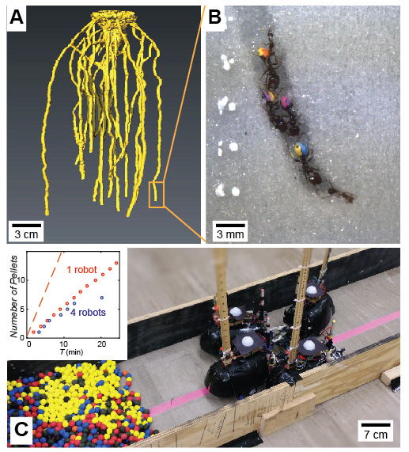

**Fig. 1** **Confined biological and robotic excavators.** (A) X-ray reconstruction of the *S. invicta* nest XX WHAT SOIL?. (B) Painted *S. invicta* fire ants excavating a tunnel. (C) Autonomous robotic diggers excavating in simulated environment with cohesive granular media (diam. 13 mm). (Inset) Number of pellets (cohesive mass of grains) deposited vs time by a robot excavating alone (red dots), and the net excavation of four robots (blue circles), whereby each robot is performing to its maximum ability. Orange dashed line indicates the performance of the group of four robots in the absence of confinement.

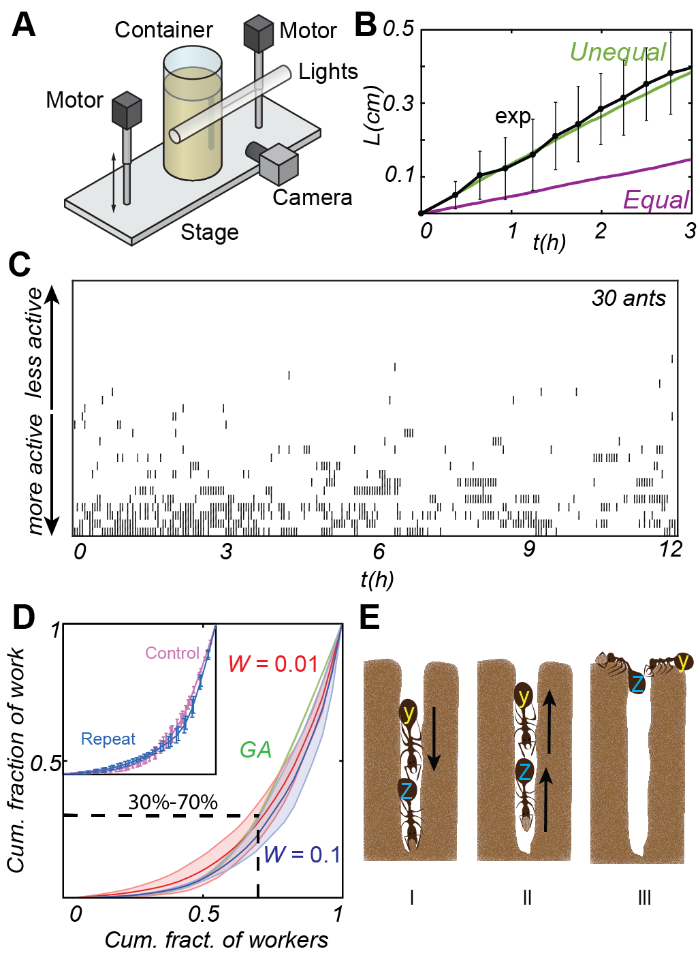

**Fig. 2 Biological observations reveal both idle and reversal behavior in ants.** (A) Experimental set up to track ant excavation. (B) The growth of the tunnel length over time: experimental results (black) and simulations for groups with equal (purple) and unequal (green) workload distribution. (C) Excavation map derived from experimental data. The map indicates the presence of a particular ant ordered most to least active (y axis) in the tunnel at a time *t*. (D) Lorenz curves for workload distributions obtained in wet media with, moisture constant, *W* = 0.1 (blue) and W = 0.01 (red) moisture content and a CA-model (green) whose excavation rate was optimized with a genetic algorithm. Shaded areas correspond to standard deviation from 3 experiments. (Inset) Lorenz curves for a workload distribution within the group before (control, purple) and after (repeat, blue) the most active diggers are removed from the group. Error bars correspond to standard deviations from 3 experiments. (E) Illustration of observed reversal behavior. (I) Ant Y’s path to excavate is blocked by ant X. (II) When X is finished collecting a pellet, it reverses, (III) forcing Y to reverse without excavating.

­­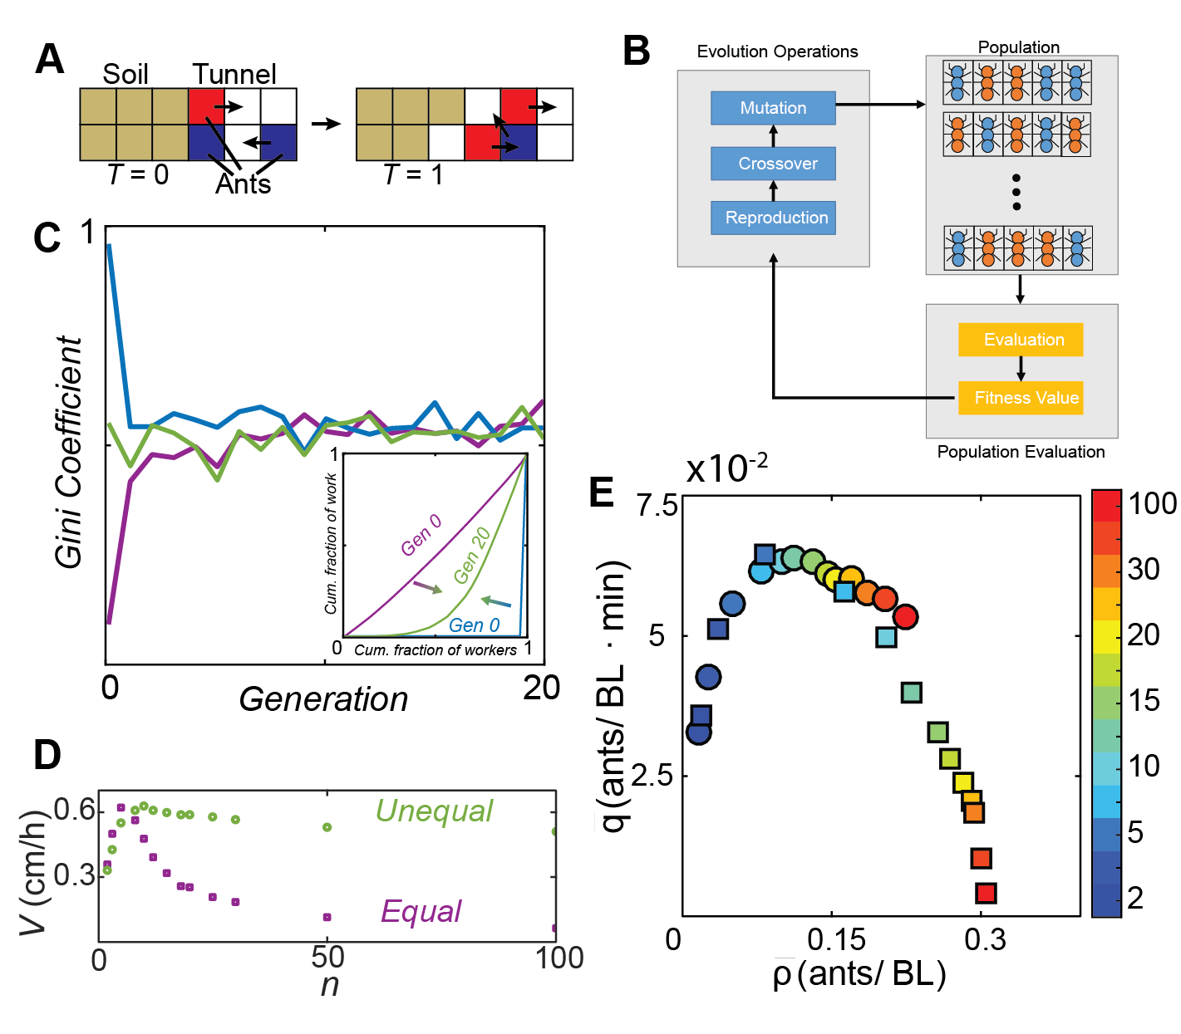

**Fig. 3 Simulations and modeling reveal benefits of unequal workload distribution in confined spaces.** (A) Schematic, showing the main components of cellular automata model. Cell colors denote soil (brown), tunnel (white), ants moving towards the excavation site (blue) and exiting the tunnel (red). (B) Schematic of genetic algorithm, where each cell (or gene) of a group (or chromosome) represents an individual ant probability to excavate. The groups with the highest digging rate of a generation are crossed over, and the least effective have a probability of mutation. (C) Gini coefficient vs generation of groups start with a completely equal (purple), completely unequal (blue) and random (green) workload distribution. Lorenz curves (inset) for groups what start completely unequal and equal illustrate how an intermittently unequal workload distribution is rapidly produced within a few generations regardless of initial workload distribution. (D) Tunnel growth rate (*V*) vs size of ant population for equally (purple squares) and unequally (green circles) active ants. Error bars are within the marker size. (E) Simulated traffic flow () plotted versus ant density () for groups of equally (squares) and unequally (circles) active ants. Color bar indicates the size of the excavating group.

­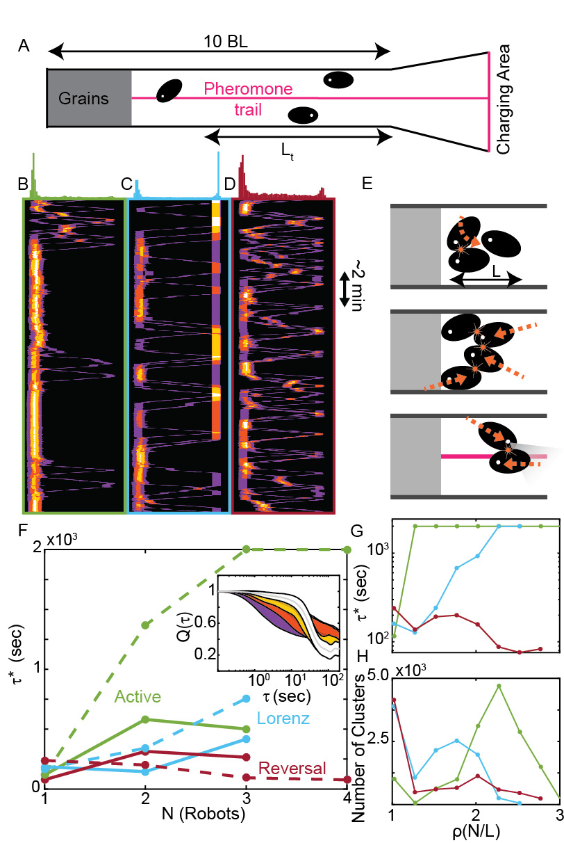

**Fig. 4** **Traffic** **flow and** **local dynamics of robotic strategies.** (A) Schematic of the excavation arena. A pink centerline along the tunnel was captured by the robots’ onboard cameras to emulate a pheromone trail to follow. (B-D) Experimental space-time overlap heat map of robot positions (x-axis) for 4-robot trials of (B) Active digging, (C) Lorenz digging and (D) Reversal digging. Color indicates number of robots occupying a particular space and time from 1 (purple) to 4 (white) robots. Histograms on top of the graphs show the frequency of occurrence of clusters with 2 or more robots at different lateral positions. (E) Illustration of various collision scenarios encountered by robots due to turning (left), forward-backward translation (middle) and movement toward simulated pheromone trail (right). (F-H) Relaxation times for Active (green), Lorenz (light blue) and Reversal (maroon) strategies. (F) Relaxation time vs aggregation size for 3-robot (solid) and 4-robot (dashed) trials. (Inset) Sample average correlation curves, Q(), measure how 1 (purple), 2 (orange), 3 (yellow) and 4 (white) robot aggregations dissolve over time during 4-robot reversal trials; shaded region indicates 1/2 standard deviation above and below average curves. (G) Relaxation times vs density for 4-robot trials and (H) corresponding number of aggregation occurrences vs aggregation density.