Homework 5: Final Project

I had a lot of success on the final project:

- Exponential shadowmap
- Motion Blur
- Depth of Field
- Better lighting

I talk a bit about all these in the powerpoint. Variance shadowmapping was nice, but it had this nasty light bleeding problem. It’s a well known problem so I decided to use exponential shadows instead. Exponential shadowmaps has a downside in that the blurring of the shadowmap must happen in log space.

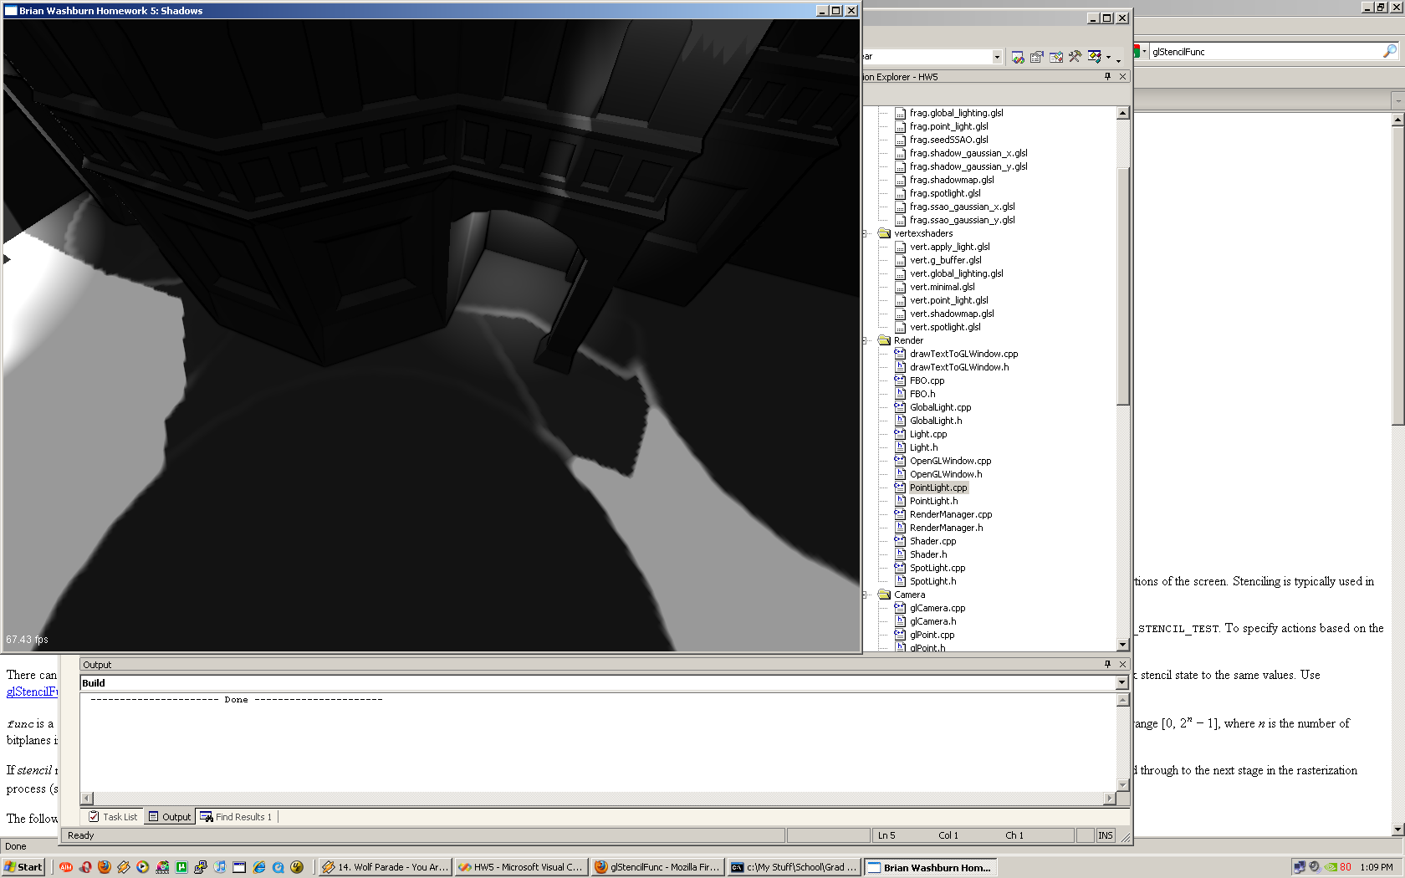
See those weird artifacts?

I added a lot of cool new options in this project:

Using the middle mouse button you can bring a menu to view all the g-buffer contents, and to turn on/off various effects. Also see lightmap, shadowmap, and exit.

I added a low-res option to start up with. Performance was getting a little low.

I did a TON of optimization and got everything pretty respectable: @ 1024 x 768 Im getting 66fps with Depth darkening + motion blur + DOF + 39 lights!

The biggest optimization was light volumes. 200% performance increase. I actually got them working and the lighting shader ONLY shades necessary pixels now.

Another optimization was reducing FBO Bind() calls.

Using the left mouse button adds a light to the scene! How cool! You can decorate the scene with Christmasy colored lights.

I also made all the lights in the scene load from a file – lights.txt. If you need more performance delete some lights from this file.

Issues: Bad mouse input on low performance

Files of interest:

LightManager
RenderManager

Shaders of interest:

DOF_x – uses a box filter for better performance that gaussian
DOF_y
Global-lighting – where the shadowmap magic is
Motion_blur
Shadow_gaussian_x

Controls:

Left mouse – add light
Middle mouse – options

Thank you so much for letting me do some research. I can only hope I continue this work without class to motivate me. I love graphics! I hope you learned something and I hope this works for you. Let me know if you run into serious problems.

