Battle of the Neighborhoods

# Data:

### 2.1 Data Gathering

For this exploratory study, the Big Ten Conference will serve to limit the scope of the analysis.  There are presently 14 schools within the conference and their locations and enrollment are easily obtained from multiple internet sources.  The data for the .csv file used for the analysis was obtained from the Wikipedia page Associated with the Big Ten;

https://en.wikipedia.org/wiki/Big_Ten_Conference

The university location data was pulled from Foursqaure and merged with the wikipedia data to form the following table:

Table 1:

|  |  |  |  |  |  |
| --- | --- | --- | --- | --- | --- |
| **Institution** | **Division** | **Location** | **Enrollment** | **Latitude** | **Longitude** |
| Indiana University | East | Bloomington, Indiana | 48,514 | 39.1772 | -86.5154 |
| University of Maryland | East | College Park, Maryland | 38,140 | 38.992 | -76.9461 |
| University of Michigan | East | Ann Arbor, Michigan | 43,625 | 42.2942 | -83.7100 |
| Michigan State University | East | East Lansing, Michigan | 50,085 | 42.7186 | -84.4779 |
| Ohio State University | East | Columbus, Ohio | 58,322 | 40.0057 | -83.0287 |
| Pennsylvania State University | East | State College, Pennsylvania | 45,518 | 40.8034 | -77.8591 |
| Rutgers University | East | New Brunswick, New Jersey | 40,720 | 40.4791 | -74.4317 |
| University of Illinois | West | Champaign-Urbana, Illinois | 49,339 | 40.1007 | -88.2313 |
| University of Iowa | West | Iowa City, Iowa | 33,334 | 41.6659 | -91.5731 |
| University of Nebraska | West | Lincoln, Nebraska | 33,273 | 40.8175 | -96.7045 |
| Northwestern University | West | Evanston, Illinois | 21,208 | 42.0551 | -87.6758 |
| Purdue University | West | West Lafayette, Indiana | 39,464 | 40.4275 | -86.9123 |
| University of Wisconsin | West | Madison, Wisconsin | 49,193 | 43.0798 | -89.4307 |

All location data for restaurants was also pulled from Foursquare. By limiting this ranking to 13 universities, the number of API calls required to pull two restaurant styles per university does not exceed the daily limits of non-fee developer accounts. The number of schools is thirteen because for our fictional scenario the origin location of the University of Minnesota is not included. Likewise, the number of calls was limited by setting the radial distance limit within Foursquare to 10 Km.

The following depicts example data for Mexican restaurants near the University of Wisconsin – Madison:

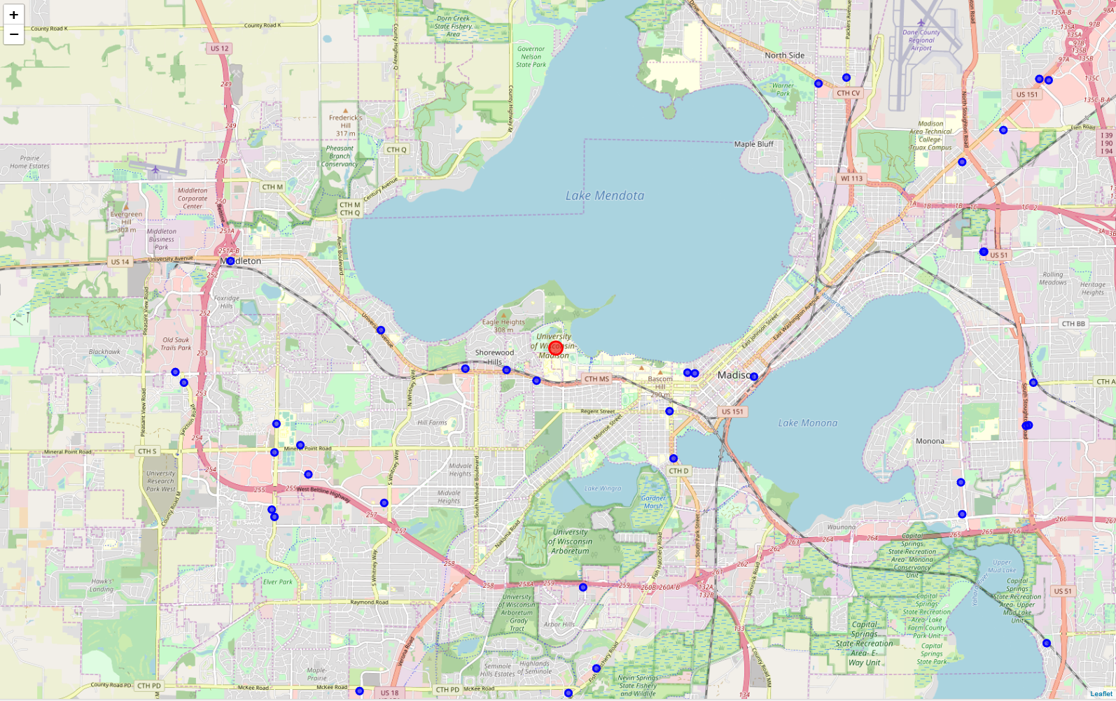

### 2.1 Concentration Score Definition:

The concentration score metric is a measure of the number of students per the restaurant styles/cuisine types. Where Up represents the number of enrolled students, and R1 and R2 represent the number of restaurants for the two styles, the value is the product of the two ratios:

Concentration Score = [(Up /10,000) / (1/R1)] * [(Up /10,000) / (1/R2)]

If there were 15 Asian restaurants and 20 Mexican restaurants within a 10 Km radius of the University of Minnesota, the score would calculate as:

Score = [(51,147 / 10,000) / (1/15)] * [(51,147 / 10,000) / (1/20)] = 179.0145

Multiple variants of this metric were considered, but set aside due to their undesired complexity. For example, distances between the individual restaurants and the center of the university can be weighted or the enrollment can be adjusted for the city/community general population. The principal of Occam’s razor applies to make this analysis more efficient.