KP3S-3Dtouch Using Method

1. Installation

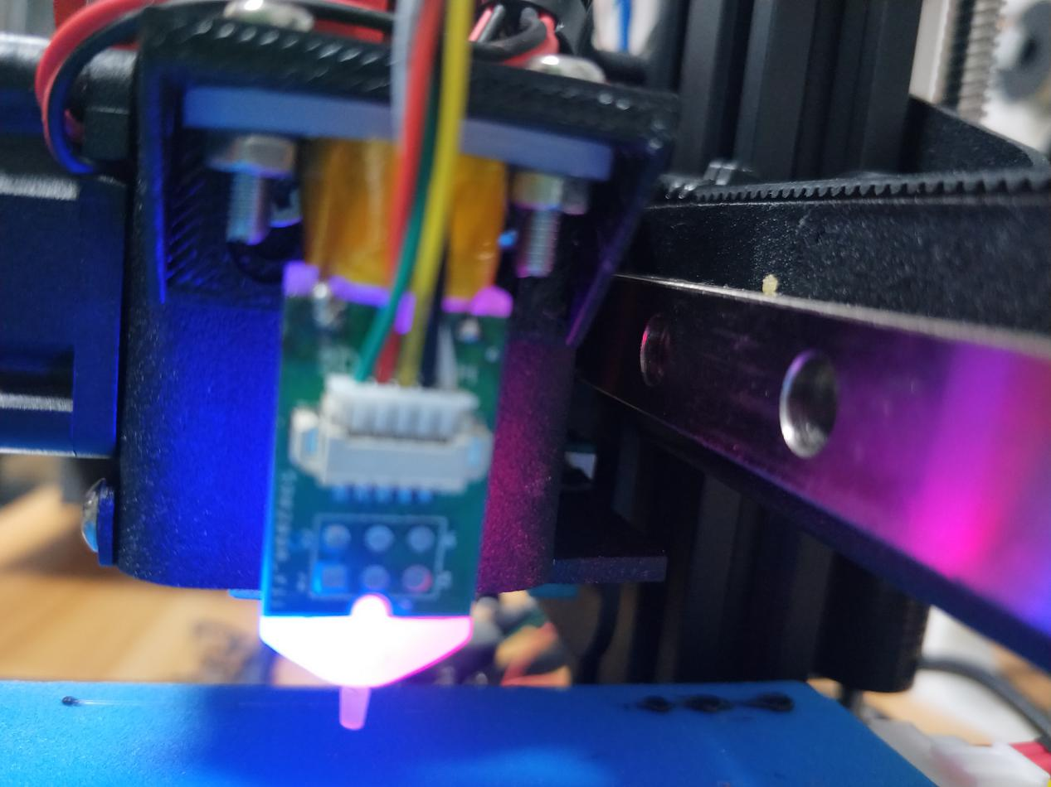Fully connect adapter board to the profile. Otherwise,it will not trigger the endstop function if the probe rod of 3D touch is too low.

1. The setting wires of Auto Leveling Sensor
   1. Connect Leveling limit wire 2pin to Zmax, please note the order between black wire and white one.

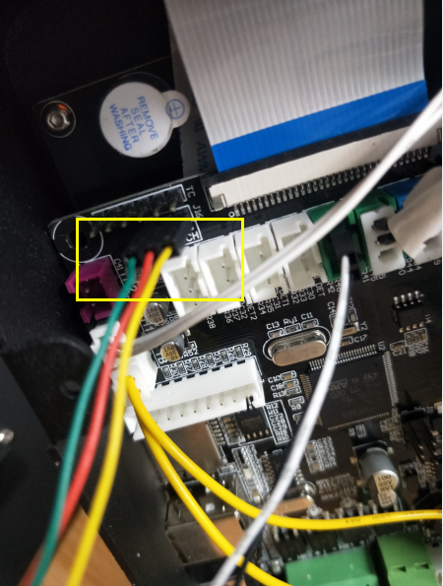2.2The order of connecting Servo wires 3pin as following photo. Also, pay attention to the order of wires.

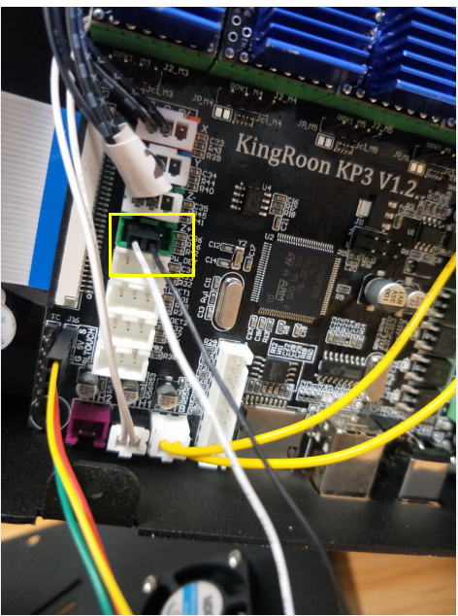

3.This is the setting of Configuration file

3.1 Change the mode as” cfg_leveling_mode” 1

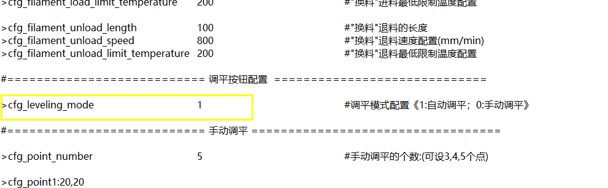

3.2 Setup it into Z Min_Probe_endstorp_inverting 0 # Z probe

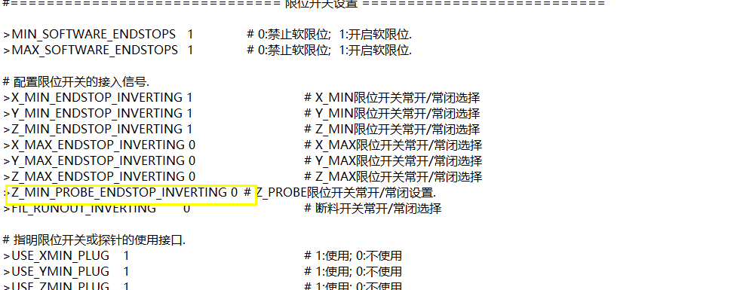

3.3 About the probe rob on ZmaxZ_min_probe_pin_mode 2

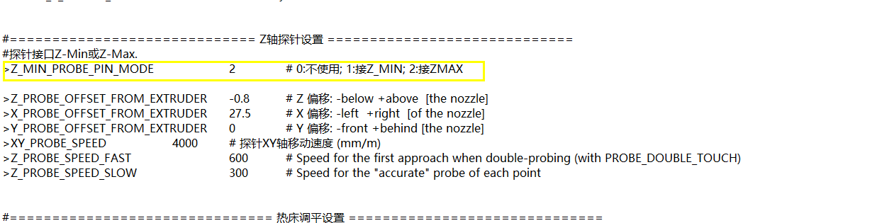

3.4 Setup the X, Y, Z axis offset ( If the distance between the extruder and the platform is too small when printing, then reduce the Z-axis offset value, otherwise, increase it.)

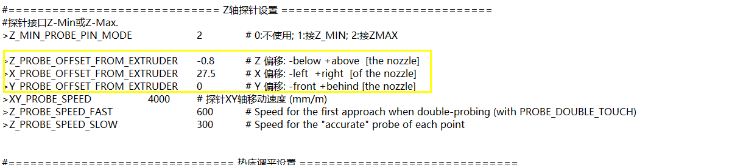

3.5 Set 3 point automatic leveling method

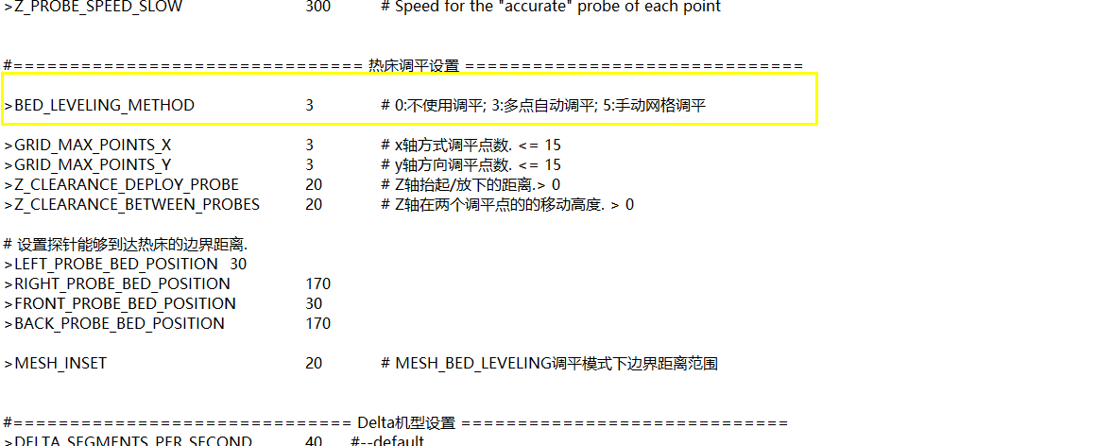

3.6 Leveling range

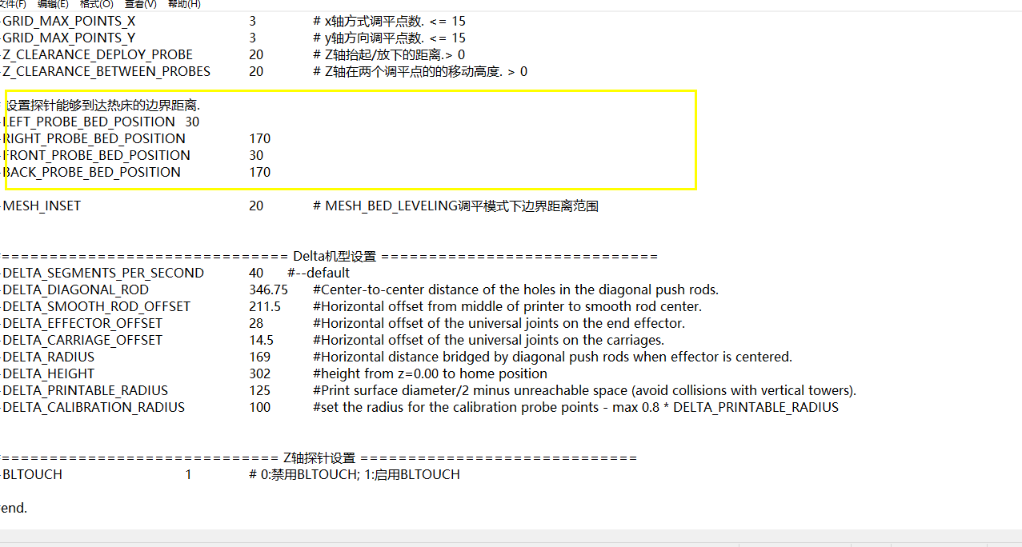

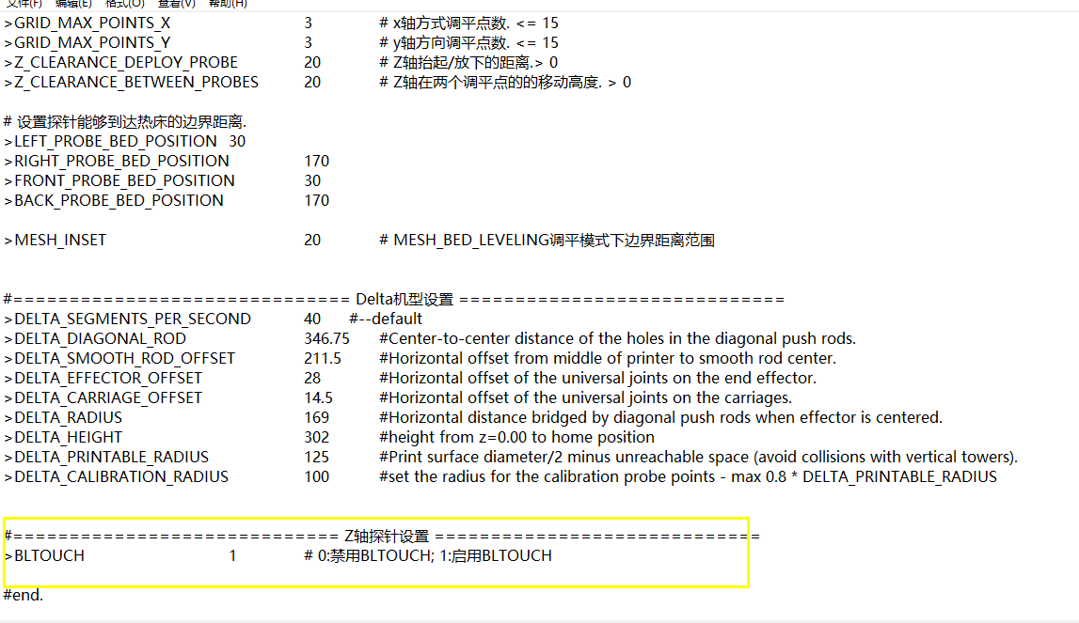3.7 Turn on 3Dtouch