Academic Year: 2025 – 2026

TABLE OF CONTENTS

CHAPTER ONE: INTRODUCTION 1
1.1 Background 1
1.2 Scientific Background 2
1.3 Importance of the Topic for Physiotherapy 3
1.4 Problem Statement 4
1.5 Aim of the Study 5
1.6 Objectives of the Study 5
1.7 Significance of the Study 5
1.8 Scope and Limitations 6
1.9 Definition of Terms 7
CHAPTER TWO: LITERATURE REVIEW 9
2.1 Anatomy of the Hip Joint 9
2.2 Normal Development of the Hip in Children 10
2.3 Definition and Classification of DDH 11
2.4 Risk Factors 12
2.5 Causes of DDH 15
2.6 Signs and Symptoms 15
2.7 Diagnostic Methods 16
2.8 Medical Treatment 18
2.9 Role of Physiotherapy in DDH 19
2.10 Previous Related Studies 21
CHAPTER THREE: METHODOLOGY 24
3.1 Study Design 24
3.2 Study Setting 24
3.3 Study Population and Sample 24
3.4 Inclusion and Exclusion Criteria 25
3.5 Data Collection Tool 26
3.6 Data Analysis 26
3.7 Ethical Considerations 27
CHAPTER FOUR: RESULTS 29
4.1 Introduction 29
4.2 Demographic Characteristics 29
4.3 Pregnancy and Delivery Factors 31
4.4 One-Sample Tests 33
4.5 Relationship between Mode of Delivery and Breech Presentation 34
4.6 Summary of Results 35
CHAPTER FIVE: DISCUSSION 37
5.1 Overview 37
5.2 Demographic Findings 37
5.3 Pregnancy and Delivery Factors 38
5.4 The Statistical Relationship between Delivery and Breech Presentation 39
5.5 Implications for Physiotherapy Practice 40
CHAPTER SIX: CONCLUSION AND RECOMMENDATIONS 42
6.1 Conclusion 42
6.2 Recommendations 43
REFERENCES 45

LIST OF TABLES

Table 2.1: Clinical classification of DDH according to hip stability 12
Table 2.2: Simplified Graf ultrasound classification (infants under 6 months) 12
Table 4.1: Distribution of the sample by sex 29
Table 4.2: Distribution of the sample by place of residence 30
Table 4.3: Distribution of the sample by mode of delivery 31
Table 4.4: Distribution of the sample by breech presentation during pregnancy 32
Table 4.5: One-sample tests of the main proportions 33
Table 4.6: Chi-square test of independence between mode of delivery and breech presentation (SPSS output) 34
Table 4.7: Summary of the main results 35

LIST OF FIGURES

Figure 4.1: Distribution of the sample by sex 29
Figure 4.2: Distribution of the sample by place of residence 30
Figure 4.3: Distribution of the sample by mode of delivery 31
Figure 4.4: Distribution of the sample by breech presentation 32
Figure 4.5: Breech presentation in the sample compared with the general population 33

ABSTRACT
Background: Developmental Dysplasia of the Hip (DDH) is one of the most common hip problems of infancy. It ranges from a slightly unstable or shallow hip to complete dislocation, and when it is found late it can lead to limping, leg-length difference and early osteoarthritis. Little is known about the children affected by DDH in western Libya.
Aim: To describe the demographic and perinatal characteristics of children diagnosed with DDH in Sabratha and Al-Ajeelat, and to examine how common the main known risk factors are among them.
Methods: A descriptive cross-sectional study was carried out on 71 children with a medical diagnosis of DDH, recruited consecutively from clinics in the two towns. Parents completed a structured Arabic questionnaire covering demographic data, pregnancy and delivery history, and clinical information. Data were analysed in SPSS 26 using frequencies, percentages, 95% confidence intervals, one-sample chi-square and binomial tests, and Pearson's chi-square test of independence (α = 0.05).
Results: Girls made up 54.9% of the sample, a majority that did not differ significantly from an equal sex split (χ²(1) = 0.69, p = 0.406). Children came from both Al-Ajeelat (54.9%) and Sabratha (45.1%). Two-thirds were born vaginally (66.2%). Breech presentation was reported for 31.0% of children (95% CI 21.4–42.5%), well above the general population rate of about 4% (p < 0.001), and for 64.7% of those whose parents knew the answer; however, 50.7% of parents did not know whether their baby had been breech. The reported association between mode of delivery and breech presentation (χ² = 71.492, p < 0.001) was found to be driven almost entirely by one incomplete record and could not be confirmed.
Conclusion: Breech presentation was very common among children with DDH in this area, and many parents were unaware of their baby's position before birth. Better recording of fetal presentation, targeted hip screening of at-risk infants, parent education and a stronger role for physiotherapists in early detection and rehabilitation are recommended.
Keywords: Developmental dysplasia of the hip; risk factors; breech presentation; physiotherapy; screening; Libya.

CHAPTER ONE: INTRODUCTION

1.1 Background
Developmental Dysplasia of the Hip (DDH) describes a group of hip problems in which the femoral head and the acetabulum fail to develop in their normal relationship. At the mild end of this group the hip is merely shallow or slightly unstable; at the severe end the femoral head lies completely outside the socket. The older label, "congenital dislocation of the hip", fell out of use because it suggested that the problem is always present and fixed at birth. In reality, some hips that look normal in the newborn period become dysplastic weeks or months later, which is why the word "developmental" is now preferred (Klisic, 1989; Kotlarsky et al., 2015).
How often DDH occurs depends heavily on where, how and by whom it is measured. A systematic review by Loder and Skopelja (2011) found reported incidence figures that ranged from well under one case per 1,000 live births in some African populations to more than 70 per 1,000 in certain Native American groups. Part of this spread is genuine, reflecting genetic background and local infant-care customs, and part of it comes from differences in screening methods and in how "dysplasia" is defined.
The reason clinicians take DDH seriously is what happens when it is missed. A hip that is left untreated, or treated late, may produce a limp, a short leg, reduced hip movement and pain, and in adulthood it is a well-recognised cause of early osteoarthritis that may end in hip replacement at a young age (Sewell & Eastwood, 2011). In contrast, a hip that is picked up in the first weeks of life can usually be managed with a simple harness and has a good chance of developing normally (American Academy of Pediatrics [AAP], 2000; Graf, 1984).
In Libya, and particularly in the western coastal towns of Sabratha and Al-Ajeelat, there is very little published information on children with DDH. Local clinicians therefore have to rely on figures from other countries when they decide whom to screen and how to counsel families. This project set out to collect basic local data on children already diagnosed with DDH in these two areas, so that discussions about screening and physiotherapy services can start from local evidence rather than borrowed numbers.

1.2 Scientific Background
Current thinking treats DDH as a condition with several interacting causes rather than a single one. Four groups of factors are usually described: genetic, hormonal, mechanical and postnatal.
The genetic contribution is shown by the way DDH clusters in families. In Wynne-Davies' (1970) classic family study, the chance of a child being affected rose to roughly 6% when one sibling had DDH, about 12% when one parent had it, and as high as 36% when both a parent and a sibling were affected. Twin studies point in the same direction (Carter & Wilkinson, 1964).
Hormonal factors are thought to act through ligament laxity. Maternal hormones such as relaxin and oestrogen soften the mother's pelvic ligaments before birth, and they appear to have a similar loosening effect on the baby's hip capsule. This is one of the main explanations offered for why girls are affected far more often than boys (Dezateux & Rosendahl, 2007).
Mechanical factors relate to the space and position of the baby in the womb. Breech presentation, especially frank breech with the hips bent and the knees straight, pushes the femoral head towards the back of a shallow socket. A small uterus in a first pregnancy and a low volume of amniotic fluid limit fetal movement in a similar way (Ortiz-Neira et al., 2012; de Hundt et al., 2012).
Postnatal factors are mostly about how babies are wrapped and carried. Tight swaddling that holds the legs straight and together has been linked to higher DDH rates, whereas carrying the infant astride the hip or back, with the legs apart and bent, seems to be protective (Mahan & Kasser, 2008; Kutlu et al., 1992).
Diagnosis combines clinical tests with imaging. The Ortolani and Barlow manoeuvres remain the standard newborn examination, although their accuracy depends a great deal on the examiner's experience. Before about six months of age, ultrasound using the method described by Graf (1984) is the imaging test of choice, because the femoral head is still made of cartilage and does not show on X-ray. After that age, once the ossific nucleus appears, plain radiographs become the main tool.

1.3 Importance of the Topic for Physiotherapy
Physiotherapists meet children with DDH at almost every stage of their care. In infancy they may help families manage a Pavlik harness or abduction brace; after casting or surgery they lead the work of restoring movement, strength and walking; and in the community they are often among the professionals who see babies regularly and can notice warning signs early.
During harness treatment, the physiotherapist's role is largely practical and educational. Parents need to know how to dress, bathe and carry the baby without undoing the hip position, and they need to recognise problems such as skin irritation or a baby who stops kicking one leg, which may suggest a femoral nerve problem. Gentle developmental activities that suit the harness also help the child keep pace with normal motor milestones.
After a spica cast or an operation, the hip is usually stiff and the surrounding muscles are weak. Rehabilitation then focuses on recovering range of motion, strengthening the hip abductors and extensors, retraining balance and correcting gait, so that the child can return to normal play and school activities. Case reports such as Baheti et al. (2024) show how a structured rehabilitation programme can improve function even in a child treated at four years of age.
Physiotherapists also have a preventive role. Advice on hip-friendly swaddling and carrying, and the habit of checking hip abduction and skin-fold symmetry during routine developmental assessments, can lead to earlier referral. In places such as western Libya, where there is no formal national screening programme, this informal surveillance matters even more. Local data of the kind collected in this study can help physiotherapists decide which infants deserve a closer look.

1.4 Problem Statement
DDH is a leading cause of hip problems in childhood and a known source of hip disease in young adults, yet no published data describe the children affected by it in Sabratha and Al-Ajeelat. Without this information, health workers in the area, physiotherapists included, cannot easily judge which infants are most at risk, how families understand the condition, or where screening effort should be directed. International figures are useful, but they may not fit a population whose genetic background, obstetric practice and infant-care traditions differ from those of the countries where most research has been done. This study was carried out to begin filling that gap.

1.5 Aim of the Study
The aim of this study is to describe the demographic and perinatal characteristics of children diagnosed with DDH in Sabratha and Al-Ajeelat, western Libya, and to examine how common the main recognised risk factors are among them, so that the findings can support earlier detection and better physiotherapy care in the region.

1.6 Objectives of the Study
- To describe the distribution of children with DDH in the sample by sex and place of residence.
- To describe the mode of delivery of the children in the sample.
- To estimate how often breech presentation was reported among the children in the sample, and how often parents were unsure about it.
- To compare the proportion of breech presentation in the sample with the figure usually reported for the general population.
- To examine the statistical relationship between mode of delivery and breech presentation.
- To draw practical recommendations for screening, parent education and physiotherapy services in the study area.

1.7 Significance of the Study
Clinical significance. The study gives physiotherapists and paediatric staff in Sabratha and Al-Ajeelat a first local picture of who is being diagnosed with DDH. This can help them decide which babies to examine more carefully and when to refer for ultrasound.
Academic significance. To the researcher's knowledge, this is one of the first attempts to describe DDH cases in this part of western Libya. It can serve as a starting point and a comparison for later studies elsewhere in the country.
Public health significance. Knowing which risk factors are common, and where parents' knowledge is weak, helps in planning screening and education campaigns that fit the local community.
Educational significance. The results highlight topics, such as hip screening and parent education, that deserve more attention in physiotherapy training.

1.8 Scope and Limitations
Scope. The study included children with a medical diagnosis of DDH living in Sabratha and Al-Ajeelat. It looked at demographic details, delivery and pregnancy history, and selected clinical information reported by parents.
Limitations.
- Only children who already had DDH were studied, and there was no comparison group of children without DDH. The study can therefore describe how common each factor is among affected children, but it cannot calculate the true prevalence of DDH in the community or measure how much each factor raises the risk.
- The cross-sectional design captures one point in time and cannot prove cause and effect.
- With 71 children, the sample is adequate for description but small for testing relationships between variables, especially when some categories contain only one or two children.
- Much of the obstetric information came from parents' memory. More than half of the parents did not know whether their baby had been in the breech position, which limits the accuracy of that variable.
- Some items included in the questionnaire (for example birth order, amniotic fluid volume, family history and type of treatment) are not analysed in this report.
- The results come from two neighbouring towns and may not apply to other parts of Libya.

1.9 Definition of Terms

1.9.1 Linguistic Definition
The Arabic term commonly used for this condition, "DDH", literally means displacement of the hip from its place. In English, "dysplasia" means abnormal growth or formation of a tissue, and "developmental" signals that the problem can appear or change while the child is growing rather than being fixed at birth.

1.9.2 Technical Definition
DDH is a range of disorders of the growing hip that extends from mild instability or a shallow acetabulum, through partial displacement (subluxation), to complete dislocation of the femoral head (Kotlarsky et al., 2015).

1.9.3 Operational Definition
In this study, a child was considered to have DDH if a paediatrician or orthopaedic specialist had diagnosed the condition on the basis of clinical examination (Ortolani or Barlow tests) and/or ultrasound or X-ray findings, and the child lived in Sabratha or Al-Ajeelat.

1.9.4 Other Key Terms
Acetabulum: the cup-shaped socket of the pelvis that receives the femoral head.
Femoral head: the rounded upper end of the thigh bone that sits in the acetabulum.
Subluxation: partial displacement of the femoral head; the joint surfaces still touch, but not normally.
Dislocation: complete loss of contact between the femoral head and the acetabulum.
Breech presentation: a position in which the baby's buttocks or feet, rather than the head, lie lowest in the uterus near the end of pregnancy.
Ortolani test: a newborn examination in which a dislocated hip is gently guided back into the socket, often with a felt "clunk".
Barlow test: a newborn examination in which gentle backward pressure on an adducted hip shows whether it can be pushed out of the socket.
Graf classification: an ultrasound system that grades infant hips (types I–IV) mainly by the alpha angle of the bony acetabular roof (Graf, 1984).
Pavlik harness: a soft brace of straps that keeps the baby's hips bent and apart while still allowing kicking movements.
Risk factor: a characteristic linked to a higher chance of developing a condition.
Cross-sectional study: a study in which information is collected from participants once, at a single point in time.

CHAPTER TWO: LITERATURE REVIEW

2.1 Anatomy of the Hip Joint
The hip is a synovial ball-and-socket joint between the femoral head and the acetabulum. It has to carry body weight during standing and walking while still allowing movement in all three planes, and this balance between stability and mobility is exactly what is disturbed in DDH (Moore et al., 2014).

2.1.1 Bones
The acetabulum is made by three pelvic bones, the ilium, ischium and pubis, which meet at the Y-shaped triradiate cartilage and fuse fully in the mid to late teens. Its horseshoe-shaped articular (lunate) surface is lined with hyaline cartilage, while the central fossa is non-articular and holds fat and the ligament of the head of the femur (Standring, 2016).
The femoral head forms about two-thirds of a sphere and is joined to the shaft by the femoral neck. In adults the neck-shaft angle is roughly 125–135° and the femoral neck is twisted forward (anteverted) by about 10–15°. Both values are larger in infants and decrease gradually as the child grows and starts walking (Kapandji, 2010; Fabry et al., 1973).

2.1.2 Labrum and Capsule
The acetabular labrum is a ring of fibrocartilage around the rim of the socket. It deepens the joint, spreads load and helps keep a seal of joint fluid that adds to stability (Ferguson et al., 2003). In a dislocated hip the labrum can fold inwards and block reduction of the femoral head.
The joint capsule is strengthened by the iliofemoral, pubofemoral and ischiofemoral ligaments. A lax capsule, as seen in many babies with DDH, gives the femoral head room to slip out of the socket (Drake et al., 2015).

2.1.3 Muscles
Several muscle groups matter for DDH. The gluteus medius and minimus hold the pelvis level when standing on one leg; if they are weak, the child walks with a Trendelenburg pattern. The adductors (adductor longus, brevis and magnus, gracilis and pectineus) and the iliopsoas tend to shorten in a long-standing dislocation and may need stretching or surgical release. The short external rotators add to joint stability (Neumann, 2017).

2.1.4 Blood Supply
Most of the blood supply to the femoral head comes from the medial and lateral circumflex femoral arteries, through small vessels that run along the femoral neck; the artery in the ligament of the head adds a variable amount (Trueta, 1957). These vessels can be squeezed if the hip is forced into extreme abduction in a harness or cast, which is how avascular necrosis, one of the most serious complications of treatment, can occur.

2.2 Normal Development of the Hip in Children
The hip joint starts forming in the first two months of embryonic life, when a block of tissue separates into femoral head and acetabulum with a joint space between them. From then on, each part shapes the other: a well-centred femoral head encourages the socket to deepen, and a good socket keeps the head round (Tönnis, 1987).
At birth the hip is mostly cartilage and the socket is relatively shallow. The ossification centre of the femoral head usually appears between four and six months of age, a little later in boys. The socket keeps deepening through infancy and childhood as long as the femoral head stays well centred, which is the logic behind treatments that hold the hip in a reduced position early on (Tönnis, 1987).
The neck-shaft angle is about 150° at birth and the femoral anteversion about 40°; both fall towards adult values under the influence of weight-bearing and muscle pull (Fabry et al., 1973). Most children walk independently between 9 and 15 months, and their gait keeps maturing until around seven years of age (Sutherland et al., 1988). The loads produced by walking are a normal stimulus for hip growth.

2.3 Definition and Classification of DDH

2.3.1 Definition
DDH refers to abnormal development of the hip in which the shape of the acetabulum, the position of the femoral head, or both, are not normal. It covers a dysplastic but stable hip at one end and a fully dislocated hip at the other (American Academy of Orthopaedic Surgeons [AAOS], 2014). Recognising that DDH is a spectrum is important, because each point on it is treated differently.

2.3.2 Classification
Several classification systems are in use. Table 2.1 summarises the clinical grouping based on stability, and Table 2.2 shows the simplified Graf ultrasound types used in infants under six months.
Table 2.1: Clinical classification of DDH according to hip stability
Type | Description
Dysplastic | Femoral head stays in the socket, but the acetabulum is shallow or abnormally shaped
Subluxatable | Head is in place at rest but can be partly displaced on testing
Subluxated | Head is partly displaced at rest, without any testing
Dislocatable | Head is in place at rest but can be pushed fully out on testing
Dislocated | Head lies completely outside the socket at rest

Table 2.2: Simplified Graf ultrasound classification (infants under 6 months)
Type | Description | Alpha angle | Usual management
I | Mature, normal hip | ≥ 60° | No treatment
II | Immature or mildly dysplastic | 50–59° | Follow-up or treatment, depending on age
III | Decentred (subluxated) hip | < 50° | Treatment needed
IV | Dislocated hip | Not measurable | Treatment needed

For older children whose femoral head has ossified, the International Hip Dysplasia Institute (IHDI) classification uses the position of the femoral head in relation to Hilgenreiner's and Perkins' lines on an X-ray to grade the hip from I (normal) to IV (high dislocation). It has shown good reliability between observers (Narayanan et al., 2015).

2.4 Risk Factors
Risk factors for DDH are usually divided into those related to the child (such as sex and family history) and those related to the environment before and after birth (such as breech position and swaddling). Two meta-analyses published in 2012 give a useful overview. Ortiz-Neira et al. (2012) pooled 31 studies and reported the highest relative risk for breech presentation (RR 3.75), followed by female sex (RR 2.54), left-sided involvement (RR 1.54), first-born status (RR 1.44) and family history (RR 1.39). De Hundt et al. (2012) reported odds ratios of 5.7 for breech delivery, 4.8 for a positive family history and 3.8 for female sex. The exact numbers differ, but both reviews place breech position, family history and female sex at the top of the list.

2.4.1 Female Sex
Girls make up most DDH cases in nearly every published series; in the large review by Loder and Skopelja (2011), the female share was close to 80%. The usual explanation is that female babies respond more strongly to maternal relaxin and oestrogen, which increases capsular laxity around the time of birth (Dezateux & Rosendahl, 2007).

2.4.2 Breech Presentation
Breech position is the strongest single mechanical risk factor (Ortiz-Neira et al., 2012). With the hips flexed and the knees extended, the hamstrings pull the femoral head backwards out of a shallow socket. Breech occurs in only about 3–4% of term births, yet it is reported in a much larger share of DDH cases (Bache et al., 2002; Holen et al., 1996). Some of the effect persists even when the baby is delivered by caesarean section, which suggests that the position in the uterus, not the delivery itself, is what matters.

2.4.3 Family History
A child with an affected parent or sibling has a clearly higher risk, as described in Section 1.2 (Wynne-Davies, 1970). Family history is therefore part of most selective screening guidelines (AAP, 2000).

2.4.4 First Pregnancy
First-born children are affected slightly more often. A first pregnancy usually comes with a tighter uterus and abdominal wall, leaving the fetus less room to move (Ortiz-Neira et al., 2012).

2.4.5 Low Amniotic Fluid (Oligohydramnios)
When there is too little amniotic fluid, the fetus is cramped and its hips may stay in an unfavourable position for longer. Oligohydramnios has been listed as a risk factor in several reviews, although the evidence is weaker than for breech position (Loder & Skopelja, 2011).

2.4.6 Left Hip
The left hip is involved more often than the right, in about 64% of cases according to Loder and Skopelja (2011). The common explanation is the usual left occiput anterior fetal position, in which the baby's left hip rests against the mother's spine and has little room to abduct.

2.4.7 Postnatal Positioning
Tight swaddling with the legs straight and pressed together has been repeatedly linked to DDH, including in Turkey (Kutlu et al., 1992) and in other communities where the custom is common (Mahan & Kasser, 2008). Since this is a habit rather than a fixed trait, it is one of the few risk factors that education can change.

2.4.8 Associated Conditions
DDH is seen more often in babies with other "packaging" problems such as congenital muscular torticollis and some foot deformities, for example metatarsus adductus. All of these are thought to share a background of restricted space in the uterus (Do, 2001).

2.5 Causes of DDH
No single cause explains DDH. Rather, several influences add up. Genetic factors are suggested by family clustering and by links with particular gene regions (Loder & Skopelja, 2011). Hormonal factors increase ligament laxity, especially in girls (Dezateux & Rosendahl, 2007). Mechanical factors, including breech position and a cramped uterus, push the femoral head out of a shallow socket (Holen et al., 1996). Cultural and environmental factors, above all swaddling and carrying customs, help explain why DDH rates differ so much between communities (Mahan & Kasser, 2008).

2.6 Signs and Symptoms
What DDH looks like depends on the child's age and the severity of the problem.

2.6.1 Newborns and Young Infants (0–3 months)
At this age the baby is usually comfortable, and the problem is found by examination rather than by the parents. The main signs are:
- A positive Ortolani test: a "clunk" as a dislocated hip slips back into the socket.
- A positive Barlow test: a feeling of the hip sliding out of the socket under gentle pressure.
- Uneven thigh or groin skin creases.
- Limited abduction or an apparently shorter leg on one side.

2.6.2 Older Infants (3 months to walking age)
As the soft tissues tighten, the Ortolani and Barlow signs fade and other findings become more useful:
- Reduced abduction on the affected side, often below 60° when 75–90° would be expected.
- A positive Galeazzi sign: with the child lying on the back and the knees bent, one knee sits lower than the other.
- Late walking or an unusual way of walking.

2.6.3 Walking Children and Beyond
- A Trendelenburg gait, with the trunk leaning towards the affected side during stance.
- Unequal leg length.
- In bilateral cases, a waddling gait and an exaggerated lumbar curve.
- Hip pain, which is unusual in young children but becomes more common in adolescence and adulthood as secondary osteoarthritis develops (Klaue et al., 1991; Sewell & Eastwood, 2011).

2.7 Diagnostic Methods

2.7.1 Clinical Examination
The routine newborn check includes the Ortolani and Barlow tests, assessment of abduction range, comparison of leg length and inspection of the skin folds. Many countries examine every newborn and send only those with risk factors or abnormal findings for ultrasound (AAP, 2000). How well these tests perform depends strongly on training; a recent nationwide survey of 255 paediatricians in Jordan found that knowledge and skills in DDH screening were generally inadequate (Aldowekat et al., 2026).

2.7.2 Ultrasound
Ultrasound is the best imaging test in the first months of life because it shows the cartilage that X-rays cannot. Graf's (1984) method measures the alpha angle (bony roof) and beta angle (cartilage roof) to assign a hip type, while the dynamic method of Harcke et al. (1984) looks at stability in real time. Whether every baby should be scanned or only those at higher risk is still debated; a Cochrane review found that the evidence for either approach was inconsistent (Shorter et al., 2013).

2.7.3 Plain Radiography
From around six months, an anteroposterior X-ray of the pelvis becomes the main test. The standard reference lines are:
- Hilgenreiner's line: a horizontal line through both triradiate cartilages.
- Perkins' line: a vertical line from the outer edge of the acetabulum; the femoral head should sit below and inside where it crosses Hilgenreiner's line.
- Acetabular index: the slope of the acetabular roof; it is about 27–30° at birth and should fall below roughly 22° by two years.
- Shenton's line: a smooth arc along the femoral neck and the upper border of the obturator foramen; a break suggests subluxation or dislocation (Tönnis, 1987).

2.7.4 Advanced Imaging
CT gives a three-dimensional view of the bones and is used to plan complex surgery. MRI shows the labrum, capsule and cartilage and is useful to confirm that the hip is well reduced after closed or open reduction (Kotlarsky et al., 2015).

2.8 Medical Treatment
Treatment depends mainly on the child's age at diagnosis and on how severe the problem is. The general rule is simple: the earlier the hip is centred, the better it tends to develop.

2.8.1 Observation
Mildly immature hips (Graf type II) seen in the first weeks of life often correct themselves, so they are usually followed with a repeat ultrasound rather than treated straight away (AAOS, 2014).

2.8.2 Pavlik Harness
For babies up to about six months, the Pavlik harness is the usual first treatment. It keeps the hips flexed and abducted while letting the baby kick, which helps the femoral head settle into the socket and stimulates the acetabulum to deepen (Pavlik, 1950). Reported success rates are high when treatment starts early, but they fall as the starting age rises (Atalar et al., 2007; Grill et al., 1988). Avascular necrosis and femoral nerve palsy are the main complications.

2.8.3 Rigid Abduction Braces
If the harness fails, or in older infants, a rigid abduction brace may be used to hold the hips apart for a longer period.

2.8.4 Closed Reduction
Between roughly six months and two years, or after harness failure, the hip may be reduced gently under general anaesthesia and held in a spica cast for several months. Some surgeons use skin traction for a short time beforehand to stretch tight tissues (Weinstein et al., 2003).

2.8.5 Open Reduction and Osteotomy
If closed reduction does not work, the hip is opened surgically, tight tendons such as the adductors and iliopsoas are released, any blocking tissue is removed and the capsule is tightened. Older children may also need a pelvic osteotomy (for example Salter or Pemberton) or a femoral osteotomy to improve coverage of the femoral head (Weinstein et al., 2003).

2.9 Role of Physiotherapy in DDH

2.9.1 During Harness or Brace Treatment
At this stage most of the physiotherapist's work is with the parents. Useful topics include:
- Putting on, checking and adjusting the device correctly.
- Holding and carrying the baby in a way that keeps the hips bent and apart.
- Bathing, dressing and nappy changing without disturbing the hip position.
- Play and movement activities suited to the baby's age within the limits of the brace.
- Warning signs such as skin breakdown or loss of active knee extension.
The physiotherapist also keeps an eye on motor development and joint mobility and steps in early if milestones start to slip (Cashman et al., 2002).

2.9.2 After Casting
Months in a spica cast leave the hip stiff and the muscles weak, and the child is often behind in motor skills. Rehabilitation after cast removal usually includes:
- Gradually increasing hip range of motion.
- Strengthening of the hip abductors, extensors and flexors.
- Balance and proprioception training.
- Gait training once standing is allowed.
- Helping the child catch up on milestones such as crawling, standing and walking.

2.9.3 After Surgery
Post-operative rehabilitation is often organised in three phases. Phase 1 covers pain control, positioning, circulation and gentle assisted movement within the surgeon's limits. Phase 2 adds progressive strengthening, especially of the abductors and extensors, recovery of range and proprioceptive work. Phase 3 focuses on walking, everyday function and a safe return to school and sport. Baheti et al. (2024) describe how such a staged programme improved strength, range and gait in a four-year-old after surgical treatment.

2.9.4 Gait Rehabilitation
Gait problems are a common long-term result of DDH, especially when treatment was late. Typical patterns include a Trendelenburg gait from abductor weakness and circumduction from a leg-length difference. Treatment combines gait analysis and retraining, targeted strengthening and, when needed, a shoe raise to equalise leg length.

2.9.5 Health Promotion and Early Detection
In primary care and community settings, physiotherapists can check infant hip mobility during developmental assessments, refer babies with suspicious signs and teach families about hip-friendly carrying. A five-year review of more than 12,000 physiotherapy referrals in Riyadh found that DDH was a regular primary or secondary diagnosis in paediatric rehabilitation practice (Vasilcova et al., 2022), which shows how often physiotherapists come across these children.

2.10 Previous Related Studies
This section reviews studies that are most relevant to the present work, starting with international evidence and moving to studies from the Arab region.
Loder and Skopelja (2011) carried out a systematic review of the epidemiology of DDH. They reported very wide variation in incidence between populations, a clear predominance of left-sided and unilateral cases, and confirmed breech presentation, family history and female sex as the main predictors. They also noted links with swaddling and with a seasonal rise in winter.
Ortiz-Neira et al. (2012) pooled data from 31 studies in a meta-analysis of newborn risk factors. Breech presentation carried the highest relative risk (3.75), followed by female sex (2.54), left side (1.54), first birth (1.44) and family history (1.39).
De Hundt et al. (2012) performed another meta-analysis focused on obstetric and child factors and reported odds ratios of 5.7 for breech delivery, 4.8 for family history and 3.8 for female sex.
Dezateux and Rosendahl (2007) reviewed screening and management in a Lancet seminar. They concluded that ultrasound finds more abnormal hips than clinical examination alone, but that it is still unclear whether scanning every baby leads to better long-term results than targeted scanning combined with careful clinical examination.
Shorter et al. (2013), in a Cochrane review of newborn screening programmes, likewise found that the available trials were too inconsistent to say firmly which screening strategy is best.
Mahan and Kasser (2008) discussed the evidence linking traditional tight swaddling with DDH and advised that babies should be wrapped in a way that leaves the hips free to bend and move apart. This is particularly relevant to communities in the Middle East and North Africa where swaddling is still practised.
Vogt et al. (2025) reviewed ultrasound screening in 3,383 newborns in Germany between 2007 and 2022. DDH was found in 2.5% of babies screened universally and in 3.2% of those screened because of risk factors, a difference that was not significant, and abnormal birth presentation was among the factors associated with DDH.
Ibrahim et al. (2021) reviewed the records of 82 children with suspected hip dislocation in Riyadh, Saudi Arabia. DDH was confirmed in 73 of them, and the authors examined factors including female sex, first birth, caesarean delivery, breech presentation, prematurity and family history.
Vasilcova et al. (2022) looked at DDH from the physiotherapy side. In a five-year retrospective review of 12,225 referrals to a children's hospital in Riyadh, they described how often DDH appeared as a primary or secondary diagnosis and which other conditions occurred with it.
Aldowekat et al. (2026) surveyed 255 paediatricians across Jordan and found that their knowledge and practical skills in DDH screening were generally inadequate, regardless of location or sector. They called for national guidelines and a training programme, noting that most of the Middle East and North Africa still lacks formal national screening guidance.
Taken together, these studies agree on the main risk factors but also show that screening practice in the Arab region is uneven. No published study was found that describes children with DDH in Sabratha or Al-Ajeelat, which is the gap the present study tries to address.

CHAPTER THREE: METHODOLOGY

3.1 Study Design
A descriptive cross-sectional design was used. Information was collected once from the parents of each child, without follow-up. This design is suitable for describing the characteristics of a group and for exploring relationships between variables at one point in time (Hulley et al., 2013). Because only children with DDH were included, the study is best described as a descriptive case series; it can show how common each factor is among affected children but not how much it increases the risk of DDH.

3.2 Study Setting
The study took place in Sabratha and Al-Ajeelat, two neighbouring municipalities on the western coast of Libya, roughly 70–80 km west of Tripoli. Data were collected in health facilities and outpatient clinics where children with DDH from these areas receive follow-up, including paediatric, orthopaedic and physiotherapy services. The two areas were chosen because they are close to each other, share many social and cultural features and could be reached within the time and resources available.

3.3 Study Population and Sample

3.3.1 Study Population
The target population was children living in Sabratha or Al-Ajeelat who had received a medical diagnosis of DDH from a paediatrician or orthopaedic specialist.

3.3.2 Sample Size and Sampling
The final sample consisted of 71 children. A consecutive (non-probability) sampling approach was used: every eligible child seen at the participating facilities during the data collection period was invited to take part until the planned number was reached. This approach is practical in a clinical setting and reduces the chance that the researcher picks particular cases, although it cannot guarantee that the sample represents all children with DDH in the area.

3.4 Inclusion and Exclusion Criteria

3.4.1 Inclusion Criteria
- Children aged from birth to 12 years living in Sabratha or Al-Ajeelat.
- A diagnosis of DDH made by a paediatrician or orthopaedic specialist on the basis of clinical examination and/or ultrasound or X-ray.
- A parent or legal guardian willing to give consent and answer the questionnaire.

3.4.2 Exclusion Criteria
- Hip dislocation caused by a neuromuscular or syndromic condition (for example cerebral palsy, spina bifida or Down syndrome) or by a skeletal dysplasia, since these have a different cause from typical DDH.
- Questionnaires with too much missing information to be analysed.
- Parents who declined to take part.
- Children living outside the two study areas.

3.5 Data Collection Tool
A structured questionnaire was prepared by the researcher for this study. It was written in Arabic so that all parents could understand it, and it was completed with the parents during clinic visits. It had three parts:
Part one – demographic data: the child's sex, age, place of residence and birth order.
Part two – pregnancy and delivery: mode of delivery, breech presentation (yes / no / don't know), amniotic fluid volume and family history of DDH.
Part three – clinical information: how the diagnosis was made, age at diagnosis, type of treatment and whether treatment was still ongoing.
Validity and reliability. The questionnaire was reviewed by specialists in physiotherapy, paediatric orthopaedics and research methods, who commented on the relevance and clarity of each item, and it was revised accordingly. It was then tried with 10 parents to check that the questions were clear and to estimate how long it took to complete, and small wording changes were made.

3.6 Data Analysis
Data were coded and entered into SPSS version 26. The following methods were used:
- Frequencies and percentages to describe each categorical variable.
- 95% confidence intervals (Wilson method) for the main proportions, to show how precise each estimate is.
- One-sample chi-square (goodness-of-fit) and binomial tests to compare an observed proportion with an expected value, for example the share of girls against an equal sex split, or the share of breech cases against the general population figure of about 4%.
- Pearson's chi-square test of independence (χ²) to examine the relationship between mode of delivery and breech presentation. Because chi-square becomes unreliable when expected cell counts are small, the contribution of each cell was checked, and Fisher's exact test is recommended when more than 20% of cells have an expected count below 5.
A p-value below 0.05 was taken as statistically significant. Results are presented in tables and bar charts.

3.7 Ethical Considerations
The study followed the principles of the Declaration of Helsinki (World Medical Association, 2013).
- Approval: permission was obtained from the department and the participating health facilities before data collection began.
- Informed consent: the purpose and procedures of the study were explained to each parent or guardian, and their consent was obtained before the questionnaire was completed. Parents were told that they could withdraw at any time.
- Confidentiality: each child was given a code number, and no names or other identifying details appear in the analysis or in this report.
- No harm: the study involved only a questionnaire and no clinical procedures.
- Voluntary participation: refusing or withdrawing had no effect on the care the child received.
- Data security: the data were kept by the researcher and used only for this study.

CHAPTER FOUR: RESULTS

4.1 Introduction
This chapter presents the results for the 71 children with DDH from Sabratha and Al-Ajeelat. Each variable is shown in a table and a bar chart, followed by a short interpretation. The chapter ends with the statistical tests and a summary of the main findings.

4.2 Demographic Characteristics
Table 4.1: Distribution of the sample by sex
Sex | Frequency | Percentage (%)
Female | 39 | 54.9
Male | 32 | 45.1
Total | 71 | 100.0

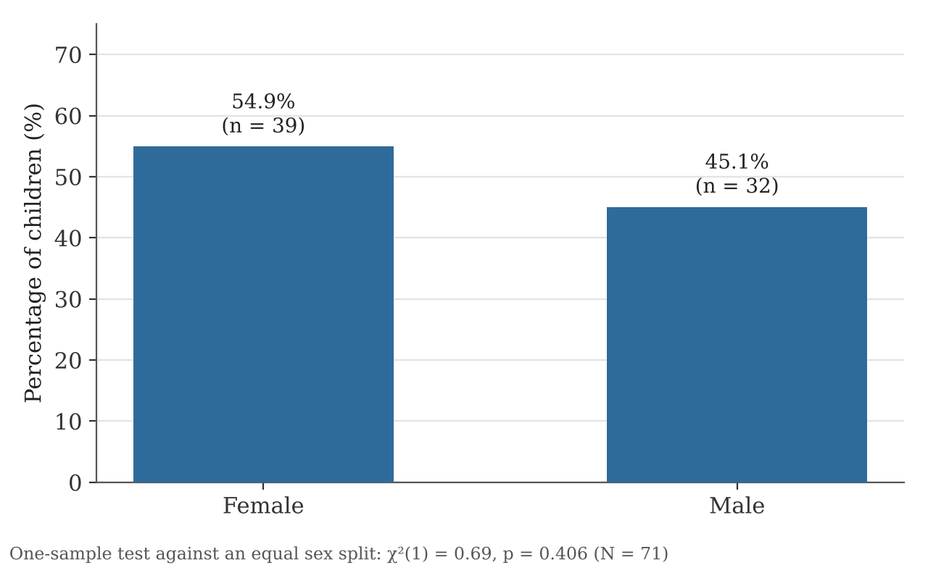
Figure 4.1: Distribution of the sample by sex
Girls made up a little more than half of the sample (54.9%, n = 39; 95% CI 43.4–66.0%), and boys the remaining 45.1% (n = 32), a female-to-male ratio of about 1.2 to 1. The direction of this result agrees with the international literature, in which DDH is more common in girls. However, the difference from an equal split was small and not statistically significant (χ²(1) = 0.69, p = 0.406). In other words, in this sample boys were affected almost as often as girls, which is a noticeably weaker female predominance than most published series report. Possible reasons are discussed in Chapter Five.
Table 4.2: Distribution of the sample by place of residence
Place of residence | Frequency | Percentage (%)
Al-Ajeelat | 39 | 54.9
Sabratha | 32 | 45.1
Total | 71 | 100.0

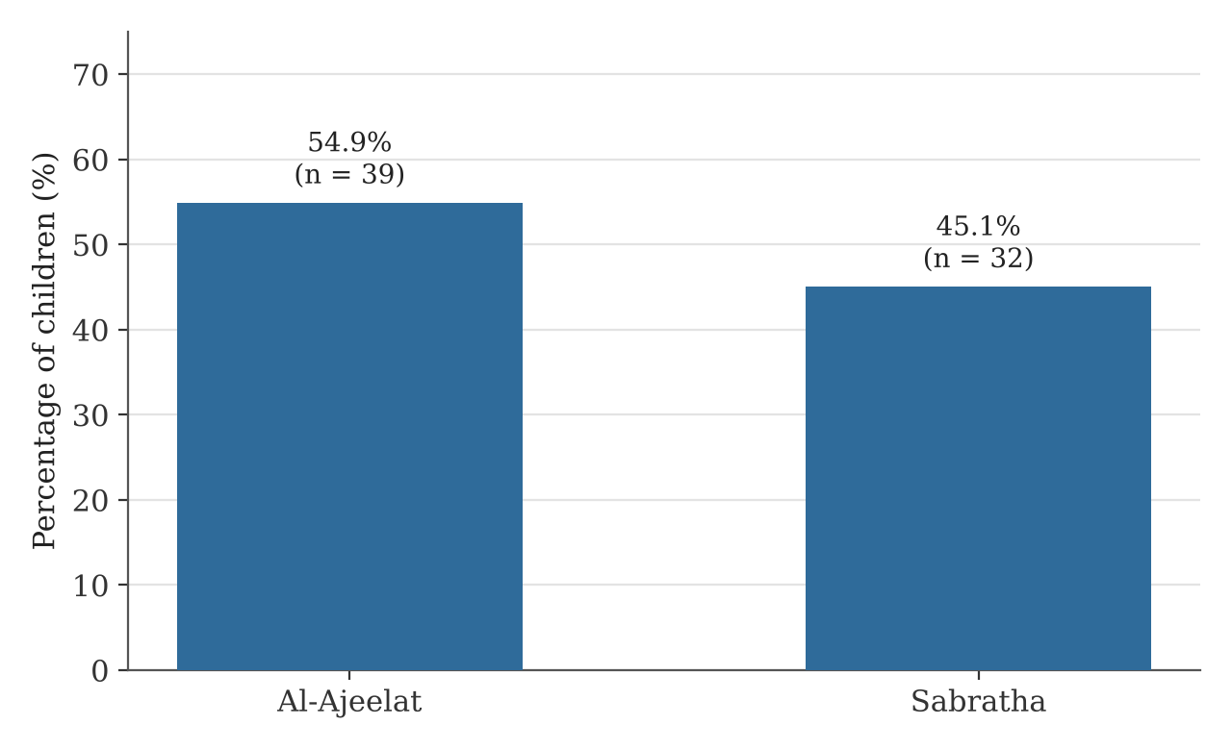
Figure 4.2: Distribution of the sample by place of residence
Slightly more children came from Al-Ajeelat (54.9%, n = 39) than from Sabratha (45.1%, n = 32). This should not be read as a difference in how common DDH is in the two towns. The study did not count all children living in each area, and the number of cases reaching the participating clinics depends on population size, distance to services and referral habits. What the figures do show is that children with DDH were found in both communities, so any awareness or screening effort should cover both.

4.3 Pregnancy and Delivery Factors
Table 4.3: Distribution of the sample by mode of delivery
Mode of delivery | Frequency | Percentage (%)
Vaginal | 47 | 66.2
Caesarean section | 23 | 32.4
Not recorded | 1 | 1.4
Total | 71 | 100.0

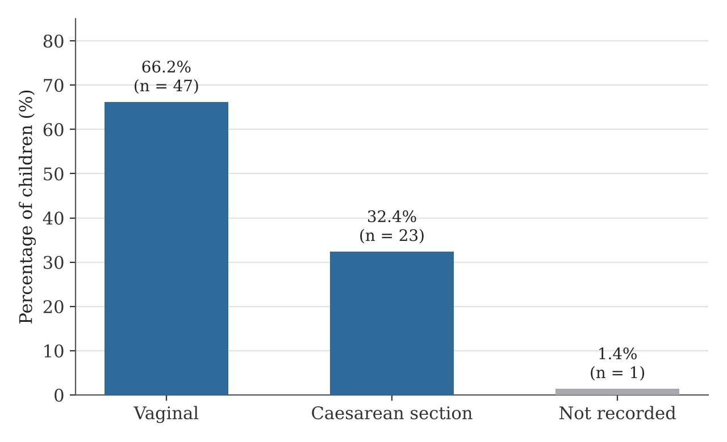
Figure 4.3: Distribution of the sample by mode of delivery
Two-thirds of the children were born vaginally (66.2%, n = 47) and about one-third by caesarean section (32.4%, n = 23); delivery mode was not recorded for one child. Caesarean section is often chosen when a baby is in the breech position, so the two variables are expected to be linked. This relationship is tested in Section 4.5. Without data on the overall caesarean rate in the two towns, it is not possible to say whether caesarean births are over-represented among children with DDH.
Table 4.4: Distribution of the sample by breech presentation during pregnancy
Breech presentation | Frequency | Percentage (%)
Don't know | 36 | 50.7
Yes | 22 | 31.0
No | 12 | 16.9
Not recorded | 1 | 1.4
Total | 71 | 100.0

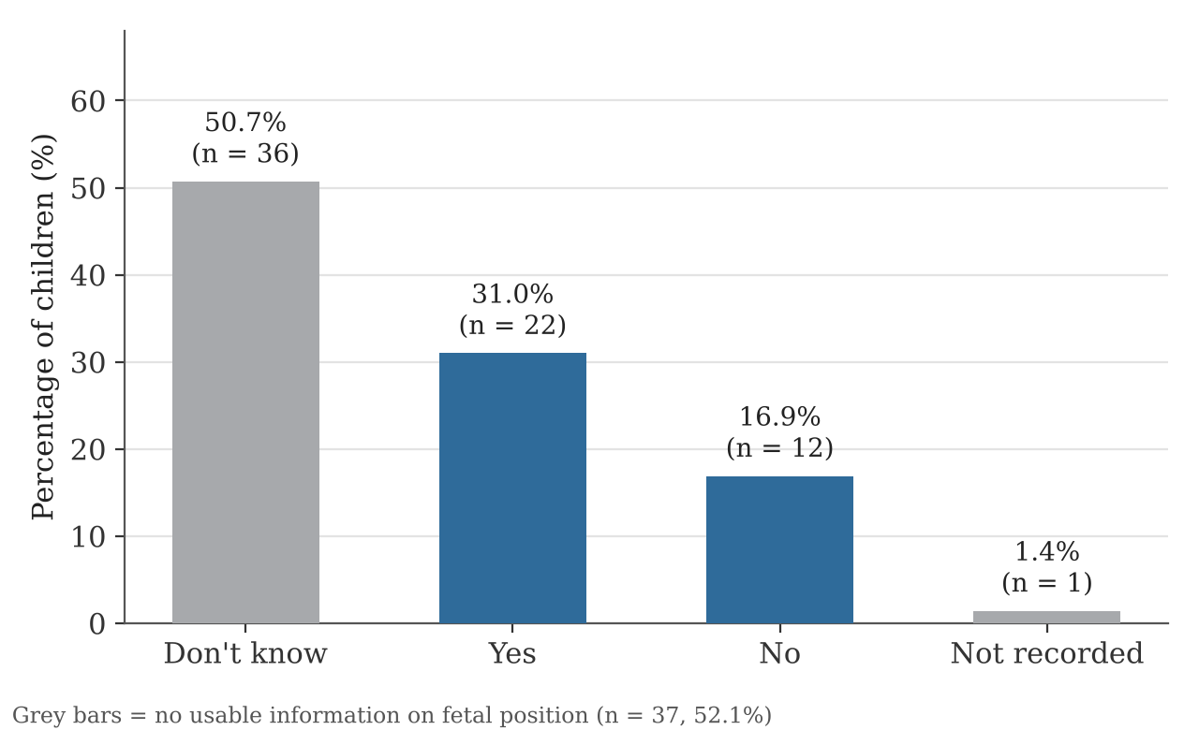
Figure 4.4: Distribution of the sample by breech presentation
The largest group of parents (50.7%, n = 36) did not know whether their baby had been in the breech position. A history of breech presentation was reported for 22 children (31.0%; 95% CI 21.4–42.5%), and 12 parents (16.9%) said there had been no breech presentation. One answer was missing.
Two points stand out. First, 31% is many times higher than the 3–4% usually reported for breech presentation at term in the general population. Second, the true figure is probably higher still, because half of the answers were "don't know". If we look only at the 34 parents who gave a definite answer, breech presentation was reported in 64.7% (22 of 34; 95% CI 47.9–78.5%). The real proportion therefore lies somewhere between these two values. Figure 4.5 places both estimates next to the general population figure.
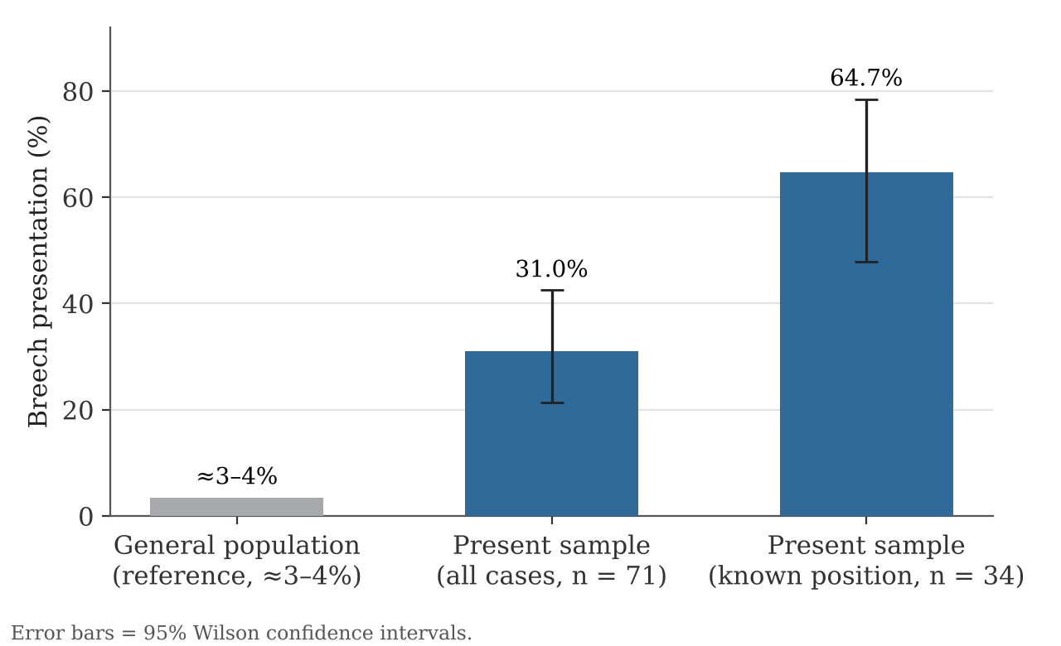
Figure 4.5: Breech presentation in the sample compared with the general population

4.4 One-Sample Tests
Table 4.5 compares the main observed proportions with an expected value.
Table 4.5: One-sample tests of the main proportions
Variable | Observed % (n/N) | 95% CI | Expected % | Test result
Female sex | 54.9 (39/71) | 43.4 – 66.0 | 50 | χ²(1) = 0.69, p = 0.406 (not significant)
Breech presentation (all cases) | 31.0 (22/71) | 21.4 – 42.5 | ≈ 4 | Binomial p < 0.001 (significant)
Breech presentation (known answers only) | 64.7 (22/34) | 47.9 – 78.5 | — | Descriptive only

The share of girls did not differ significantly from 50%. By contrast, the share of breech presentation, even when the cautious figure of 31% is used, was far above the 4% expected in the general population (p < 0.001). This is the clearest statistical finding of the study. It should still be read with care, because the 4% figure comes from the international literature and not from local birth records.

4.5 Relationship between Mode of Delivery and Breech Presentation
Table 4.6: Chi-square test of independence between mode of delivery and breech presentation (SPSS output)
Variables | χ² value | df | p-value | Note
Mode of delivery (3 categories) × breech presentation (4 categories) | 71.492 | 6 | < 0.001 | Expected counts below 5 in most cells

The SPSS output gave a chi-square value of 71.492 with a p-value below 0.001, which at first sight suggests a very strong relationship. A closer look, however, shows that this result should not be accepted at face value.
The value of 71.492 is almost equal to the sample size (N = 71). When a single child falls in a row and a column that each contain only that child, as happens when the same child is "not recorded" for both delivery mode and breech presentation, the expected count for that cell is 1 × 1 / 71 = 0.014. That one cell then contributes (1 − 0.014)² / 0.014 ≈ 69.0 to the chi-square total. This leaves only about 2.5 for all the other cells together, which would correspond to a p-value of around 0.87, far from significant. In addition, most cells in the table have expected counts below 5, which breaks a basic condition of the chi-square test.
The reported significance is therefore most likely an artefact of the single incomplete record rather than evidence that breech babies in this sample were delivered by caesarean section more often. To obtain a valid answer, the analysis should be repeated after excluding the "not recorded" answers, and ideally the "don't know" answers as well, leaving a 2 × 2 table (vaginal / caesarean × breech yes / no) analysed with Fisher's exact test. Until that is done, the relationship between delivery mode and breech presentation in this sample should be considered unconfirmed.

4.6 Summary of Results
Table 4.7: Summary of the main results
Variable | Category | n | %
Sex | Female | 39 | 54.9
 | Male | 32 | 45.1
Residence | Al-Ajeelat | 39 | 54.9
 | Sabratha | 32 | 45.1
Mode of delivery | Vaginal | 47 | 66.2
 | Caesarean section | 23 | 32.4
 | Not recorded | 1 | 1.4
Breech presentation | Don't know | 36 | 50.7
 | Yes | 22 | 31.0
 | No | 12 | 16.9
 | Not recorded | 1 | 1.4

The main results can be summarised as follows:
- Sex: girls formed a slight, non-significant majority (54.9%; p = 0.406).
- Residence: children with DDH were found in both towns, slightly more often from Al-Ajeelat (54.9%).
- Breech presentation: reported for at least 31% of the children, and for 64.7% of those whose parents knew the answer, far above the general population figure of about 4% (p < 0.001).
- Parental knowledge: half of the parents (50.7%) did not know whether their baby had been in the breech position.
- Delivery and breech: the apparently strong chi-square result (χ² = 71.492) is explained almost entirely by one incomplete record, so a link between delivery mode and breech presentation is not confirmed by these data.

CHAPTER FIVE: DISCUSSION

5.1 Overview
This chapter interprets the results in the light of previous research, considers why some findings differ from what was expected, and draws out what they mean for physiotherapy practice in Sabratha and Al-Ajeelat.

5.2 Demographic Findings

5.2.1 Sex
Girls made up 54.9% of the sample. This matches the direction of the literature, but the gap was much smaller than usual and not statistically significant. Large reviews report that about 80% of children with DDH are girls (Loder & Skopelja, 2011), and the meta-analyses estimate that girls carry two to four times the risk of boys (Ortiz-Neira et al., 2012; de Hundt et al., 2012). A ratio of 1.2 to 1, as found here, is clearly lower.
There are several possible explanations. The sample is small, and with 71 children the confidence interval for the female share is wide (43–66%), so the true value could be considerably higher. The study also included children up to 12 years old who were recruited from clinics, which means it may contain more late-diagnosed and more severe cases, and the sex ratio in such groups can differ from that in newborn screening studies. Finally, it is possible that some of the children had hip problems that were labelled as DDH without strict imaging criteria. These possibilities cannot be separated with the present data, but they suggest that the finding should not be taken as evidence that sex matters less in this population. Girls, especially those with other risk factors, should still be given priority in screening.

5.2.2 Residence
Both towns contributed a similar number of cases. Since the two communities are close to each other and share many customs, including infant-care practices, a broadly similar picture is not surprising. The slightly higher number from Al-Ajeelat may reflect population size or access to the participating clinics rather than a real difference in risk. The practical message is that awareness and screening activities should include both towns.

5.3 Pregnancy and Delivery Factors

5.3.1 Breech Presentation
The most striking result is how often breech presentation was reported. Even the conservative figure of 31% is about eight to ten times the usual population rate, and among parents who knew the answer the figure rose to almost two-thirds. This fits well with the international evidence that breech position is the strongest single risk factor for DDH (Ortiz-Neira et al., 2012; de Hundt et al., 2012) and with the findings of Vogt et al. (2025), who also linked abnormal birth presentation with DDH. The mechanism is well understood: in the frank breech position the hamstrings pull the femoral head backwards out of a shallow socket (Holen et al., 1996).
Equally important is the fact that half of the parents did not know whether their baby had been breech. This may reflect limited discussion of fetal position during antenatal visits, poor transfer of information from the maternity unit to the family, or simple difficulty remembering, particularly for parents of older children. Whatever the reason, it matters clinically. Breech presentation is one of the main triggers for hip ultrasound in screening guidelines (AAP, 2000), so if neither the parents nor the child's later health records carry this information, at-risk babies may never be referred.

5.3.2 Mode of Delivery
One-third of the children were born by caesarean section. In the literature, caesarean delivery is mostly a marker of breech position rather than a cause of DDH in its own right, and recent meta-analytic work has not found caesarean delivery to be an independent risk factor once presentation is taken into account (Ortiz-Neira et al., 2012). Without information on the general caesarean rate in the two towns, the present study cannot say whether caesarean births are more common among children with DDH than in the wider population.

5.4 The Statistical Relationship between Delivery and Breech Presentation
The original analysis reported a highly significant relationship between delivery mode and breech presentation (χ² = 71.492, p < 0.001). Chapter Four showed that this value is almost entirely produced by one child whose information was missing for both variables, and that the rest of the table contributes very little. Many of the cells also had expected counts far below 5, which makes the chi-square test unsuitable.
This does not mean that there is no link between breech presentation and caesarean delivery; in obstetric practice such a link is expected, because breech babies are often delivered by caesarean section. It means that the present data, with half of the breech answers unknown, cannot demonstrate it reliably. Re-analysing the data with Fisher's exact test on the complete answers only would give a fairer picture. More generally, this example shows why it is worth checking cell counts and the contribution of each cell before trusting a very large chi-square value in a small sample.
It is also worth remembering that both variables describe children who already have DDH. Even a valid relationship between delivery mode and breech presentation would tell us about obstetric practice, not about the risk of DDH itself. To study risk, a future study would need a comparison group of children without DDH.

5.5 Implications for Physiotherapy Practice

5.5.1 Screening and Early Detection
Physiotherapists who see infants in community or hospital settings should ask about breech presentation, family history and first pregnancy, and should pay special attention to girls. A quick check of hip abduction, the Galeazzi sign and skin-fold symmetry takes little time, and any doubt should lead to referral for ultrasound or orthopaedic review.

5.5.2 Parent Education
The high rate of "don't know" answers shows a clear need for parent education. Physiotherapists can contribute through antenatal classes, postnatal wards and child health clinics, explaining in simple language what DDH is, which babies are at higher risk and which signs should prompt a visit to the doctor. Advice on swaddling that leaves the legs free to bend and move apart, and on carrying the baby astride the hip, is a low-cost measure supported by the literature (Mahan & Kasser, 2008).

5.5.3 Rehabilitation Services
Because many children in the area are diagnosed after early infancy, a good number will need casting or surgery and the rehabilitation that follows. Local physiotherapists therefore need solid skills in brace management, post-cast and post-operative rehabilitation and gait training. Data on the types of treatment the children in this sample received would help plan these services, and should be added in future analyses.

5.5.4 Teamwork
DDH care involves obstetricians, paediatricians, radiologists, orthopaedic surgeons and physiotherapists. Clear pathways between them, for example routine recording of breech presentation on the newborn discharge card and direct referral for hip ultrasound, would make it less likely that an at-risk baby slips through the system.

CHAPTER SIX: CONCLUSION AND RECOMMENDATIONS

6.1 Conclusion
This study described 71 children with DDH from Sabratha and Al-Ajeelat in western Libya, using a parent questionnaire on demographic, pregnancy and delivery factors. The main conclusions are:
- Girls formed a slight majority of the sample (54.9%), but the difference from boys was not statistically significant. The weaker-than-expected female predominance needs to be checked in a larger study.
- Children with DDH came from both towns in similar numbers, so screening and awareness efforts should cover both communities.
- Breech presentation was very common among the children, at least 31% and probably considerably higher, compared with about 4% in the general population. This supports breech position as a key risk factor in the local population.
- Half of the parents did not know whether their baby had been in the breech position, which points to a gap in antenatal communication and in the records that follow the child after birth.
- The reported relationship between delivery mode and breech presentation was not confirmed. The large chi-square value was caused mainly by one incomplete record, and the analysis should be repeated with Fisher's exact test.
- Physiotherapists are well placed to support early detection, parent education and rehabilitation, especially in an area without a formal screening programme.

6.2 Recommendations

6.2.1 For Clinical Practice
- Examine the hips of all newborns in Sabratha and Al-Ajeelat, and refer for ultrasound those with risk factors, especially breech presentation, a positive family history or female sex.
- Record fetal presentation at birth clearly on the newborn's discharge card and child health record, so that it is available to later health workers.
- Use a standard hip examination form in clinics so that findings are recorded in the same way across facilities.
- Provide physiotherapists with training in infant hip screening, brace management and post-operative rehabilitation.

6.2.2 For Public Health
- Include information about DDH and breech presentation in antenatal care, and make sure mothers are told the position of their baby before delivery.
- Run community campaigns on hip-friendly swaddling and carrying, using health centres, community health workers and social media.
- Train midwives, nurses and primary care doctors to recognise risk factors and early signs of DDH.

6.2.3 For Future Research
- Re-analyse the present data on delivery mode and breech presentation using Fisher's exact test on complete answers only, and report the remaining questionnaire variables (birth order, amniotic fluid, family history, method of diagnosis and treatment).
- Carry out a case–control study comparing children with and without DDH, so that the risk linked to each factor can be measured.
- Use hospital birth records rather than parental memory for obstetric information.
- Study local swaddling and carrying customs and their relationship with DDH.
- Evaluate the outcomes of physiotherapy programmes for children with DDH in Libya.
- Extend the study to other Libyan regions to build a national picture.

REFERENCES
Aldowekat, O. M., et al. (2026). Pediatricians' knowledge, skills, and practices in screening for developmental dysplasia of the hip: A nationwide cross-sectional study. Musculoskeletal Care, 24(2), e70198.
American Academy of Orthopaedic Surgeons. (2014). Detection and nonoperative management of pediatric developmental dysplasia of the hip in infants up to six months of age: Evidence-based clinical practice guideline. AAOS.
American Academy of Pediatrics. (2000). Clinical practice guideline: Early detection of developmental dysplasia of the hip. Pediatrics, 105(4), 896–905. https://doi.org/10.1542/peds.105.4.896
Atalar, H., Sayli, U., Yavuz, O. Y., Uras, I., & Dogruel, H. (2007). Indicators of successful use of the Pavlik harness in infants with developmental dysplasia of the hip. International Orthopaedics, 31(2), 145–150.
Bache, C. E., Clegg, J., & Herron, M. (2002). Risk factors for developmental dysplasia of the hip: Ultrasonographic findings in the neonatal period. Journal of Pediatric Orthopaedics B, 11(3), 212–218.
Baheti, N. C., et al. (2024). Impact of early rehabilitation in a four-year-old patient with developmental dysplasia of the hip: A case report. Cureus, 16(2), e54900.
Barlow, T. G. (1962). Early diagnosis and treatment of congenital dislocation of the hip. Journal of Bone and Joint Surgery (British Volume), 44-B(2), 292–301.
Carter, C. O., & Wilkinson, J. A. (1964). Persistent joint laxity and congenital dislocation of the hip. Journal of Bone and Joint Surgery (British Volume), 46-B(1), 40–45.
Cashman, J. P., Round, J., Taylor, G., & Clarke, N. M. P. (2002). The natural history of developmental dysplasia of the hip after early supervised treatment in the Pavlik harness. Journal of Bone and Joint Surgery (British Volume), 84-B(3), 418–425.
de Hundt, M., Vlemmix, F., Bais, J. M. J., Hutton, E. K., de Groot, C. J., Mol, B. W. J., & Kok, M. (2012). Risk factors for developmental dysplasia of the hip: A meta-analysis. European Journal of Obstetrics & Gynecology and Reproductive Biology, 165(1), 8–17.
Dezateux, C., & Rosendahl, K. (2007). Developmental dysplasia of the hip. The Lancet, 369(9572), 1541–1552. https://doi.org/10.1016/S0140-6736(07)60710-7
Do, T. T. (2001). Congenital muscular torticollis: Current concepts and review of treatment. Current Opinion in Pediatrics, 13(1), 26–31.
Drake, R. L., Vogl, A. W., & Mitchell, A. W. M. (2015). Gray's anatomy for students (3rd ed.). Churchill Livingstone/Elsevier.
Fabry, G., MacEwen, G. D., & Shands, A. R. (1973). Torsion of the femur: A follow-up study in normal and abnormal conditions. Journal of Bone and Joint Surgery (American Volume), 55(8), 1726–1738.
Ferguson, S. J., Bryant, J. T., Ganz, R., & Ito, K. (2003). An in vitro investigation of the acetabular labral seal in hip joint mechanics. Journal of Biomechanics, 36(2), 171–178. https://doi.org/10.1016/S0021-9290(02)00365-2
Graf, R. (1984). Classification of hip joint dysplasia by means of sonography. Archives of Orthopaedic and Trauma Surgery, 102(4), 248–255.
Grill, F., Bensahel, H., Canadell, J., Dungl, P., Matasovic, T., & Vizkelety, T. (1988). The Pavlik harness in the treatment of congenital dislocating hip: Report on a multicenter study of the European Paediatric Orthopaedic Society. Journal of Pediatric Orthopaedics, 8(1), 1–8.
Harcke, H. T., Clarke, N. M., Lee, M. S., Borns, P. F., & MacEwen, G. D. (1984). Examination of the infant hip with real-time ultrasonography. Journal of Ultrasound in Medicine, 3(3), 131–137.
Holen, K. J., Tegnander, A., Terjesen, T., Johansen, O. J., & Eik-Nes, S. H. (1996). Ultrasonographic evaluation of breech presentation as a risk factor for hip dysplasia. Acta Paediatrica, 85(2), 225–229.
Hulley, S. B., Cummings, S. R., Browner, W. S., Grady, D. G., & Newman, T. B. (2013). Designing clinical research (4th ed.). Lippincott Williams & Wilkins.
Ibrahim, A., Mortada, E., et al. (2021). Developmental dysplasia of the hip and associated risk factors in Saudi children: A retrospective study. Journal of Back and Musculoskeletal Rehabilitation, 34(4). https://doi.org/10.3233/BMR-191819
Kapandji, I. A. (2010). The physiology of the joints: Vol. 2. The lower limb (6th ed.). Churchill Livingstone/Elsevier.
Klaue, K., Durnin, C. W., & Ganz, R. (1991). The acetabular rim syndrome: A clinical presentation of dysplasia of the hip. Journal of Bone and Joint Surgery (British Volume), 73-B(3), 423–429.
Klisic, P. J. (1989). Congenital dislocation of the hip: A misleading term. Journal of Bone and Joint Surgery (British Volume), 71-B(1), 136.
Kotlarsky, P., Haber, R., Bialik, V., & Eidelman, M. (2015). Developmental dysplasia of the hip: What has changed in the last 20 years? World Journal of Orthopedics, 6(11), 886–901. https://doi.org/10.5312/wjo.v6.i11.886
Kutlu, A., Memik, R., Mutlu, M., Kutlu, R., & Arslan, A. (1992). Congenital dislocation of the hip and its relation to swaddling used in Turkey. Journal of Pediatric Orthopaedics, 12(5), 598–602.
Loder, R. T., & Skopelja, E. N. (2011). The epidemiology and demographics of hip dysplasia. ISRN Orthopedics, 2011, 238607. https://doi.org/10.5402/2011/238607
Mahan, S. T., & Kasser, J. R. (2008). Does swaddling influence developmental dysplasia of the hip? Pediatrics, 121(1), 177–178. https://doi.org/10.1542/peds.2007-1618
Moore, K. L., Dalley, A. F., & Agur, A. M. R. (2014). Clinically oriented anatomy (7th ed.). Lippincott Williams & Wilkins.
Narayanan, U., Mulpuri, K., Sankar, W. N., Clarke, N. M., Hosalkar, H., Price, C. T., & International Hip Dysplasia Institute. (2015). Reliability of a new radiographic classification for developmental dysplasia of the hip. Journal of Pediatric Orthopaedics, 35(5), 478–484.
Neumann, D. A. (2017). Kinesiology of the musculoskeletal system: Foundations for rehabilitation (3rd ed.). Elsevier.
Ortiz-Neira, C. L., Paolucci, E. O., & Donnon, T. (2012). A meta-analysis of common risk factors associated with the diagnosis of developmental dysplasia of the hip in newborns. European Journal of Radiology, 81(3), e344–e351. https://doi.org/10.1016/j.ejrad.2011.11.003
Ortolani, M. (1937). Un segno poco noto e sua importanza per la diagnosi precoce di prelussazione congenita dell'anca. La Pediatria, 45, 129–136.
Pavlik, A. (1950). Die funktionelle Behandlungsmethode mittels Riemenbügel als Prinzip der konservativen Therapie bei angeborenen Hüftgelenksverrenkungen der Säuglinge. Zeitschrift für Orthopädie und ihre Grenzgebiete, 89, 341–352.
Sewell, M. D., & Eastwood, D. M. (2011). Screening and treatment in developmental dysplasia of the hip: Where do we go from here? International Orthopaedics, 35(9), 1359–1367. https://doi.org/10.1007/s00264-011-1257-z
Shorter, D., Hong, T., & Osborn, D. A. (2013). Cochrane review: Screening programmes for developmental dysplasia of the hip in newborn infants. Evidence-Based Child Health, 8(1), 11–54.
Standring, S. (Ed.). (2016). Gray's anatomy: The anatomical basis of clinical practice (41st ed.). Elsevier.
Sutherland, D. H., Olshen, R. A., Biden, E. N., & Wyatt, M. P. (1988). The development of mature walking. Mac Keith Press.
Tönnis, D. (1987). Congenital dysplasia and dislocation of the hip in children and adults. Springer-Verlag.
Trueta, J. (1957). The normal vascular anatomy of the human femoral head during growth. Journal of Bone and Joint Surgery (British Volume), 39-B(2), 358–394.
Vasilcova, V., et al. (2022). Developmental dysplasia of the hip: Prevalence and correlation with other diagnoses in physiotherapy practice — A 5-year retrospective review. Children, 9(2), 247. https://doi.org/10.3390/children9020247
Vogt, B., Tureck, L., Gosheger, G., et al. (2025). Early screening for developmental dysplasia of the hip: Sonographic reference values, risk factors, and treatment considerations. International Journal of Neonatal Screening, 11(3), 81. https://doi.org/10.3390/ijns11030081
Weinstein, S. L., Mubarak, S. J., & Wenger, D. R. (2003). Developmental hip dysplasia and dislocation: Part II. Journal of Bone and Joint Surgery (American Volume), 85(10), 2024–2035.
World Medical Association. (2013). World Medical Association Declaration of Helsinki: Ethical principles for medical research involving human subjects. JAMA, 310(20), 2191–2194. https://doi.org/10.1001/jama.2013.281053
Wynne-Davies, R. (1970). Acetabular dysplasia and familial joint laxity: Two etiological factors in congenital dislocation of the hip. Journal of Bone and Joint Surgery (British Volume), 52-B(4), 704–716.

