SAMSON PALKURI

Mobile: 0470424899
E-mail: samsonpalkuri@gmail.com

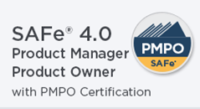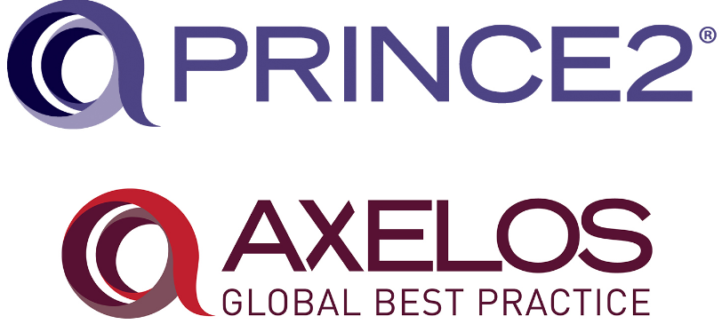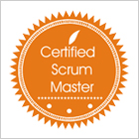

Prince2 Foundation Certificate in Project Management
SAFe 4.0 Product Manager / Product Owner certified
Certified Scrum Master®
ITIL V3® Foundation Certificate in IT Service Management
BCS Certified Tester
HP – Quality Center 10.0 Certified

Profile (12 years’ experience)

A highly skilled multi-faceted Product Owner / Manager Business professional offering exceptional performance record recognized by steady advancement through increasingly responsible positions at companies such as Real Page, Thomson Reuters, and CCH Wolters Kluwers. Experience in high profile operations; project & product planning, management and execution; quality assurance and UAT; and brand creation and development supporting the overall strategy and goals of the company. Increased efficiency and profits and reduced costs through utilization of strong troubleshooting and problem resolution skills.

I love working with internal and external stake holders to effectively & efficiently handle communication strategy and manage challenging situations. An excellent communicator and negotiator with the product teams(s) and external entities, under promise and over deliver is exactly how I work. I have a complete understanding of software development life cycle, Project Management Discipline, Iterative, Waterfall, and AGILE (Scrum) methodologies. I’m SAFe 4.0 Agile Product Manager / Product Owner certified.

I desire to associate myself with an organization that provides me a progressive and challenging career, maximizes my potential to apply my expertise and skills to deliver high quality work products / projects.

Professional Summary

- Demonstrated record of success defining and launching products. Adept at gathering and prioritizing product and customer requirements; defining the product vision and working closely with development, sales and marketing teams to ensure revenue and customer satisfaction goals are met.
- Have profound knowledge of capturing, assessing and defining business requirements, conducting workshops, working with internal and external stakeholders on budgets, reviewing and prioritizing requests, developing relationship and client engagement with the Australian Tax Office (ATO).
- Led several business and team development initiatives related to business efficiency improvements, driving proficiency and productivity, quality, lowering cost, process improvements and driving client and team engagement.
- A SAFe agilest; expert in Agile Scrum, Iterative, and waterfall project management methodologies; able to individually manage large projects and known for high-quality deliverables that meet or exceed timeline and budgetary targets.
- Lead, Manage & supervise global product teams for development life cycle activities
- Possess Strategic capability; the ability and desire to think beyond immediate issues, to consider the long-term and broader implications, and clearly identifies what needs to be done
- Highly effective written and oral communication skills – able to communicate complex technical information to the understanding and able to develop high quality documentation

Academics
- Masters in Science (Information Technology) (2011-2013)
- Bachelors in Computer Applications 1999-2002 (First Class with Distinction)
- Associate Member of British Computer Society (AMBCS) # 990492532

Technical Skills and Core Strengths
Skills | Strategic Planning and Execution, Success Mapping and Metrics Management, User Experience Improvements Analyses and Quantitative Skills, New Product Development and Launch, Matrix Management, Multitasking Collaboration and Cross-Functional Expertise, Product enhancement and optimization, Requirement gathering, Researcher, Problem solving, algorithms, vendor/Stake holder management, Business continuity process, Risk analysis, Document writing, UAT Test Strategy/Plans
Office | Strong Atlassian Portfolio - JIRA and Confluence, MS Office, Visio, and Power point capabilities
Tools | Atlassian JIRA, Confluence, Team Foundation Server (TFS), and Bugzilla,
Methodologies | Agile Scrum, Waterfall, Iterative, Prototype, and V models
Languages / Tools | JIRA, MS-VSS, TFS, SVN, GIT, Source tree, Eclipse, TOAD, HTML, XML, CSS, VB Script, Java Script, JSON, Jenkins, Axure 8.0, Balsamiq
Servers & Databases | Tomcat 5.0, Web sphere, JBoss 4.0/3.2.5, Oracle 9i/10g, SQL Server 2012

Employment Experience

Product Owner at CCH Wolters Kluwer, Australia Mar ’17 - present

Project 1: CCH iFirm Tax – Australia and New Zealand
Employer: CCH Wolters Kluwer AUSTRALIA (Melbourne, Australia)
URL: https://www.cchifirm.com.au
Designation: Product Owner

Roles and responsibilities:

- Lead and product manage the entire project life-cycle for CCH iFirm projects and drives product management in support of corporate, cross-functional initiatives ensuring the end result meets the client’s requirements.
- Own the development of the product strategy and vision supported by internal and external analysis
- Define the product roadmap based on the strategy and vision; manage prioritization and trade-offs among customer experience, site performance and operational support load
- Write complete and detail-oriented product requirements documents, ensuring clear communication of those requirements to the business, design, usability and development teams
- Creator and guardian of world-class customer experiences that delight C-level execs and continually raise the bar on functionality, flow, consistency, usability and simplicity.
- Act as a champion to the structured project management approach to encourage strong practices around the organization.
- Meets established project milestones, goals and objectives within established time frames by utilizing a disciplined approach to delivering within budget and timelines.
- Manage transition issues when new enhancements, changes, or products are introduced and provides additional support to users where necessary.
- Advocates change management and anticipates the types of issues that may arise during such transitions, and takes steps to proactively resolve those issues.
- Develops testing strategy and sets up testing environments for projects. Engages in systems testing, facilitates user acceptance testing and obtains appropriate sign-off for changes and enhancements.

Sr. BA/Product Specialist at the Thomson Reuters Melbourne, Australia June ’11 – Feb’17

Project 1: SOFTWARE ASSISTANT / ONVIO
Employer: THOMSON REUTERS PROFESSIONAL AUSTRALIA (Melbourne, Australia)
URL: https://www.softassist.com.au (Tax, Ledger, and Practice Assistant) & SBR Assistant
Designation: Sr. Business Analyst / Product Specialist

Roles and Responsibilities:

- Involved and a key player of the initial approach to build a local reporting framework driven by local requirements and granularity
- Requirements management using TFS and creating mapping diagrams to provide test coverage as metrics
- Understand system engineering concepts and conduct cost/benefit analysis
- Business case development for Tax / accounting products
- Research and provide new modelling techniques and methods for better requirement clarification to internal and external stakeholders
- Planning and monitoring project life cycle and working software deliverables
- Create, manage, test, and upgrade well established existing tax & accounting products to the next generation level.
- Led several business and team development initiatives related to business efficiency improvements, driving proficiency and productivity, quality, lowering cost, process improvements and driving client and team engagement.
- Facilitated local tax reporting, single regime and to allow detailed reports within that region (AU region)
- Communication and interaction with key stake holders, ATO, and senior management on product roadmaps.

Business Analyst at Real Page June’09 – June 11’

Project: One Site Budgeting
Employer: REALPAGE INC. (Leader in Property Management Solutions)
URL: www.realpage.com
Designation: Business Analyst

- Responsible for the BA activities of the product development right from kickoff till delivery. Point of Contact for day-to-day items and successful test results.
- Developing and maintaining test methodology, defining test strategies for projects.
- Involved in creating structured processes to manage defects right through to resolution.
- Identify test approaches that optimize the delivery schedule.
- Design tests; create test cases; and record and communicate test results from requirements and specifications, while complying with defined standards, processes and templates
- Strong technical aptitude and solid understanding of Software Development Lifecycle

Achievements
  - Increased efficiency and profits and reduced costs through utilization of strong troubleshooting and problem resolution skills.
  - Received accolades for consistently meeting 100% quality and exceeding proficiency target.
  - Managing multiple projects at any given time based on the organization requirements.

References

- Available upon request

