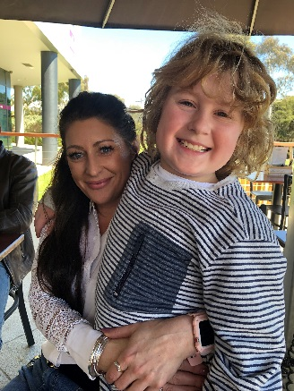 Leyla McDermott

2/5 Kerr Street, Lilydale, Vic, 3140

0410 518 959

01/05/2019

Dear Sir/Madam

I am very interested in this opportunity with your company and believe that my qualifications, education and professional experience would make me a strong candidate for the position.

I am a strong and motivated professional who would add value and customer satisfaction to your business with numerous years of customer service, sales, sales support EA & PA and administration.

Enclosed is my resume that more fully details my background and work experience, and how they relate to your position.

Currently still working in the Sales Retail industry I manage my own department and have KPI’s to meet along with a lot of other responsibilities as listed in my resume.

I firmly believe that I can be a valuable asset to your team. I welcome the opportunity to speak with you about this position and how my experience could help your company achieve its goals.

Thank you in advance for your consideration.

Kind regards,

Leyla McDermott