Curriculum Vitae

**Shaoyi Li**

**Employment Experience**

**March 2013-Current**

***Staralum Aluminium (Melbourne) Pty Ltd***  Melbourne, Dandenong South VIC

**Liaising with the various suppliers and manufacture factory daily**

**Answer customer inquiry through the phone and e-mail**

**Effectively update the daily business information into financial and logistics system**

**Review the price or cost structure and participate in new products development**

**Resolve quality and operation issue with suppliers and customers**

**Booking related transportation and commercial service for organization**

**Provide accurate and timely advice and information for manager and customer**

**January 2011-March 2013**

***B&K Bigwheel Arts & Crafts Co. Pty Ltd***  Melbourne, Huntingdale VIC

Daily office jobs such as data entry, manage the database and documentation preparation (invoice, delivery and inventory files.)

Assist the Manager in processing and follow up of production of orders

Timely and accurately upload all paper works, as well as report to manager

Booking and tracking of freight and local transportation

Excellent customer service skills. Able to serve domestic and international suppliers

Accurate and efficient data entry skills as well as maintain database

Excellent time management skill and strong analytical and investigation skills

**Professional Membership**

**Current**  Member of Australian Computer Society

**Demonstrated Skills & Abilities**

A professional and highly motivated individual, currently completed a Master of Business Information Technology and Master of Commerce

**Exceptional interpersonal, verbal and written communication skills, progressed by communicating effectively at all levels including customers, suppliers, colleagues, and managers**

**Ability to plan, organise, set priorities and manage time effectively, in high pressured environments, to achieve fixed goals**

**Committed to fostering a positive team environment, through open communication and showing respect to fellow team members**

**Basic in Decision support systems, various IT analysis systems and proficient in the use of MS Office such as Access, Excel and PowerPoint, Word, Outlook and Internet Explorer**

**Liaising with the external and internal stakeholders and coordinate with related departments within company**

**Good ability in analyzing and implementing the IT projects and e-business**

**Good customer service and communication skills, exceptional negotiation and problem solving skills developed by resolving complaints and dealing with challenging behaviors**

**(Personal Abilities)**

**Honest, mature, reliable worker with the ability to meet deadlines**

**An ability and willingness to learn and apply knowledge**

**Be goal oriented and enjoy dealing with and helping people**

**High level of accuracy and attention to detail**

**Fluent in spoken and written Mandarin**

**Fluent in spoken Taiwanese**

**IT Special Skills:**

* Good ability in solving the daily computer problems such as computer maintenance, software diagnose and website maintenance and providing necessary assistance for daily business operation.
* Be able to create the relating databases for departments which can help them implement the tasks quickly and accurately.
* Understanding of the SDLC and industry programming languages, databases and infrastructure technologies
* Understanding the link and relationships between IT and Business. Able to use IT function to improve business
* Providing the useful ideas and suggestions for different IT projects through using advanced systems in order to help organization reduce the risk, cost and time.
* Quick learner for learning different IT systems and basic skills in solving hardware problems.

**Educational Qualifications**

**2010 - 2011** **Master of Commerce** VIC Australia

*RMIT University*

**2009 - 2010** **Master of Business Information Technology**

*RMIT University*  VIC Australia

**2004 - 2008**  **Bachelor of Logistics Management**

*Fuzhou University*  Fuzhou China

**Achievements** Successfully completed with an overall mark of Distinction in Bachelor and Master Degree

**Personal Details**

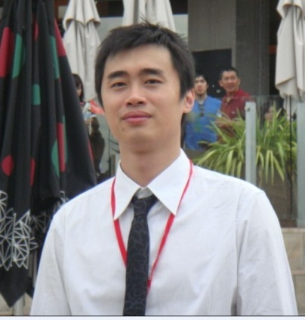

**Name:** Shaoyi Li

**Preferred Name:** Terrence

**Address:** 165 Harcrest Bvd, Wantirna South, VIC 3152

**Phone:** 0430 908 777

**Email:** terrence1020@hotmail.com

**License:** **Victorian Vehicle Driver’s License**

**Referee**

Grace Guo Job Title: Administration Manager

Contact Detail: 0433 948 681

Stephen Smith Job Title: Regional Manager

Contact Detail: 0407 844 579