I chose to look into NOAA's Great Lakes Environmental Research Laboratory (GLERL) Ice Coverage Analysis, and I honestly had a blast at it. I grew up on the shores of Lake Erie, and generally define myself as being from the Great Lake's region, so it was super fun to dive into the data on them. The first thing to note is that each lake has its own characteristics that affect climate and ice coverage. Depth is one of the most important factors with Lake Erie, the shallowest lake, having a maximum depth of 210 feet while Lake Superior, the deepest lake, has a maximum depth of 1,332 feet (EPA, 2025). Depth affects things like average temperature, warming rates, and wave size. Beyond depth, the lakes exist at slightly different latitudes and in different general climates. The average temperature in January in Northern Ohio near Lake Erie is in the 20's while in Northern Minnesota near Lake Superior, it's in the single digits. Additionally, location impacts how wind flows across the lake, affecting wave size and ice movement.
So, getting into the details, what does this look like? 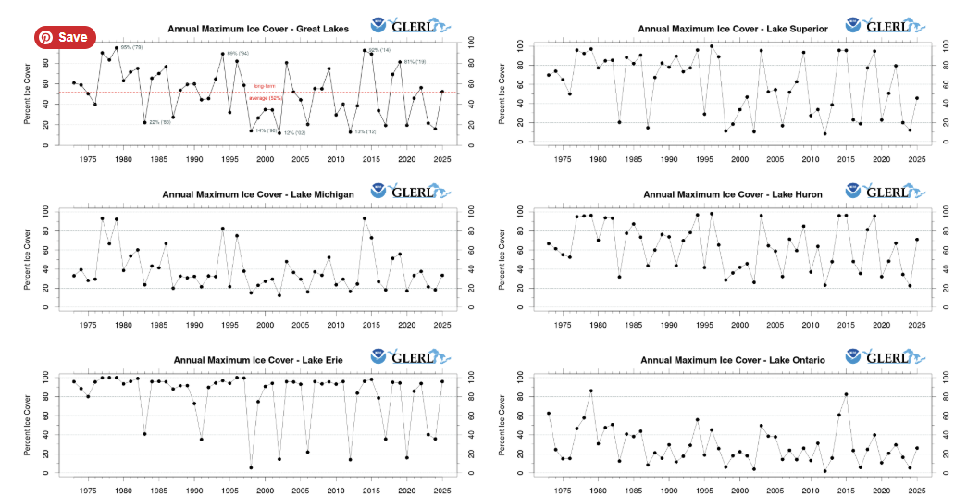
The annual maximum ice plots differ strongly for each lake. Lake Erie tends to freeze over almost completely or barely at all, and almost always gets more than 80% coverage. Ontario which is roughly the same size and at the same latitude has only breached 80% coverage twice. This likely has a lot to do with depth (Lake Erie has less heat stored in it and can quickly expel its heat to freeze over while Ontario has much deeper water). Wind and waves may also serve a factor in breaking up forming ice making it harder to freeze over. Superior also often freezes over almost completely even though it's significantly deeper, it part because it's deep enough that it doesn't often warm up and it has a lot of very cold water year round. It also exists at a higher latitude and experiences colder temperatures than Erie and Ontario.
The biggest thing you'll notice about this data is that it is noisy. This is in part because it is recording the max coverage which may be susceptible to extreme events where polar vortexes bring frigid air down from Northern latitudes for a short time, causing temporary freeze overs. Lake freezing is also susceptible to other climate factors like El Ninos which account for about half of the years that Lake Erie only froze up to about 20%. Additionally, whether the lake freezes over one year may impact its ability to freeze over the next year since a lot of the spring heat goes into the phase change of melting ice and less into heating the water itself, meaning that the lake may not heat up as much the summer after a freeze and may be more likely to freeze the following year.
GLERL also provides plots of the daily ice coverage going back as far as 1973 and showing the current year to date.
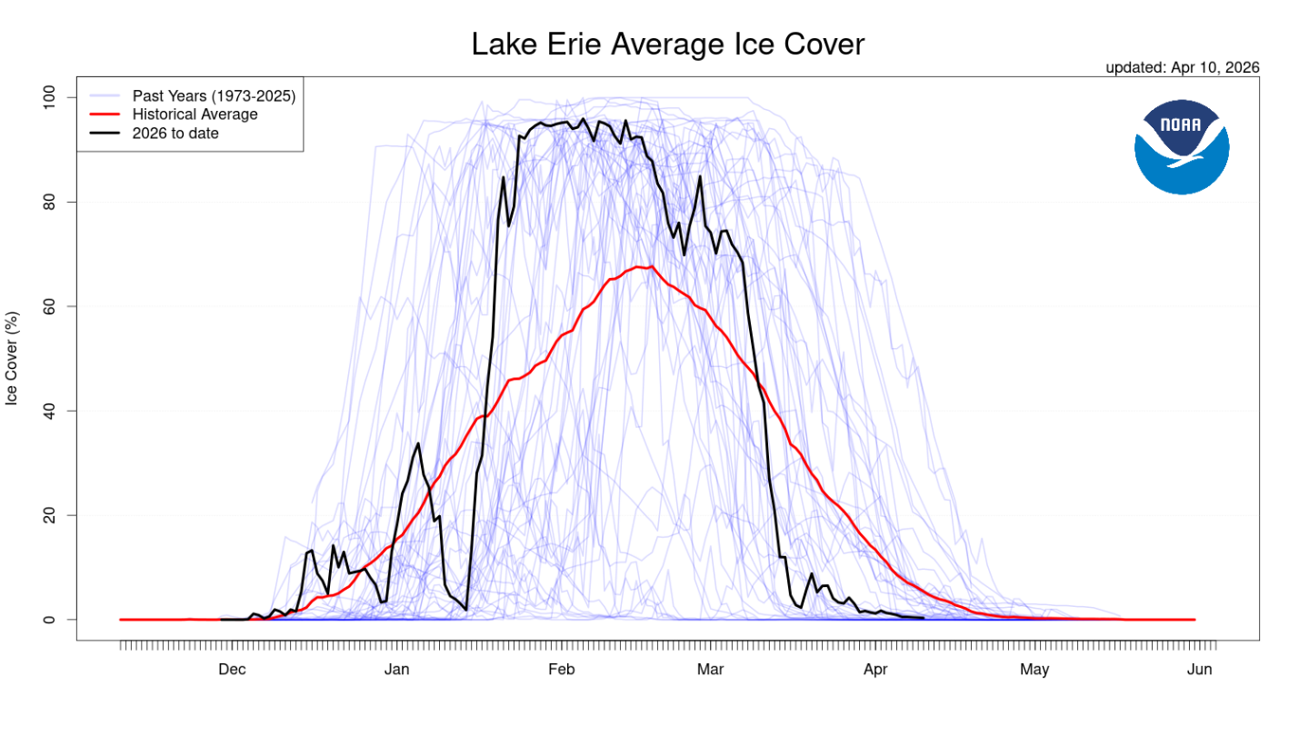
While this has more granularity, it makes it difficult to see any specific trends over the 50 years of data recorded. In order to see some clearer climate trends, I pulled the data used to make this chart and used Claude Code to help build my own plots that add some dimension to better see how the curve evolves over multiple years. I have the more recent years in red and the older years in blue with the 5 most recent years at a darker opacity. These plots help show a stronger trend in the time period of the year in which the lakes have large ice coverage shrinking (like for Lake Erie) and the maximum coverage also shrinking (like for Lake Superior). As temperature increase, the lakes become energy stores for more heat, making it more difficult for regular temperatures to cause the lakes to freeze over which in turn decreases the chances of them freezing in following years.
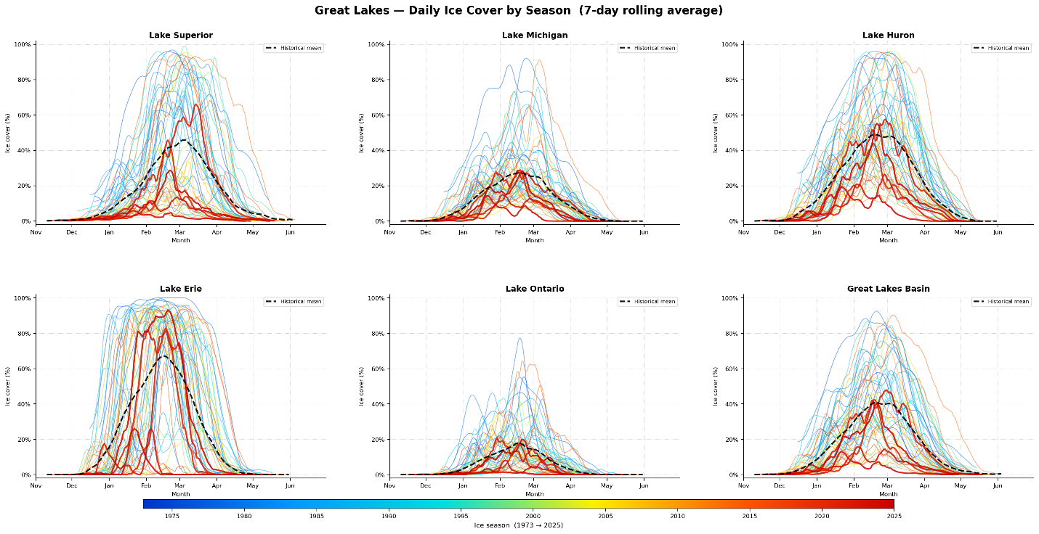
Anecdotally, Lake Erie's tendency to freeze over is a huge part of Erie PA's culture. We're known for ice fishing, ice skating, many snow-related sports due to the Lake Effect snow we get. My parents and grandparents tell stories of playing hockey on the lake and ice skating yearly. In my lifetime, it has often been considered too dangerous due to how thin the ice is. I've never been allowed to walk out on the lake, though I've seen ice fishers still out on the bay. There's no skating area on the bay front or down at the Peninsula. Between my grandparents' generation and my own, this cultural touch stone has completely vanished due to climate change, and I think of it as part of the history of my hometown.

U.S. Environmental Protection Agency. (2025, October 31). Physical features of the Great Lakes. https://www.epa.gov/greatlakes/physical-features-great-lakes
NOAA Great Lakes Environmental Research Laboratory. (n.d.). Great Lakes ice cover. Retrieved April 11, 2026, from https://www.glerl.noaa.gov/data/ice/#historical
Great Lakes Integrated Sciences and Assessments. (n.d.). Lake-effect snow in the Great Lakes region. University of Michigan. Retrieved April 11, 2026, from https://glisa.umich.edu/resources-tools/climate-impacts/lake-effect-snow-in-the-great-lakes-region/
As an afterthought, I plotted the area under the seasonal curve for each year with a trendline showing the evolution over time. I think this is somewhat more informative than simply plotting the maximum over each year in terms of being able to pull out solid trends, though the data is still very noisy.
