Crystal Application Tutorial: Initial calculations

***Aim:*** *The tutorial aims to check you have a working version of the Crystal application in RepTate and explore some of the features of the GO-polyStrand model.*

**Data**: *The ‘data’ are all synthetic, meaning they are outputs of the theory. If you use the same model parameters you should be able to perfectly reproduce these data.*

***Summary:*** *We will import the synthetic data, run the model to reproduce the calculations and then explore some feature of the model.*

# Load data

* Load the Crystal application (Click on the crystal application 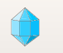 on the top toolbar)
* Open the folder /RepTate/RepTate/data/Crystal/ and select the 3 files InitialTest***.shearxs

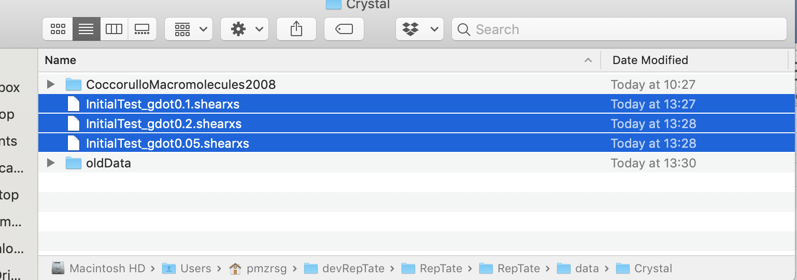

* Drag and drop all files on to the Reptate window

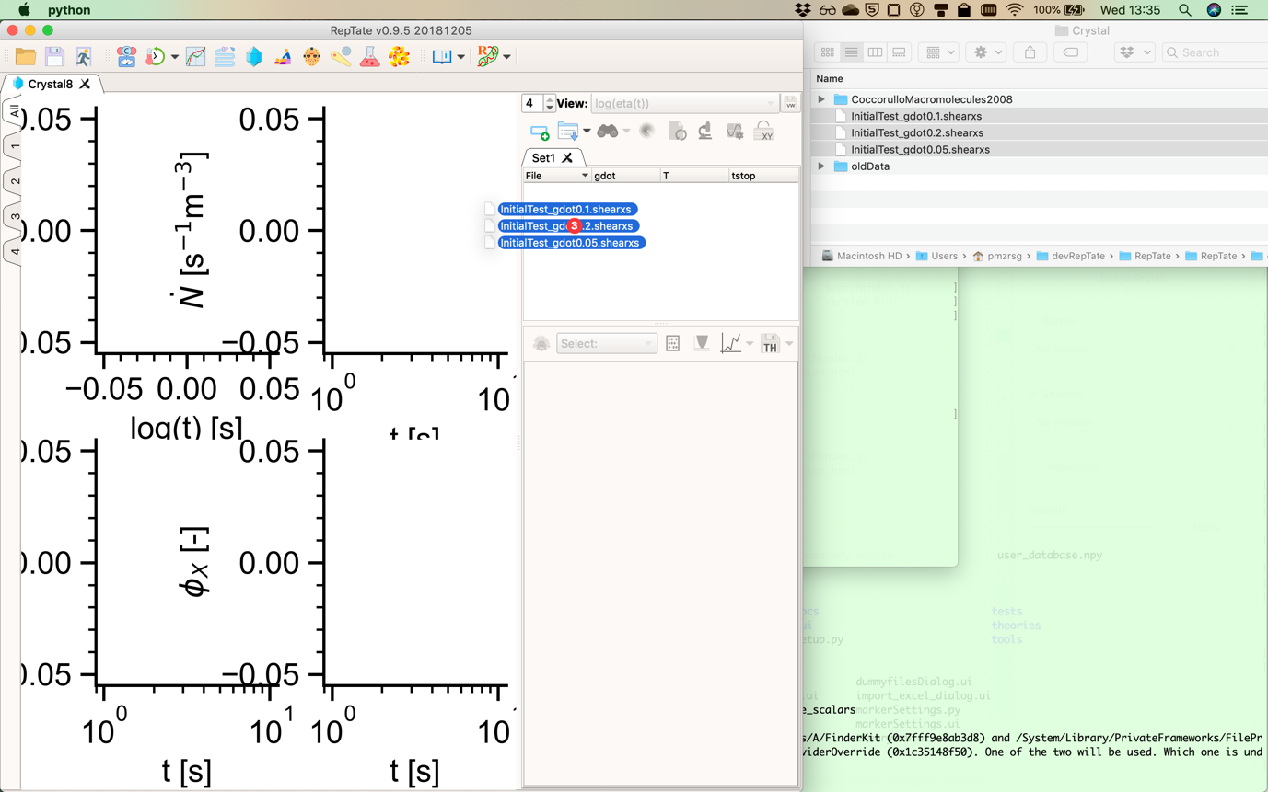

* You should now see

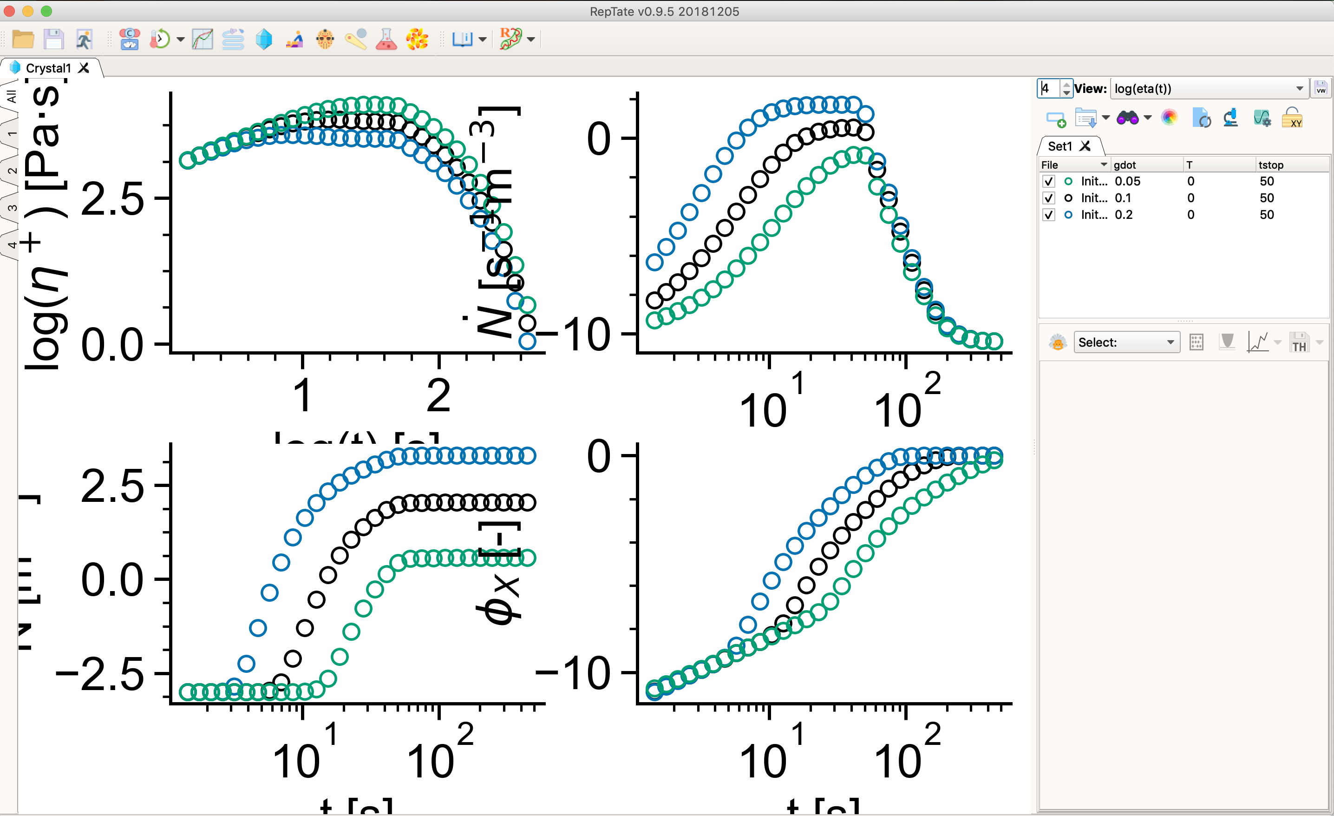

# Run the model

* Load GO-polyStrand model (choose the model from the drop down list and then click the theory icon ). The calculation should take about 4 seconds.

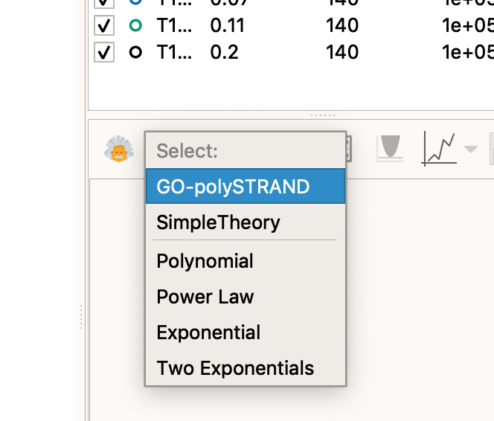

* The default parameters are fine for this calculation so click compute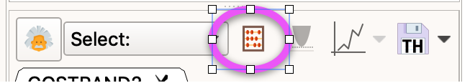
* You should see 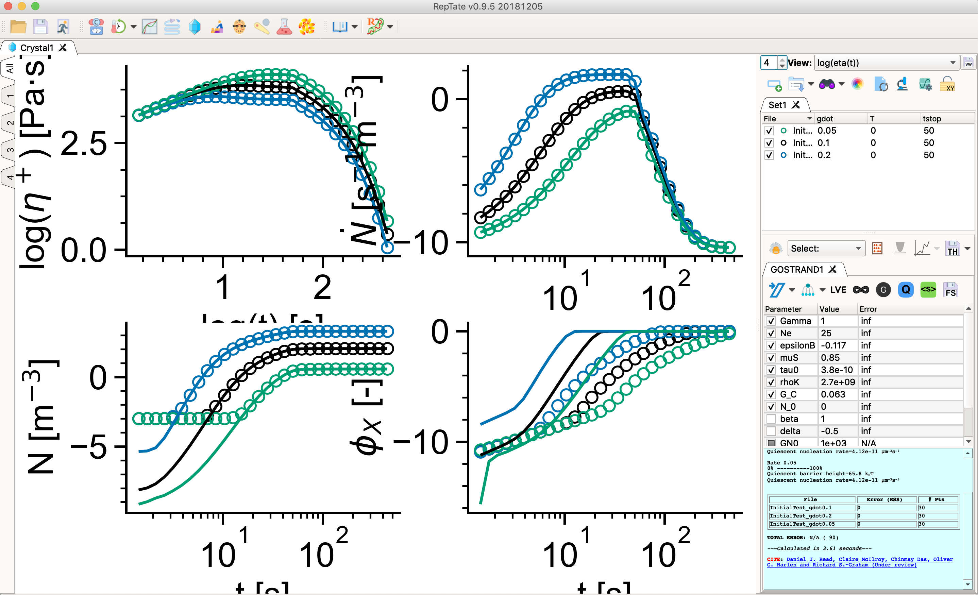
* Set the both parameters G_C and N_0 1e-3 to produce full agreement for N and phi_x.

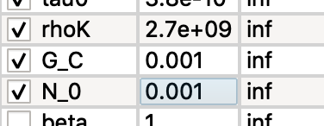

# Things to try

* Change Gamma to adjust the sensitivity to shear
* Make *small* changes to epsilonB to adjust the quiescent barrier (equivalent to changing temperature)
* Adjust tau0 to scale all nucleation rates
* Adjust G_C to change the crystal growth rate
* Change the molecular weight distribution by clicking 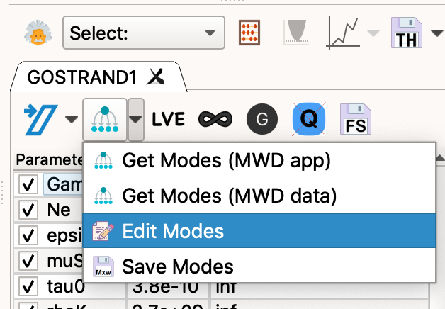

and changing the relaxation times, number of modes, and concentrations (this needs to add up to 1).

* Double click on a data set and change the shear rate (gdot) and shear end time (tstop) [T is temperature, which currently has no effect]

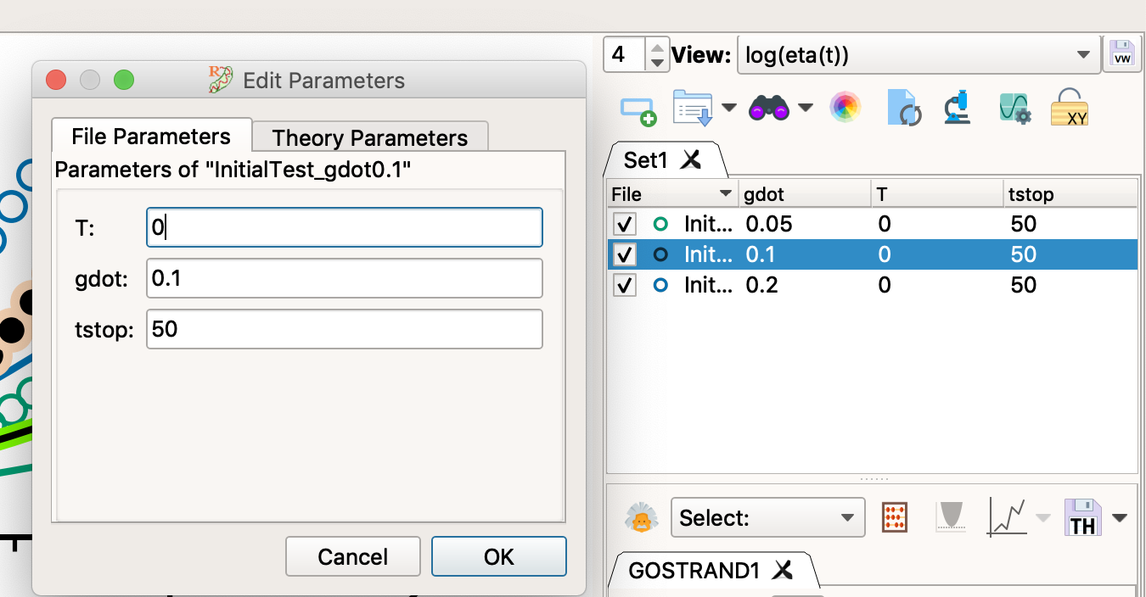

* Click the numbered tabs on the left of the screen to make individual plots fill the window

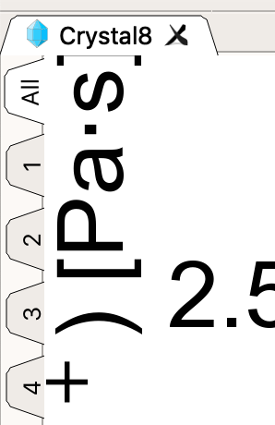

* Use the ‘View’ menu towards the upper right corner to choose different views.

