Crystal Application Tutorial: Comparing with steady state nucleation data

***Aim:*** *The tutorial aims to compare the nucleation models to direct nucleation rate measurements from flowing melts.*

**Data**: *In this tutorial we will model FIC experiments on a single isotactic polypropylene. The experiments directly measured the steady state nucleation rate during continuous shear. Experiments were performed for a range of shear rates and at 3 different temperatures. Experiments by* *Coccorullo et al. Macromolecules* ***41****, 9214 (2008) and Pantani et al. Macromolecules,* ***43****, 9030 (2010).*

***Summary:*** *We will import the molecular weight distribution data, take most parameters from the literature and fit the remaining crystallisation parameters to one temperature. The other temperatures will then by captured by varying only one parameter (the bulk free energy of crystallisation). Predicting the effect of temperature is important for the design and control of polymer processing.*

# Load data and set the view

* Load the Crystal application (Click on the crystal application  on the top toolbar)
* Reduce the number of views to 1 (Top right corner)

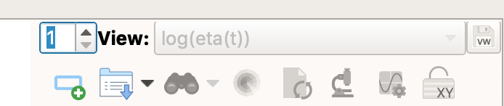

* Open the folder RepTate/RepTate/data/Crystal/CoccorulloMacromolecules2008/

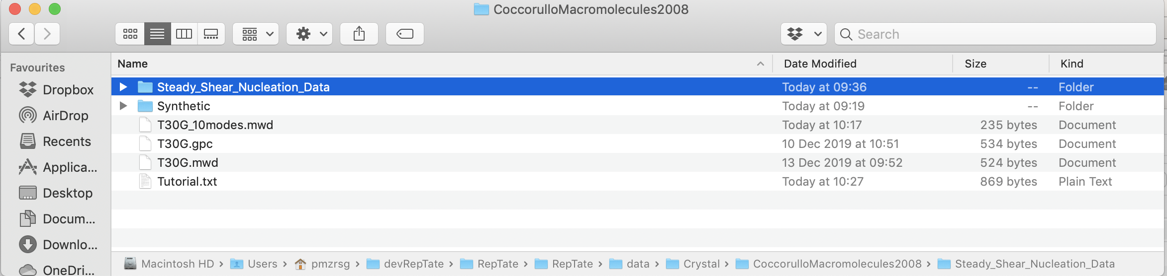

* From the folder ‘Steady_Shear_Nucleation_Data’ drag and drop all files that begin with T140 on to the Reptate window

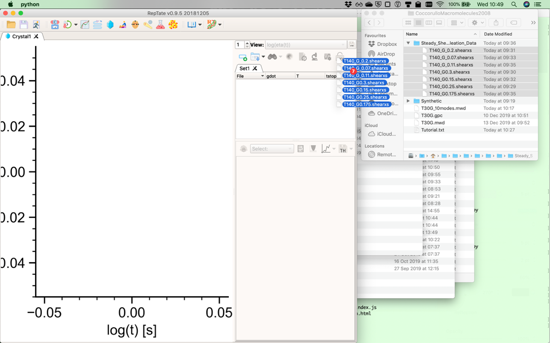

* Select 'Steady Nucleation' View

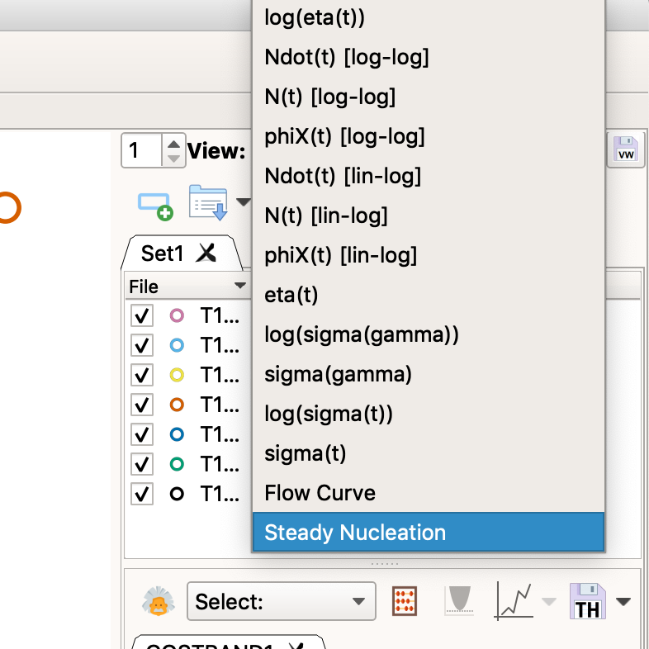

# Set-up a fast-running calculation

* Load GO-polyStrand model (choose the model from the drop down list and then click the theory icon )

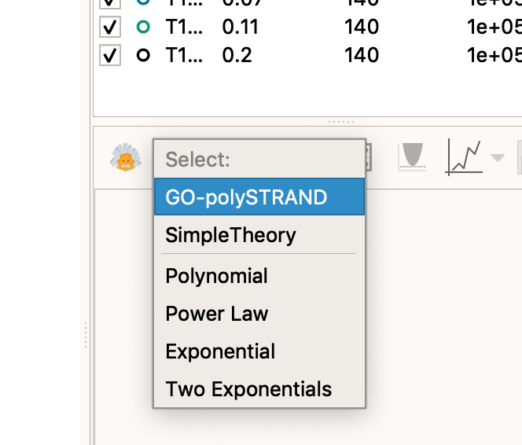

* Click 'Get modes MWD data'

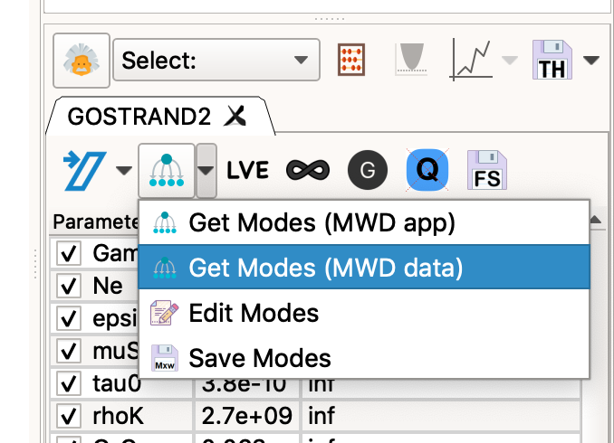

-In the pop-up window set Me=4400, tau_e=9.0E-8 and the number of modes to 10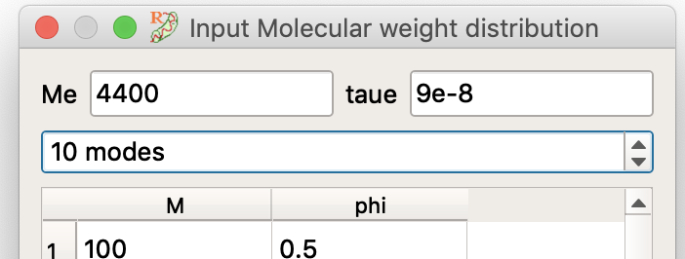

In a text editor, open 'T30G_10modes.mwd' and copy whole file contents to the clipboard.

* Click on the first element of the table and paste the copied file (use ctrl-v or a similar keyboard shortcut)

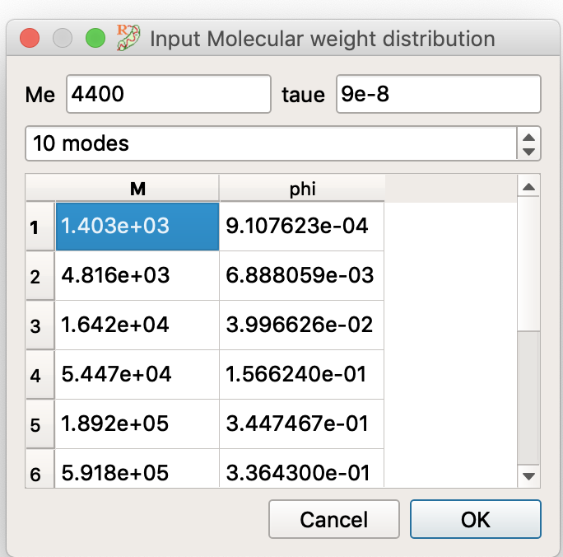

Close the mode window by clicking 'Ok'

* Back in the theory window, turn on the modulus correction button and set Gamma=4.3 and GNO=5.06E5

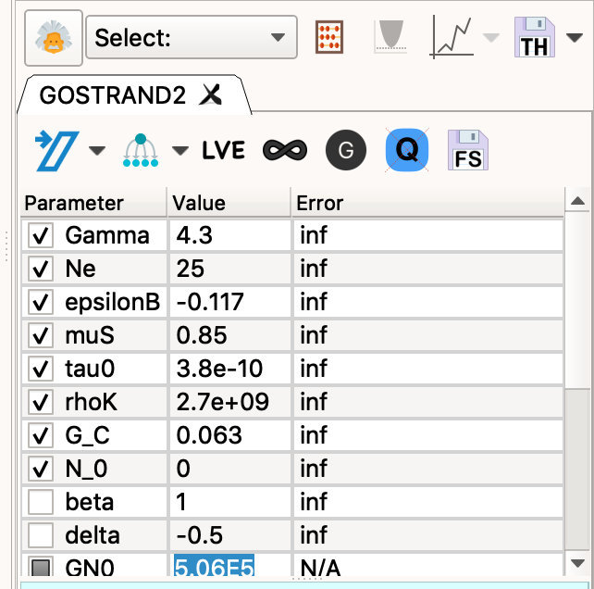

* Other parameters default to the correct values, here's a full list.
* Gamma 4.3
* Ne 25
* epsilonB -0.117
* muS 0.85
* tau0 3.8e-10
* rhoK 2.7e+09
* G_C 0.063
* N_0 0
* beta 1
* GN0 506000

*The parameters tau_e, Me, Ne, rhoK, beta amd GN0 are all from the literature and tau) can be determined from Ne and tau_e. The parameters muS and epsilon determine the quiescent free energy landscape and these are chosen so that the critical nucleus size is approximately the lamella thickness and the barrier height matches the quiescent nucleation rate. The remaining parameter, Gamma, is adjusted to best fit the FIC experiments at 140oC.*

* Hit compute, and the calculation should take about 15 secs (depending on how good your laptop is!)

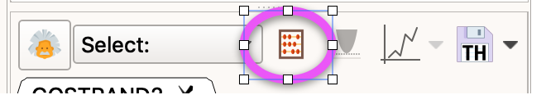

* You should see (open symbols are experiments and closed symbols are the model)

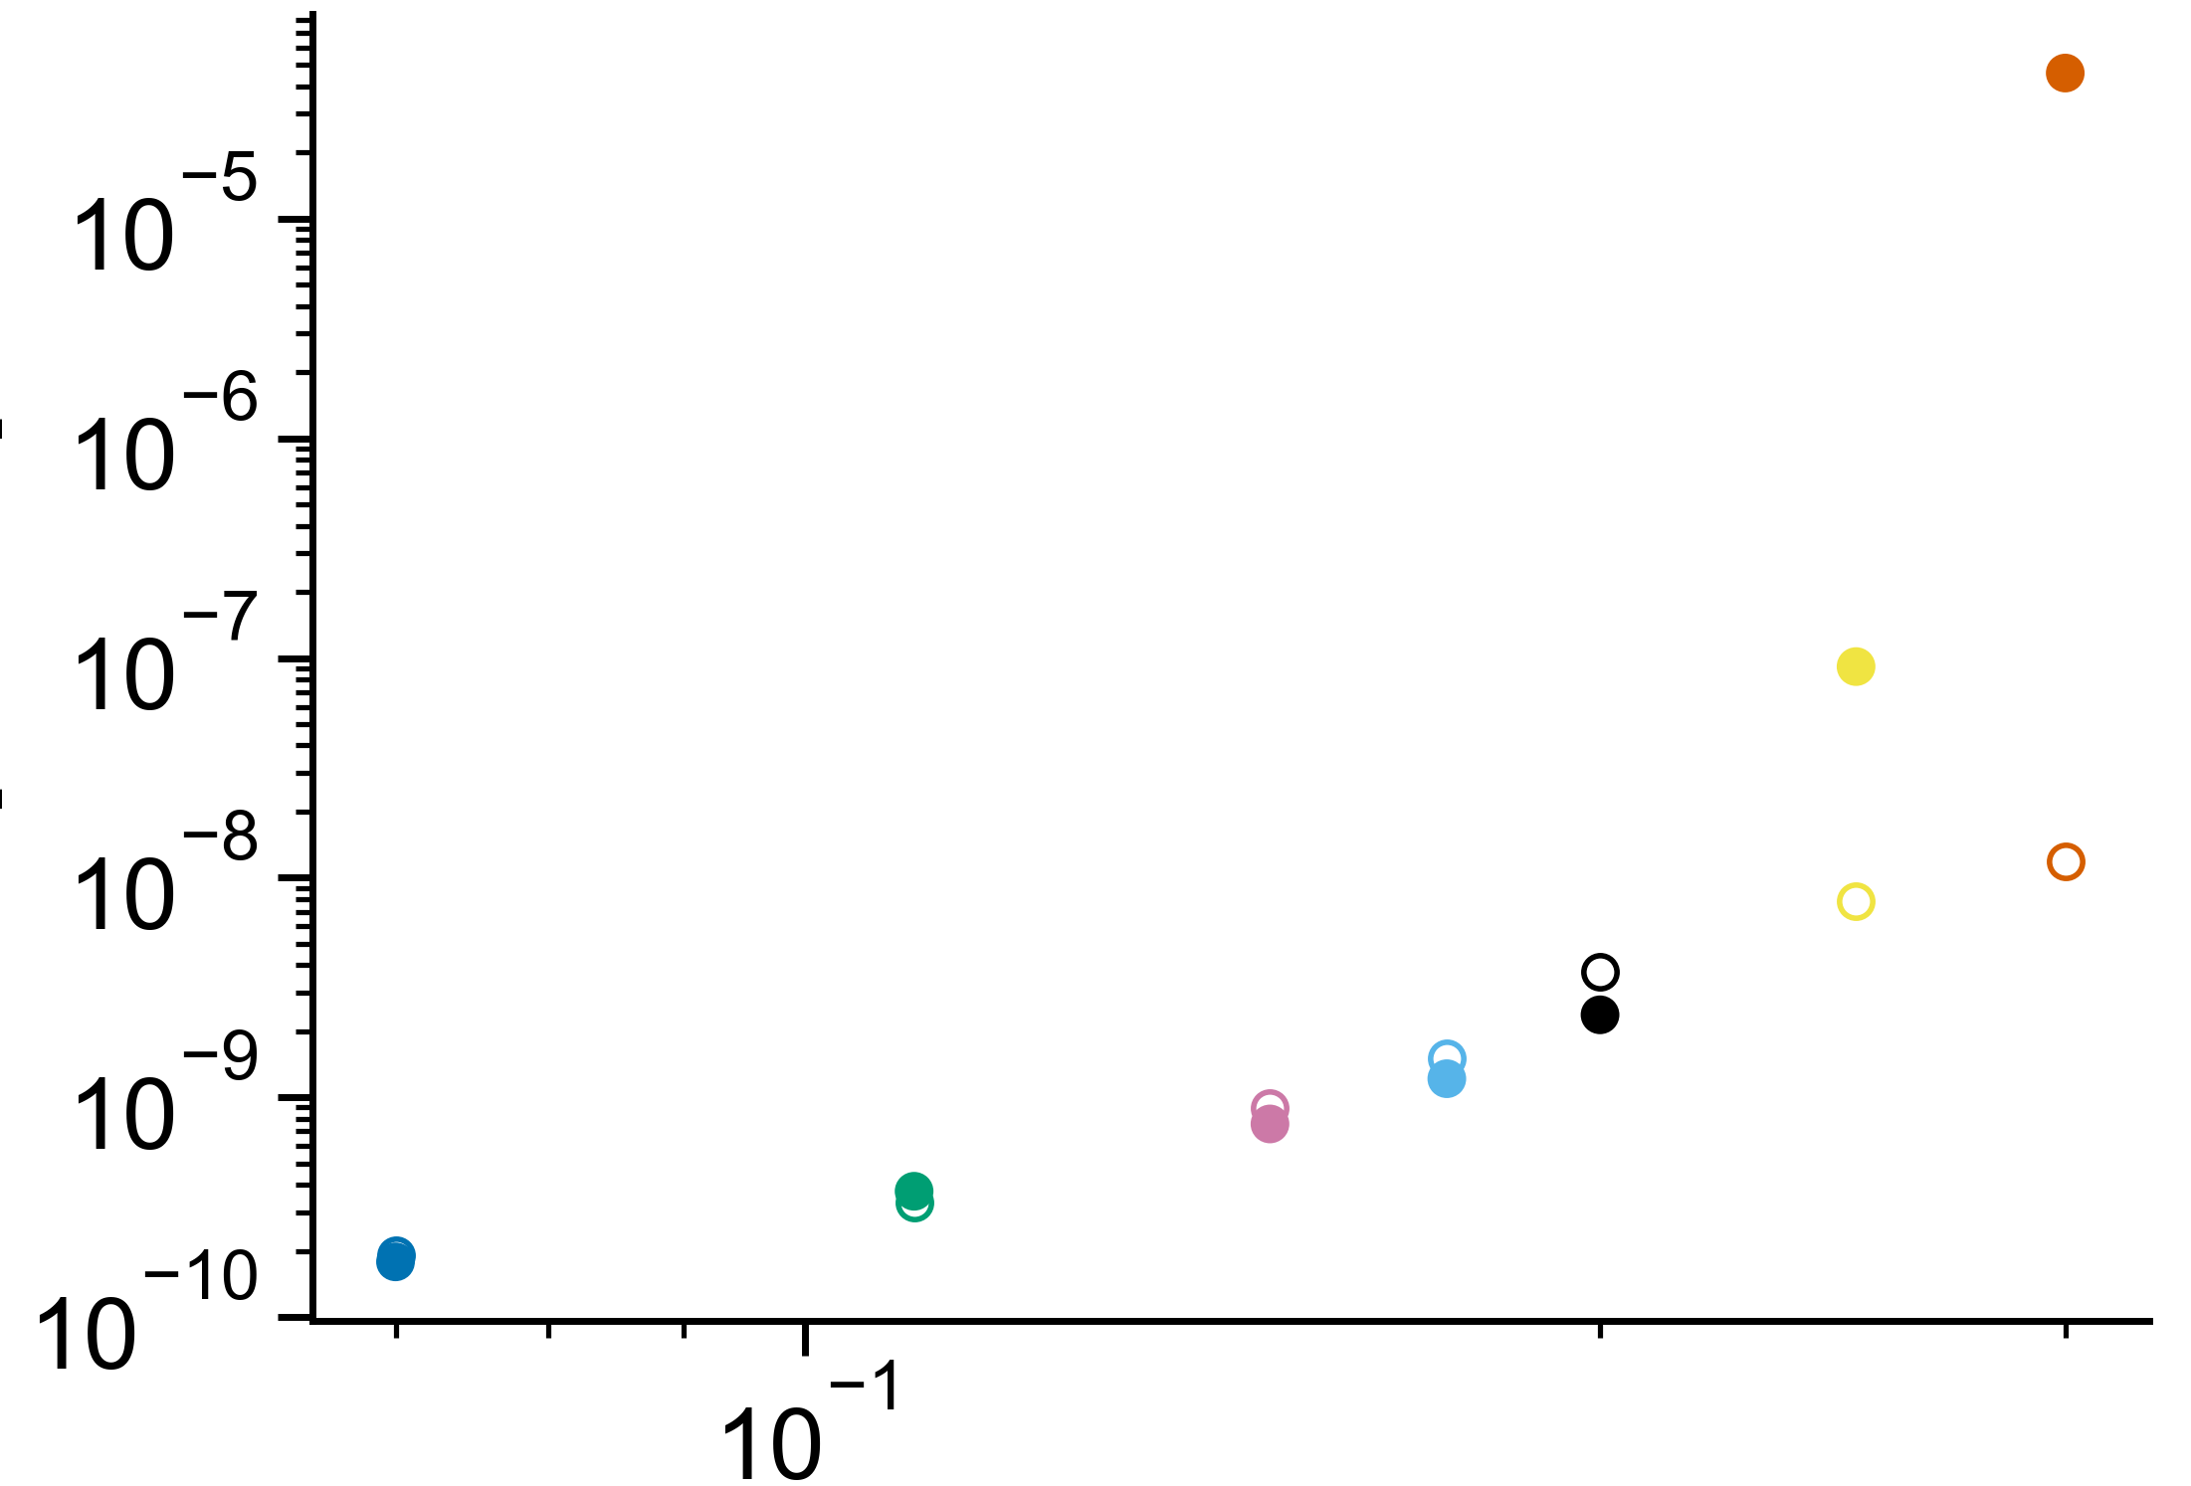

# Adjusting the view

* Click ‘show/hide’ toolbar’  (top right corner underneath the views selector)
* 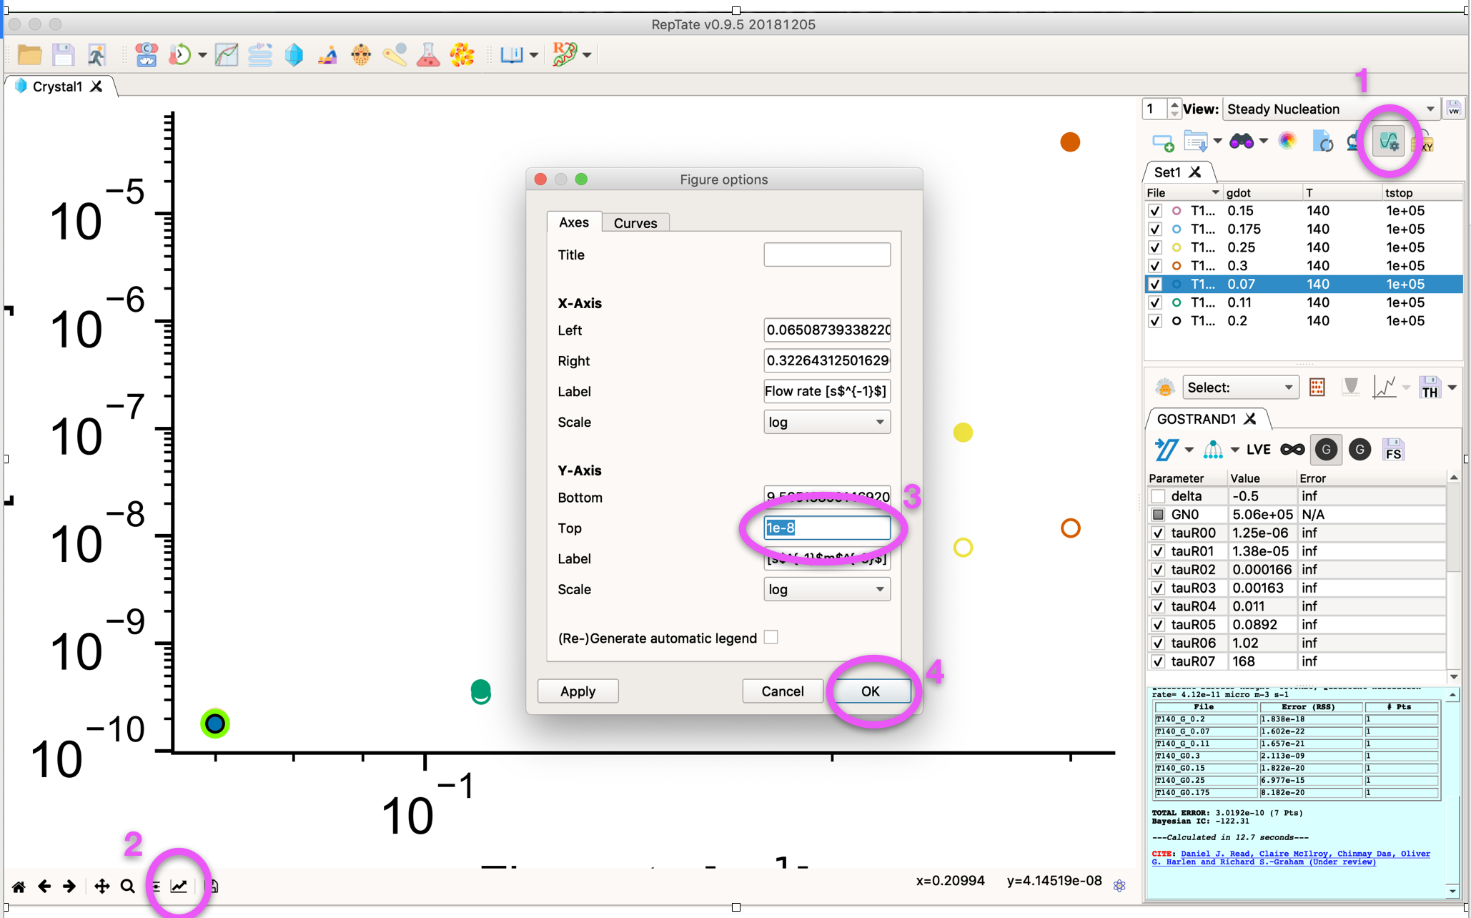
* Click the ‘Edit axis’ button () to bring up the axis properties
* Change the Y-Axis: Top value to ‘1e-8’
* Click ‘Apply’ or ‘Ok’

# Comparing with the ‘average stress model’

*The ‘average stress model’ averages the chain deformation over all modes in the melt, before treating this averaged mode as a single species during nucleation. We will see that this neglect of the role of multiple cooperating species during nucleation fails to capture the upward curvature in the nucleation experiments.*

* Copy parameters from your data comparison above 
* Create a new GO-polyStrand model 
* Paste the model parameters. (This create an identical copy of the model above)
* Double click on the name of theory and rename it to ‘Average Stress’ 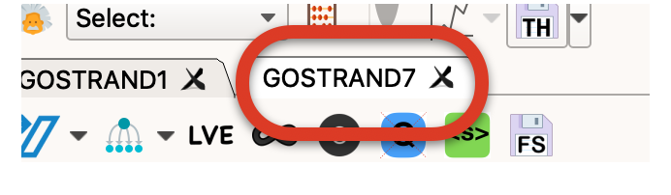
* Click the ‘average stress’ button  and run the model 
* Towards the top of the window click ‘View All Theories’ to show both theories on the same plot.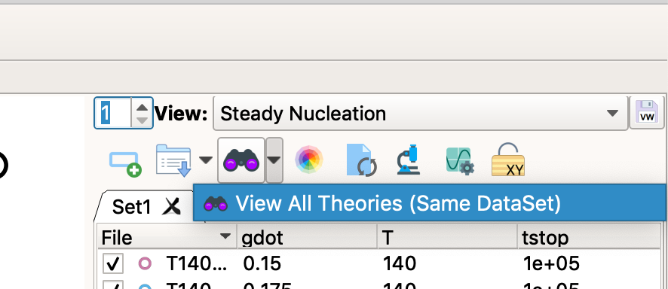

# Comparing with the smooth-polySTRAND model

*The smooth-polyStrand model is similar to the Go-polyStrand model but has some additional physical detail. Specifically, it penalises rough nuclei (those with widely differing stem lengths) and self-consistently conserves chain stems inside a volume around the growing nucleus. Both effects cap the excessive enrichment of long chains in the nucleus at high shear rates and so reduce the overprediction of the nucleation rate.*

* From the list of models, select the smooth-polySTRAND model 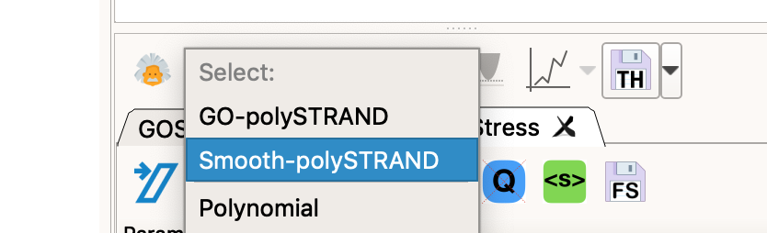
* And click new model 

*We begin by importing the same molecular weight distribution and tube model parameters as before.*

* Add modes as before: Click 'Get modes MWD data'



* In the pop-up window set Me=4400, tau_e=9.0E-8 and the number of modes to 10

In a text editor, open 'T30G_10modes.mwd' and copy whole file contents to the clipboard.

* Click on the first element of the table and paste the copied file (use ctrl-v or a similar keyboard shortcut)



* Scroll down to the last mode and increase it from 1.9e8 to 3e8 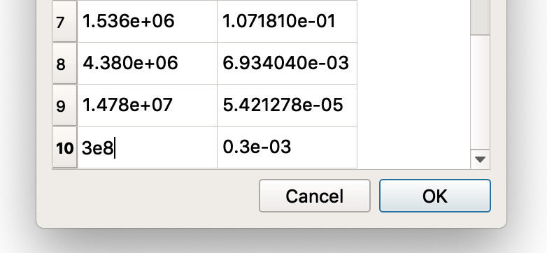

Close the mode window by clicking 'Ok'

*The flow-induced nucleation parameter Gamma needs to be larger for this model.*

* Back in the theory window, turn on the modulus correction button and set Gamma=4.3 and GNO=5.06E5.
* Other parameters default to the correct values, here's a full list.
* ﻿﻿Gamma 4.3
* Kappa0 0.1
* Qs0 30
* Ne 25
* epsilonB 0.044
* muS 0.94
* tau0 7.4e-10
* rhoK 2.7e+09
* G_C 0.063
* N_0 0

*The values of epsilonB and muS are different to the GO-polyStrand model comparison because the roughness penalty changes the quiescent barrier. These parameters produce the same quiescent barrier for the two models.*

* Click ‘View All Theories’ as above.

# Comparing with experiments at 144oC

*Now we have parameters at 140oC we’re going to test how the model performs at different temperatures. We will assume that all parameters are fixed apart from the bulk free-energy of crystallisation, epsilonB, which changes as the degree of undercooling changes with temperature.*

* Double click on the Crystal application tab and rename this to ‘140oC’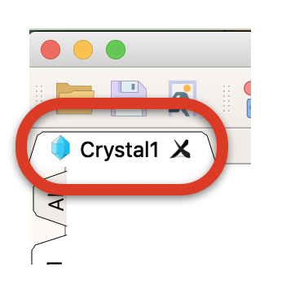
* Open a new Crystal Application and rename this to ‘144oC’
* In the ‘144oC’ application reduce the number of views to 1
* Go back to the folder with the experimental data in (‘CoccorulloMacromolcules2008’) and drag all files that begin T144 onto the Reptate window
* Make this view ‘Steady Nucleation’
* Create new GO-polySTRAND theory 
* Go back to the ‘140oC’ tab, return to the GO-polySTRAND model and copy the GO-model parameters



* Return to 144oC and paste these parameters onto the theory

*Copy and pasting parameters like this moves ensures that we begin the comparison at 144oC using the same parameters as at 140oC.*

* Run the model to confirm that this gives the predictions for 140oC. You should see something like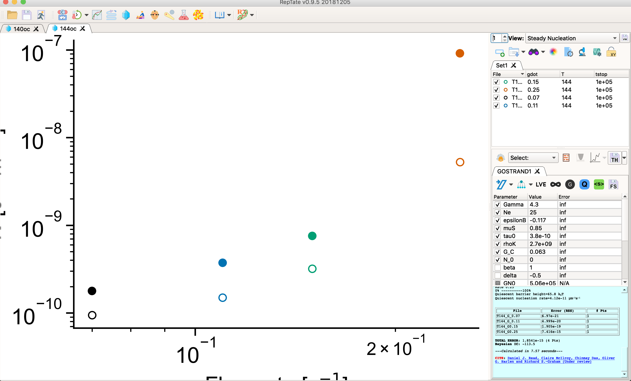
* Change epsilonB to -0.118

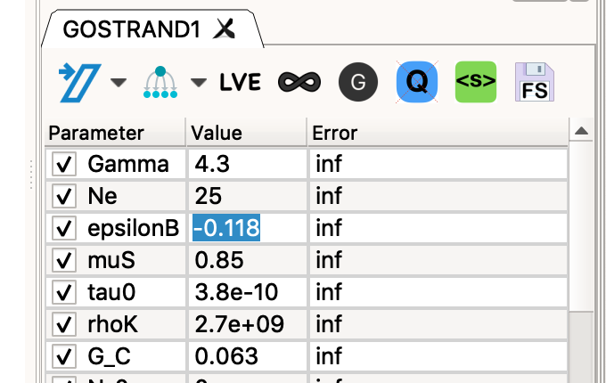

*This small change in epsilon is chosen to give the same quiescent nucleation rate at the experiments at 144oC – all other model parameters remain unchanged.*

* Rerun the model to get improved agreement.
* Repeat the steps above to make an ‘Average Stress’ model
* Create a new smooth-PolySTRAND model, copy the parameters for this model from 140oC into this new model and change epsilonB to 0.0429 to give reasonable agreement for all rates.
* Repeat all of the above steps to create new tab for the data at 138oC. For the GO-polySTRAND model use epsilon=-0.01146 and for 0.0463 for the smooth-polyStrand model.

# Things to try

* Change Gamma to adjust the sensitivity to shear
* Make *small* changes to epsilonB to adjust the quiescent barrier (equivalent to changing temperature)
* Adjust tau0 to scale all nucleation rates
* Change the molecular weight distribution by clicking ‘Get modes (MWD data)’ and changing the Molar Mass values (M) by hand. You can also change phi but this needs to add up to 1.
* For the smooth polystrand model try changing Qs0.
* For the GO-polyStrand model, increase the resolution of the molecular weight distribution by copy/pasting the modes from the file ‘T30G.mwd’ (this has 23 modes, should give similar results and will take a 4 mins to calculate)