HW4-1

202334441

김준영

1. explain the insertion sort algorithm with an example.

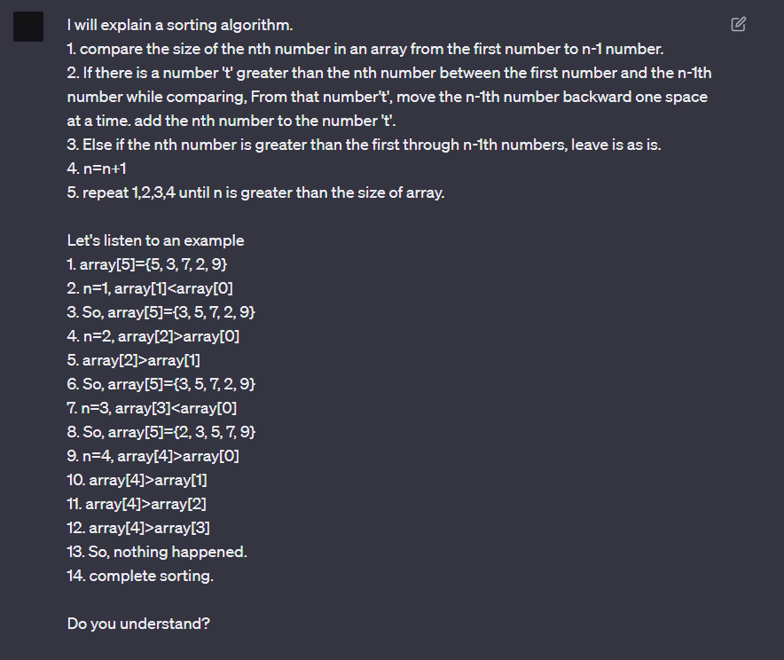

ChatGPT understood my explanation and mentioned insertion sort despite I didn’t say insertion sort.

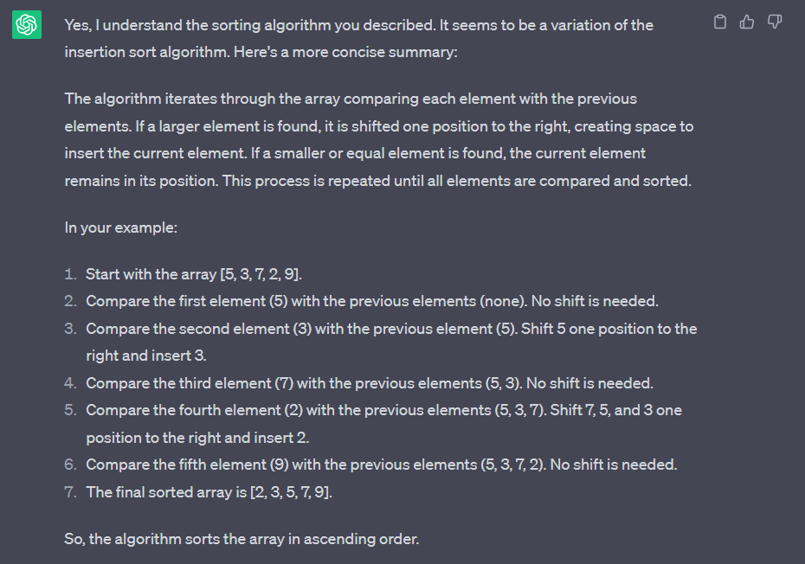

I told chatGPT to write the code that I explanation.

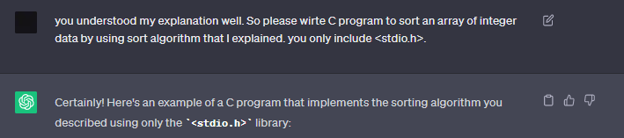

This code is almost correct. But in sortArray function, int variable ‘i’ is not used. The memory is wasted.

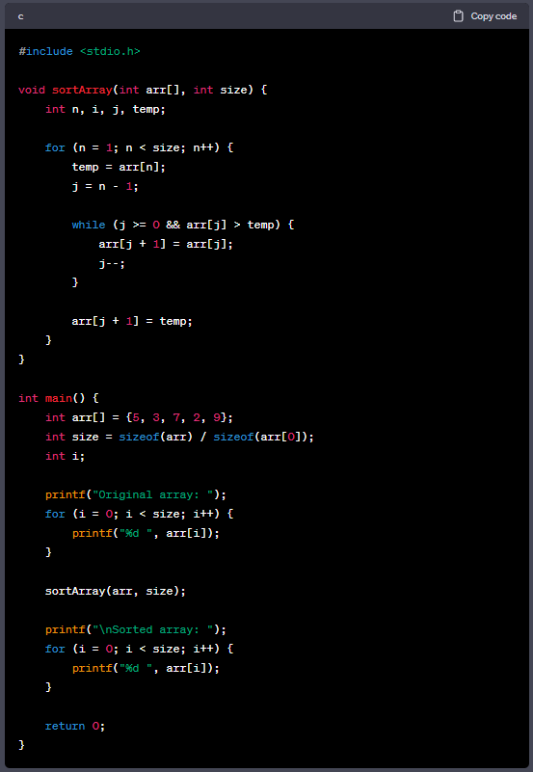

Example is correct.

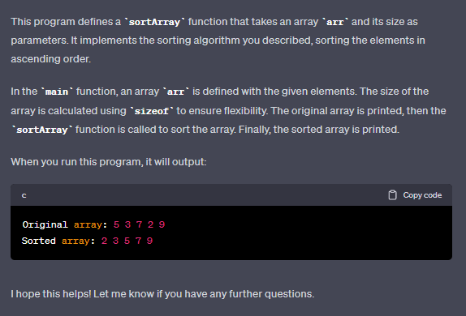

To not waste memory space, rewrite the code using I instead of n in the sortArray function.

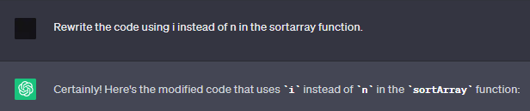

The code is correct.

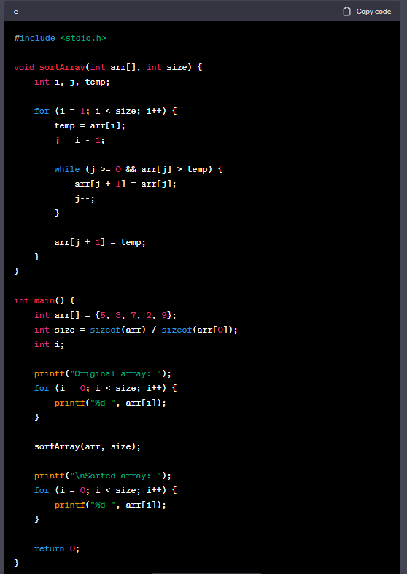

I was wondering if this code could be optimized, so I asked ChatGPT to optimize it.

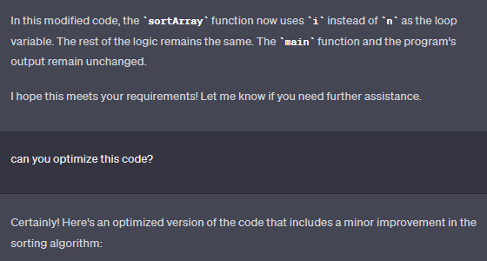

Nothing changed.

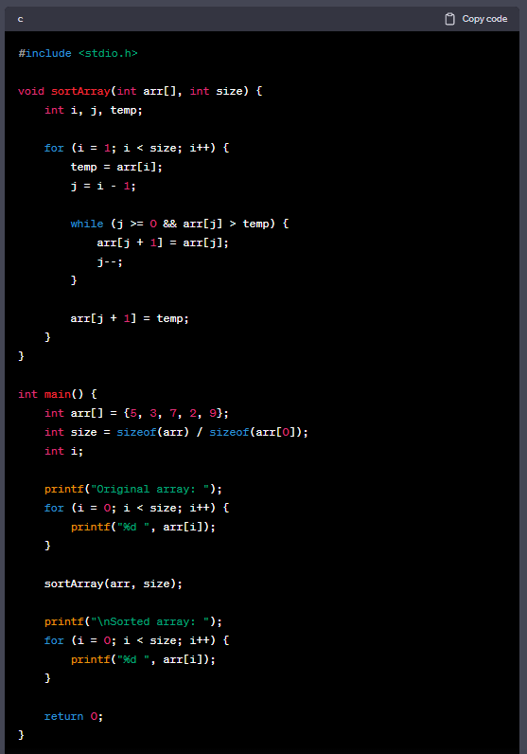

To check whether ChatGPT understood it well, I asked ChatGPT to show another example.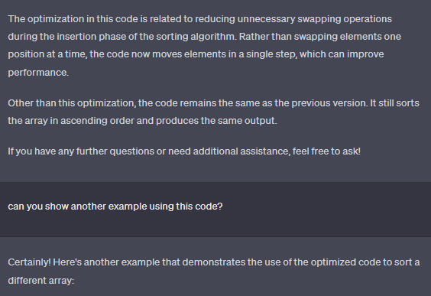

Another example is also correct.

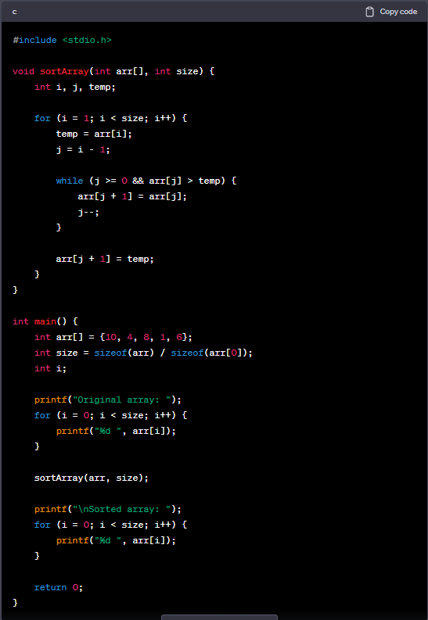

I asked ChatGPT to give me a citation. So the citation of this code is openai.

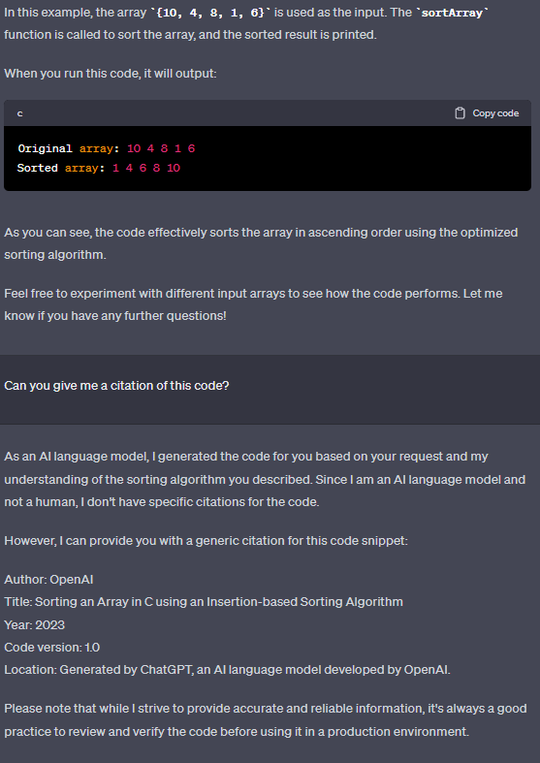

I asked to modify this code to conform to the c language guidelines.

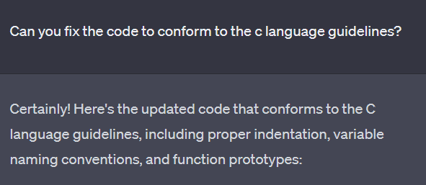

This code is added function prototype.

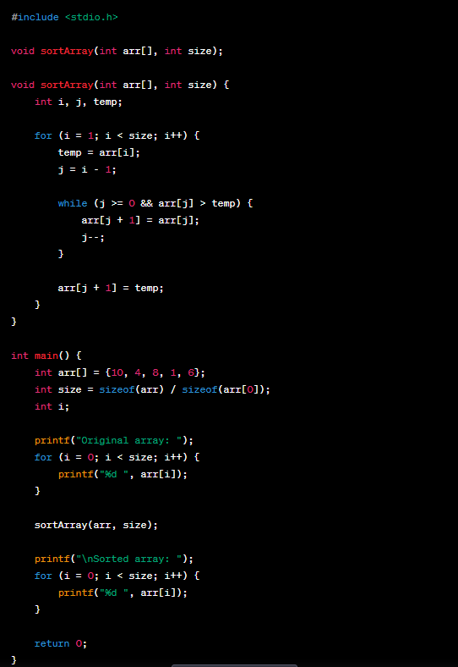

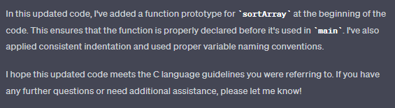

3. pros and cons

At a time when I need to fill in more knowledge, I think it is a tool that is not helpful to me now because finding answers quickly is forgotten from memory faster than finding answers while searching and debugging. However, if there is a reason why chatGPT must be used, it would be useful to use it while recognizing that it is sometimes inaccurate.

I was interested in NLP in high school, and I also tried to create sentence-generating AI using GPT2 model. I knew about GPT, but I used chatGPT for the first time on this homework. In order to get a job now, I need to become an irreplaceable talent with ai, but if I use only chatGPT to solve activities that can improve skills, such as homeworks, quiz, reports and tests, I think it will eventually become expendable. To not be expendable, I will study hard without chatGPT. And I will study models that are more efficient with less time and money that transformer based models that increase the number of parameters and train more sentences.