**Team4**

**Project : Connect Pipes Game**

**Brief**

**Connect the pipe game**

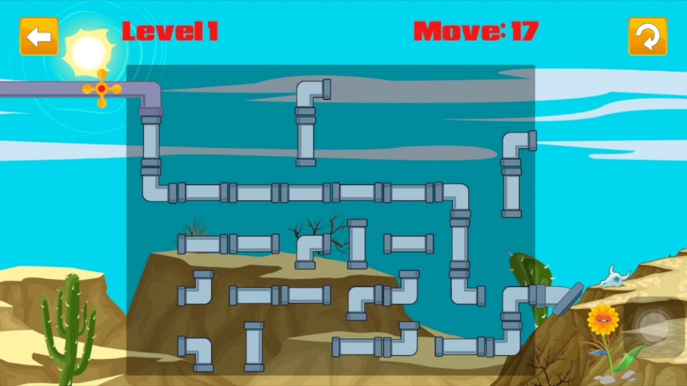

**Website will contain () page:-**

**One page contain Many Pages (User login- Level-Resigtertion- Game )**

**Team Members:-**

**1. Beshoy Nebih Aziz**

**2. Ahmed Atef Kamal**

**3. Sally Ekram**

**4. Noor Eldeen Ahmed**